



Faculty of Electrical and Computer Engineering; Nanoelectronic Materials Laboratory

Title

Development of HfO2-Based   
Ferroelectric Memories for Future CMOS Technology Nodes

A dissertation presented   
by   
Stefan Ferdinand Mueller   
in fulfillment of the requirements   
for the degree of   
Doctor of Engineering

2014

Acknowledgements

This thesis was carried out at NaMLab gGmbH in the timeframe of April 2011 until Januray 2014. First of all, I would like to thank Prof. Dr.-Ing. Thomas Mikolajick for the supervision of the thesis.

The underlying study was perfromed in the framework of a research project between NaMLab gGmbH, Fraunhofer IPMS-CNT and GLOBALFOUNDRIES. In the following I would like to express my gratitude to the numerous colleagues who contributed during the course of the project.

First of all I would like to thank Johannes Mueller for the overall support during the project. His technical expertise in the field as well as the support in processing of MFM capacitors and integrated device lots enabled a significant portion of this thesis.

Furthermore I am grateful for the support of several colleagues at my institute: I would like to thank Dr.-Ing. Stefan Slesazeck for electrical characterization support and fruitful discussions on device and array operation. Moreover, I always appreciated discussions with Tony Schenk regarding the origin of ferroelectricity in HfO2. I would also like to thank Dr. Uwe Schroeder for the introduction to the topic.

From GLOBALFOUNDRIES I would like to thank Roman Boschke and especially Stefan Flachowsky for supporting the processing of the integrated device lots. Tom Herrmann and Alban Zaka are acknowledged for providing the TCAD model and for stimulating discussions on FeFET modeling and simulation.

Several other persons deserve mentioning as well: Thanks go to Patrick Polakowski and Jan Paul from Fraunhofer for ALD and RIE support. I also enjoyed discussions with Ekaterina Yurchuk and Johannes Ocker regarding electrical characterization of ferroelectric field effect transistors. In addition I want to thank Claudia Richter and Dr. Matthias Grube for proof-reading of the thesis.

Last but not least I want to thank my family for their lifelong support which had always been and still is exceptional.

I

Abstract

In 2007 it was found that Si:HfO2 thin films can show ferroelectric behavior if processed under the right conditions. Since then, the discovery has given hope to finally enable the commercialization of memory concepts based on the ferroelectric field effect transistor (FeFET). By combining the advantages of both read-only-memories (ROM) and random-access-memories (RAM), the FeFET might severely influence the semiconductor memory landscape of the future.

The aim of this thesis was to evaluate the viability of ferroelectric Si:HfO2 and its derived FeFET application for non-volatile data storage. At the beginning, the ferroelectric effect is explained briefly such that the applications that make use of it can be understood. Afterwards, the latest findings on ferroelectric HfO2 are reviewed and their potential impact on future applications is discussed. The research efforts are furthermore motivated by benchmarking the Si:HfO2-based FeFET concept with respect to state-of-the-art and emerging non-volatile memories (NVM).

Experimental data is presented afterwards focusing on the ferroelectric material characteristics of Si:HfO2 that are most relevant for memory applications. Besides others, the stability of the ferroelectric switching effect could be demonstrated in a temperature range of almost 400 K. Moreover, nanosecond switching speed and endurance in the range of 106 - 1010 cycles could be proven. Retention and imprint characteristics have furthermore been analyzed and are shown to be stable for 1000 hours bake time at 125 ºC.

Derived from the ferroelectric effect in HfO2, a 28 nm FeFET memory cell is introduced as the central application of this thesis. Based on numerical simulations, the memory concept is explained and possible routes towards an optimized FeFET cell are discussed. A description of the FeFET integration concept illustrates the ease of integration of the HfO2-based FeFET and highlights its potential as an embedded memory solution.

Subsequently, the results from electrical characterization of FeFET multi-structures are presented and discussed. By using Si:HfO2 it was possible to realize the world's first 28 nm FeFET devices possessing i.a. 104 cycling endurance and an extrapolated 10 year data retention at room temperature. Moreover, fast transient characterization methodologies were applied in order to prove nanosecond write and read speeds of FeFET-based memory cells.

The next step towards a FeFET memory is represented by connecting several memory cells into matrix-type configurations. A cell concept study illustrates the different ways in which FeFET cells can be combined together to give high density memory arrays. For the proposed architectures, operational schemes are theoretically discussed and analyzed by both electrical characterization of FeFET multi-structures and numerical simulations. A new operational scheme called the positive-source-drain-erase-scheme (PSDES) is presented which enables a true random program / erase operation of FeFET-AND-arrays. Several array architectures were finally transferred to a test chip which was then manufactured during the course of this study.

The thesis concludes with the electrical characterization of small FeFET memory arrays. First results show that a separation between memory states can be achieved by applying poling and incremental step pulse programming (ISPP) sequences. These results represent an important cornerstone for future studies on Si:HfO2 and its related applications.

II

Contents

Acknowledgements ................................................................................................................... I Abstract .................................................................................................................................. II Contents ................................................................................................................................. III List of Symbols ...................................................................................................................... VI Acronyms ............................................................................................................................. VII

1 Introduction ..................................................................................................................... 1 1.1 Ferroelectric Effect and Materials ............................................................................ 1 1.1.1 Physics of Ferroelectricity ................................................................................ 3 1.1.2 Traditional and Modern Ferroelectrics ............................................................. 5 1.2 Ferroelectric Applications in Industry and Research ............................................... 6 1.2.1 Ferroelectric Random Access Memory ............................................................. 6 1.2.2 Ferroelectric Field Effect Transistor ................................................................. 9 1.2.3 Future CMOS Applications Based on Ferroelectrics ...................................... 11 1.3 Discovery of Ferroelectricity in HfO2 ..................................................................... 12 1.4 Comparison of Ferroelectric HfO2 to Classical Ferroelectrics ................................ 13 1.5 State-of-the-Art Memory Solutions and Limitations ............................................. 15

2 Material Properties of Ferroelectric HfO2 ...................................................................... 19 2.1 Polarization Hysteresis in Si:HfO2 .......................................................................... 19 2.1.1 Composition and Annealing Dependence ....................................................... 21 2.1.2 Temperature Stability of Ferroelectric Hysteresis .......................................... 24 2.1.3 Conditioning Effects ....................................................................................... 26 2.2 Switching Kinetics .................................................................................................. 27 2.3 Specific Characteristics with Focus on Non-Volatile Memories ............................. 30 2.3.1 Write Endurance and Ferroelectric Fatigue ................................................... 30 2.3.2 Same-State, Opposite-State and New-Same-State Retention ......................... 32 2.3.3 Imprint ............................................................................................................ 35

III

2.4 Effects of Film Thickness and Increased Dopant Concentration ........................... 36 2.5 Reference Capacitors for Integrated Device Lot .................................................... 37

3 The Si:HfO2 FeFET: From TCAD Model to Integrated 28 nm Device ........................ 39 3.1 Compact Model of Ferroelectric Hysteresis ............................................................ 39 3.2 Application of the Ferroelectric Model for TCAD Simulation of FeFETs ............ 41 3.2.1 Theoretical Model of the FeFET .................................................................... 41 3.2.2 Memory Window and Polarization Hysteresis ................................................ 43 3.2.3 Depolarization Fields and Interfacial Oxide Fields ........................................ 45 3.2.4 Optimization of HfO2-based Ferroelectric Field Effect Transistors ................ 47 3.3 FeFET Integration into a 28 nm Technology Node ............................................... 54 3.3.1 Simplified FEOL Flow of a 28 nm CMOS Technology .................................. 54 3.3.2 Process Changes Required for Manufacturing of HfO2-based FeFETs .......... 56 3.3.3 Embedded Memory Capability of FeFET Devices ......................................... 58

4 Electrical Characteristics of Si:HfO2-Based Ferroelectric Field Effect Transistors ....... 60 4.1 Foreword on Statistical Effects in FeFET Multi-Structures .................................. 60 4.2 Basic Electrical Characteristics .............................................................................. 61 4.2.1 Capacitance- and Current-Voltage Characteristics ........................................ 61 4.2.2 Memory Window and Program / Erase Matrices .......................................... 64 4.2.3 Endurance and Fatigue ................................................................................... 68 4.3 Fast Transient Characteristics ............................................................................... 72 4.3.1 PUND Characterization of MFIS Capacitors ................................................. 72 4.3.2 "Single Pulse" Id-Vg Characteristics and Fast Retention ............................... 77 4.3.3 Transistor Access Time .................................................................................. 80

5 FeFET Cell Array Study ............................................................................................... 83 5.1 Cell Array Concepts based on Classical Non-Volatile Memory Architectures ...... 83 5.2 Multi-Transistor Arrays and Operational Schemes................................................ 90 5.3 Validation and Verification of Proposed Array Concepts ...................................... 92 5.3.1 TCAD Simulation of Elementary Array Architectures .................................. 93 5.3.2 State Disturb and Write Inhibition of Single FeFET Cells .......................... 102

IV

6 FeFET Memory Arrays................................................................................................ 104

6.1 Ferroelectric Reference Capacitors ....................................................................... 104

6.2 Program / Erase Characteristics of FeFET Cell Arrays ...................................... 106

7 Conclusion and Outlook ............................................................................................... 109

References ............................................................................................................................ 111

Curriculum Vitae ................................................................................................................. 122

V

List of Symbols

|  |  |  |
| --- | --- | --- |
| Symbol | Description | Unit / Value |
| A | Area | m2 |
| Inh  C | Inhibit factor | unitless |
| Capacitance | F |
| CBL  CFE  CS | Bitline capacitance | F |
| Dielectric capacitance of ferroelectric film | F |
| Signal capacitance | F |
| D | Electric displacement field | C/cm2 |
| Dn  d | Electron diffusion coefficient | m2/s |
| Film thickness | m |
| 0 | Vacuum permittivity | 8.85  10-12 F/m |
| r  E | Relative permittivity | unitless |
| Electric field | V/m |
| EBD  EC  EDep  F | Breakdown field | V/m |
| Coercive field | V/m |
| Depolarization field | V/m |
| Helmholtz free energy | J |
| gm  H | Transconductance | A/V |
| Magnetic field | A/m |
| Id  IOFF  ION  J | Drain current | A |
| OFF-current | A |
| ON-current | A |
| Current density | A/cm2 |
| JFN | Fowler Nordheim tunneling current density | A/cm2 |
| k | Boltzmann constant | 1.38  10-23 J/K |
| k | Wavenumber | cm-1 |
| Lg  M | Transistor length | m |
| Magnetization | A/m |
| n  n | Electron mobility | cm2/Vs |
| Electron density | cm-3 |
| NA  P | Acceptor concentration | cm-3 |
| Power | W |
| P | Polarization | C/cm2 |
| Pmax | Maximum polarization | C/cm2 |
| Pr | Remanent polarization | C/cm2 |
| Pr,rel | Relaxed remanent polarization | C/cm2 |
| PS | Spontaneous polarization | C/cm2 |
| PSW | Switched polarization | C/cm2 |
| Q | Charge | C |
| q | Elementary charge | 1.6  10-19 C |
| S  t | Surface charge density | C/cm2 |
| Time | s |
| T0  TC  VC  VDD  VE  VFB  VGB  VP  VT  W | Transition / Curie temperature | ºC |
| Curie temperature | ºC |
| Coercive voltage | V |
| Operational voltage | V |
| Erase voltage | V |
| Flatband voltage | V |
| Gate to bulk voltage | V |
| Program voltage | V |
| Threshold voltage | V |
| Transistor width | m |
| W | Work | J |
| w | Space charge region width | m |
| F | Fermi potential | V |
| T  | Temperature voltage | V |
| Electric susceptibility | 1 |
| S | Surface potential | V |

VI

Acronyms

|  |  |  |  |
| --- | --- | --- | --- |
| Term | Description | Term | Description |
| 1T | One-transistor | MFM | Metal ferroelectric metal |
| 1T-1C | One-transistor one-capacitor | MFMIS | Metal ferroelectric metal |
| AC | Alternating current | insulator semiconductor |
| MFS |
| ALD | Atomic layer deposition | Metal ferroelectric |
| AMP | Amplitude | semiconductor |
| MIM |
| APC | Advanced process control | Metal insulator metal |
| BEOL | Back end of line | MLC | Multi-level cell |
| BL | Bitline | MLD | Molecular layer deposition |
| BTO | Barium titanate | MOCVD | Metal organic chemical vapor |
| CHE | Channel hot electrons | deposition |
| MOSFET |
| CMOS | Complementary metal oxide | Metal oxide semiconductor |
| semiconductor | field effect transistor |
| CMP | MPW |
| Chemical mechanical | Multi project wafer |
| polishing | MW | Memory window |
| CVD |
| Chemical vapor deposition | NCFET | Negative capacitance field |
| CVU | Capacitance voltage unit | effect transistor |
| NDRO |
| DC | Direct current | Nondestructive read out |
| DRAM | Dynamic random access | NGE | Negative gate erase |
| memory | NLS | Nucleation limited switching |
| DRO |
| Destructive read out | NMOS | N-channel metal oxide |
| DUT | Device under test | semiconductor |
| NSS |
| eNVM | Embedded nonvolatile | New same state |
| memory | NVM | Non-volatile memory |
| EOT |
| Equivalent oxide thickness | OS | Opposite state |
| ESD | Electrostatic discharge | PCM | Phase change memory |
| F | Feature size / floating | PDES | Positive drain erase scheme |
| condition | PFM | Piezo force microscopy |
| FEA |
| Finite element analysis | PL | Plateline |
| FeFET | Ferroelectric field effect | PMA | Post-metallization-anneal |
| transistor | PMU | Pulse measurement unit |
| FeMEM |
| Ferroelectric memristor | POR | Process of record |
| FEOL | Front end of line | PSDES | Positive source drain erase |
| FG | Floating gate | scheme |
| PTO |
| FLOTOX | Floating gate tunnel oxide | Lead titanate |
| FN | Fowler Nordheim | PUND | Positive up negative down |
| FOF | Figure of feasibility | PVD | Physical vapor deposition |
| FOM | Figure of merit | PW | Pulse width |
| FOP | Figure of performance | PZO | Lead zirconate |
| FRAM | Ferroelectric random access | PZT | Lead zirconate titanate |
| memory | RAM | Random access memory |
| FWHM |
| Full width half maximum | RIE | Reactive ion etching |
| GER | Giant electroresistance | RL | Read line |
| GSBPI | Global self-boost program | ROM | Read only memory |
| inhibit | RRAM | Resistive random access |
| HKMG |
| High-k metal gate | memory |
| RTA |
| HRS | High resistance state | Rapid thermal annealing |
| HR-TEM | High resolution transmission | SBT | Strontium bismuth tantalate |
| electron microscopy | SEM | Scanning electron microscopy |
| HV |
| High voltage | SGD | Select gate drain |
| IC | Integrated Circuit | SGS | Select gate source |
| ILD | Inter layer dielectric | Si:HfO2  SL | Silicon doped hafnium oxide |
| ISPP | Incremental step pulse | Sourceline |
| programming | SLC | Single level cell |
| KAI |
| Kolmogorov Avrami Ishibashi | SMU | Source measurement unit |
| LD | Landau Devonshire | SRAM | Static random access memory |
| LGD | Landau Ginzburg Devonshire | SS | Same state |
| LN | Liquid nitrogen | ST-RAM | Spin torque magnetic random |
| LRS | Low resistance state | access memory |
| TCAD |
| LSBPI | Local self-boost program | Technology computer aided |
| inhibit | design |
| MFIS | TPI |
| Metal ferroelectric insulator | Traditional program inhibit |
| semiconductor | WL | Wordline |
| WLW | Wordline-wise |

VII

INTRODUCTION

1Introduction

This chapter introduces the physics behind ferroelectricity which is fundamental to understand the concept of ferroelectric memories and FeFETs in particular. The theoretical description of ferroelectrics is presented in terms of the phenomenological Landau-Devonshire (LD) mean field theory. Classical ferroelectrics and their characteristic properties are discussed whereas also advances of modern ferroelectrics will be briefly reviewed.

Derived from the special material properties of ferroelectrics, state-of-the-art semiconductor applications are presented with a focus on ferroelectric memories. Moreover, research areas which promise to create revolutionary applications based on ferroelectrics in the future are summarized as well.

Subsequently, the latest research findings on ferroelectric HfO2 are reviewed and compared to traditional ferroelectrics. Furthermore, derived from the basic ferroelectric properties of HfO2, its implications on potential applications are discussed. Since this thesis researches the memory properties of ferroelectric HfO2 and its related FeFET application, alternative state-of-the-art (emerging) memory concepts are briefly summarized at the end of this chapter. This enables a "best case" measure for the potential of ferroelectric HfO2 as compared to competing memory concepts. Throughout the following chapters, experiments and simulations shall clarify if ferroelectric HfO2 and the FeFET application might live up to these theoretical expectations.

1.1Ferroelectric Effect and Materials

The term "ferroelectric" was coined by Schroedinger [94, 154] already in 1912 since he expected similar phenomena to occur for dielectric solids as they were known from ferromagnetism. This was experimentally confirmed in 1920, when the ferroelectric effect was discovered by Valasek during his work on Rochelle salt [202]. Valasek observed an electric P-E hysteresis which was similar to what was already known from the M-H hysteresis in ferromagnetism. In the electric domain, P represents the electric polarization and E the electric field whereas in the magnetic domain, M is the magnetization and H the magnetic field. Hence, the macroscopic definition of a ferroelectric is given in terms of the description of a P-E hysteresis: If a material is of ferroelectric nature, it possesses a permanent polarization which can be reversed by the application of an external electric field [66].

With respect to Maxwell's equations, the polarization P contributes to the electric displacement field which is defined as:

(1-1)

where D represents the electric displacement field, 0 the vacuum permittivity and E the electric field. For traditional insulators / dielectrics, the contribution of P is in general linearly dependent on the electric field. However, ferroelectrics possess an additional spontaneous polarization PS which is history dependent and responsible for the hysteretic nature of the P-E characteristic as predicted by Schroedinger and verified by Valasek. Hence, the polarization has to be expressed in terms of the sum of field dependent dielectric and ferroelectric contribution and the electric displacement field can be reformulated:

1

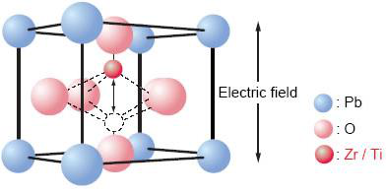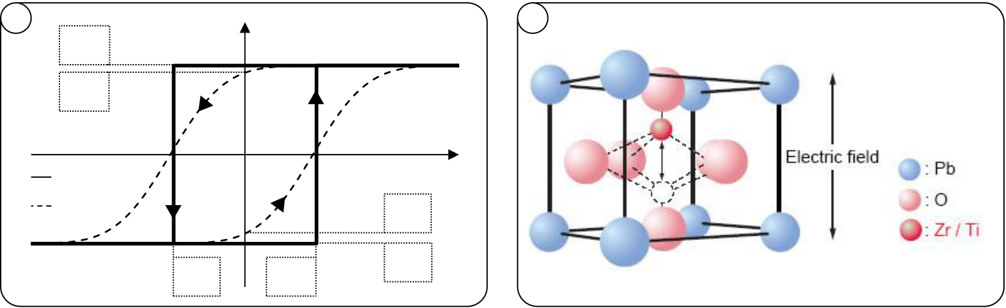

INTRODUCTION

(1-2)

( ) (1-3)

The quantity  is the electric susceptibility of the insulator and represents the degree of dielectric polarizability in multiples of the vacuum permittivity. Hence, as can be seen from equation (1-3), the relative permittivity r can be introduced and enables the separation of the dielectric and ferroelectric contributions to the electric displacement field.

The traditional microscopic / crystallographic understanding of the second summand of equation (1-3) is that certain atoms within the crystal unit cell can reside in two stable positions. This leads to a certain degree of polarity / spontaneous polarization inside the unit cell which implies that the crystallographic space group of the ferroelectric has to be non-centrosymmetric [193].

|  |  |  |  |  |  |
| --- | --- | --- | --- | --- | --- |
| a | *Ps +* | *Ec-* | Spontaneous Polarization | | b |
| *Pr +* | Electric Field | |
| ideal |
| real | *Pr-* | |
| *Ec +* | *Ps-* |

Fig. 1-1: Macroscopic and microscopic description of a ferroelectic. (a) PS-E characteristics of an ideal (solid) and real (dashed) ferroelectric. For the real case, a Gaussian distribution of coercive fields is assumed. (b) Microscopic origin of ferroelectric hysteresis exemplified for PZT [44]. The Zr/Ti atoms can reside in two stable positions which are switched by an external electric field.

Both macroscopic and microscopic phenomena can be illustrated by using ideal and real PS-E hystereses (Fig. 1-1 (a)) as well as the perovskite crystal unit cell of Pb(ZrxTi1-x)O3 (PZT), the most well-known ferroelectric today (Fig. 1-1 (b)). By applying an electric field to PZT, the central Zr / Ti ion can shift into one of two energetically stable positions inside the unit cell. This in turn also shifts the center of charge and results in a permanent polarization of the material. In a macroscopic PS-E characteristic, the two stable positions are represented by either a positive or a negative spontaneous polarization value PS. In an ideal case, the PS   
+ and the PS- state can be reached by applying the so called coercive field Ec + and Ec- respectively. This would correspond to an ideal rectangular shape of the ferroelectric hysteresis which can however barely be achieved in reality. For example, in ferroelectric ceramics which are inherently of polycrystalline nature, the crystal grains are oriented in a random manner. This in turn leads to different electric field projections with respect to the polar axis of the ferroelectric and hence rather to a distribution of Ec values than to one distinct coercive field [32]. As illustrated in Fig. 1-1 (a), this leads to a deviation from an ideal rectangular towards an s-type shape of the hysteresis. Depending on the width of the coercive field distribution, a difference between PS and the polarization at zero E-field emerges which is expressed in terms of the remanent polarization Pr. From a microscopic point of view, this reduction of the polarization can e.g. be caused by polarization relaxation of nonpolar axis oriented grains [122].

2

INTRODUCTION

1.1.1Physics of Ferroelectricity

A phenomenological macroscopic description of ferroelectricity is given in terms of the Landau-Devonshire (LD) theory. In the LD theory, a power series expansion of the Helmholtz free energy is used in order to describe the energy-polarization landscape in terms of the order parameter P (one dimensional description) [22, 35, 86]:

(1-4)

where F represents the Helmholtz free energy, P the polarization and E the electric field. The meaning of coefficient a can be understood by differentiating equation (1-4) first with respect to the polarization and then extracting the ratio of polarization to electric field at P = 0:

|  |  |  |
| --- | --- | --- |
| ( | ) | (1-5) |

Hence, a can be extracted from experiments my measuring the electric susceptibility when the polarization becomes zero. This is the case when the temperature surpasses the so called Curie point T0 at which a ferroelectric loses its polarization and transitions from the lower symmetry ferroelectric phase to a higher symmetry non-ferroelectric phase. Moreover, in LD theory, the coefficient a is temperature dependent which results in the Curie-Weiss law known from ferromagnetism [157]:

|  |  |  |
| --- | --- | --- |
| ( ) | ( ) | (1-6) |

Hence, a0 is extracted from the susceptibility at an arbitrary temperature Tx above T0. Another phenomenological quantity, i.e. the nature of the phase transition at T0, is contained in the second coefficient b. If in experiments, a monotonous polarization loss is observed when the temperature approaches T0, then the sign of b is positive and the fifth order term in equation (1-5) can be neglected to a first approximation. This enables the extraction of b from experiments if a0 and the polarization at zero electric field and at a temperature lower than T0 is known (otherwise there would obviously be no polarization):

|  |  |  |  |
| --- | --- | --- | --- |
|  | | | |
| ( ) ( | ( )) | ( ) | (1-7) |
| ( ) |
|  |  | (1-8) |
| ( ) |

Accordingly, the polarization value that is used for calculating b corresponds to the spontaneous polarization that can be extracted from experiments performed at an arbitrary temperature Ty below T0. However, if experiments show that the polarization value discontinuously drops to zero at a certain temperature, a phase transition of first order is present. In this case, higher order terms cannot be neglected anymore and the Landau

3

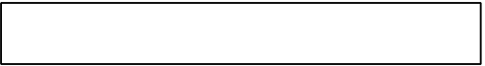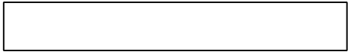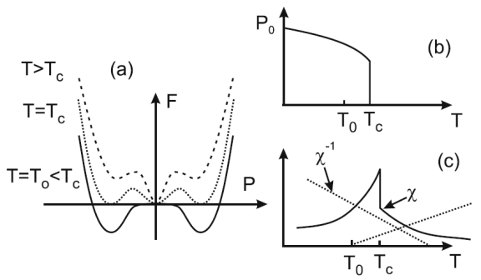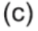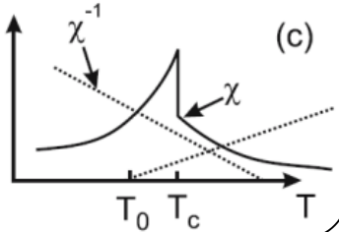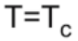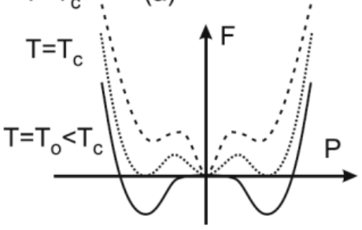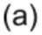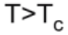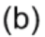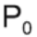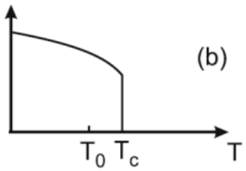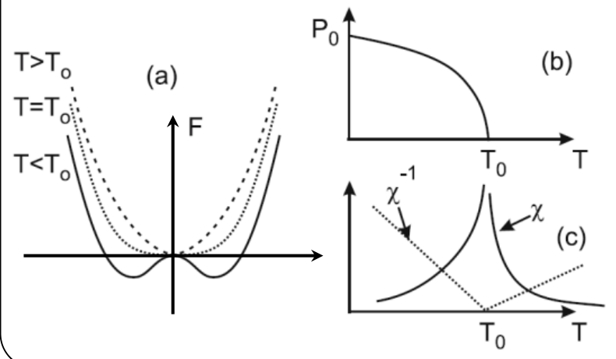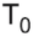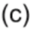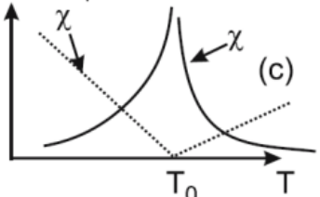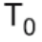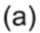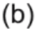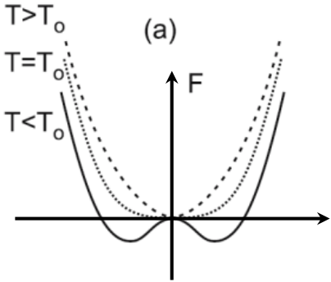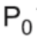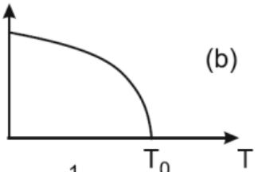

INTRODUCTION

coefficients have to be extracted from additional measurements of P and  at selected tempteratures [37, 54].

Both types of transitions, first order and second order, can be visualized in terms of their free energy versus polarization characteristics. Furthermore, the diverging susceptibility characteristics during phase transition are another analogy of experiment and LD theory (Fig. 1-2).

|  |  |
| --- | --- |
| First-order phase transition | Second-order phase transition |
|  | |

Fig. 1-2: First and second-order phase transitions in terms of Landau-Devonshire theory [133]. In (a) the Helmholtz free energy versus polarization behavior is shown. The smaller figures (b) and (c) show how the polarization and susceptibility evolve when the temperature approaches the phase transition at T0 and Tc respectively.

The family of perovskite ferroelectrics which are considered most important from the application side, generally show a first order phase transition [42]. Second order phase transitions are known to occur for e.g. hydrogen bonded ferroelectrics like triglycine sulfate (TGS) [48].

Even though the research on ferroelectric HfO2 is still in its infancy and no Landau parameters were derived by experiments yet, first indications on the order of the phase transition are given by ab initio calculations. For the pure HfO2 system, a second-order phase transition was proposed [27]. For the chemically similar ZrO2 system antiferroelectricity (AFE) was discovered experimentally [112] and later confirmed by ab initio calculations suggesting a first-order phase transition [139]. As will be shown in more detail in section 1.3, the order of the phase transition in HfO2 appears to be linked to the dopant species which is incorporated into the host lattice.

Besides the classical LD approach, Devonshire's application of the Landau theory was extended by Ginzburg to incorporate effects of nonuniform polarization and boundary conditions as it is the case in e.g. thin films [22]. This extension results in the Landau-Ginzburg-Devonshire (LGD) theory, which is, due to the very nature of Si:HfO2 films, more suitable for this particular ferroelectric (see also section 1.3).

Moreover, besides the macroscopic phenomenological L(G)D theory, the "modern theory of polarization" gives a quantum mechanical, i.e. microscopic explanation of the ferroelectric polarization [138]. This is achieved by applying the so called Berry phase approach and for more information on that topic, the interested reader is referred to [76, 137].

In the next subsection, the focus again shifts more to the application side and the most important traditional and modern ferroelectrics are discussed. Especially their material and processing properties are reviewed and serve as a basis for comparison to HfO2 in section 1.4.

4

INTRODUCTION

1.1.2Traditional and Modern Ferroelectrics

As mentioned in the previous sections, the concept of ferroelectricity was first confirmed by Valasek based on his work with Rochelle salt. However, due to the water solubility of Rochelle salt, the material was not very suitable for applications. The advent of ferroelectrics actually began with the research on high dielectric constant materials. In the course of these studies, ferroelectricity was discovered for barium titanate (BaTiO3 or BTO) which is a polycrystalline ceramic [49, 203, 212]. The main applications that are served by BTO are high dielectric constant capacitors. By use of certain additives, Tc can be shifted from 120 ºC to the desired thermal operating range such that the diverging susceptibility at the phase transition can be utilized. This enables the manufacturing of capacitors possessing dielectric constants up to 104 or even 105 [49].

In the 1950s, two material systems, i.e. lead titante (PbTiO3 or PTO) and lead zirconate (PbZrO3 or PZO), and their solid solution lead zirconate titanate (Pb(ZrxTi1-x)O3 or PZT) were studied in detail [30]. Whereas PZO is known to show antiferroelectric properties [150], PTO was discovered as a ferroelectric [165]. Most importantly however was that at the so called morphotropic phase boundary (MPB) for Pb(Zr0.55Ti0.45)O3, the most pronounced piezoelectric properties appear [58]. The definition of a MPB includes that the symmetry of the crystal unit cell changes, which in the case of PZT means that the tetragonal crystal structure changes to rhombohedral. Furthermore, due to the fact that the MPB is rather temperature independent, very stable material properties can be maintained over a wide temperature range. This led to the wide adoption of PZT in many applications like transducers, actuators, sensors and of course ferroelectric memories. At this point, it shall already be highlighted that also for HfO2, the ferroelectric and antiferroelectric properties are only visible at the phase boundary between the higher symmetry tetragonal / cubic phase and the lower symmetry monoclinic phase. The difference with respect to PZT is that all of the phases outside the phase transition region show centrosymmetry. In chapter 2 it will be shown that for HfO2, also the composition greatly influences the ferroelectric properties and that there might also be a MPB of high temperature stability.

After several decades, PZT became the first ferroelectric that was used in actual semiconductor memories [16] which resulted in the first 4Kbit FRAM in 1993 [136]. However, PZT long suffered from poor fatigue properties [181], i.e. after a certain amount of ferroelectric switching cycles, the material degraded. Hence, research into other ferroelectrics aiming at memory applications had a strong focus on improving these properties.

Already during the advent of ceramic ferroelectrics it was found that layered perovskites such as strontium bismuth tantalate (SrBi2Ta2O9 or SBT) also can possess ferroelectric properties [168]. The advantage of this material is that the perovskite strontium tantalate layers are alternatingly interrupted by bismuth oxide layers. This reduces the amount oxygen vacancies which are indirectly responsible for the fatigue mechanism [129]. Hence, in 1995 it could be shown that FRAMs based on SBT are in principle fatigue-free [130]. Nowadays ferroelectric memories based on SBT are used in i.a. commuter fare cards and e-cash systems [176].

At the end of the twentieth century and within the last decade, research on ferroelectrics progressed significantly. This was driven by the ongoing improvements of deposition techniques which nowadays allow to grow single crystalline ferroelectric thin films and superlattices in the range of a few nanometers [34]. These developments have not only challenged the fundamental thickness limit for ferroelectrics [28, 65] but have also enabled the experimental research on physical phenomena like the tunnel electroresistance

5

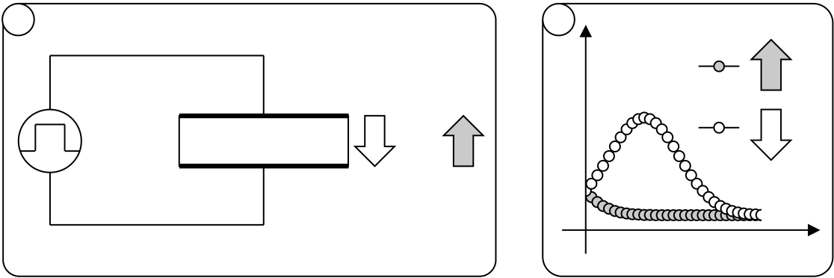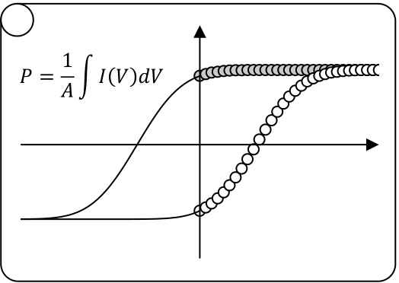

INTRODUCTION

(TER) effect [45, 96]. Moreover, physical characterization techniques like piezo-force-microscopy (PFM) or high-resolution transmission electron microscopy (HR-TEM) combined with electron holography are now available for the in depth analysis of phenomena occurring on the atomic scale [69, 91]. All these advances have finally led to the birth of a new material class called multiferroics [135] which combine both ferroelectric and magnetic effects. These tailor-made material systems might enable new device approaches in the future and are especially promising with respect to memory applications [134, 156].

1.2Ferroelectric Applications in Industry and Research

With the advent of ferroelectric ceramics, many applications followed: Actuators, sensors, transducers, pyroelectric detectors, bypass capacitors, microwave applications and ferroelectric memories are only an excerpt [158, 179]. Due to the fact that this thesis deals with ferroelectric HfO2 in the context of memory applications, the development and state-of-the-art of FRAM and FeFET devices are treated in more detail in the next subsections. Beyond that, emerging semiconductor applications, that may, by the judgment of the author, benefit significantly from the discovery of ferroelectric HfO2, will be discussed as well.

1.2.1Ferroelectric Random Access Memory

The concept of a memory utilizing a ferroelectric was first proposed by Buck in 1952 [18]. He proposed to use capacitor structures that possess a ferroelectric, back in that time for example BTO, as an insulator whereas the binary information would be encoded in the ferroelectric polarization state. The differentiation between these two states can be made by analyzing the transient current responses to a voltage pulse depending on the polarization state in which the capacitor resides (Fig. 1-3).

|  |  |  |  |  |
| --- | --- | --- | --- | --- |
| a | b | Current | c | Polarization |

Datenreihen3

|  |  |  |  |  |  |
| --- | --- | --- | --- | --- | --- |
| Ferroelectric | P | or | P | Datenreihen2 Datenreihen3 | Voltage |
| Datenreihen2 P |

Time or Voltage

Fig. 1-3: Reading of binary states in a ferroelectric capacitor. (a) A voltage pulse is applied to a ferroelectric capacitor which resides either in a positive (up) or in a negative (down) polarization state. (b) Corresponding transient ferroelectric displacement current as a response to the voltage pulse. (c) The integrated current response leads to the well-known P-E hysteresis. A voltage pulse of positive amplitude is assumed.

Hence, assuming a positive voltage pulse applied to a ferroelectric capacitor (Fig. 1-3 (a)), the polarization will switch if the ferroelectric resides in a negative polarization state. The result will be a large ferroelectric displacement current (Fig. 1-3 (b)) that can be observed with measurement setups like the Sawyer-Tower circuit [1]. If the ferroelectric already resides in a positive polarization state, almost no current will flow since no polarization is switched. However, it has to be mentioned that in reality, dielectric displacement currents, leakage currents and relaxation currents are superimposed on the ferroelectric displacement current. Nevertheless, the discrimination between a "0" and a "1"

6

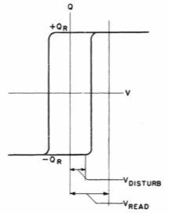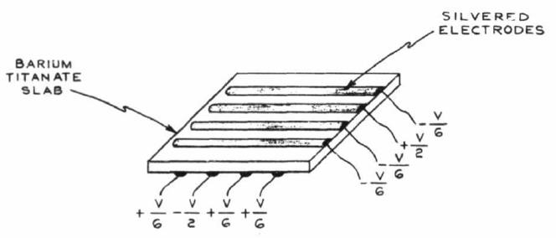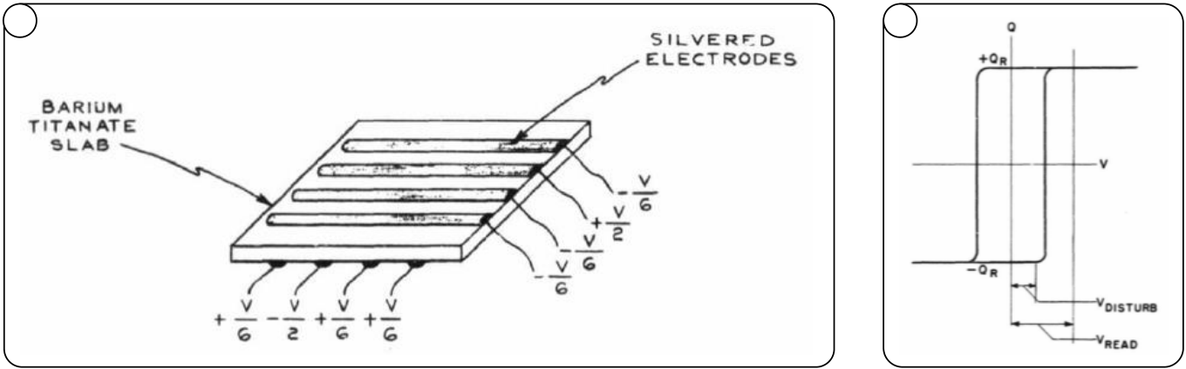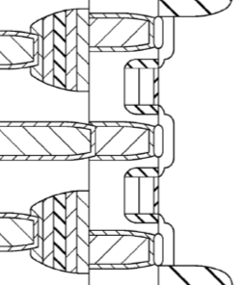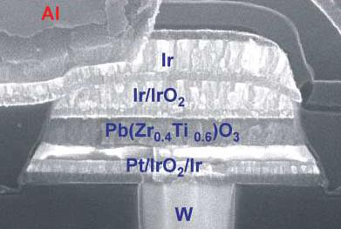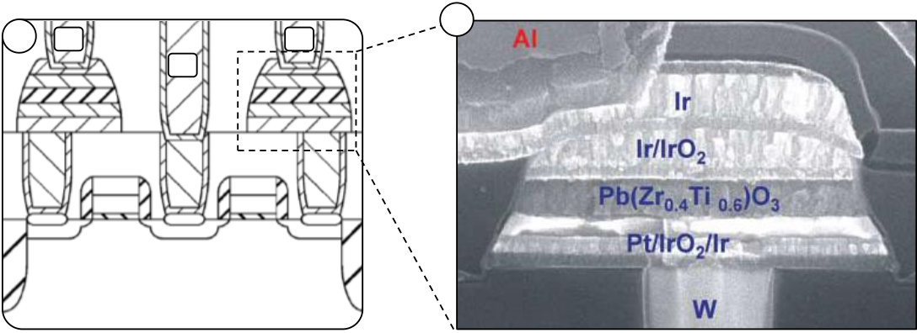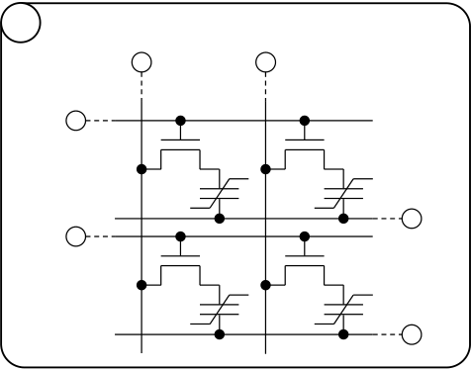

INTRODUCTION

is based on the ferroelectric displacement current. Hence, at this point this explanation shall suffice to understand the basic operational principle of the FRAM.

In order to build a memory, Buck proposed a standard n x n matrix architecture which is nowadays best known as a "cross-bar array". That is, several capacitors have their top electrodes connected together in one row and their bottom electrodes are furthermore series connected in a column. By that it can be realized that the combination of top electrode row and bottom electrode column is unique to each capacitor (Fig. 1-4 (a)).

a b

Fig. 1-4: Dudley A. Buck's ferroelectric memory from 1952 [18]. (a) Proposed matrix architecture with operational scheme to avoid disturb. V/2 signals are applied to selected rows and columns respectively. Neighboring signal lines are raised or lowered to V/6 such that unselected cells are not exposed to disturb voltages VDISTURB higher than V/3. (b) Requirements for the ferroelectric Q-V hysteresis such that the proposed scheme of (a) works as a disturb-free write / read operation.

Buck also realized that in order to write or read binary information from such a cross-bar array, the applied voltage pulses would also disturb the states of the cells which are not supposed to be read or written (Fig. 1-4 (b)). Hence, he proposed an array operation which is nowadays known as the "VDD/3 scheme" [199]. He used additional voltages on unselected rows and columns in order to avoid the unwanted polarization switching of cells neighboring the selected capacitor.

Unfortunately, Buck's capacitor-only cross-bar architecture never made inroads into real product applications. Due to the fact that ferroelectric ceramics show P-E hystereses that are more similar to Fig. 1-3 (c) than to Fig. 1-4 (b), disturb is inevitable. However, new deposition techniques that enable the epitactic growth of single crystalline ferroelectric thin films might revive Buck's vision of a capacitor-only FRAM.

The idea of a ferroelectric memory did however not vanish and in the 1990s, Ramtron was able to introduce first products [136]. By adding an access transistor in series to each ferroelectric capacitor, the disturb problem could be solved. Hence, a 1T-1C (one transistor, one capacitor) cell represents the fundamental memory unit for state-of-the-art FRAM products (Fig. 1-5).

|  |  |  |  |  |  |  |
| --- | --- | --- | --- | --- | --- | --- |
| a | BL | BL | b | PL | PL | c |

BL

WL

|  |  |  |  |  |
| --- | --- | --- | --- | --- |
| WL | PL | WL | A-A | WL |
| PL |

Fig. 1-5: State-of-the-art 1T-1C FRAM architecture. (a) 2 x 2 FRAM memory array unit cell possessing wordlines (WL), bitlines (BL) and platelines (PL). (b) Actual FRAM geometry along a column of cells [197] and the corresponding SEM cross-section of a PZT ferroelectric capacitor is given in (c) [158].

7

INTRODUCTION

Besides the row and column signal lines that already exist for a cross-bar architecture, another signal line, the so called wordline, is added in order to control the series connected transistor (Fig. 1-5 (a)). For a read operation, the selected wordline is raised to the internal supply voltage VDD, the plateline is pulsed and the bitlines, which had previously been precharged to ground, are left floating. Depending on the polarization state of the ferroelectric, either a switching or a non-switching current response is the result (see Fig. 1-3). As mentioned previously, in a simplified manner, the different current responses act as the indicator for determining the binary state. However, to be precise, in a real circuit configuration the sensing of the binary states is based on the voltage divider between ferroelectric capacitance CFE and the bitline capacitance CBL. That is, if the ferroelectric capacitor switches, its effective capacitance is larger than for the non-switching case. Hence, the voltage on the bitline is higher for the switching case than for the non-switching case. By comparing these voltages to a reference voltage, the actual sensing of the polarization state takes place.

This also illustrates one of the major disadvantages of the FRAM concept, i.e. that the read operation is inherently destructive. However, the re-write operation is automatically achieved due to the bi-stable nature of the sense amplifiers: In case the FRAM capacitor switches during read out, the bitline is raised to the switching voltage by the sense amplifier. By grounding the plateline afterwards, the re-write is achieved. Moreover, a write operation is performed by raising the selected wordline to VDD while keeping the plateline on ground and actively pulsing the bitlines of the cells to be programmed. The bitlines of the cells which are not supposed to be programmed are kept at ground thereby maintaining the polarization state of the ferroelectric capacitor.

Due to the destructive read-out (DRO) of the FRAM, the requirements for endurance and fatigue of the ferroelectric material become more stringent: For any type of memory, proper read operations have to be provided over the complete lifespan of the memory device. Hence, assuming a read cycle time of 100 ns, a lifespan of 10 years and continuous read operation, more than 1015 write cycles have to be endured in total. Nevertheless, due to continuous improvements of the capacitor stack, this benchmark can nowadays be achieved [26]. Besides the progress on the material side, many more advances have been made in terms of the FRAM memory cell, sensing concepts and memory architecture. For a thorough summary of these innovations, the interested reader is referred to [140, 162].

At the end of this subsection, the main disadvantage of current FRAM concepts shall be highlighted: As shown in Fig. 1-5 (c), the ferroelectric capacitor in state-of-the-art FRAM products is still of planar type. This in turn means that with ongoing scaling of the technology, the area and therefore the capacitance of the memory cell is continuously shrinking. Consequently, the ratio of ferroelectric capacitance (independent of the switching or non-switching case) to bitline capacitance decreases. This means that at a certain technology node, the read margin will simply be too low to discriminate between "0" and "1". This is the main reason why FRAM products are currently stuck at the 130 nm technology node [142]. In order to resolve this problem and similar to what had already been done for DRAM decades ago, the ferroelectric capacitor area would have to be increased using trench or stacked capacitors. However, for perovskites like PZT that are used for FRAM capacitors, a conformal deposition into high-aspect ratio 3D capacitors could not be demonstrated yet [83]. Ferroelectric HfO2 however might resolve this road block (see subsection 1.4).

8

INTRODUCTION

1.2.2Ferroelectric Field Effect Transistor

Five years after Buck's proposal, Ian Ross from Bell Labs proposed a "Semiconductive Translating Device" [143] that later became known as the ferroelectric field effect transistor (FeFET) (see [102] and references therein). It should be highlighted that the idea of the FeFET therefore emerged already many years before first floating gate (FG) devices were envisioned [67] and demonstrated [43].

The memory concept of the FeFET is based on controlling the conductivity of a transistor channel by use of the ferroelectric polarization. In order to achieve this, a ferroelectric material is placed in between the gate electrode and the channel of a field effect transistor (FET). Several approaches have emerged since the first proposal in 1957 and the most well-known device geometries are illustrated in Fig. 1-6.

|  |  |  |  |  |  |
| --- | --- | --- | --- | --- | --- |
| |  | | --- | | MFS | | |  | | --- | | MFIS | | |  | | --- | | MFMIS | |
| |  |  | | --- | --- | |  |  | | Gate | | | |  |  | | --- | --- | |  |  | | Gate | | |
| |  |  | | --- | --- | |  |  | | Gate | | |
| Ferroelectric |
| Ferroelectric   |  |  |  |  |  |  |  | | --- | --- | --- | --- | --- | --- | --- | |  |  |  |  |  |  |  | |  |  | Insulator |  |  | | Source | | | Bulk | Drain | | | | Bulk | | | | | | | | |  |  |  |  |  |  |  | | --- | --- | --- | --- | --- | --- | --- | |  | | Insulator | | |  | | | |  |  |  | |  |  |  |  |  |  |  | |
|  |
|  |  |  |

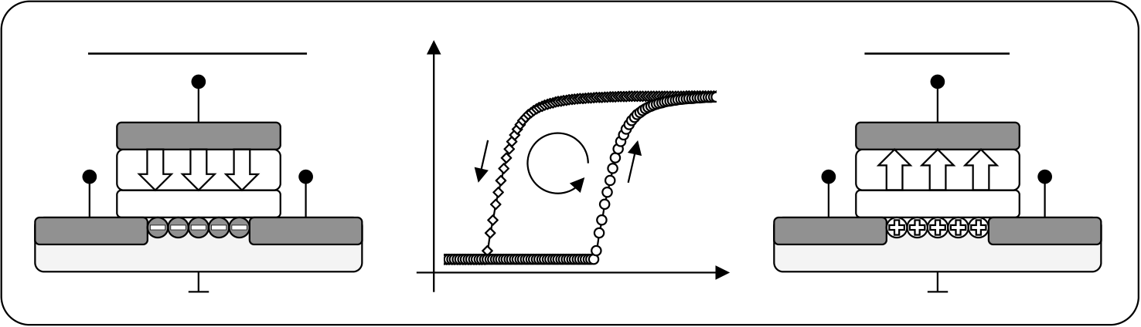

INTRODUCTION

The last FeFET architecture of MFMIS-type tries to solve the retention problem by inserting a floating gate in between the buffer layer and the ferroelectric. This would provide sufficient charge compensation for the ferroelectric polarization due to the fact that an actual bottom electrode is present. Hence, the MFMIS is a true series connection of an MFM and a MOS capacitor. Unfortunately, besides the more complicated manufacturing procedure due to the bottom electrode, potential leakage currents from e.g. the bulk into the floating gate might render the MFMIS non-functional. If charge injection by excessive leakage current happens, electrons will accumulate on the floating gate and the ferroelectric control over the channel is lost.

The target cell structure of this thesis is of MFIS-type since the integration requires only small adjustments to a standard high-k metal-gate (HKMG) process flow (see also section 3.3). Based on this architecture, the actual memory operation of an n-type FeFET is illustrated in Fig. 1-7.

|  |  |  |  |  |  |  |  |  |
| --- | --- | --- | --- | --- | --- | --- | --- | --- |
| Programmed State | | | Log Drain Current | Source | Erased State | | | Drain |
| Gate | | | CCW | Gate | | |
| P | P | P | P | P | P |
| Insulator | | | Insulator | | |
| Source | Drain | |

Gate Voltage

Fig. 1-7: Binary states in an n-type ferroelectric field effect transistor. The programmed state (left) is established after application of a positive pulse on the gate and the FeFET stays in inversion thereafter. The erased state (right) is generated after a negative voltage pulse on the gate has been applied whereas the FeFET remains in accumulation afterwards. For a hysteretic gate voltage sweep, this results in a counter-clockwise (CCW) drain current characteristic (middle).

In order to store binary states in an MFIS cell, the polarization of the ferroelectric is controlled by the electric field across the gate stack. The easiest way to write a binary state to a FeFET cell is by applying a voltage pulse to the gate terminal while keeping source, drain and bulk on ground. If the pulse is of positive polarity and high enough to overcome the coercive field of the ferroelectric, the polarization will flip into the "down" state. Within this thesis, applying a positive pulse to the gate is called programming and consequently the cell resides in the programmed state afterwards. The polarization of the ferroelectric is then compensated by electrons from the source, drain and bulk regions. This effectively shifts the threshold voltage VT of the transistor to lower values.

The application of a negative voltage pulse to the gate induces exactly the opposite behavior: The polarization flips into the "up" state which causes holes to accumulate at the gate stack to bulk interface. This is called the erased state which shifts the threshold voltage of the MFIS-FeFET to higher values.

Similar to floating gate (FG) devices which shift the threshold voltage by charge storage in the floating gate, the binary states of a FeFET are also encoded in the value of VT. However, the shifts in VT that are caused by the program and erase operations are exactly inverted when comparing FG devices to FeFETs. For FG devices, a positive gate pulse injects electrons into the floating gate and therefore shifts the VT to higher values. The negative gate pulse releases the electrons from the FG and shifts the VT again back to lower values.

The inverted behavior of FeFET devices as compared to FG devices is sometimes also illustrated in terms of a hysteretic drain current versus gate voltage (Id-Vg) sweep. For FG

10

INTRODUCTION

devices, such a sweep will show clockwise behavior due to charge injection at high positive voltages. For a FeFET device, the behavior is counterclockwise due to the fact that the polarization flips into the down state when the gate voltage overcomes EC (see Fig. 1-7 middle).

Thus, at first sight, the operation of a ferroelectric field effect transistor is very similar to floating gate or charge trap devices, even though based on fundamentally different physics. Accordingly, the advantages of FG architectures can in principle be inherited by the FeFET concept: Small cell size footprint due to 1T architectures, unlimited read endurance due to non-destructive read-out (NDRO) and, as compared to e.g. the FRAM approach, good scalability due to different encoding of the binary state. The last point mentioned refers to the fact that the FeFET is, to a first approximation, independent of the amount of switched charge. By utilizing the transistor architecture, the read-out operation can exploit the transconductance of a MOSFET which significantly improves the read margin. Moreover, the FeFET approach offers multiple additional benefits that make it an attractive alternative to Flash-based devices even after more than 40 years of FG device development. Especially the advantages of FeFETs based on ferroelectric HfO2 will be highlighted in subsection 1.4.

1.2.3Future CMOS Applications Based on Ferroelectrics

Even though a FeFET memory is one of the most obvious applications for a ferroelectric material, there are various research fields that might also make use of novel ferroelectrics in the future. The following considerations will be limited to CMOS applications that, from the viewpoint of the author, represent the most innovative approaches which utilize the properties of ferroelectrics.

First of all, besides utilizing a FeFET as an NVM cell, various industry and research groups have also proposed to make use of the ferroelectric non-volatility for logic applications: Non-volatile CMOS circuits [145], dynamically programmable gate arrays [97] or a ferroelectric flip-flop [205], SRAM [104, 188] and DRAM [50] cells are only some of these proposals. This might lead to significant improvements in the field of reconfigurable computing [47, 127] or to non-volatile processor architectures altogether [206, 213].

Besides these innovative concepts, even more radical approaches are looking for novel computer architectures beyond the classical von Neumann model. By utilization of the memristive behavior of ferroelectric tunnel junctions (FTJ) [23] or of the FeFET itself [124, 198], neural networks based on the ferroelectric effect might become viable in the future. In 2013, Panasonic successfully demonstrated a 3T-FeMEM (three-terminal ferroelectric memristor) neural network including 9 neurons and 144 synapses [71].

Finally, the ferroelectric transistor might also be useful to optimize a standard transistor device by use of the so-called negative capacitance effect [146, 147]. That is, the imperfect switching properties of a transistor, which are represented by the so called subthreshold-slope, can be improved by use of a ferroelectric inside the gate stack. Hence, the active as well as passive power consumption of standard logic devices could be reduced similar to other approaches aiming at steep subthreshold-slope devices [56]. A detailed description of this so called negative capacitance field effect transistor (NCFET) can be found in [144, 148].

In the next section, the recent progress regarding the research of ferroelectricity in HfO2 will be presented. Especially due to the unparalleled CMOS compatibility as well as the scalability of HfO2, many of the above mentioned research directions might benefit from the discovery.

11

INTRODUCTION

1.3Discovery of Ferroelectricity in HfO2

At the time the semiconductor industry introduced HfO2 as MOSFET high-k dielectric, the material was also evaluated as a potential dielectric for DRAM capacitors. Hafnium

oxide is known to possess several polymorphs and crystallizes into the monoclinic P21/c phase at ambient conditions, into a tetragonal P42/nmc phase at 2000 K and finally into a cubic Fm3m phase at 2900 K. Due to the fact that the theoretical dielectric constant

changes from 16 to 70 and 29 for the mentioned polymorphs [222], especially a stabilization

of the tetragonal phase is highly desirable for DRAM applications. The higher permittivity

values increase the capacitance which provides then more charge for read-out of the DRAM. This effectively enables further scaling of the memory cell.

Moreover it was found that the high temperature polymorphs can be stabilized at room

temperature if different dopant atoms like Si, Al, Gd or Y [87, 195] are used as substituting

species for Hf. In 2007 and during the course of the study on Si:HfO2, i.e. utilizing silicon as a substituting species, a deviation from the standard dielectric behavior of HfO2 was discovered [12]. This anomaly occurred for approximately 5 mol% silicon incorporation

which stabilized HfO2 right at the phase boundary in between monoclinic and tetragonal. Based on various experimental results and theoretical studies, an intermediate non-centrosymmetric, orthorhombic Pbc21 transition phase was suggested to induce ferroelectricity in Si:HfO2 [14, 15]. Even though never seen before for HfO2, the Pbc21 phase had experimentally been observed for ZrO2 by Kisi et al. [77] and was later also theoretically confirmed by Lowther et al. [92]. Moreover, the direct incorporation of ferroelectric HfO2 into a high-k metal-gate (HKMG) transistor stack yielded functional FeFET devices with counter-clockwise hysteresis behavior [13]. Based on the Si:HfO2 system it was possible to demonstrate the world's first 28 nm ferroelectric field effect

transistor [113] which is explicitly analyzed in chapter 4.

Several other dopant elements and material compositions were subsequently identified

to cause ferroelectricity in HfO2 as well. Right after the discovery of ferroelectricity in the Si:HfO2 system, the same behavior was also reported for the solid solution of HfO2 and ZrO2 [109]. The most pronounced ferroelectric properties in this system appeared for Hf0.5Zr0.5O2 which was quite different as compared to the 5 mol% silicon incorporation in the Si:HfO2 system. Nevertheless, it represented a reasonable result due to the fact that the HfxZr1-xO2 system crosses the mentioned phase boundary for a mixing ratio of approximately 1:1 [108].

As anticipated from previous studies on high-k phase stabilization, it was confirmed that 3 - 10 mol% of Y [110], Al [116], Gd [115] or Sr [151] incorporation can also induce ferroelectric

properties for HfO2. Together with antiferroelectricity / the field driven ferroelectric phase transition for pure ZrO2 [112, 139], the picture of a ferroelectric phase transition in HfO2 was strengthened.

12

INTRODUCTION

1.4Comparison of Ferroelectric HfO2 to Classical Ferroelectrics

With reference to the two most relevant ferroelectric memory applications (the 1T-1C FRAM and the 1T FeFET), ferroelectric HfO2 is now compared to the ferroelectrics that are currently used in FRAM products. Ramtron (Cypress), Texas Instruments and Fujitsu are using PZT as ferroelectric material whereas Panasonic and ROHM (Lapis Semiconductor) use SBT. Tab. 1-1 shows basic ferroelectric material properties, processing specifications and integration considerations for PZT and SBT and compares them to the properties of ferroelectric HfO2.

Tab. 1-1: Ferroelectric material parameters of classical ferroelectrics as compared to X:HfO2. X represents the dopant elements that were reported to stabilize HfO2 at the monoclinic to tetragonal / cubic phase boundary.

|  |  |  |  |
| --- | --- | --- | --- |
|  | SrBi2Ta2O9 (SBT) | Pb(ZrxTi1-x)O3 (PZT) | X:HfO2 |
| Film thickness |  25 nm |  70 nm | 5 - 30 nm |
| Annealing temp. | 700 ºC | 600 ºC | 450 ºC - 1000 ºC |
| Pr | 10 C/cm2 | 20 - 40 C/cm2 | 10 - 40 C/cm2 |
| Ec | 10 - 100 kV/cm |  50 kV/cm | 1 - 2 MV/cm |
| Dielectric constant | 150 - 250 |  1300 |  30 |
| Deposition | CSD, PLD | MOCVD | ALD, PVD |
| CMOS compatibility | Bi diffusion | Pb diffusion | Stable |
| References | [21, 84, 157, 214, 221] | [157, 173] | [13, 14, 109, 110, 116, 125, 151, 218] |

Even though the layer thicknesses of SBT and PZT could be reduced below 100 nm in the past, a further reduction of the film thickness while maintaining acceptable ferroelectric properties could not be demonstrated yet. For HfO2 however, a very small film thickness of around 10 nm actually led to the discovery of ferroelectricity. Even for polycrystalline Si:HfO2 films in the range of 5 nm, ferroelectricity could be observed. Hence, the X:HfO2 system can be considered very suitable for applications requiring extremely scaled film thicknesses. Moreover, due to the fact that HfO2 is a simple binary oxide, well established atomic-layer-deposition (ALD) processes exist. Recently, this led to the demonstration of ferroelectric 3D Al:HfO2 capacitor geometries with an aspect ratio of 13:1 [114]. In comparison, for classical ferroelectrics like PZT, the MOCVD deposition cannot provide sufficient uniformity to coat high aspect-ratio geometries [83]. Attempts to apply ALD to perovskite ferroelectrics like PTO were not successful in the past [88, 211].

Another important aspect with respect to the integration of ferroelectrics in a CMOS process flow is represented by the thermal annealing conditions that are required to crystallize the ferroelectric. For PZT and SBT, an annealing temperature above 600 ºC and above 700 ºC respectively is required in order to induce crystallization into the ferroelectric phase. Since FRAM architectures nowadays solely utilize the capacitor concept, the annealing temperature of the ferroelectric has to comply with the back-end-of-line (BEOL) thermal budget requirements (the capacitor is formed in the BEOL). Hence, due to its reduced annealing temperature, PZT can be considered more integration friendly than SBT. In comparison, ferroelectricity in HfO2 can either be induced already at 450 ºC when the Zr:HfO2 system is considered, or at and above 1000 ºC when e.g. the Si:HfO2 system is considered. Consequently, ferroelectric HfO2 can be tailored to match both front-end-of-line (FEOL) as well as BEOL specifications. By way of example, next-generation 1T-1C

13

INTRODUCTION

concepts requiring a 3D-capacitor could therefore utilize both trench- as well as stacked-capacitor implementations (these require FEOL respectively BEOL thermal budget compatibility).

With respect to the remanent polarization a ferroelectric can provide, it is known that SBT possesses a much smaller PS value than PZT. For an FRAM, a lower remanent polarization is not desirable because the switched charge required for sensing becomes less. However, analyzing the sensing of an FRAM more closely reveals that the non-switched charge obviously affects the sensing margin in a similar fashion. That is, the switched charge should be as large as possible (large PS) and the non-switched charge should be as small as possible (low dielectric constant of the ferroelectric). Since the dielectric constant of SBT is approximately one order of magnitude smaller than for PZT, the drawback of a smaller remanent polarization is diminished. Experiments on ferroelectric HfO2 have shown that the remanent polarization can be tuned in a wide range from almost zero up to 40 C/cm2. Furthermore, the dielectric constant is, compared to SBT or PZT, very small (30) which is also favorable for a 1T-1C concept. Moreover, as will be shown in more detail in chapter 3, the comparatively small dielectric constant of ferroelectric HfO2 is even more beneficial for FeFET-type applications.

Again with respect to an FRAM application, ferroelectric HfO2 however has one major disadvantage: The coercive field required for reversing the polarization is around one order of magnitude larger than for SBT or PZT. Even though film thicknesses of 5 nm were demonstrated (which corresponds to a coercive voltage of Vc = 0.5 V), a smaller coercive field is always advantageous for FRAM applications. On the other hand, with respect to FeFET applications, this property of HfO2 is exactly what enabled the realization of the world's first 28 nm FeFET (see chapter 3).

Finally, the strategically most relevant advantage of ferroelectric HfO2 is given by its proven CMOS compatibility at state-of-the-art technology nodes. Whereas Pb and Bi always pose the threat of contamination and deterioration of logic device performance, HfO2 is well accepted in any HKMG process flow. Besides the mentioned material properties, this might, by judgment of the author, represent the most significant advantage of ferroelectric HfO2 that could foster increased research and industrial efforts in the future.

14

INTRODUCTION

1.5State-of-the-Art Memory Solutions and Limitations

In the following, the HfO2-FeFET application and its related properties that were known at the beginning of this thesis [13] are benchmarked against state-of-the-art memory solutions. The comparisons are drawn with respect to existing and emerging non-volatile memory solutions that could in the past be integrated into larger memory arrays. The following table illustrates the current potential of a HfO2-based FeFET solution and therefore again motivates the research that was carried out during the course of this thesis.

Tab. 1-2: State-of-the-art and emerging non-volatile memory solutions as compared to the HfO2-based ferroelectric field effect transistor.

|  |  |  |  |  |  |  |  |
| --- | --- | --- | --- | --- | --- | --- | --- |
|  | NAND | NOR | ST-RAM | PCM | RRAM | FRAM | FeFET |
| Node | 16 nm | 45 nm | 90 nm | 45 nm | 180 nm | 130 nm |  80 nm |
| Cell size | 4 F2 | 10 F2 |  45 F2 | 5.5 F2 |  4.5 F2 |  40 F2 | 4 - 10 F2 |
| MLC | 2 - 4 Bit | 2 -4 Bit | tbd | tbd | Yes | No | tbd |
| 3D-capab. | Yes | No | No | tbd | Yes | No | tbd |
| Write [V] | 15-25 V | 10-15 V |  1 V | 1 -3 V | 1-3 V | 2.3 V | 3-4 V |
| Speed* | 10us-1ms | 1 us - 1 s |  10 ns |  100 ns | 10-100 ns | 50-100 ns |  10 ns |
| Energy | 1 nJ/Bit | 10 nJ/Bit | 2 pJ/Bit | 3 pJ/Bit | 50 pJ/Bit | 50 fJ/Bit |  1 fJ/Bit |
| Endurance | 103 - 106 | 105 - 107 |  105 |  108 |  108 |  1014 | tbd |
| Ref. | [2, 53, 59, 123] | [60, 169, 190, 194, 215] | [106, 141, 166, 196] | [3, 25,  106, 160] | [72, 123, 163, 164, 216] | [26, 106,  142, 173] | [13] |

* This refers to the write speed of the respective memory technologies. Depending on memory architecture and type, write speeds are further subdivided on a program / erase and on per bit / page / sector / block basis. Especially for NAND and NOR Flash, this causes the speed ranges to be quite wide.

The first two columns of Tab. 1-2 list state-of-the-art NAND and NOR Flash characteristics as they are present in stand-alone memory products. The two technologies are both based on charge storage in a floating gate or trap layer which shifts the threshold voltage of a transistor and thereby encodes the binary state. On the one hand, NAND and NOR differ in terms of the way cells are connected together in an array (an illustration can be found in chapter 5). This is the reason why the cell size of NOR is more than double the cell size of NAND. On the other hand, the two concepts differ with respect to their programming mechanism: For NAND-Flash, charges are injected into the storage layer by means of Fowler-Nordheim (FN) tunneling whereas for NOR-Flash they are injected by channel-hot-electron injection (CHE). Both mechanisms differ in terms of their injection efficiency and therefore in terms of their write speed and write energy.

In the last years, scaling of NAND-based floating gate devices advanced to the 16 nm node. Together with its small cell size of 4F2 (F stands for the minimum feature size and reflects the smallest geometry that can be manufactured on a certain technology node) and the ability to store multiple bits in one memory cell (multi-level-cell, MLC), NAND Flash still offers the highest storage capacity of all solid-state memories. However, increasing the bit density of NAND Flash becomes more and more difficult due to scaling issues like cell-to-cell interference and the ever decreasing number of charge carriers representing binary states [99]. Nevertheless, large companies have already succeeded in integrating NAND Flash into 3D architectures which might represent a path to continue on Moore's Law also in the future.

15

INTRODUCTION

One of the major problems that come with NAND Flash is its very high operational voltage required for programming and erasing a memory cell. This represents an issue that is inherent to the concept of encoding binary states based on charge carriers injected into a storage layer: Due to the fact that the charges stored on e.g. a floating gate must not leak out within a ten year data retention period, the tunnel oxide thickness has to have a thickness of around 8 nm. Accordingly, this requires high voltages in the range of 15 - 25 V in order to reach electric fields of 12 MV/cm that are required for injecting charges into the floating gate. Moreover, the peripheral charge pumps required for generating such high voltages are only efficient to a certain degree. Due to these high voltages and the low programming efficiency of periphery, the energy required for storing the information is relatively high. Moreover, continuous write operations cause the tunneling barrier to degrade which effectively results in a limited write endurance in the range of 103 (MLC) to 106 (single level cell, SLC).

NOR represents the second most common Flash architecture. It is not as aggressively scaled as NAND and nowadays lags more than two technology nodes behind. Even though there are additional scaling issues faced by NOR Flash (e.g. punch through, junction breakdown), these are not the reason why scaling does not continue as fast as for NAND Flash. Emerging memory solutions, as they will be described in the following, are starting to replace NOR Flash which results in a market driven slowdown of NOR scaling [57]. Besides the additional scaling issues that come with CHE injection, the different programming mechanism nevertheless offers a faster programming speed at slightly reduced amplitudes. However, since CHE injection is based on current flow through the transistor channel, its power consumption and therefore the energy/bit is the highest of all concepts shown in Tab. 1-2. Due to the fact that the binary data encoding is the same as for NAND Flash, i.e. a VT-shift due to charges injected into the gate stack, the write endurance of NOR Flash is quite similar. Even though some concepts like nanocrystal Flash have managed to slightly improve cycling stability [215], also NOR Flash endurance is fundamentally limited by the degradation of the tunneling barrier.

The emerging memory technologies are represented by Spin-Torque Magnetic-RAM (ST-RAM), Phase-Change-Memory (PCM) and Resistive-RAM (RRAM). In this context, the term "emerging" means that these memory technologies are still predominantly in the R&D stage. These concepts have been developed for the last two decades and are gradually reaching sample (ST-RAM) or product stage (PCM, RRAM). Due to the fact that Ferroelectric-RAM (FRAM) reached product stage already in the 1990s, it is not considered an emerging memory anymore.

The ST-RAM is an 1T-1R (one-transistor, one-resistor) concept utilizing a transistor as an access device and a magnetic tunnel junction (MTJ) as resistor. In the resistor part, two magnetic thin film layers are separated by a thin tunneling barrier. The ST-RAM then encodes the binary data in a low and a high electrical resistance state (LRS and HRS respectively) which is experienced by a tunneling current through the barrier. The low resistance state is achieved in case the magnetic polarizations of the two thin films are parallel whereas the high resistance state evolves for anti-parallel orientation. The first ST-RAM samples are currently being manufactured on a 90 nm technology node whereas 30 nm single cell demonstrations already exist [78]. However, the cell size of the ST-RAM technology is currently still determined by the size of the access transistor which has to be very wide in order to provide enough current to write the cell [217]. Moreover, for highly scaled MTJs, a statistically stable magnetic polarization still needs to be proven. Furthermore, even though ST-RAM requires only very low voltages and can switch in the nanosecond regime, a high write current is required for changing the magnetization

16

INTRODUCTION

direction. This results in a per bit energy consumption in the range of picojoules. The in principle infinite write endurance of ST-RAM also needs to be demonstrated on array level and is currently limited to approximately 105 cycles.

The PCM concept is also based on an 1T-1R architecture whereas the resistor consists of a chalcogenide material. The difference between the resistance values originates from two distinguishable crystallographic states of the chalcogenide, i.e. amorphous or crystalline. In order to switch between these states, the Joule heat generated by the current flow through the resistor is utilized to crystallize or quench the chalcogenide. A longer SET pulse ( 150 ns) of reduced amplitude causes crystallization of the chalcogenide and induces the LRS. A short but higher RESET pulse ( 50 ns) causes amorphization of the chalcogenide which in turn leads to the HRS [19]. Similar to ST-RAM, the write operation of PCM is based on current flow which effectively impedes write operations below the picojoule range. Moreover, endurance has been demonstrated up to 109 cycles and is specified with 106 in first products manufactured by Micron [100].

Another class of memories that has recently transitioned from research to product stage is called Resistive RAM. Even though ST-RAM and PCM are also resisitive memories, the term RRAM is mainly used for systems achieving a reversible resistance change by redox-related chemical effects [209]. For example, the first product to include RRAM is based on a TaOx thin film. Different meta-stable phases of the transition metal oxide (TMO) can be stabilized or destabilized by the movement of oxygen ions which effectively results in a HRS and a LRS. Moreover, the fact that RRAMs are envisioned to be arranged in 3D cross-bar architectures might enable effective cell sizes of less than 1 F2. In the future, due to their 3D integration potential together with proven MLC capability, RRAMs are considered to be the most viable candidate to replace NAND Flash memories. Nevertheless, even though for RRAM write speeds are in the nanosecond regime and programming voltages are relatively low, due to the current driven write mechanism also these memories are not an ultimate low-power solution.

In the 1990s, capacitor based ferroelectric memories (FRAM) actually were the first emerging NVM that could combine the fast operation of RAM with the non-volatility of a ROM. However, due to the planar architecture of the capacitor, FRAM was not able to scale into Gbit generations. As compared to the ST-RAM, PCM and RRAM, it is essential to highlight that FRAM-memories are based on a completely different operational principle: Since both write and read are based on the electrical field effect to surmount the coercive field of the ferroelectric, only the ferroelectric as well as the dielectric displacement current contribute to energy consumption. Hence, ferroelectric memories are by far the most energy efficient NVMs in the market. Furthermore, the decade long material and electrode development finally resulted in products that practically possess infinite write endurance.

The discovery of ferroelectricity in HfO2 promises to provide the general advantages of ferroelectrics without the drawbacks that were faced by scaling classical FRAMs. Due to the fact that film thicknesses can be reduced to approximately 5 nm, high-density ferroelectric applications might become viable by use of the FeFET concept. At the beginning of this thesis it was known that Si:HfO2 FeFETs can at least be scaled to channel lengths of 80 nm. Further scaling to a 28 nm technology node was analyzed during the course of this thesis. Moreover, the 1T architecture of the FeFET might either adopt architectures similar to NAND (4 F2) or NOR (10 F2). This will mainly depend on the various ferroelectric disturb scenarios that are different for each architecture. An analysis can be found in chapter 5. Another task of this thesis was also to provide information about important memory characteristics like thermal stability, retention and endurance of the

17

INTRODUCTION

ferroelectric and the FeFET in order to give a proper estimate on the potential of the HfO2 FeFET.

Due to the fact that the sensing of the FeFET does not depend on the amount of switched charge of the ferroelectric, its minimum area is only defined by lithography limits. Accordingly, the energy required to alter the cell state on a cutting edge technology node can easily be estimated (excluding system overhead like charge pump efficiency):

|  |  |
| --- | --- |
| ( ) | (1-9) |

In the above calculation, a worst case programming voltage of 5 V was assumed. Moreover a switched charge of 20 C/cm2 appears to be a reasonable assumption for ferroelectric HfO2 and the minimum area is derived from the lithography limits of a 28 nm technology node. Hence, it becomes clear that a 28 nm FeFET would reduce the per bit energy consumption to below one femtojoule. Compared to state-of-the-art as well as emerging memory solutions, the FeFET would by far represent the most energy efficient NVM solution. Besides the excellent CMOS compatibility of the HfO2 ferroelectric, the energy efficiency of the concept was one of the major drivers for this thesis.

In the next chapter, the discovered ferroelectric properties of HfO2 are tested with respect to the stringent requirements that are imposed by memory applications. Based on these characteristics, a sound judgment can be given regarding the suitability of ferroelectric HfO2 as a memory material. In the subsequent chapters, these findings are then transferred to the target device application, i.e. the ferroelectric field effect transistor.

18

MATERIAL PROPERTIES OF FERROELECTRIC HFO2

2Material Properties of Ferroelectric HfO2

The target material composition that is analyzed throughout this thesis is represented by silicon doped hafnium oxide (Si:HfO2). Even though additional dopant species like aluminum or gadolinium were also characterized in detail [115, 116], due to its proven CMOS compatibility, only the Si:HfO2 was utilized for FeFET fabrication later on.

In this chapter, the hysteretic properties of Si:HfO2 metal-ferroelectric-metal (MFM) capacitors are analyzed first. Large signal polarization versus electrical field (P-E) represent the most suitable electrical characterization methodology to visualize the phenomenon of ferroelectric hysteresis. Especially with respect to memory applications, these characteristics are analyzed in terms of the temperature stability of polarization switching. This is an important measure for determining the potential application space of a novel memory technology. Moreover, depending on processing conditions and thermal annealing treatments, conditioning effects were discovered to be present in the Si:HfO2 system. Due to the field cycling based conditioning sequence, a homogenization of the ferroelectric properties could be observed.

The fact that ferroelectric polarization reversal can be achieved at the speed of sound [183], i.e. for nanometer-sized thin films in the range of picoseconds, ferroelectric memories can in principle reach processor speeds. This makes these types of memories attractive as true RAM replacement [159]. Hence, the switching speed limitations of the Si:HfO2 films were characterized by modified Positive-Up Negative-Down (PUND) measurements. This leads to the proposal of a nucleation-limited-switching (NLS) mechanism in Si:HfO2.

Besides a fast switching mechanism, the Si:HfO2 system has to fulfill several other important memory benchmarks in order to be useful as an NVM storage material. One important parameter is represented by the number of polarization reversals the ferroelectric material can endure. The phenomenon leading to polarization loss during the course of bipolar voltage cycling is called ferroelectric fatigue and is analyzed for different annealing conditions of ferroelectric capacitors.

Moreover, the actually most important characteristic of a non-volatile memory is represented by its ability to retain binary data for at least 10 years when power supply is removed. In order to analyze this specific property for Si:HfO2, so called retention tests were performed in order to investigate proper non-volatile data storage.

The last of the memory characteristics that was investigated is an effect that is rather unique to ferroelectrics. Under certain circumstances, the ferroelectric coercive fields drift over time leading to one polarization state that is preferred whereas the other one is unfavored. These so called imprint characteristics are presented as a function of both annealing temperature and storage time at 125 ºC.

2.1Polarization Hysteresis in Si:HfO2

The most prevalent visualization of ferroelectric material characteristics is given in terms of the polarization hysteresis. In order to acquire these characteristics, a triangular voltage signal is applied to an MFM capacitor and the current response is recorded. From the current response, the large signal polarization and capacitance hysteresis can be derived [40]. For a dielectric insulator material, the current response to a triangular voltage signal is obviously a constant current which changes sign when the triangular signal changes its slope from rising to falling. However, for a ferroelectric, the response is quite different (Fig. 2-1).

19

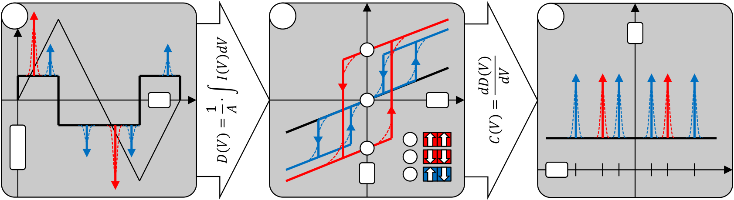

MATERIAL PROPERTIES OF FERROELECTRIC HFO2

|  |  |  |  |
| --- | --- | --- | --- |
| a | b | c | *C* |

1

|  |  |  |  |  |  |  |  |  |  |
| --- | --- | --- | --- | --- | --- | --- | --- | --- | --- |
| *V/I* | *t* | 3 | 1 | *V* | *V* | *VC1-* | *VC-* | *VC +* | *VC1 +* |
| 2 |
| 2 |
| *P* | 3 | *VC2-* | *VC2 +* |

Fig. 2-1: Theoretical and actual ferroelectric P-V and C-V characteristic. (a) Transient current response of dielectric (black), ferroelectric (red) and antiferroelectric (blue) materials. Ideal responses are given as Dirac delta function, dashed lines illustrate the deviation that occurs in reality. (b) The integrated current response results in the electric displacement field / the polarization hysteresis. Numbers indicate domain orientations at characteristic points in the (anti-) ferroelectric hysteresis. (c) Large signal capacitance-voltage characteristic as derived from the polarization characteristic. Coercive voltages VC are indicated.

At the point in time when the triangular voltage signal reaches the coercive voltage of the ferroelectric, a large current peak can be observed (Fig. 2-1 (a)). For an ideal ferroelectric, that current pulse would be described by a Dirac delta function since this represents an operation of ideally instantaneous switching. However, due to random grain orientation and the existence of defects and pinning centers, a distribution of coercive voltages is present in actual ferroelectric materials [8]. For an antiferroelectric material, these considerations hold as well whereas actually four and not two current peaks occur in the transient response. The two peaks that occur on the falling edges of the excitation signal can be assigned to back-switching from a parallel into an anti-parallel domain state [79]. The fundamental origin of antiferroelectricity is however quite complex and most recent studies indicate that flexoelectricity (spontaneous polarization induced by a strain gradient) plays an important role for the understanding of antiferroelectric materials [180].

Integrating the recorded current response with respect to voltage / time and dividing it by the area of the capacitor yields the electric displacement field D (Fig. 2-1 (b)). By neglecting the contribution of vacuum to the electric displacement field it is possible to replace D with P. This is a reasonable assumption because the growth of the electric displacement field due to the contribution of vacuum amounts to only  0.1 C/cm2 per 1 MV/cm applied electrical field. Hence, for a dielectric, the polarization response is simply a straight line whereas for a ferroelectric, the well-known hysteresis with polarization remanence manifests. For an antiferroelectric, two hysteresis occur, one in the first and the other one in the third quadrant of the P-V characteristic. Here it becomes visible that the parallel alignment of domains requires higher fields as compared to a ferroelectric material composition. This is sometimes also described in terms of a field driven ferroelectric phase transition [186], i.e. the energy required for the ferroelectric phase to appear has to be provided by the electrical field that is applied.

Calculating the derivative of the P-V characteristic with respect to voltage results in the large signal capacitance voltage characteristic (Fig. 2-1 (c)). However, the difference to a standard C-V characterization has to be highlighted: For a traditional capacitance-voltage measurement of e.g. metal-insulator-metal (MIM) capacitors, a dedicated capacitance-voltage-unit (CVU) is utilized [74]. It enables the superposition of a DC voltage ramp together with an AC small-signal excitation. Hence, a traditional C-V measurement is a small-signal characterization. At each DC-bias point, the current response due to the AC signal is recorded and the impedance of the device under test (DUT) is derived. This gives

20

MATERIAL PROPERTIES OF FERROELECTRIC HFO2

a more appropriate measure on the intrinsic capacitance as a function of the applied voltage.

Before presenting Si:HfO2 P-V characteristics, a short comment on P-V versus P-E characteristics shall be added: From the viewpoint of materials science it would actually be more appropriate to speak in terms of P-E characteristics, i.e. in terms of the coercive fields instead of the coercive voltages. The coercive field is more of an intrinsic material property which is better suited to compare between different materials. Nevertheless, it also varies according to an Ec(d)  d -2/3 relationship [73]. With respect to an application driven investigation it is sometimes more useful to speak in terms of voltages that have to be applied in order to write the desired binary state. In the end, an important benchmark for judging a memory concept is always the voltage that is required to program and erase the NVM cell.

2.1.1Composition and Annealing Dependence

The principle of inducing ferroelectric properties in hafnium oxide is based on the stabilization of the non-centrosymmetric orthorhombic Pbc21 phase. Various measures exist which make the ferroelectric phase favorable: Incorporation of different dopant species [14, 110, 115, 116], post metallization annealing or variation of the thin film thickness itself [218] are only some of these methods. Since this thesis focusses on the Si:HfO2 system, in this subsection the P-V characteristics are first of all analyzed as a function of silicon content incorporated into the HfO2 host lattice. Later, the dependence of the hysteretic properties on the annealing temperature will be presented in addition.

In order to analyze the P-V characteristics, MFM capacitors were used that had been fabricated on standard 300 mm silicon substrates. First, a 10 nm TiN bottom electrode was deposited at 450 ºC in an ALD batch furnace using TiCl4 and NH3 as precursor gases. A single wafer ALD process was subsequently used to deposit the 10 nm Si:HfO2 functional

|  |  |  |  |  |  |  |
| --- | --- | --- | --- | --- | --- | --- |
| layer | at | 266 | ºC. | Tetrakisethylmethylaminohafnium | (TEMAH), | tetrakisdi- |

methylaminosilane (4DMAS) as well as ozone were used as precursor gases. Various samples with different silicon molar concentrations ranging from 4.9 mol% to 7.8 mol% could be realized by varying the precursor gases pulse ratios (TEMAH:4DMAS) from 12:1 to 6:1. After the Si:HfO2 layer was deposited, a 10 nm TiN top electrode was processed again in the ALD batch furnace. Then, the Si:HfO2 compositions were either left as-deposited (thermal budget of TiN process: 450 ºC / 7 h) or split and annealed at 650 ºC / 20 s, 800 ºC / 20 s or 1000 ºC / 10 s. Platinum dots were evaporated through a shadow mask and served as a hard mask for etching the TiN top electrode. This led to the formation of capacitor geometries (A = 104m2) that could properly be contacted and tested on a standard single needle probe station. P-V measurements were performed on an aixACCT TF Analyzer 3000 and the frequency of the triangular voltage signal was set to 1 kHz. Results of 1000 ºC annealed samples are shown in Fig. 2-2.

21

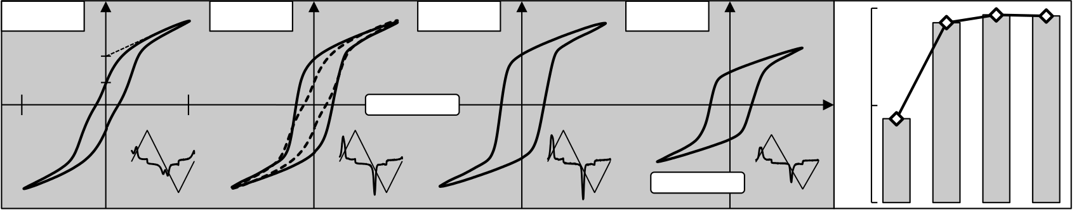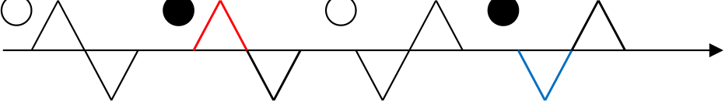

MATERIAL PROPERTIES OF FERROELECTRIC HFO2

|  |  |  |  |  |  |
| --- | --- | --- | --- | --- | --- |
| 7.8 mol % | 50 | 6.6 mol % | 5.8 mol % | 4.9 mol % | 1 |

Ps

|  |  |  |  |  |  |  |  |  |  |  |
| --- | --- | --- | --- | --- | --- | --- | --- | --- | --- | --- |
| -4 | Pr | -50 | 4 | *E* [MV/cm] | *P* [µC/cm2] | *Pr,rel* / *Pr* | 7.8 mol % | 6.6 mol % | 5.8 mol % | 4.9 mol % |
| 0 |

Fig. 2-2: Si:HfO2 ferroelectric hysteresis of 10 nm thin films. The polarization versus electric field characteristics are shown for four different silicon dopant concentrations. For 7.8 mol%, ferroelectric relaxation is highlighted by the comparison of the extrapolated spontaneous polarization against the remanent polarization. The 6.6 mol% composition is superimposed by the 7.8 mol% composition (dashed hysteresis) in order to further illustrate relaxation effects. Transient current responses to the triangular voltage signal are shown as inset. The ratio of relaxed remanent and transient remanent polarization is shown on the right.

For a large amount of silicon incorporated into the HfO2 lattice, antiferroelectric or relaxor-type [31, 149] tendencies can be discovered. That is, for an antiferroelectric there is actually no remanence since domains will flip back into the antiparallel state when the

absolute magnitude of the applied voltage falls below VC2 (see Fig. 2-1). However, since the ferroelectric phenomena in polycrystalline hafnia occur at the phase boundary between monoclinic and tetragonal / cubic, statistical effects should be considered as well. Hence, there could be different regions of ferroelectric and antiferroelectric tendency whose superposition leads to a hysteresis as seen for the 7.8 mol% composition. Though, since switching into the presumably parallel domain configuration occurs at around the same voltage as compared to the other compositions, ferroelectric relaxation represents the most likely cause. For silicon contents of 6.6 mol% and 5.8 mol%, the Pr / PS ratio improves significantly due to a higher polarization remanence. Furthermore, the coercive field grows by approximately 0.1 MV/cm for 6.6 mol% to 5.8 mol%. For the lowest analyzed silicon content of 4.9 mol%, the remanent polarization started to decrease significantly whereas the hysteresis shape remained almost ideal. Due to the fact that the monoclinic phase becomes energetically more favorable for lower silicon contents, the reduced remanent polarization might be attributed to a reduced ferroelectric phase fraction similar to results presented in [218].

Moreover, the standard polarization measurement is performed in such a way that it also enables the extraction of polarization relaxation, which is a well-known effect occurring in ferroelectrics. On a microscopic scale, ferroelectric relaxation can be correlated to grain orientations that are off-axis oriented with respect to the polarization axis of the unit cell [122]. Hence, especially for highly scaled ferroelectric devices, the extraction of macroscopic polarization relaxation on MFM capacitors might give important insights into effects taking place on the microscopic scale. In order to study the ferroelectric relaxation behavior, the pulse train that is utilized for P-E measurements consists of actually four triangular voltage pulses (Fig. 2-3).

|  |  |  |  |  |  |  |  |  |  |
| --- | --- | --- | --- | --- | --- | --- | --- | --- | --- |
|  |  |  |  | time |  |  |  |  |  |
| 1s | 1s | 1s |  |

Fig. 2-3: Measurement sequence applied for P-E characterization. Four triangular voltage pulses (1 kHz) with a delay time of one second are used whereas only pulse 2 and 4 are measured. The combination of polarization responses that results in the final transient hysteresis is shown on the right (polarization deltas due to relaxation are highlighted with dotted circles).

22

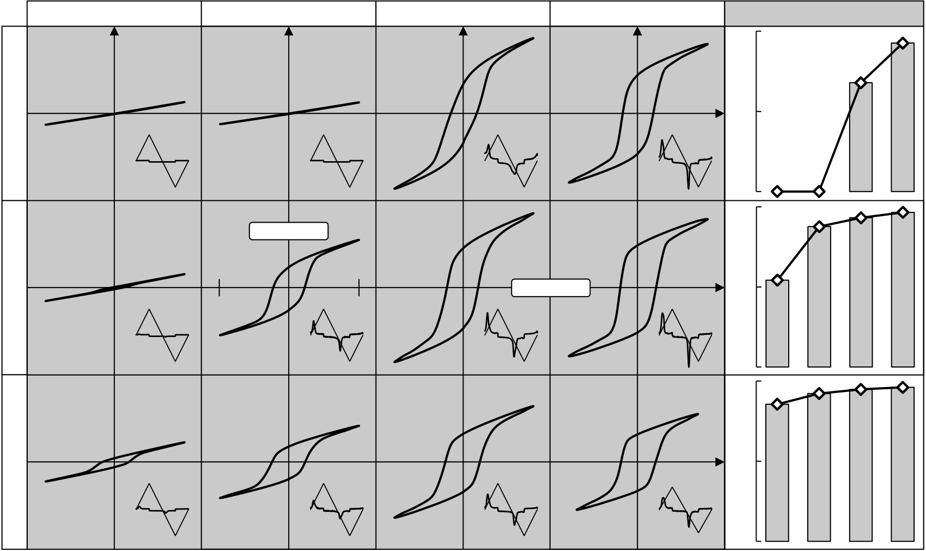

MATERIAL PROPERTIES OF FERROELECTRIC HFO2

The first and third pulse of the hysteresis measurement are used to set a negatively and a positively polarized reference state respectively. For both second and fourth pulse, after a delay time of one second, the current response to the triangular voltage signal is recorded. The polarization can then be derived as described e.g. in Fig. 2-1. More importantly, the final hysteresis that is recorded represents the sum of the second halves of the polarization responses to pulse two and four. Hence, a true transient polarization response is derived. The first halves of the recorded pulses however contain additional information, i.e. the amount of relaxed polarization: Due to the fact that there is a delay time of one second in between each triangular voltage pulse, unstable ferroelectric domains will relax before another excitation signal is applied. This can be extracted from the polarization data and represents the so called relaxed remanent polarization Pr,rel. This parameter can be compared to the transient remanent polarization Pr that is recorded based on the sum of the second halves of pulse two and four.

For the different Si:HfO2 compositions, the ratio of Pr,rel/Pr was calculated and is shown in Fig. 2-2 on the right. The results verify what has previously been anticipated from the Pr/PS ratio: For the 7.8 mol% composition, more than 50 % of the transient remanent polarization relaxes within the one second delay period. Furthermore, with decreasing silicon content, the polarization becomes almost ideally stable.

Besides the dependence on silicon molar concentration, also post metallization annealing conditions were analyzed with respect to the ferroelectric polarization hysteresis. All of the mentioned post-metallization-anneals were tested for samples showing the most pronounced ferroelectric properties (6.6 mol%, 5.8 mol% and 4.9 mol%).

|  |  |  |  |  |  |  |  |  |  |
| --- | --- | --- | --- | --- | --- | --- | --- | --- | --- |
| 6.6 mol % | 450 °C PMA | 650 °C PMA | 800 °C PMA | 1000 °C PMA | 1 | 450 °C | *Pr,rel* / *Pr* | 800 °C | 1000 °C |
| *Pr,rel* / *Pr* | 650 °C |

0   
 50 1   
*P* [µC/cm2]

|  |  |  |  |  |  |  |  |  |  |
| --- | --- | --- | --- | --- | --- | --- | --- | --- | --- |
| 5.8 mol % | -4 | -50 | 4 | *E* [MV/cm] | *Pr,rel* / *Pr* | 450 °C | 650 °C | 800 °C | 1000 °C |
| 0 |

1

|  |  |  |  |  |  |
| --- | --- | --- | --- | --- | --- |
| 4.9 mol % | *Pr,rel* / *Pr* | 450 °C | 650 °C | 800 °C | 1000 °C |

0

Fig. 2-4: Annealing temperature dependence of Si:HfO2 P-E characteristics. The polarization versus electric field characteristics are shown for different silicon molar concentrations and post-metallization-annealing (PMA) conditions. Transient current responses are given as inset. The ratio of relaxed remanent to transient remanent polarization is shown on the right. Due to the paraelectric nature of the 6.6 mol% composition at 450 ºC and 650 ºC, for these samples, no reasonable Pr,rel/Pr extraction could be performed.

23

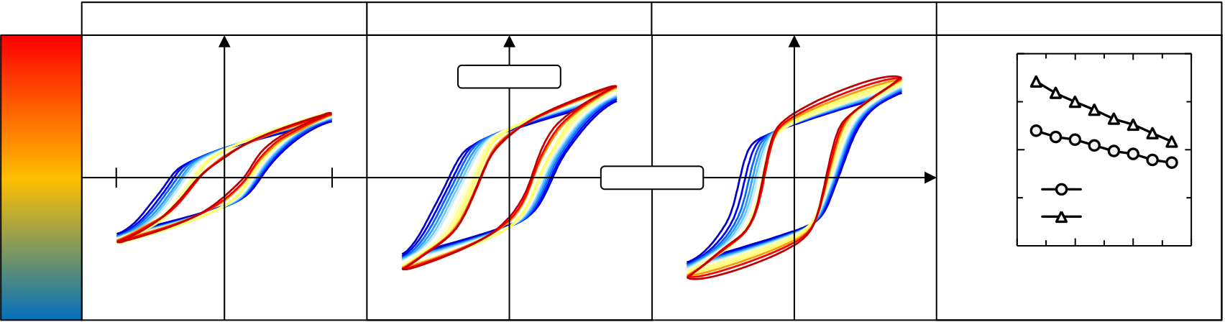

MATERIAL PROPERTIES OF FERROELECTRIC HFO2

As it is known from previous research on Si:HfO2, a larger amount of dopant species incorporated into the HfO2 host lattice shifts the crystallization temperature to higher values [195]. This can also be observed for the 6.6 mol% composition which stays paraelectric up to 650 ºC. At 800 ºC, a proper ferroelectric hysteresis develops whereas a certain amount of polarization relaxes when the sweeping voltages approaches 0 V. Hence, the Pr/PS ratio is degraded. Furthermore, this is again confirmed by the Pr,rel/Pr ratio which shows that for the 6.6 mol% composition annealed at 800 ºC the polarization degrades by about 30% within the one second delay time. This improves even further when the annealing temperature is raised to 1000 ºC. Comparing these results to the compositions which incorporate less silicon into HfO2, a general trend can be derived: The less the silicon content in the host lattice, the earlier crystallization sets in and the more stable the ferroelectric polarization at a given annealing condition. However, as already seen in Fig. 2-2, the remanent polarization also decreases at a certain point, that is, from 5.8 mol% to 4.9 mol%. Hence, the earlier crystallization might run in parallel with an inhibition of the orthorhombic phase transformation.

2.1.2Temperature Stability of Ferroelectric Hysteresis

For the Si:HfO2 system with 4.9 mol% silicon content, almost no ferroelectric relaxation was observed in the previous section, especially at elevated annealing temperatures. Hence, this material composition was chosen for an analysis of the temperature dependent polarization hysteresis [119]. P-E measurements were carried out on a cryostat probe station which enabled measurements in a temperature range of 80 K to 470 K using liquid nitrogen (LN) and a sample heater (Fig. 2-5).

|  |  |  |  |  |  |  |  |  |  |
| --- | --- | --- | --- | --- | --- | --- | --- | --- | --- |
| **470 K** | -3 | 650 °C PMA | 3 | 800 °C PMA | *E* [MV/cm] | 1000 °C PMA | |*EC*| [MV/cm] | 2 | Coercive Field (T) |
| 40 | *P* [µC/cm2] | 800 °C PMA |
| 1 | Ec+ |
| Ec- |

0

|  |  |  |  |  |  |
| --- | --- | --- | --- | --- | --- |
| **80 K** | -40 | 50 | 140 | 230 | 320 |
| Temperature [K] | | | |

Fig. 2-5: P-E temperature stability of 4.9 mol% Si:HfO2 composition. For three different post-metallization-annealing conditions, the temperature dependence of the polarization hysteresis is illustrated. For a lower temperature range not affected by leakage currents, the positive as well as the negative coercive field is plotted against temperature (right side).

The standard P-E characterization at 1 kHz was performed at slightly reduced bipolar voltage amplitudes of  3 V which gave rise to a  3 MV/cm field across the 10 nm film. This ensured that even at elevated temperatures where the leakage current is known to increase, the MFM capacitor would not suffer from dielectric break down. Hence, from an 80 K cryogenic temperature, the temperature was raised in 30 K increments and the P-E hysteresis was recorded accordingly. For the annealing conditions of 650 ºC/20s, 800 ºC/20s and 1000 ºC/10s, Fig. 2-5 shows that the coercive field clearly decreases when the sample is heated up. Moreover it becomes apparent that the negative polarization direction is less favored at low temperatures. This might be ascribed to a phenomenon called ferroelectric imprint which can occur if a ferroelectric is continuously kept in one of its polarization states for a certain period of time (see in detail section 2.3.3). That is, the

24

MATERIAL PROPERTIES OF FERROELECTRIC HFO2

polarization state before cool-down is actually defined by the reference measurements that had previously been carried out at room temperature. Hence, these basic P-E characterizations leave the ferroelectric in a positive polarization state (see Fig. 2-3) that militates in favor of the imprint assumption. However, with reference to classical ferroelectrics [183], the tendency towards imprint reduces with decreasing temperature. Even though this ambiguity exists, both coercive fields, Ec + and Ec-, demonstrate a proper linear dependence with respect to temperature (Fig. 2-5 right). This is in accordance to Landau-Ginzburg mean-field theory which predicts a linear dependence of Ec on temperature assuming the temperature independence of the polarization [39].

The remanent polarization decreased only slightly at elevated temperatures and did not show any signs of an antiferroelectric transition as would have been expected from earlier publications [15]. This might be due to the fact that a composition was chosen that most likely has a higher amount of monoclinic phase fraction as discussed in the previous subsection. At temperatures above 470 K, a further reduction of Pr could not be observed due to dielectric breakdown of the samples. This is a general problem with respect to the temperature dependent analysis of 10 nm Si:HfO2 thin films. Both temperature and the comparatively large coercive field induce a high leakage current that ultimately degrades the MFM capacitor. This is even more pronounced for films annealed at 1000 ºC. There, the remanent polarization artificially increases due to the growing leakage current contribution. With respect to the polarization hysteresis, this can be seen by the transition from a concave towards a convex shape of the hysteresis saturation region (around  3 V). Hence, the actually expected second order phase transition [27] from orthorhombic to tetragonal cannot be observed for 10 nm thin films. Future investigations will have to focus on stabilizing ferroelectric properties also in thicker films and utilizing compositions with higher silicon content in order to investigate the phase transition in more detail.

In terms of memory applications, the measurements demonstrated stable ferroelectric switching over a wide temperature range. This is a prerequisite for a potential utilization of Si:HfO2-based memories also in harsh environments (e.g. automotive applications). However, as will be shown in the next subsections, there are many other criteria that have to be fulfilled in order to qualify Si:HfO2 for real memory applications.

25

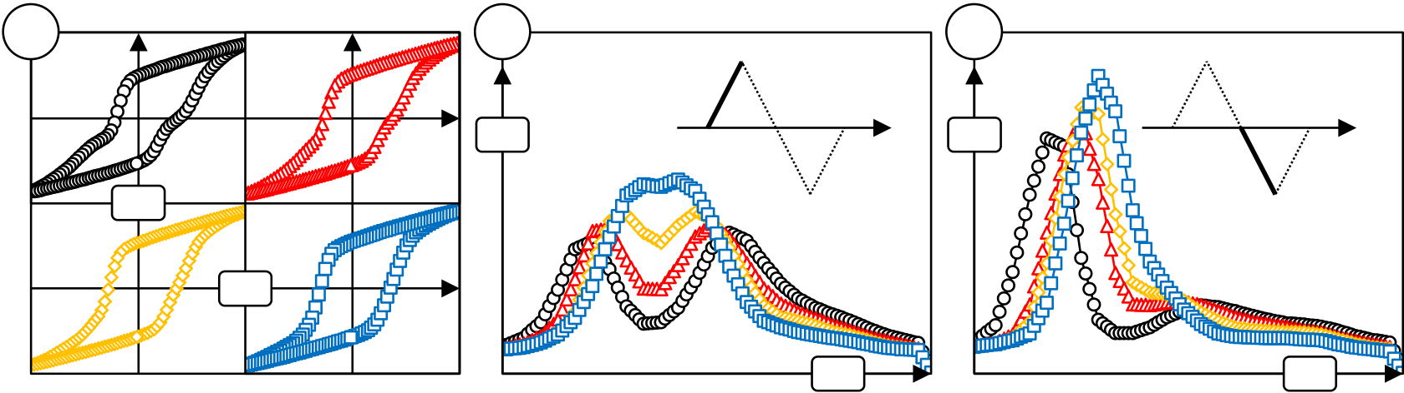

MATERIAL PROPERTIES OF FERROELECTRIC HFO2

2.1.3Conditioning Effects

Another phenomenon that can occur for ferroelectrics is represented by the deviation from an ideal hysteresis towards a more pinched hysteresis shape. In the past, volume, domain wall and grain boundary effects were assigned to be responsible for this type of phenomenon [107]. During the course of this thesis, it was discovered that under certain processing conditions, virgin P-E hysteresis of Si:HfO2 can possess these pinched shapes [119]. By use of AC voltage cycling, a transition towards a smooth ferroelectric hysteresis could be achieved (Fig. 2-6).

|  |  |  |
| --- | --- | --- |
| a | b | c |
| *I* | *I* |

*P*

*E*

*t*  *t*

Fig. 2-6: Conditioning effect for field cycling of Si:HfO2. (a) Virgin (◯), 10x (△), 100x (→) and 1000x (⇨) cycled P-E hysteresis. The cycling and measurement fields were  3 MV/cm. (b) Corresponding switching current responses to the rising edge of the triangular voltage pulse. (c) Switching current response to the falling edge of the triangular excitation signal.

Initial P-E hystereses (Fig. 2-6 (a)) showed a characteristic double-hump current response when the triangular voltage signal rose to 3 V (Fig. 2-6 (b)). Hence, it becomes apparent that the notion of a coercive field might be quite confusing for such a virgin P-E hysteresis. If the coercive field is taken as the formal point at which the polarization returns to zero, it is obviously not identical to the field at which switching takes place. Due to the symmetric shape of the virgin current response shown in Fig. 2-6 (b), the resulting hysteresis even suggests a coercive field which is positioned right in between the two switching peaks. In those situations, a differentiation between coercive field and switching field should be addressed.

After 1000x  3 V cycling, the two current peaks which existed for the virgin state merge into one broader peak whereas some tendencies of the double hump feature are still present. Furthermore, the long tail of the current response, i.e. the fraction of the film that switches only at rather high amplitudes, is significantly reduced with cycling. This field cycling effect due to an AC voltage signal is well known for classical ferroelectrics and is mainly assigned to the mobilization of defects [80]. Furthermore, AC field cycling has been reported to remove pinned domain walls and can ultimately lead to a change in the preferred crystallographic orientation [81]. This also represents an important field for future research on Si:HfO2 and can be addressed by in-situ XRD analysis [33].

With cycling, the evolution of the current response to a negative voltage is quite different as compared to the positive current response (Fig. 2-6 (c)). First of all, the double-hump feature is not visible whereas a long tail current response also exists. Hence, a larger amount of polarization switches already at fields which are low in negative amplitude. This might be interpreted as a common back-switching threshold for those regions which correspond to the long tail positive current response. With cycling and similar to the positive response, the long tail is reduced whereas at the same time the switching field

26

MATERIAL PROPERTIES OF FERROELECTRIC HFO2

increases. Hence, the overall ferroelectric hysteresis becomes more symmetric. However, even though the P-E hysteresis might suggest proper switching behavior, the remaining difference between positive and negative current response is quite severe. Especially on a microscopic scale and for highly scaled devices, this behavior cannot be ignored.

2.2Switching Kinetics

With respect to state-of-the-art memory solutions, the most prevalent non-volatile memory, i.e. NAND Flash, shall be used to introduce this section on switching kinetics: Even though NAND Flash memories possess and unmatched degree of parallelism and data rates, a single bit write operation is rather slow. Programming and erasing a memory cell is based on Fowler-Nordheim (FN) tunneling and hence, the write speed is actually limited by the magnitude of the tunneling current. Due to the fact that JFN Eox 2 [99], it might at first seem straightforward to simply reduce the tunnel oxide thickness to increase the electric field. This however would go hand in hand with reduced data retention because the probability to tunnel out of the floating gate also increases. Hence, one is left with what is sometimes referred to as the "voltage-time dilemma" [209]. That is, a higher programming speed comes at the cost of lower retention and vice versa. Due to the fact that the voltage time dilemma originates from the fundamental physical memory mechanism, charge storage based memory devices are not expected to evolve as a non-volatile RAM solution.

Binary data storage in ferroelectrics is however based on a fundamentally different physical mechanism and addresses the voltage-time dilemma in a much better way. As mentioned in the introduction of this section, for ferroelectric thin films in the range of nanometers, the switching can theoretically be achieved within picoseconds [183]. Moreover, for an ideal ferroelectric, the switching event is a perfect threshold process at Ec and hence, no retention loss should be observed below the coercive field. Of course in reality, both ferroelectric switching speed and data retention deviate from the theoretical predictions. The degree of deviation obviously influences the feasibility of a memory concept and therefore will be addressed specifically in the following sections.

This section will address the first part of the voltage-time dilemma, i.e. how fast Si:HfO2 can actually be switched between Pr + and Pr-. In the succeeding section, the second part of the voltage-time dilemma, that is data retention, will be analyzed.

The most common procedure to quantify switching kinetics in ferroelectrics is represented by an electrical positive-up negative-down (PUND) test [40]. The PUND test very closely resembles the actual operation of an FRAM memory, i.e. the pulsing of the plateline and the read-out of the corresponding switching current (which is in reality translated to a change in the CBL / CS ratio). Another alternative to judge the switching kinetic of a ferroelectric would be by a frequency dependent P-E (f) measurement. However, due to the fact that for very fast measurements the actual ferroelectric switching current has to be recorded in the MHz regime, the indirect PUND approach represents the method of choice.

The original PUND method utilizes a pulse train of two consecutive positive pulses (P and U) followed by two consecutive negative pulses (N and D). Each pulse leads to a different current response whose integral can be assigned to the various branches of a ferroelectric hysteresis (Fig. 2-7).

27

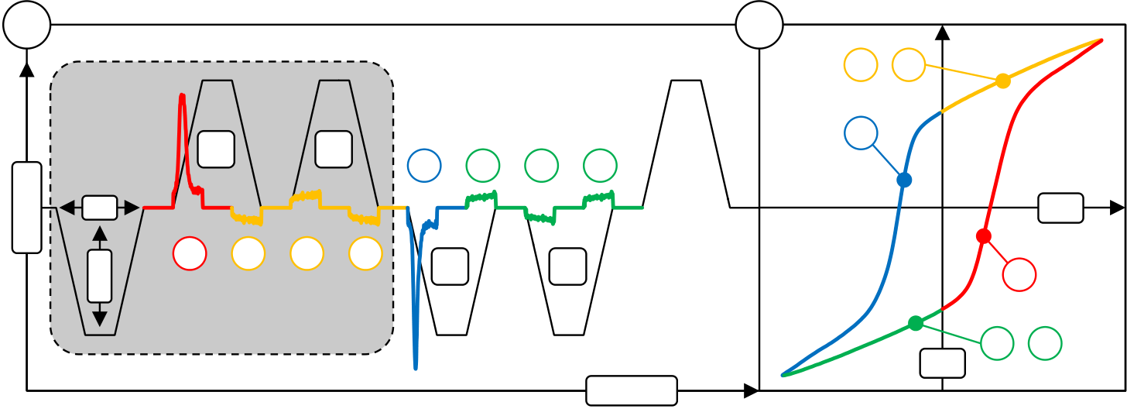

MATERIAL PROPERTIES OF FERROELECTRIC HFO2

|  |  |  |  |  |  |  |  |  |  |  |  |  |  |  |  |  |  |  |  |  |  |  |  |
| --- | --- | --- | --- | --- | --- | --- | --- | --- | --- | --- | --- | --- | --- | --- | --- | --- | --- | --- | --- | --- | --- | --- | --- |
| a | PW | 1 | P | 2 | 3 | U | 4 | 5 | N | 6 | 7 | D | 8 | Reset | b | 2 | - | 4 | *P* | 6 | 1 | 8 | *E* |
| *V / I* | 5 |
| Amp |
| - |

time

Fig. 2-7: PUND pulse sequence and corresponding hysteresis graph. (a) The pulse width and amplitude of the first pulse are varied and the following pulses are used for read-out. The last pulse again sets a reference state. Color coding and numbers correlate the current responses to the branches of the hysteresis in (b). The grey area highlights the reduced PUND sequence that was used in the thesis.

Before the four pulses of the PUND sequence are applied, the negative polarization state has to be written first. The first pulse of negative polarity can be parameterized in terms of its amplitude and pulse width in order to extract the switching kinetics of the thin film. Afterwards, the actual PUND sequence is carried out (Fig. 2-7 (a)). The pulse widths and absolute amplitudes of the four pulses should be identical and high enough / long enough in order to ensure that the ferroelectric is brought into complete saturation. Depending on the magnitude of the P pulse current response it is possible to calculate the amount of polarization that has been switched by the parameterized first pulse. Therefore, the U pulse current response is subtracted from the P pulse current response. This effectively eliminates contributions from dielectric displacement and leakage currents such that the pure ferroelectric switching current is extracted. This assumption is of course only valid if leakage currents are independent of the polarization state [121]. Integration of the P-U current response with respect to time and division by the MFM capacitor areas results in the so called switched polarization PSW. The amount of switched polarization as a function of the, in terms of pulse amplitude and pulse width, parameterized first pulse is the actual measure for the switching dynamic of a ferroelectric. The succeeding N and D pulse again reverse the polarization and act as a reference for how much polarization should have been switched by the parameterized first pulse. The last pulse resets the device into a saturated positive polarization state such that the next parameterized pulse sequence can be applied. In order to analyze the switching kinetics of the positive polarization state, all voltage polarities simply have to be inverted.

Within this thesis, a reduced PUND measurement, utilizing only a parameterized and two consecutive pulses of same voltage polarity, was applied. This reduced the amount of sampled data points and by increasing the parameterized pulse width to and above the P and U pulse widths, the N-D reference was included in the measurement results. For both negative as well as positive write pulses, the switched polarization was extracted and normalized to the maximum switched polarization (Fig. 2-8) [117].

28

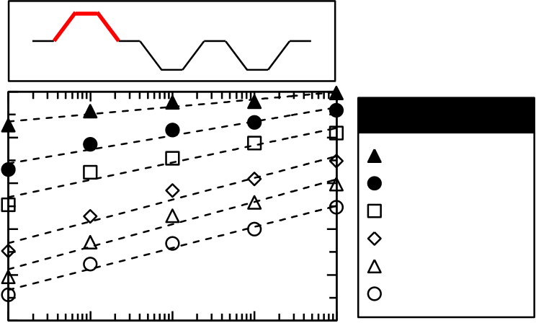

MATERIAL PROPERTIES OF FERROELECTRIC HFO2

|  |  |  |  |  |  |  |  |  |
| --- | --- | --- | --- | --- | --- | --- | --- | --- |
| Normalized *PSW* [1] | 1 | 0.6 0.4 0.2 0 1  0.8  10-5 10-4 10-3 10-2 10-1 | 10-5 | 10-4 | 10-3 | 10-2 | 1 | **Amplitude** |
| 0.8 |
| 0.5 V-2V / +1.5V |
| 0.6 | 0.8 |
| 0.6 V-1.5V / +1V |
| 0.8 V-1.3V / +0.8V |
| 0.4 |
| 0.6 | 1 V-1.1V / +0.6V |
| 0.2 | 1.5 V-0.9V / +0.5V |
| 0.4 |
| 3 V-0.4V / +0.4V |
| 0 | 0.2 10-1 |
| Pulse Width [s] | | 0 |

Fig. 2-8: PUND results for both negative and positive pulse amplitudes. The polarization that is switched (PSW) by the first pulse (highlighted in red) depends on both the width and amplitude of the pulse. Logarithmic fits of the PSW are shown as dashed lines. The switched polarization is normalized to PSW achieved for 0.1 s pulse width and maximum amplitude. Different write amplitudes were used for positive and negative voltage polarities due to an asymmetry of the polarization response.

The resulting PSW versus pulse width graphs could be fitted logarithmically whereas this behavior was not in accordance with the standard Kolmogorov-Avrami-Ishibashi (KAI) model [5, 82, 126]. In the past, such characteristics had been observed for e.g. 135 nm

Pb(ZrxTi1-x)O3 (PZT) thin films and were explained by a nucleation-limited-switching (NLS) model [171, 182]. Due to the small film thickness, NLS models assume that domain

coalescence can be neglected and that nucleation statistics dominate the switching kinetics [62]. Since the Si:HfO2 films are at least an order of magnitude thinner than standard ferroelectric thin films, it is a reasonable assumption to apply the NLS model.

In summary, Fig. 2-8 reflects that for pulse widths down to 10 s, around 80 % of the

available polarization could be switched. Increasing the excitation voltages to  3V (not

shown in the graph because of independence of pulse width) led to a normalized PSW that was close to unity even for a pulse width of 10 s. Hence, by logarithmic extrapolation,

switching dynamics in the range of nanoseconds would be expected. This indicates that the first part of the voltage-time dilemma can properly be solved by ferroelectric Si:HfO2. The second part, i.e. if the polarization states can be maintained for a longer period of time, will

be analyzed in the next section.

29

MATERIAL PROPERTIES OF FERROELECTRIC HFO2

2.3Specific Characteristics with Focus on Non-Volatile Memories

Besides the second part of the voltage-time dilemma, this section will focus on material characteristics of Si:HfO2 that are specifically important from an NVM application perspective. First, the amount of write cycles that the material can endure will be analyzed. This corresponds to how often the polarization of the ferroelectric can be changed from a positive to a negative polarization state which in turn is identical to the number of hysteresis cycles that the material can withstand. In the end, the result of this characterization represents an essential benchmark for judging the ability to replace RAM cells with Si:HfO2-based ferroelectric memory cells. As an example, DRAMs are specified to endure continuous write operations ( 40 ns / write operation / bit) over a period of ten years. This corresponds to approximately 1016 write operations in total. For an actual NVM, the benchmark is much more relaxed and is in the range of 103 (MLC Flash) to 106 (SLC Flash) write operations. Hence, depending on the amount of write cycles the Si:HfO2 can endure, the potential memory architectures that might be addressed can be derived.

The second part of the voltage-time dilemma, i.e. the retention of the polarization state, is addressed afterwards. From an NVM perspective, retention tests are fundamental to the concept of non-volatile data storage. In general, a non-volatile memory has to ensure that data is retained for a period of 10 years. In order to prove such characteristics, tests were carried out under temperature acceleration. Moreover, the retention measurements were derived from an actual FRAM reliability test and include opposite-state and new-same-state characteristics of the Si:HfO2 thin film.

From the retention tests, the ferroelectric imprint characteristic of Si:HfO2 were extracted as well. The imprint characteristics show how the coercive field of Si:HfO2 changes when a polarization state is permanently maintained at an elevated temperature. These results are specifically important with respect to FeFET applications due to the fact that the memory window of these devices directly depends on the absolute value of the coercive field (for a more detailed treatment of the FeFET, see e.g. chapter 3).

2.3.1Write Endurance and Ferroelectric Fatigue

For classical ferroelectrics like PZT, the number of polarization cycles the material can endure is limited by phenomena such as domain wall pinning and oxygen vacancy ordering [157, 181]. Due to these effects, at the beginning of the FRAM era, write endurance was limited to 104 - 107 cycles. These limitations were later overcome by the introduction of oxide electrodes [4] and SrBi2Ta2O9 (SBT) as a ferroelectric [130]. Nowadays, FRAM endurance is "practically unlimited" [191] and can be extrapolated to 1015 cycles [26].

In order to analyze Si:HfO2 in terms of its endurance characteristics, fatigue measurements were carried out for the 4.9 mol% composition (post TiN metallization anneal (PMA), at 650 ºC, 800 ºC and 1000 ºC) [119]. Alternatingly, the ferroelectric hysteresis was recorded and field cycled applying an exponentially increasing cycle number. The evolution of the remanent polarization for different cycling amplitudes was extracted and plotted against the amount of field cycles (Fig. 2-9).

30

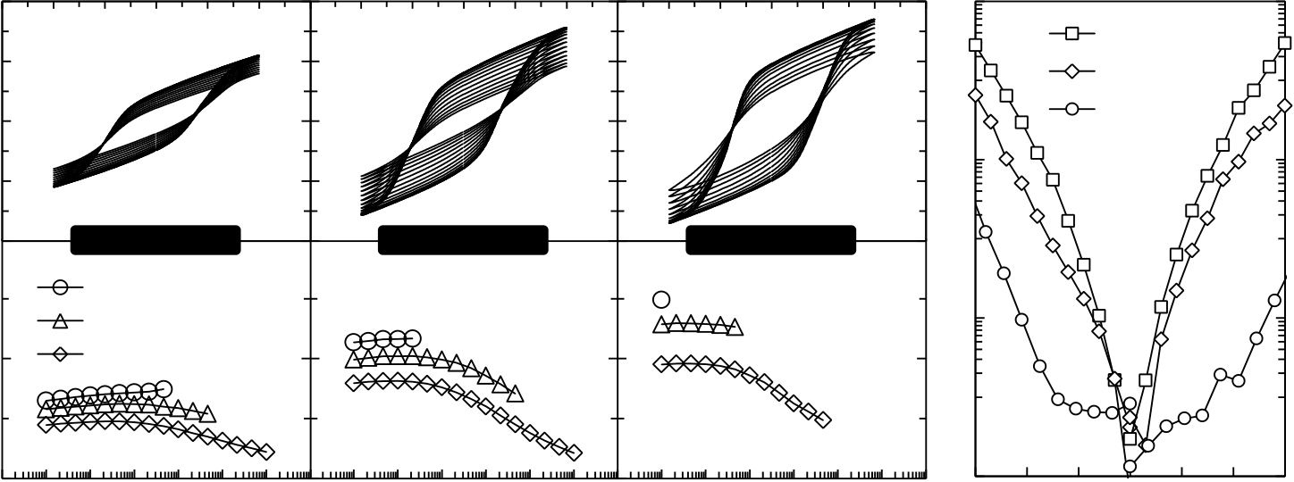

MATERIAL PROPERTIES OF FERROELECTRIC HFO2

Electric Field [MV/cm]

|  |  |  |  |  |  |  |  |  |  |  |  |  |  |  |  |  |  |  |  |  |  |  |  |  |  |  |  |  |  |
| --- | --- | --- | --- | --- | --- | --- | --- | --- | --- | --- | --- | --- | --- | --- | --- | --- | --- | --- | --- | --- | --- | --- | --- | --- | --- | --- | --- | --- | --- |
| Polarization [µC/cm2] | 20 | -3 | -2 | -1 | 0 | 1 | 2 | 3 | -2 | -1 | 0 | 1 | 2 | 3 | -2 | -1 | 0 | 1 | 2 | 3 | -3 | 1000 °C PMA | | | | | 3 | 10-2 | Current Density [A/cm2] |
| 10 | **650°C PMA** | | | | | | **800°C PMA** | | | | | | **1000°C PMA** | | | | | 800°C PMA | | | | | 10-4 |
| 0 | 650°C PMA | | | | |
| -10 |
| 20 |
| *Pr* [µC/cm2] | 15 | -2 | -1 | 0 | 1 | 2 | 10-6 |
| 2.5 MV/cm | | | | | |
| 2.25 MV/cm | | | | | |
| 10 | 2 MV/cm | | | | | |
| 105 106 107 108 109 1010 | | | | | | 105 106 107 108 109 1010 | | | | |
| 5 | 10-8 |
| 105 106 107 108 109 1010 | | | | | |
| 0 |
| Endurance Cycles [1] | | | | | | Electric Field [MV/cm] | | | | |

Fig. 2-9: Ferroelectric fatigue of Si:HfO2 MFM capacitors. Hysteresis fatigue is shown for 2 MV/cm cycling and measurement amplitude (top). For different cycling / measurement amplitudes, the evolution of the remanent polarization Pr was monitored until 1010 endurance cycles and was aborted when hard electric breakdown occurred (bottom). Leakage current characteristics for the respective annealing conditions are shown on the right.

The cycling frequency was set to 100 kHz in order to enable measurements up to 1010 cycles within a reasonable amount of time. Bipolar field amplitudes of 2 MV/cm, 2.25 MV/cm and 2.5 MV/cm were used for analyzing the electric field dependence of the ferroelectric fatigue. For samples annealed at 650 ºC and cycled with 2 MV/cm no electrical breakdown was observed within the measurement range of 1010 cycles. However, the remanent polarization decreased to  2 C/cm2. These polarization fatigue characteristics can i.a. be linked to electron injection from the interface [181]. Due to the fact that dead layers at the electrode / ferroelectric interface are likely to be present also for HfO2 [132], an elevated electrical field stress in the low permittivity dead layer corroborates the assumption of endurance degradation by charge injection.

For the higher field cycling amplitudes of 2.25 MV/cm and 2.5 MV/cm, electrical breakdown occurred after 4.6  108 and 4.6  107 cycles respectively. As it was already shown in subsection 2.1.1, higher annealing temperatures in general lead to higher Pr values. The fatigue measurements however show that this is accompanied by earlier electric breakdown with cycling which can be explained by the in principle increased leakage currents of films annealed at high temperature. This is a well-known indication that degradation of the film will be accelerated. As compared to classical ferroelectric endurance characterization, it is rather unusual that fatigue is limited by the dielectric breakdown. This can however be understood by considering the fact that the coercive field of Si:HfO2 is approximately one order of magnitude larger than for classical ferroelectrics. Hence, the coercive field is much closer to the electrical breakdown field EBD which will ultimately lead to earlier degradation of the film.

From the application side, the fatigue measurements demonstrated that state-of-the-art NVM specifications (103 - 106 endurance cycles) can be fulfilled. However, endurance characteristics have to be improved if a RAM-type application shall be addressed.

31

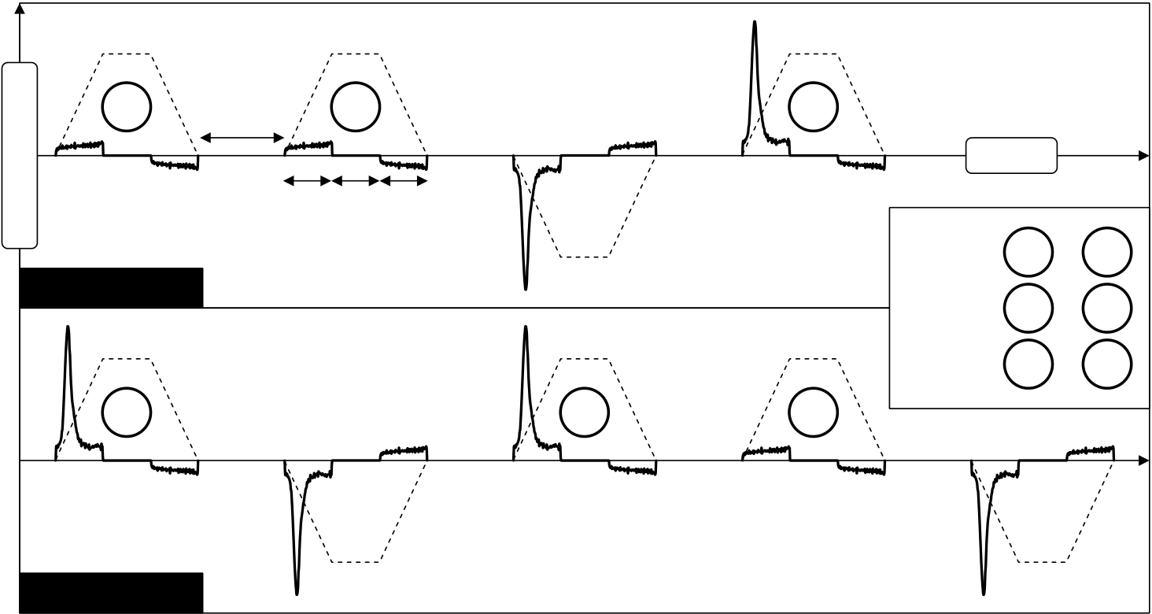

MATERIAL PROPERTIES OF FERROELECTRIC HFO2

2.3.2Same-State, Opposite-State and New-Same-State Retention

The most characteristic property of a non-volatile memory is represented by its ability to maintain the written binary states even when power supply is removed. The tests analyzing the idealness of this property are called retention tests. These are generally performed under elevated temperature acceleration in order to conclude on potential 10 year data retention. For capacitor-based FRAM memories in particular, same-state (SS), opposite-state (OS) and new-same-state (NSS) retention are of specific interest [142]. The meaning of these terms can best be explained with respect to the pulse sequences that are applied in between the respective retention periods (Fig. 2-10).

|  |  |  |  |  |  |  |  |  |  |  |
| --- | --- | --- | --- | --- | --- | --- | --- | --- | --- | --- |
| Voltage / Current | **11** | 1 s | **12** | **23** | **14** | **SS** | ≡ | Time | ─ | **11** |
| 1 ms each |
| **21** |
| **MFM Capacitor 1** | **24** | **NSS** | ≡ | ─ |
| **23** | **12** |
| **OS** | ≡ | **14** | ─ | **24** |
| **21** |

**MFM Capacitor 2**

Fig. 2-10: Pulse sequences for MFM retention tests. Two capacitors are required to evaluate same-state (SS), new-same-state (NSS) and opposite-state (OS) retention. Calculation formulas for the respective quantities are shown as inset. The current responses (solid lines) to the voltage pulses (dashed lines) are subtracted and subsequently integrated with respect to time in order to derive polarization values. In between each measurement sequence, capacitors are stored at 125ºC.

For the retention measurement of a certain polarization state (positive or negative), two MFM capacitors are required in general. Referring to the nomenclature of section 2.2, an Up-Up-Negative-Positive (UUNP) sequence is applied to the first capacitor whereas a Positive-Negative-Positive-Up-Negative (PNPUN) sequence is used for the second capacitor. Before and after the measurement sequences are carried out, the capacitors are generally stored in an oven and exposed to elevated temperatures. Since measurements are performed regularly in between the storage period, the last pulse of a measurement sequence determines the polarization state in which the MFM capacitor resides during storage. Hence, starting out with the pulse sequence for capacitor 1, for an ideal case, the current response to pulse 11 should solely be of dielectric nature. This results from the fact that the capacitor was left in the positive polarization state at the end of a previous measurement sequence (pulse 14). However, since polarization relaxation might have occurred during the retention time, the amount of relaxed polarization will be switched again as a response to pulse 11. A quantification of the amount of relaxed polarization can be given by considering the current response to pulse 12. This pulse succeeds after one second and should, if polarization relaxation occurred during the storage period, show a current response that is smaller in magnitude. Moreover, it is likely that ferroelectric relaxation in the 12 pulse response is even reduced with respect to a virgin sample. This

32

MATERIAL PROPERTIES OF FERROELECTRIC HFO2

originates from the fact that the positive polarization state will be favored after a certain period of storage time (called "imprint", see next section). The third pulse of the first sequence switches to the negative polarization state whereas the current response to the negative voltage pulse will decrease over time. This is again due to the favored positive polarization direction. Hence, the opposite state cannot be switched properly anymore and the current response decreases. This can then also be observed in the current response of the last pulse of that sequence which in turn also decreases since the negative polarization state was not brought into full saturation. The same effects need to be considered for the pulse sequence applied to the second MFM capacitor. The major difference is that a negative polarization state is set by the last pulse and henceforth maintained during storage. Moreover, the additional pulse allows for the calculation of all parameters that are relevant for an FRAM read operation: First of all, the same-state (SS) retention parameter subtracts the current responses to pulse 21 and 11 in order to quantify a worst case read out margin for the positive polarization state. The response to 21 will be affected by negative imprint which reduces the ferroelectric switching response. The response to pulse 11 can be affected by ferroelectric relaxation which effectively increases the non-switching response. Together, this reduces the overall read margin of the positive polarization state. The new-same-state (NSS) retention parameter subtracts the response of pulse 23 from the one of 12. The current response to pulse 23 will again be reduced due to negative polarization imprint. The response to pulse 12 might be increased due to a reduced ferroelectric relaxation after positive polarization imprint has happened. Hence, the NSS parameter represents the worst case read scenario after the polarization state of interest, in this case the positive one, has been read out once. This analysis also exists for the negative polarization state and is called opposite-state (OS) retention. That is, it reflects the worst case scenario for how good the opposite state, in this case the negative polarization state, can be read out after a certain storage period. The calculation subtracts the response to pulse 14 from the one to pulse 24. The response to pulse 14 shows a reduced switching response due to the imprinted positive polarization because the negative polarization could not be brought into saturation with pulse 13. Moreover, the non-switching response to pulse 24 might grow over time due to negative polarization imprint and therefore an increased switching of potentially relaxed polarization might occur. The difference between these two current responses again represents a worst case scenario for the read margin.

The tests were performed on the 4.9 mol% composition which had previously been annealed at 650 ºC, 800 ºC and 1000 ºC. Four capacitors were used for each annealing condition such that SS, NSS and OS retention could be analyzed for both positive as well as negative polarization states. Samples were stored in an oven at 125 ºC for 1000 hours in order to accelerate a potential retention loss. Furthermore, the difference between non-saturated (sub-loop) and saturated loop retention was analyzed by performing tests for both 3 MV/cm and 1.5 MV/cm pulse amplitudes (Fig. 2-11).

33

MATERIAL PROPERTIES OF FERROELECTRIC HFO2

|  |  |  |  |  |  |  |  |  |  |  |  |  |  |  |  |  |  |  |  |  |  |  |  |  |  |  |  |  |  |  |  |  |  |  |  |  |  |  |  |  |  |  |  |  |  |  |  |  |  |  |  |  |  |  |  |  |  |  |  |  |  |  |  |  |  |  |  |  |  |  |  |  |  |  |  |  |  |  |  |  |  |  |  |  |  |  |  |  |  |  |  |  |  |  |  |  |  |  |  |  |  |  |  |  |  |  |  |  |  |  |  |  |  |  |  |  |  |  |  |  |  |  |  |  |  |  |  |  |  |  |  |  |  |  |  |  |  |  |  |  |  |  |  |  |  |  |  |  |  |  |  |  |  |  |  |  |  |  |  |  |  |  |  |  |  |  |  |  |  |  |  |  |  |  |  |  |  |  |  |  |  |  |  |  |  |  |  |  |  |  |  |  |  |  |  |  |
| --- | --- | --- | --- | --- | --- | --- | --- | --- | --- | --- | --- | --- | --- | --- | --- | --- | --- | --- | --- | --- | --- | --- | --- | --- | --- | --- | --- | --- | --- | --- | --- | --- | --- | --- | --- | --- | --- | --- | --- | --- | --- | --- | --- | --- | --- | --- | --- | --- | --- | --- | --- | --- | --- | --- | --- | --- | --- | --- | --- | --- | --- | --- | --- | --- | --- | --- | --- | --- | --- | --- | --- | --- | --- | --- | --- | --- | --- | --- | --- | --- | --- | --- | --- | --- | --- | --- | --- | --- | --- | --- | --- | --- | --- | --- | --- | --- | --- | --- | --- | --- | --- | --- | --- | --- | --- | --- | --- | --- | --- | --- | --- | --- | --- | --- | --- | --- | --- | --- | --- | --- | --- | --- | --- | --- | --- | --- | --- | --- | --- | --- | --- | --- | --- | --- | --- | --- | --- | --- | --- | --- | --- | --- | --- | --- | --- | --- | --- | --- | --- | --- | --- | --- | --- | --- | --- | --- | --- | --- | --- | --- | --- | --- | --- | --- | --- | --- | --- | --- | --- | --- | --- | --- | --- | --- | --- | --- | --- | --- | --- | --- | --- | --- | --- | --- | --- | --- | --- | --- | --- | --- | --- | --- | --- | --- | --- | --- |
| ~~a~~  **650°C PMA**  **800°C PMA**  **1000°C PMA**   |  |  |  |  |  |  |  |  |  |  |  |  |  |  |  |  |  |  |  |  |  |  |  |  |  |  |  |  |  |  |  |  |  |  |  |  |  |  |  |  |  |  |  |  |  |  |  |  |  |  |  |  |  |  |  |  |  |  | | --- | --- | --- | --- | --- | --- | --- | --- | --- | --- | --- | --- | --- | --- | --- | --- | --- | --- | --- | --- | --- | --- | --- | --- | --- | --- | --- | --- | --- | --- | --- | --- | --- | --- | --- | --- | --- | --- | --- | --- | --- | --- | --- | --- | --- | --- | --- | --- | --- | --- | --- | --- | --- | --- | --- | --- | --- | --- | |  |  | | | | | | | | | | | | | | | | | | |  | | | | | | | | | | | | | | | | | |  | | | | | | | | | | | | | | | | | | |  | | |  |  | | --- | --- | | lized | -1 | |  | | | | | | | | | | | | | | | | | | |  | | | | | | | | | | | | | | | | | | |  |  |  |  | | --- | --- | --- | --- | |  | SS+ |  | NSS+ | |  |  | | OS+ | SS- | |  | NSS- |  | OS- | | | | | | | | | | | | | | | | | | | |  | | | | |  |  |  |  |  |  |  |  |  |  |  |  |  |  |  |  |  |  |  |  |  |  |  |  |  |  |  |  |  |  |  |  |  |  |  |  |  |  |  |  |  |  |  |  |  |  |  |  |  |  |  |  |  |  |  |  |  |  | | | | | | | | | |
|  |  |  |  |  |  |  |  |  |

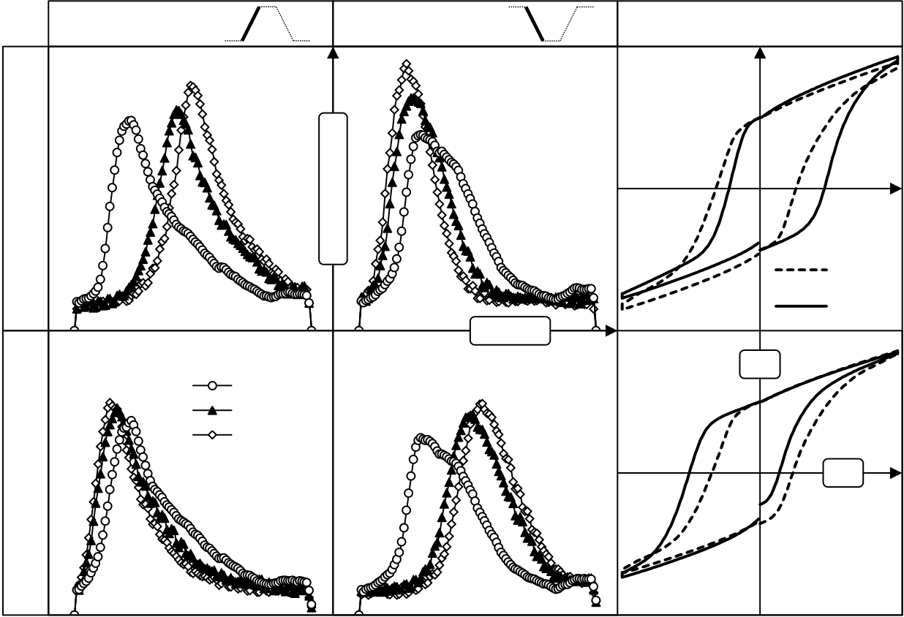

MATERIAL PROPERTIES OF FERROELECTRIC HFO2

2.3.3Imprint

Ferroelectric imprint is considered to be present when a certain polarization direction is favored over the other due to an internal bias field [157]. This effectively translates to a horizontal shift of the P-E hysteresis. There are several forms of ferroelectric imprint whereas "aging induced imprint" and "external bias induced imprint" are the most common [6]. That is, imprint can either be caused by keeping the ferroelectric in a defined polarization state for a certain period of time or stressing it with an AC (unipolar) or DC voltage signal. The most relevant of the two imprint types is the aging induced imprint [6] which is reported to be caused by oxygen vacancy-related defect dipole generation [207]. Moreover due to the fact that ferroelectric imprint is temperature accelerated [7], the retention tests of subsection 2.3.2 actually include the elevated temperature aging induced imprint. For imprint quantification, the polarization hystereses were extracted such that the shift in coercive fields could be visualized (Fig. 2-12).

|  |  |  |  |  |
| --- | --- | --- | --- | --- |
| ─ *P* at 125 °C | 0  3 MV/cm | Abs (Current) | 0  -3 MV/cm | *P-E* Hysteresis |

0 h

1000 h   
Time

|  |  |  |  |
| --- | --- | --- | --- |
| + *P* at 125 °C | 0 h | P | E |
| 48 h |
| 1000 h |

Fig. 2-12: Imprint characteristics of Si:HfO2. Positive and negative polarization states +P respectively -P were written to MFM capacitors which were then stored at 125 ºC. Current responses on rising and falling edges of  3 MV/cm pulses were recorded after 0 h, 48 h and 1000 h storage time at 125 ºC. Corresponding polarization hystereses are shown on the right.

The 800 ºC PMA sample was analyzed with respect to a change in switching voltage / coercive field due to the storage at 125 ºC. Therefore, the current responses to the second pulse train of Fig. 2-10 were used in order to visualize changes in the current peak positions. In particular, the first and second pulse of the pulse sequence lead to the switching out of and back to the potentially imprinted state. Due to a conditioning sequence that preceded the measurement, the initial switching voltages / coercive fields could be approximated to be symmetrical.

When the negative polarization state was exposed to 125 ºC for only 48 hours, a severe imprint towards the storage state was visible. The positive and negative coercive fields increased and decreased by approximately 0.3 MV/cm and 0.1 MV/cm respectively. At the end of the retention period of 1000 hours, that trend had continued but the further increase in asymmetry was negligible as compared to the imprint that happened during the first 48 hours.

35

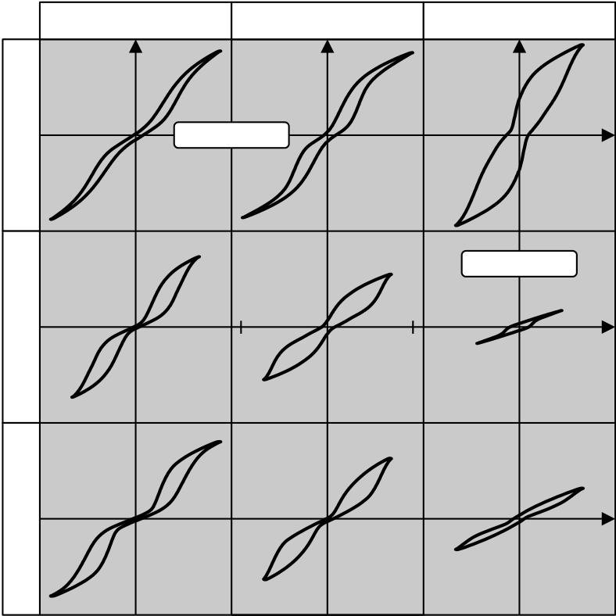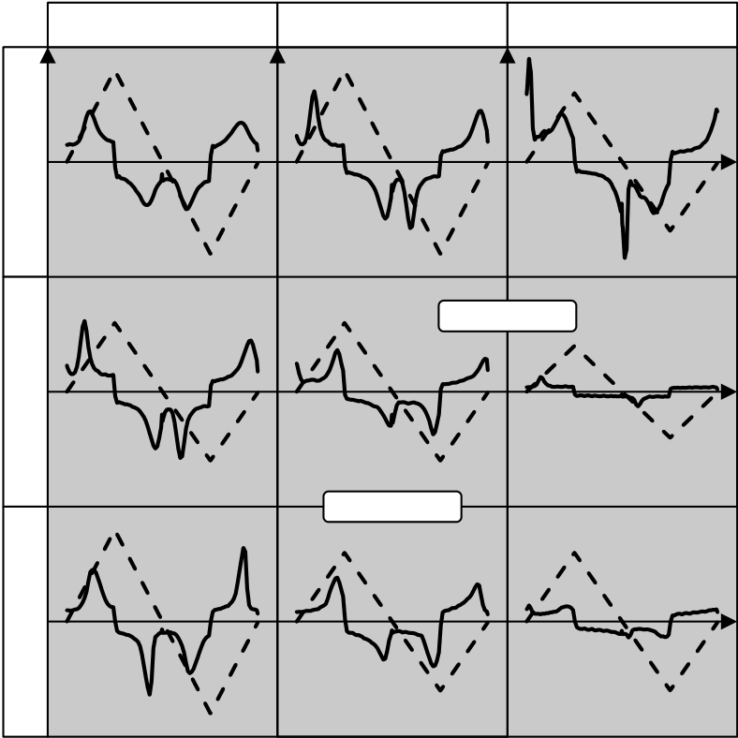

MATERIAL PROPERTIES OF FERROELECTRIC HFO2

For MFM capacitors stored in a positive polarization state, the trend was inverted but very similar with respect to the Ec shifts: The positive coercive field decreased by approximately 0.1 MV/cm and the negative coercive field increased by approximately 0.4 MV/cm.

Due to the fact that for the 800 ºC PMA 4.9 mol % Si:HfO2 sample the virgin Ec is approximately  0.8 MV/cm, the aging induced imprint can be as high as 50 % of Ec. Especially with respect to the FeFET concept, these observations have to be considered when it comes to sensing of the binary states by use of the memory window (see chapter 3).

2.4Effects of Film Thickness and Increased Dopant

Concentration

Up to this point, the ferroelectric properties of 10 nm Si:HfO2 films were analyzed with respect to their memory characteristics. Due to the fact that the memory window of a FeFET can be increased by the thickness of the ferroelectric (see chapter 3), also thicker Si:HfO2 films were characterized in the course of this thesis.

On the one hand it was found that the antiferroelectric tendency increases for thicker films and on the other hand that the magnitude of polarization can be tailored by the thickness of the film. Due the specific relevance for FeFET applications, the thickness dependence of Si:HfO2 films with high Si-concentration are discussed in the following.

|  |  |  |  |  |  |  |  |  |
| --- | --- | --- | --- | --- | --- | --- | --- | --- |
| 10 nm | 8.8 mol% | *E* [MV/cm] | 6.6 mol% | 5.6 mol% | 10 nm | 8.8 mol% | 6.6 mol% | 5.6 mol% |

40

|  |  |  |  |  |  |  |  |
| --- | --- | --- | --- | --- | --- | --- | --- |
| 30 nm | -4 | -40 | 4 | *P* [µC/cm2] | 30 nm | Time [a.u.] | I / V [a.u.] |
| 50 nm | 50 nm |

Fig. 2-13: Thickness and composition dependence of ferroelectricity in Si:HfO2. The left hand side shows the P-E characteristics for three different silicon concentrations and film thicknesses. On the right, the corresponding current responses (solid line) to the triangular voltage signal (dashed line) are illustrated.

The samples under test were again of MFM-type and manufacturing was similar to the capacitor devices described before. For 10 nm films, when the silicon concentration in the HfO2 host lattice was increased, a transition from a pinched ferroelectric to an antiferroelectric-like behavior was observed. This was in accordance to previous results as e.g. presented in [14]. Furthermore, the difference between VC2 and VC1 (see Fig. 2-1), i.e. the width of the polarization hysteresis, decreased with increasing silicon concentration. For films of 30 nm and 50 nm thickness, the width of the antiferroelectric-like hysteresis increased. Moreover, the electric fields required for transitioning into the ferroelectric phase also rose with increasing film thickness. One remarkable property was revealed for samples

36

MATERIAL PROPERTIES OF FERROELECTRIC HFO2

of 30 nm film thickness and 5.6 mol% silicon concentration: An almost ideally rectangular ferroelectric hysteresis was observed with a remanent polarization of approximately 2 C/cm2. Moreover, due to the well-shaped P-E hysteresis, almost no polarization relaxation was observed, i.e. the Pr to PS ratio was close to one. The origin of the reduced remanent polarization was in the past ascribed to a lower ferroelectric phase fraction due to the earlier onset of crystallization for thicker films [218]. Moreover, an off-polarization-axis texture of the film was also proposed in the past to be responsible for a reduction of the remanent polarization [55]. However, if this would be the case, also a higher coercive voltage would be expected due to the fact that only a fraction of the applied field projects onto the polarization axis. Since the coercive fields for the 5.6 mol% sample of 30 nm film thickness are still in the range of 1 MV/cm, the reduced ferroelectric phase fraction is assumed to be the cause for the reduction in P.

With respect to the target application discussed in this thesis, i.e. the ferroelectric field effect transistor, low polarization and a high Pr to PS ratio are both in favor of the device. Hence, the observed hysteresis for 5.6 mol% silicon concentration and 30 nm film thickness will again be used to illustrate these effects for the FeFET in the next chapter. Nevertheless, the potential effect of a reduced ferroelectric phase fraction on device statistics has always to be kept in mind.

2.5Reference Capacitors for Integrated Device Lot

The results that so far were presented in this chapter were based on Si:HfO2 thin films created by atomic layer deposition (ALD). More specifically it was mentioned, that metal-organic TEMAH and 4DMAS precursor gases were used for ALD processing. These precursor chemistries are specifically well suited for deposition of thin films into high aspect ratio geometries due to their extraordinary conformality. For planar device geometries it is however more common to use inorganic metal-halide precursor chemistries due to a larger process window and better particle performance. Hence, for the integrated FeFET device lots, the precursor gases were changed to HfCl4 and SiCl4 whereas the ozone oxidant was replaced by water.

In order to verify that these ALD chemistries lead to the same ferroelectric behavior, MFM reference capacitors were processed before the actual device lot was later manufactured. The capacitors serve as a material reference in order to allow for a better interpretation of the FeFET performance (see chapter 4). In order to create the capacitors, a 10 nm TiN bottom electrode was first processed at 450 ºC/3 h using pulsed chemical vapor deposition (CVD) and the precursor gases TiCl4 and NH3. Afterwards, the 10 nm Si:HfO2 layer was ALD processed whereas the pulse ratios were varied from 12:1 over 14:1 to 20:1. This ensured that a wide molar concentration range from 5.7 mol% over 4.5 mol% to 3.5 mol% could be covered. This was required since the MFM process window for inducing the ferroelectric properties was expected to change slightly with the integration into a CMOS device flow. The MFM capacitors were subsequently finalized by deposition of another TiN top electrode which was finally structured by a platinum hard mask.

In the following, the results from endurance measurements on these samples will be presented. The endurance measurements inherently include the hysteresis, conditioning as well as break-down characteristics of the films (Fig. 2-14).

37

|  |  |  |  |  |  |  |
| --- | --- | --- | --- | --- | --- | --- |
| |  |  |  | | --- | --- | --- | |  |  |  | |  |  |  | |

THE SI:HFO2 FEFET: FROM TCAD MODEL TO INTEGRATED 28 NM DEVICE

3The Si:HfO2 FeFET: From TCAD Model to Integrated 28 nm Device

With the discovery of ferroelectricity in Si:HfO2 and its suitable NVM characteristics, which were presented in the previous chapter, first steps were taken which might revive the FeFET concept. In order to predict device properties of FeFETs that are based on ferroelectric HfO2, a FeFET simulation model represents a viable tool. In the past, several compact models for first describing a ferroelectric hysteresis were established [41, 63, 93, 102, 155, 174, 175, 199-201]. These helped in creating FeFET simulation models which provided the link to the integrated circuit (IC) design. These compact models were later also implemented into commercial TCAD (Technology Computer Aided Design) software which provides the opportunity to create an even deeper physical device understanding.

Within this chapter, the concept of the ferroelectric field effect transistor is explained in detail and supported by TCAD simulations performed with Sentaurus Device (Synopsis) [177]. First, the modeling of the ferroelectric hysteresis is briefly explained. Afterwards, the model is applied for simulating a 28 nm FeFET device geometry as it was manufactured during the course of this thesis. In combination with experimental observations made for the Si:HfO2 ferroelectric, the TCAD model is used to quantify possible optimizations of the FeFET that can be achieved by material engineering.

The chapter concludes with the integration scheme of Si:HfO2 FeFETs in a standard HKMG process flow. Deviations from the standard flow are highlighted and a judgment regarding the capability FeFETs to serve as embedded memories is given.

3.1Compact Model of Ferroelectric Hysteresis

In order to model the M-H characteristics for ferromagnetic materials, already in 1935, F. Preisach developed a mathematical approach to describe the hysteretic behavior [131]. The model assumes that the material which possesses hysteretic behavior can be described in terms of a summation of elementary hysteresis loops that have individual coercive fields and are weighed with respect to each other. By choosing the distribution of the coercive voltages respectively the weight of the elementary hysteresis loops appropriately, the macroscopic hysteresis observed in experiments can be reproduced. Moreover, in order to avoid the numerically inefficient solution of the Preisach model, it was shown that a simplified mathematical approach based on a hyperbolic tangent function can be used [63]. This type of empirical description of hysteresis phenomena is known to be applicable also for ferroelectrics and is implemented within Sentaurus Device as follows [177]:

|  |  |  |  |
| --- | --- | --- | --- |
| ( ) ( | ( | ) ( )) | (3-1) |

The above formula gives an expression for the polarization P as a function of the electric field E. The history dependence of the hysteresis is expressed in the  sign whereas plus corresponds to decreasing and minus to increasing electric fields. Moreover, sub-loop states are encoded in the parameters c and Poff, which result from the most recent turning points of the hysteresis (a turning point is defined as the simulation step at which the electric field changes from increasing to decreasing or vice versa).

39

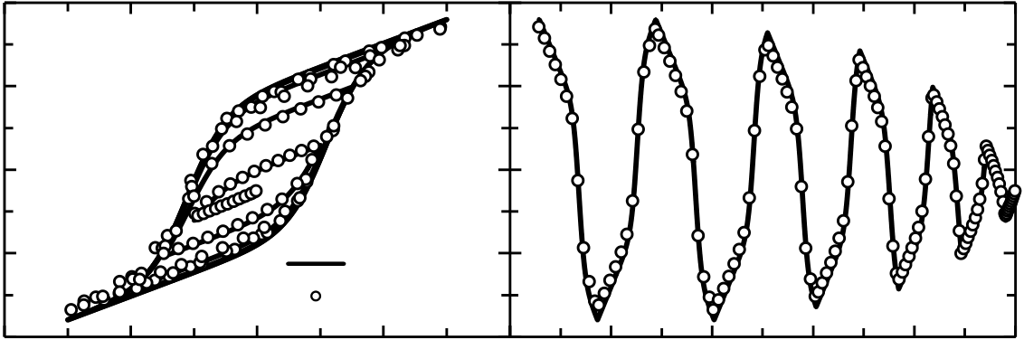

THE SI:HFO2 FEFET: FROM TCAD MODEL TO INTEGRATED 28 NM DEVICE

Besides the polarization P and the electric field E, there are several material specific constants that serve as input for the ferroelectric model: PS represents the spontaneous polarization, Ec the coercive field and Pr the remanent polarization. Within the performed simulations and to a first approximation, the polarization as well as the coercive field values were considered to be constant and not depending on the frequency of the excitation. This is, however, only true to a certain degree as it was demonstrated by experiments in section 2.2. In case transient effects of the ferroelectric itself need to be taken into account, it is possible to model both the electric field and the polarization in terms of an auxiliary field and polarization. This approach can then reflect the frequency dependence of both coercive field and polarization and the interested reader is referred to [36].

Due to the fact that experimental data on ferroelectricity in Si:HfO2 was quite limited, the validity of a Preisach-based modeling approach for Si:HfO2 was not proven at the beginning of this thesis. Hence, before simulating the FeFET with the hysteresis model just described, the validity of the modeling approach was tested by comparing experimental and simulated P-E characteristics [120]. Therefore, a triangular voltage signal of monotonically decreasing amplitude was applied to an MFM capacitor and the polarization response was recorded. The capacitor had been manufactured according to the specifications given in chapter 2. The material specific constants PS, Pr, Ec and r were extracted from the experimental hysteresis and used as input for TCAD simulation. A very simple 2D geometry consisting of two electrodes with a 10 nm HfO2 layer was utilized and a quasistationary simulation was performed.

|  |  |  |  |  |  |  |  |
| --- | --- | --- | --- | --- | --- | --- | --- |
| Polarization [µC/cm2] | 20 | *Pr* = 9µC/cm2 20  Polarization [µC/cm2]  *Ps* = 9.5µC/cm2 10  *Ec* = 1.1MV/cm 0  *r* = 32 -10  -20 | -4 | -2 | 0 | 2 | 4 |
| 10 |
| 0 |
| -10 | Simulation |
| Experiment |

-20

|  |  |  |  |  |  |  |  |  |
| --- | --- | --- | --- | --- | --- | --- | --- | --- |
| -4 | -2 | 0 | Electric Field [MV/cm] 2 0.0 | 0.2 | 0.4 | 0.6 | 0.8 | 1.0 |
| Electric Field [MV/cm] | | | Normalized Time [a.u.] | | | |

Fig. 3-1: Comparison of experimental and simulated P-E hysteresis. For a bipolar triangular excitation signal of decreasing amplitude the polarization transitions from the saturated to sub-loop states (left). The evolution of P over time / the quasistationary simulation period is shown in addition (right). Simulation parameters are given as inset.

The polarization response from the experiment showed proper depolarization of the ferroelectric when a voltage sequence of [-3V;+3V;-2.5V;+2.5V;-2V;...;0V] was applied. By applying the same voltage sequence for the quasistationary simulation it was possible to show that the Preisach-based modeling approach could very well reproduce the experimental sub-loop characteristics (Fig. 3-1). Therefore, the hysteresis model was considered valid also with respect to Si:HfO2 and the parameterization was consequently used for the simulation of FeFET devices.

40

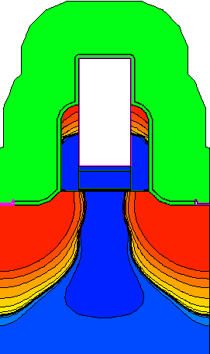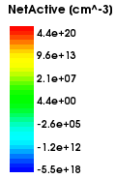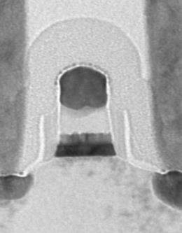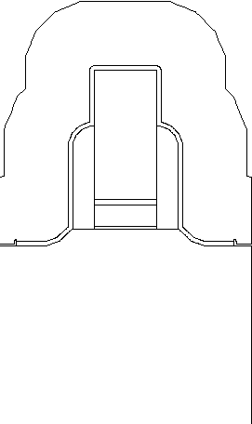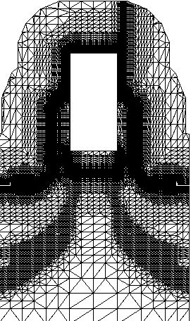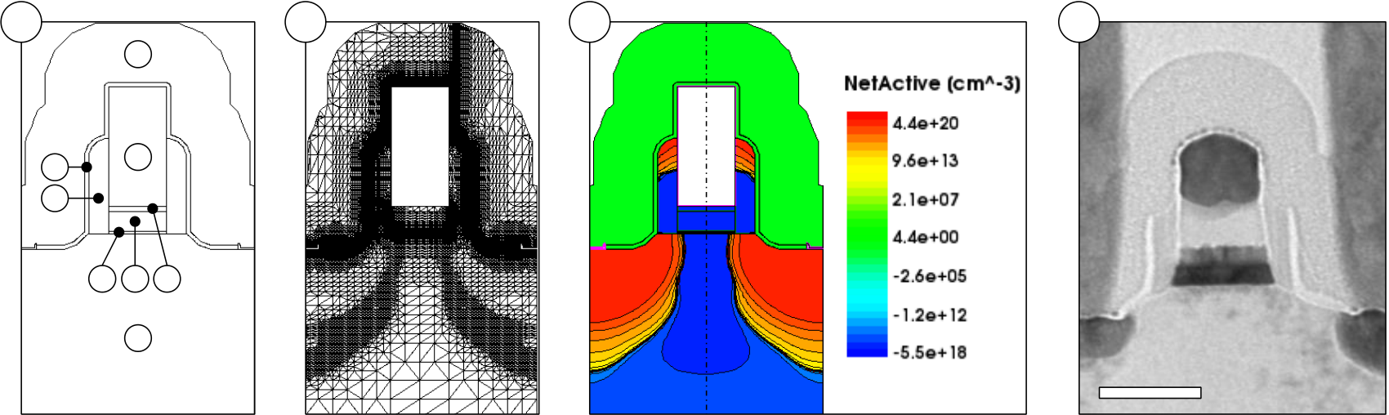

THE SI:HFO2 FEFET: FROM TCAD MODEL TO INTEGRATED 28 NM DEVICE

3.2Application of the Ferroelectric Model for TCAD Simulation of FeFETs

In order to perform TCAD device simulations for FeFET transistors, not only a valid hysteresis model, but also an appropriate FeFET device geometry is required. Therefore, TCAD environments in general provide two simulation categories: Process simulation and device simulation. The first category provides the possibility to model and simulate manufacturing processes like dopant implantation and thermal treatments. The result of a process simulation can for example be a transistor model that is subsequently used for device simulations (Fig. 3-2 (a) and (c)). In a device simulation, voltage or current boundary conditions are applied to the terminals of the device. Subsequently, numerical solutions of e.g. the drift-diffusion and continuity equations are calculated on a discrete mesh of the geometry (Fig. 3-2 (b)). Therefore, the Preisach-based description of the polarization hysteresis is part of the physical models that are used within the device simulation.

The transistor geometry that was required for FeFET device simulations had been derived from a process simulation of a 28 nm HKMG logic transistor. It was furthermore adjusted with respect to implant variations and HfO2 film thickness as they occurred for actual FeFET test chips (see section 3.3). The TCAD geometry closely reflected the actual FeFET device geometry as confirmed by TEM micrographs of actual FeFETs (Fig. 3-2 (d)).

|  |  |  |  |  |  |  |
| --- | --- | --- | --- | --- | --- | --- |
| **a** | **7** | **8** | **b** | **c** | Cutline | **d** |
| **5** | **G** |

**6**

|  |  |  |  |  |
| --- | --- | --- | --- | --- |
| **2** | **3 4** | **S** | **B** | **D** |
| **1** |

**30 nm**

Fig. 3-2: 2D TCAD FeFET geometry and corresponding TEM micrograph. (a) FeFET geometry consisting of silicon bulk (1), SiON interface layer (2), HfO2 high-k (3), TiN metal gate (4), poly Si (5), SiN spacer (6), SiO2 liner (7) and nitride stress liner (8). (b) TCAD mesh with densly meshed regions at junctions and interfaces. (c) Active dopant concentration, positive for donor, negative for acceptor type. Cutline is shown with reference to succeeding subsections. (d) TEM micrograph of an actual Si:HfO2 FeFET with 10 nm high-k layer.

3.2.1Theoretical Model of the FeFET

In this subsection, the most important phenomena affecting the FeFET memory characteristics will be described in detail. In order to generate a theoretical understanding of the FeFET memory behavior, the general effect of ferroelectric polarization on the drain current characteristics of a FET is summarized. The first thorough theoretical treatment of the FeFET was given by Miller and McWhorter who also proposed a numerical procedure to account for the history dependence of the FeFET [102]. Afterwards, an illustrative approach based on charge conservation respectively Maxwell's first equation applied to the FeFET gate stack was given by Ullmann [199]. The most important findings of these studies are used to explain the concept of the ferroelectric field effect transistor.

41

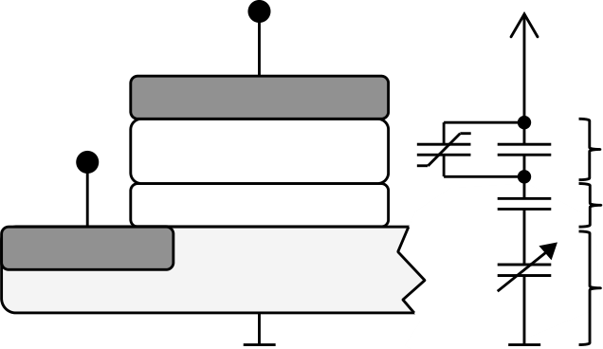

THE SI:HFO2 FEFET: FROM TCAD MODEL TO INTEGRATED 28 NM DEVICE

First of all, as mentioned in the introduction, the FeFET encodes its binary states in terms of a shifted threshold voltage. The threshold voltage of any MOSFET can be extracted from the drain current versus gate voltage (Id-Vg) characteristics. From the summation of drift and diffusion current in a semiconductor [178], the drain current along the channel direction x can be expressed as follows [102]:

|  |  |
| --- | --- |
| ⏞ | (3-2) |

where q represents the elementary charge, n the electron mobility, n the electron density, E the electric field and Dn the electron diffusion coefficient which equals ((kT/q)n). In order to understand the memory characteristics of the FeFET it is sufficient to operate the transistor in the linear regime, i.e. the contribution of the diffusion current to the total drain current can be neglected. Consequently, for a given electric field from drain to source, the current through an n-channel FET is determined by the minority carrier concentration n. Hence, this again shows that the memory characteristics of a FeFET, i.e. the parallel shift of the Id-Vg characteristics, are caused by controlling the minority carrier concentration. It shall be highlighted at this point that caution should be exercised when correlating the spontaneous polarization with this change in minority carrier concentration. As it will be shown in the course of this chapter, even though PS is required for a functional FeFET, the magnitude of the spontaneous polarization is however only of minor importance to the memory characteristics.

What differentiates the FeFET from a standard MOSFET is that the silicon surface potential S is not only a function of the currently applied gate voltage but also depends on the history of the gate voltage. Due to the fact that the minority carrier concentration n is controlled by S [46], the ferroelectric history in turn controls the drain current. The interrelation of surface potential, ferroelectric polarization and gate voltage can be understood when applying Maxwell's first equation to the FeFET gate stack:

|  |  |  |  |  |  |  |  |
| --- | --- | --- | --- | --- | --- | --- | --- |
| Source | Gate | *VGB* | *VFE* | ( ) | ( | ( ) | (3-3) |
| (3-4) |
| Ferroelectric |
| Insulator | *VIF* | ) | (3-5) |
| Bulk |
| *S* |

Fig. 3-3: Equivalent circuit and physical description of an MFIS gate stack. The ferroelectric thin film is described as a parallel connection of dielectric and ferroelectric capacitors whereas the silicon bulk can be represented by a voltage controlled capacitance.

It shall be mentioned that for simplicity, the flatband voltage is considered to be zero (no fixed charges or workfunction differences are considered). Equation (3-5) gives a relation between the applied gate to bulk voltage VGB, the polarization P (as a function of the electric field across the ferroelectric EFE) and the surface potential S. The surface charge density S is itself a function of the surface potential and can be derived by integration of Poisson's equation along the space charge region. The resulting expression

42

THE SI:HFO2 FEFET: FROM TCAD MODEL TO INTEGRATED 28 NM DEVICE

that links the surface charge density and the surface potential can be stated as follows [199]:

|  |  |  |  |
| --- | --- | --- | --- |
|  | | | |
| ( )√ √ ( | ( | )) | (3-6) |

where the signum function indicates that for a positive surface potential, the surface charge density of an NFET is negative. Moreover, NA represents the acceptor concentration in the silicon bulk, T the temperature voltage kT/q with k being Boltzmann's constant and F being the Fermi potential. Hence, by combining equation (3-6) and (3-5), the surface potential becomes a function of the applied gate voltage and ferroelectric polarization. However, the link from the surface potential / surface charge density to the electron density is still missing. For any FET device and to a first approximation, only the free charge carriers of the inversion layer can contribute to the current flow. Though, the surface charge density S includes both the contribution of the inversion layer as well as the contribution from the ionized acceptors. Since the ionized acceptors do not take part in current transport from drain to source, their contribution to S needs to be subtracted in order to derive n. For calculation of the surface charge density due to the ionized acceptors, it is possible to apply the so called charge-sheet approximation [178]. For this approximation it is assumed that the surface potential S completely drops across the depletion region. Using this assumption, it is possible to determine the width of the space charge region w and hence, conclude on the surface charge contribution of ionized acceptors:

|  |  |  |  |
| --- | --- | --- | --- |
| ⏞ | √ | √ | (3-7) |

Equation (3-7) then finally gives the relation between electron density n and surface charge density / surface potential. Together with equation (3-5), the drain current can be calculated by integration of equation (3-2) from drain to source. In order to solve the mentioned set of equations and to account for the history dependence of the ferroelectric, numerical solutions as suggested e.g. in [102] can be applied.

For the demonstration of FeFET device behavior, a TCAD environment as mentioned before could be used which inherently solves e.g. the drift-diffusion equation in a numerical manner. Combined with the compact model that was able to properly account for ferroelectric hysteresis (see section 3.1), FeFET device characteristics could be simulated in a comfortable fashion.

3.2.2Memory Window and Polarization Hysteresis

The occurrence of the memory window (MW) represents the fundamental FeFET property enabling the storage of binary data. As described theoretically in the previous section, the memory window will be determined by the effect of polarization hysteresis on the surface potential. In order to illustrate this, the experimentally determined ferroelectric material parameters (see Fig. 3-1) were adapted also for the transistor TCAD model (Fig. 3-2). A quasistationary bipolar gate voltage sweep of decreasing amplitude was chosen in

43

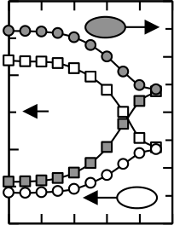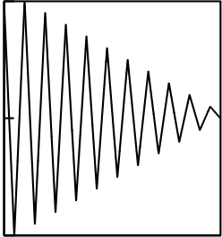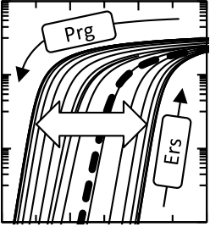

THE SI:HFO2 FEFET: FROM TCAD MODEL TO INTEGRATED 28 NM DEVICE

order to maintain comparability to the MFM simulation. The triangular voltage signal was specified to decrease from a 10 V amplitude down to 0 V in increments of -1 V. During the gate voltage sweep, the drain voltage was kept at 0.1 V such that the FeFET was operated in the linear regime.

|  |  |  |  |  |  |  |  |  |  |  |  |  |  |  |
| --- | --- | --- | --- | --- | --- | --- | --- | --- | --- | --- | --- | --- | --- | --- |
| a | 10 | | Prg state | b | 10-3 | **MW** | | 2 |  | | *P* at *VG*=0V [µC/cm2]  ErsPrg Prg  *P* at *VG*=0V [µC/cm2]  2 6  -1 1  0  10 8-1  0  6 4 2   *VT,Std*  -1  0  1  0  10  3  0  -3  -6  8 6   0  -3  -6 4 0 *VT* [V]   *VT* [V]   2 1 2 6 3  *VT* [V]  -10 -5 0 5 10 Sweep Range [V] 10 8 6 4 Sweep Range [V] 2 0 | | 6  3  0 -3-6 | *P* at *VG*=0V [µC/cm2] |
| 12 | |
| *VG* [V] | 0 | *P* [µC/cm2] | 6 0-6 |
| 10-5 *ID* [A]   10-7 |
| -10 | | Ers state | 10-9 | 0 | 1 | -12 | |
| Time [a.u.] |
| -1 |
| *VG* [V] | | *VG* [V] | Sweep Range [V] |

Fig. 3-4: Quasistationary simulation results for FeFET memory window and polarization hysteresis. (a) The quasistationary gate voltage ramp decreased from 10 V to 0V in steps of -1V. (b) Corresponding Id-Vg characteristics of the FeFET with gradually decreasing memory window MW. Current characteristics of a non-ferroelectric transistor are shown as thick dashed line. (c) FeFET polarization versus gate voltage hysteresis with kinks occurring due to the depletion of the substrate. (d) Threshold voltage VT and polarization at zero gate voltage as function of the sweep range. The threshold voltage of a non-ferroelectric transistor VT,Std lies at approximately 0.5 V.

For the applied voltage sequence (Fig. 3-4 (a)), a proper shift of the Id-Vg characteristics could be observed (Fig. 3-4 (b)). The maximum sweep range of  10 V led to a VT separation / memory window of approximately 1.8 V which decreased only slightly when the sweep range is incrementally reduced to  7 V (Fig. 3-4 (d)). For lower sweep ranges the memory window decreased more significantly, mainly triggered by a loss of the high-VT erased state. This behavior was caused due to the fact that the transistor model possesses a gate stack specification in favor of the positive polarization, i.e. the flatband voltage is negative. Moreover, for the sweep section of 3 V to -2 V this led to the irreversibility of the polarization to negative values. This finally resulted in a positive polarization at the end of the sweep sequence.

By analyzing the polarization characteristics more closely it becomes clear that the saturated polarization is only reached for rather high gate voltages, i.e. at approximately 7 V (Fig. 3-4 (c)). This is a reasonable result since it corresponds to the point of maximum memory window. That is, the memory window cannot grow beyond the point at which the saturated polarization is reached. However, it is not possible to utilize the actual remanent polarization value of 9 C/cm2 for the FeFET: Even at elevated sweep ranges, the polarization returns only to values not larger than  4.4 C/cm2 and not smaller than  -3.8 C/cm2 respectively (Fig. 3-4 (d)). The reason for this is the so called "depolarization field" Edep which will be explained in more detail in the next section. The fact that Edep counteracts the ferroelectric polarization leads to smaller polarization value at zero gate voltage as compared to Pr.

Both the shift of saturated memory operation to high gate voltages as well as the depolarization field is caused by the MFIS structure itself. As the FeFET stack is actually a series connection of three capacitors, already due to the simple capacitive voltage divider (see equation (3-5) to (3-7)), the write voltage increases. Moreover, both interface layer as well as semiconductor bulk are not able to provide the necessary charge compensation required by the spontaneous polarization of the ferroelectric. The resulting depolarization

44

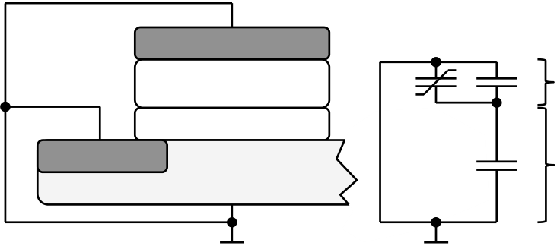

THE SI:HFO2 FEFET: FROM TCAD MODEL TO INTEGRATED 28 NM DEVICE

field and the field distribution within the FeFET will be explained in more detail in the following paragraphs.

3.2.3Depolarization Fields and Interfacial Oxide Fields

Besides the VT-shift representing the fundamental memory property, there are certain phenomena occurring for a MFIS-type FeFET which are detrimental to memory operation. The insulating buffer layer worsens the depolarization field which has, since the invention of the FeFET, been a major barrier prohibiting a commercialization of the device. From an analytical standpoint, the depolarization field can easily be derived for a short circuited MFIS capacitor:

(3-8) Gate

|  |  |  |  |  |  |
| --- | --- | --- | --- | --- | --- |
| Source | Ferroelectric | *VFE* | ( ( | )) | (3-9) |
| Insulator | *VIS* | (3-10) |
| Bulk |

Fig. 3-5: Equivalent circuit and physical description of an MFIS gate stack during data retention periods. The gate and bulk regions are both connected to ground which causes the depolarization field EDep to evolve across the ferroelectric.

For simplicity, in the above consideration, the insulator and semiconductor region are combined to an insulator-semiconductor capacitor CIS. Moreover, the coercive field is assumed to be larger than the actually evolving depolarization field Edep. Even though the last assumption is only true for very specific circumstances, it is appropriate for explaining the nature of the depolarization field.

For a polarized MFIS-type FeFET and different from a standard logic transistor (with VFB = 0V), the electric fields within the ferroelectric as well as the interface-semiconductor region are non-zero at VG = 0V. This can be understood by using Kirchhoff's voltage law (3-8) and Maxwell's first equation (3-9). By elimination of the electric field of the insulator-semiconductor region, the electric field across the ferroelectric represents the depolarization field. As shown in equation (3-10), by reduction of the ferroelectric polarization it is possible to reduce Edep. This can be achieved by operating the FeFET in a subloop state which however reduces also the memory window as shown in Fig. 3-4. Therefore, the preferred way to reduce Edep would be to reduce the actual spontaneous polarization of the material itself such that saturated operation can be maintained.

In addition, by increasing the ratio of insulator-semiconductor to ferroelectric capacitance (dielectric contribution only), it is also possible to reduce Edep. This approach has already been proposed for the MFMIS-type FeFET whereas the area ratio of ferroelectric to insulator was minimized [41]. However, from an integration perspective, the realization of two different gate areas is not straight forward.

Moreover, the electric field across the interfacial oxide is aggravated due to the continuity of the electric displacement field. That is, the interfacial oxide field is superimposed by the contribution arising from the ferroelectric polarization. Hence, for saturated memory operation, interfacial oxide field stress is enhanced and ultimately leads to reliability concerns. In consequence, the electric field across the ferroelectric is reduced which leads to an unwanted increase in operational voltage.

45

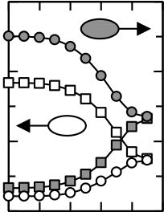

THE SI:HFO2 FEFET: FROM TCAD MODEL TO INTEGRATED 28 NM DEVICE

The described phenomena that are actually detrimental to memory operation can again be visualized and extracted by quasistationary TCAD simulations. For the incrementally decreasing voltage sweep shown in Fig. 3-4, electric field characteristics for the MFIS stack were extracted.

|  |  |  |  |  |  |  |  |  |  |  |  |  |  |  |  |  |  |  |  |  |  |  |  |  |  |  |  |  |
| --- | --- | --- | --- | --- | --- | --- | --- | --- | --- | --- | --- | --- | --- | --- | --- | --- | --- | --- | --- | --- | --- | --- | --- | --- | --- | --- | --- | --- |
| 12 | |  | | | | | *EFE* [MV/cm] | 4 |  | | | | *EIF* [**10** MV/cm] | 4 | *VT* [V] | | | | 2 | | *VT* [V] | |  |  | | --- | --- | |  |  | | *P* at *VG*=0V [µC/cm2] | 6 | *EIF,0* [MV/cm] | *P* at *VG*=0V [µC/cm2] |
| *P* [µC/cm2] | 6 0-6 | 2 | 2 | *EFE,0* [MV/cm] | 1 0 | 3 |
| 0 | 0 | 0 |
| -2 | -2 |
| -12 | | -4 | -4 | -1 | | Sweep Range [V] | | | -3 |
| -4 | -2 | 0 | 2 | 4 | -10 -5 | 0 | 5 | 10 | -10 -5 | 0 | 5 | 10 |
| *EFE* [V] | | | | | *VG* [V] | | | | *VG* [V] | | | |

Fig. 3-6: Simulated electric field characteristics of FeFET gate stack with 10 nm Si:HfO2. (a) Polarization versus electric field characteristics for the ferroelectric as a response to the voltage ramp of Fig. 3-4 (a). (b) The corresponding electric field versus gate voltage characteristics show a clockwise response to the excitation. The dashed line indicates the EFE-VG relationship for a non-ferroelectric transistor. (c) Electric fields across the interface layer EIF are about an order of magnitude higher than in the ferroelectric (changed scale). The grey area reflects the operational area that results below a critical interfacial field of 20 MV/cm. (d) Electrical fields in the ferroelectric and interface layer at zero gate bias extracted for different sweep ranges of the gate voltage.

By plotting polarization against electric field in the ferroelectric, the anticipated P-EFE hysteresis with proper subloop characteristics is visualized (Fig. 3-6 (a)). Moreover, the depolarization field and also the reduction of EFE during switching due to the continuity of D are shown in Fig. 3-6 (b). It is important to notice that the path of the EFE-VG hysteresis is clockwise and that at around 4 V gate bias, the electric field changes sign and starts to depolarize the ferroelectric. For ferroelectric parameters that were chosen based on the experimental results, the gate bias at which the EFE changes sign approximately also corresponds to the point at which P starts to decrease (see Fig. 3-6 (a)). However, for a higher Pr/PS ratio and larger coercive fields this will not be the case, i.e. there will be a region of zero polarization loss after the point at which EFE changes sign. These characteristics become even more important when so called "disturb" signals appear in a FeFET array that additionally increase depolarization (see section 5.3.1).

By comparing the EFE-VG characteristics of the FeFET to a non-ferroelectric transistor, again the EFE reduction due to the continuity in D is revealed. Vice versa, the increase in EIF due to the ferroelectric polarization is shown in Fig. 3-6 (c). Moreover, for the EIF-VG hysteresis, the orientation is counterclockwise and at zero gate bias, EIF is of inverse polarity as compared to EFE. In total it can be stated that the interfacial field stress is more than ten times the electric field across the ferroelectric. Hence, for saturated memory operation above five volts, EIF will exceed 20 MV/cm which is known to lead to a hard dielectric breakdown [24].

Another common approach to visualize both the memory characteristics and depolarization fields is to plot the gate stack band diagram at different gate voltages (Fig. 3-7).

46

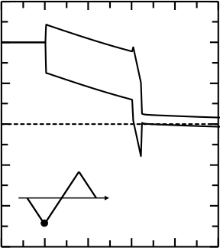

THE SI:HFO2 FEFET: FROM TCAD MODEL TO INTEGRATED 28 NM DEVICE

|  |  |  |  |  |  |  |  |  |  |  |  |
| --- | --- | --- | --- | --- | --- | --- | --- | --- | --- | --- | --- |
|  | 15 | G | HfO2 | Si |  | 6 | 15  -10  -15 -5  0  10  5 |  |  | 4 |  |
| 10 | | 4 | 2 |
| *E*/*q* [V] | 5  0 -5 | 2 | 0 |
| SiON | | 0 | -2 |
| -2 | -4 |
| -10 | | Cutline [a.u.] | | -4 | -6 |
| -15 | | -6 | -8 |
| Cutline [a.u.] | Cutline [a.u.] |
| Cutline [a.u.] |

Fig. 3-7: FeFET band diagram during erase, program and retention periods. The cutline position through the gate stack is illustrated in Fig. 3-2 (c). (a) Erase at -10 V gate bias. (b) Retention at 0 V gate bias after erase. Arrows indicate the polarization direction inside the HfO2. The grey arrow represents the fraction of depolarized P. HfO2 and SiON band bending is inverted due to the depolarization field Edep. (c) Program at 10 V gate bias. (d) Similar to (c), after program, depolarization takes place and HfO2 and SiON band bending is again inverted. For all graphs, a snap-shot of the corresponding quiescent point on the triangular gate voltage signal is given as inset.

The additional information that is provided by the band diagram is represented by the visualized non-zero surface potential at zero gate voltage (Fig. 3-7 (b) and (d)). Therefore, the accumulation / strong inversion state after erase / program can be observed by means of the Fermi level position. Moreover, the inverse band bending of HfO2 and SiON / Si bulk again visualizes the depolarization field at zero gate bias.

3.2.4Optimization of HfO2-based Ferroelectric Field Effect Transistors

In the last two subsections, it was shown that for 10 nm Si:HfO2 layers, which were parameterized according to experimental findings, certain phenomena were discovered that are detrimental to memory operation. For the given device geometry, implant conditions and interfacial layer properties, depolarization to  4.4 C/cm2 was observed even for fully saturated memory operation. Moreover, for a FeFET, the rather high spontaneous polarization value of 9.5 C/cm2 led to the retarded onset of MW saturation and also to severe interfacial field stress.

In order to reduce the observed detrimental effects, one approach is to tailor the Si:HfO2 ferroelectric properties such that the spontaneous polarization is reduced. This had already been observed for thicker Si:HfO2 films [218], in particular for the 30 nm Si:HfO2 layers presented in section 2.4. The difference as compared to 10 nm films was explained in terms of an earlier onset of crystallization due to the increased film thickness. In turn, it was indicated that the ferroelectric phase fraction for 30 nm films will be lower and hence, the spontaneous polarization was reduced. Moreover, almost no polarization relaxation was observed. Therefore, modeling the PS and Pr value with 2.005 C/cm2 and 2 C/cm2 led to a good agreement of experiments and simulation [120]. Moreover, for 30 nm films both the coercive field as well as the dielectric constant were reduced to 0.9 MV/cm and 25 respectively. By increasing the HfO2 thickness in the TCAD model and utilization of the mentioned material parameters, the voltage sequence shown in Fig. 3-4 (a) was again simulated for the modified FeFET. The changed material parameters together with the increased film thickness led to a significantly improved behavior of the FeFET device (Fig. 3-8).

47

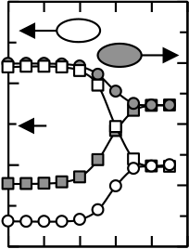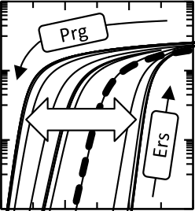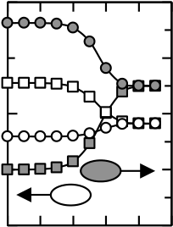

THE SI:HFO2 FEFET: FROM TCAD MODEL TO INTEGRATED 28 NM DEVICE

|  |  |  |  |  |  |  |  |  |  |  |  |  |  |  |  |  |  |  |  |  |  |  |
| --- | --- | --- | --- | --- | --- | --- | --- | --- | --- | --- | --- | --- | --- | --- | --- | --- | --- | --- | --- | --- | --- | --- |
|  | | | | | | |  | 4 | *VT* [V] | | | | 4 | | *VT* [V] | |  |  | | --- | --- | |  |  | | *P* at *VG*=0V [µC/cm2] | 4 | *P* at *VG*=0V [µC/cm2] | *P* at *VG*=0V [µC/cm2] |
| 10-3 | | | | | | |
| 10-5  *ID* [A]   10-7 | | | **MW** | | | | *P* [µC/cm2] | 2 | *VT* [V] | 2 0 | 2 |
| 0 | *VT,Std* | 0 |
| -2 | -2 |
| 10-9 | | | | | | |
| -2 | |
| -4 | -4 |
| -2 | | | 0 | | 2 | 4 |  | 4 | -10 -5 | 0 | 5 | 10 |  | | Sweep Range [V] | | | 4 | *EIF,0* [MV/cm] | *P* at *VG*=0V [µC/cm2] |
| *VG* [V] | | | | | | | *VG* [V] | | | |
| *VT* [V] | | *P* at *VG*=0V [µC/cm2] |
|  | | | | | | |
| *VT* [V] | | | |
| *EFE* [MV/cm] | 4 |  | | | | | 1 | |
| *EIF* [**10** MV/cm] |
| *EFE,0* [MV/cm] | 0 |
| 2 | 2 | 2 |
| 0 | 0 | 0 |
| -2 | -2 | -2 |
| -4 | -4 | -1 | | Sweep Range [V] | | | -4 |
| -10 -5 | 0 | 5 | 10 |
| -10 -5 | | | | 0 | 5 | 10 |
| *VG* [V] | | | | | | | *VG* [V] | | | |

Fig. 3-8: Quasistationary simulation results for a FeFET device with 30 nm Si:HfO2. (a) An increased memory window can be extracted from the drain current versus gate voltage characteristics. (b) MFIS polarization hysteresis without kinks resembling MFM characteristics. (c) Programmed and erased threshold voltages and ferroelectric polarizations at zero gate bias. (d) The electric field across the ferroelectric EFE is similar to the one occurring in non-ferroelectric transistors (dashed line). (e) The interfacial field stress EIF remains below 20 MV/cm within the whole sweep range of the gate voltage. (f) Ferroelectric depolarization fields and electric field stress in the interface layer at zero gate bias.

An obvious drawback of a 30 nm Si:HfO2 film is that the voltage required to reach the coercive field scales linearly with the film thickness. However, this only holds for basic voltage divider considerations and does not account for the contribution of P to the electric displacement field. This is the reason why in Fig. 3-8 (a)-(c) memory window as well as polarization saturation already occur at 6 V, that is, at much lower fields than for the FeFET with 10 nm Si:HfO2. This results from the lower spontaneous polarization, the lower dielectric permittivity as well as from the higher Pr/PS ratio of the 30 nm ferroelectric. Accordingly, the electric fields across ferroelectric and interface layer are almost identical to the ones occurring for a non-ferroelectric FET (Fig. 3-8 (d) and (e)). Hence, better reliability of the interface layer as well as better retention due to reduced Edep (see also Fig. 3-8 (f)) can be anticipated for FeFETs utilizing tailored Si:HfO2 films. Anyhow, from an application perspective, a deeper understanding of the altered ferroelectric properties with increasing film thickness is required. The mentioned reduction of the ferroelectric phase fraction, which potentially causes the lower PS, might be detrimental with respect to statistical effects.

In order to create a more general understanding on how to optimize FeFETs, an illustrative approach based on Maxwell's first equation can be utilized [199]. That is, the continuity of the electric displacement field can be expressed in terms of operating points on the charge versus gate voltage (Q-VG) characteristics for ferroelectric and semiconductor insulator region. Therefore, the operating points are defined as the intersection of the ferroelectric hysteresis and the section-wise defined insulator-semiconductor load line (Fig. 3-9).

48

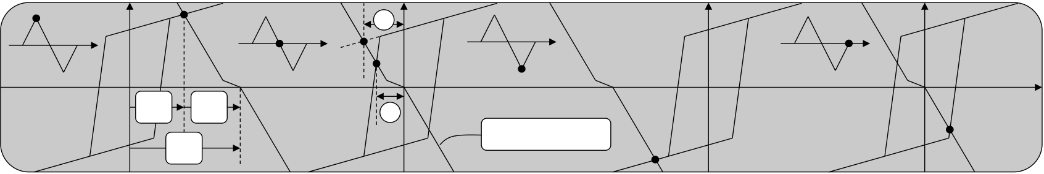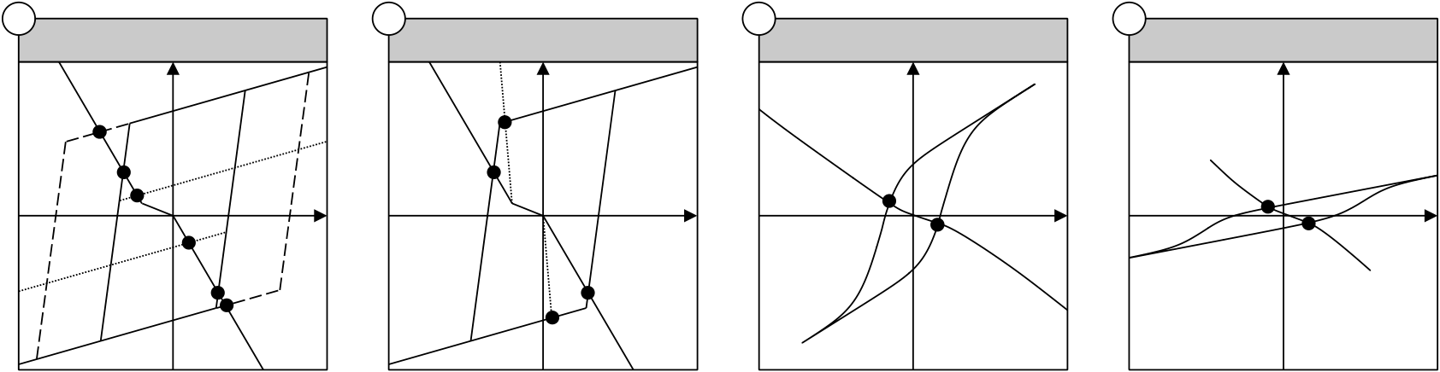

THE SI:HFO2 FEFET: FROM TCAD MODEL TO INTEGRATED 28 NM DEVICE

|  |  |  |  |  |  |
| --- | --- | --- | --- | --- | --- |
| *Q* | *VFE* | *VIS* | 1 | IS load line | *VG* |
| 2 |
| *VG* |

Fig. 3-9: Graphical derivation of the FeFET operating points. The corresponding triangular gate voltage signal is given as inset. Operating points are defined by the intersection of ferroelectric Q-VFE hysteresis and insulator-semiconductor (IS) load line (kinked line). The depolarization is visualized at zero gate bias by the position of the operating point on the high capacitance slope of the ferroelectric. (1) and (2) illustrate the difference between analytically derived and actually remaining depolarization field Edep when depolarization has already occurred.

By utilizing both the ferroelectric Q-V hysteresis and the insulator-semiconductor load line, several phenomena occurring in FeFET devices can be understood in an illustrative manner. For example, the occurrence of the depolarization field is visualized by the non-zero ferroelectric and insulator-semiconductor voltage for operating points at zero gate bias. Moreover, the difference between the analytically derived depolarization field (see equation (3-10)) and Edep at zero gate bias (e.g. Fig. 3-6) is highlighted by numerals (1) and (2) in Fig. 3-9. Furthermore, the loadline in inversion and accumulation solely reflects the interfacial capacitance which is common to all MOSFETs. Hence, just from a geometric point of view it can be concluded that a larger slope, i.e. a higher IF, can reduce Edep.

Consequently, the graphical representation of the charge neutrality in the gate stack represents a feasible approach to create an understanding of the optimization potential for FeFETs. This is now exemplified in terms of changing the ferroelectric material parameters and a comparison is drawn with respect to the results obtained for the 10 nm and 30 nm Si:HfO2 films.

|  |  |  |  |  |  |  |  |  |  |  |  |
| --- | --- | --- | --- | --- | --- | --- | --- | --- | --- | --- | --- |
| a | *Ec* and *Ps* Variation | *VG* | b | *IF* and *dIF* Variation | *VG* | c | 10 nm Si:HfO2 | *VG* | d | 30 nm Si:HfO2 | *VG* |
| *Q* | *Q* | *Q* | *Q* |

Fig. 3-10: FeFET optimization by graphical illustration approach. (a) A stable ferroelectric state can be induced by reduction of the spontaneous polarization (dotted line) or by an increased coercive field (dashed line). (b) Increasing the dielectric constant or decreasing the film thickness of the interface layer also stabilizes the ferroelectric state. (c) Charge-voltage characteristics for a FeFET with 10 nm Si:HfO2 extracted from TCAD simulation. (d) Increasing the high-k thickness leads to an artificial widening of the ferroelectric hysteresis.

As indicated at the beginning of this subsection, by reduction of the spontaneous polarization it is possible to induce a stable ferroelectric state in the MFIS. That is, depolarization can be avoided since the load line then intersects with the dielectric region of the ferroelectric (Fig. 3-10 (a), upper respectively lower branch of the hysteresis). In addition, the depolarization field itself is decreased due to the fact that the amount of required screening charges is reduced.

If the spontaneous polarization is kept constant, another approach to stabilize the polarization is by an increased coercive field (Fig. 3-10 (b)). However, the depolarization

49

THE SI:HFO2 FEFET: FROM TCAD MODEL TO INTEGRATED 28 NM DEVICE

field increases due to the fact that a larger amount of screening charges is required. Moreover, operational voltages and interfacial as well as ferroelectric field stress will increase which is not desirable for memory operation. Due to the ability to tailor the ferroelectric properties of HfO2 (see section 2.4), both changing PS and Ec resemble important possibilities to improve the HfO2-based FeFET.

Besides changing the ferroelectric material parameters, a reasonable approach is to tailor the interfacial layer properties. The aim is to increase the interfacial layer capacitance to higher values such that the ability to screen the ferroelectric polarization is improved. Moreover, this also changes the dielectric voltage divider in favor of the ferroelectric thereby decreasing the required operational voltages. For HKMG transistors, this is mainly achieved by nitridation of the interfacial SiO2 layer which effectively increases the dielectric constant. Moreover, an epitactic growth of HfO2 on silicon would represent the transition from MFIS- to MFS-type FeFETs which would effectively increase the interfacial layer capacitance to infinity. Significant advances have been made with respect to epitactic growth of HfO2 by ALD [101, 185] and might represent an interesting path towards optimizing FeFET properties in the future.

With respect to the FeFET simulations performed for 10 nm and 30 nm Si:HfO2 films, Fig. 3-10 (c) and (d) again illustrate the severe difference between the two types of FeFET devices. For the 10 nm case and similar to Fig. 3-4 (c), a significant portion of PS is depolarized mainly due to the low dielectric constant of the interface layer (SiO2 = 4) and also due to the large absolute value of PS. The FeFET with the 30 nm HfO2 film increases the coercive voltage due to the different voltage divider of the gate stack. This leads to a much more stable polarization while still maintaining low voltage operating conditions due to i.a. the decreased spontaneous polarization.

In order to finalize the considerations regarding an optimized FeFET design, an individual variation of material parameters for a 10 nm FeFET was carried out. Four different figures of performance (FOP) were chosen to judge the device performance of the FeFET as a function of the material parameters: The ratio Pmax/PS, i.e. the maximum polarization that is achieved by a given VG sweep divided by the spontaneous polarization, expresses how good the FeFET can be brought into saturated operation. Therefore, the ratio indirectly gives a measure of the potential retention characteristics: As shown in subsection 2.3.2, non-saturated polarization states are prone to early retention loss. Moreover, the ratio P0/Pmax (P0 represents the polarization at zero gate bias) reflects the degree of depolarization that takes place when the gate voltage returns to zero. Accordingly P0/Pmax implies the ratio of depolarization to coercive field and the effect of polarization relaxation due to a Pr/PS ratio of less than one. The memory window MW represents another FOP which serves as a figure to judge the general memory characteristics of the device, that is, MW should always be as large as possible. The last figure of performance is given by maximum electrical field in the interface layer EIF,max which can serve as a measure for the potential reliability of the device.

50

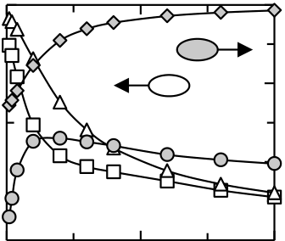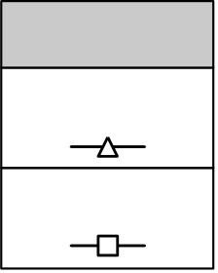

THE SI:HFO2 FEFET: FROM TCAD MODEL TO INTEGRATED 28 NM DEVICE

Default parameters:

|  |  |  |  |  |  |  |  |  |  |  |  |  |  |
| --- | --- | --- | --- | --- | --- | --- | --- | --- | --- | --- | --- | --- | --- |
| *tFE* = 10 nm | | *VG* = 5 V | | *Pr* = 9 µC/cm2 | | | *Ps* = 10 µC/cm2 | | | | | 50  50 | 3 3 |
| *EC* = 1 MV/cm | | *FE* = 30 | | *IF* = 4 1  1 | | | *Pr* / *Ps* = 0.9 | | | 3 | P0/Pmax   |  | | --- | | FOP | | MW [V]   |  |  | | --- | --- | |  | MW | | | *EIF,max* [10MV/cm] MW |   Pmax/Ps  Eox,max*0.1  Eox,max*0.1  P0/Pmax  Pmax/Ps |
| 1 | 3 |
|  | | | | |  | | | 2 2 |
| FOP | |
| 2 |
| P0/Pmax  *Pmax* / *PS* [1] | |
| Pmax/Ps  *P0* / *Pmax* [1] MW  P0/Pmax  Eox,max*0.1 Pmax/Ps 0  MW | 3 2  *Ps* [µC/cm2] 25 2 1 |
| 1 | 1 1 |
| 0 |
| 50 | 0.0 | | 1.5 | 3.0 | 0 | 10 | 20 |
| *Ec* [MV/cm] | | | | | *IF* [1] | | | 0 0 |
| Fig. 3-11: Important device parameters affecting FeFET operation. Only individual simulation parameters Eox,max*0.1 0  25 were varied (x-axis) and the effect of each parameter variation was judged with respect to four figures of performance (FOP). The default simulation parameters that were left unchanged are given on top. Primary and secondary y-axes are identical for all graphs. 50 1 0 0 0 0 *Ps* [µC/cm2] 25 25  *Ps* [µC/cm2] In a first run, the spontaneous polarization was varied from some C/cm2, up to the 0 *Ps* [µC/cm2] | | | | | | | | | | | |
| 25 theoretically predicted values of  50 C/cm2 [27] while keeping almost all other parameters 50 | | | | | | | | | | | |
| *Ps* [µC/cm2] at their default values. Only the remanent polarization was adjusted to follow PS in order  to maintain a constant Pr/PS ratio of 0.9. Up to a spontaneous polarization of 5 C/cm2, | | | | | | | | | | | |

the memory window grows to 1.3 V. At very low PS values, the P-V hysteresis is very flat and together with non-ideal hysteresis shape (Pr/PS ratio of 0.9) leads to a smaller voltage separation of the operating points, i.e. to a reduced MW. Above 5 C/cm2, depolarization sets in and is reflected in a reduction of the FOP parameters Pmax/PS and P0/Pmax. For higher PS values, less voltage drops across the ferroelectric due to the continuity of the electric displacement field. Hence, the FeFET is then operated in a subloop state which in turn reduces the memory window. Moreover, due to the increased spontaneous polarization, EIF,max increases up to 30 MV/cm. Concluding it can be stated that increasing the spontaneous polarization by e.g. inducing a higher ferroelectric phase fraction or growing a textured film is only useful to a certain degree. On the one hand, it cannot be utilized for the given parameter set and, on the other hand, a higher spontaneous polarization is likely to cause device degradation and retention issues.

According to experiments, the coercive field can also be varied in a relatively wide range mainly depending on the type of dopant that is used [114]. This justifies the analysis of Ec as an additional material parameter. Simulations show that the largest memory window for the given parameter set is achieved by coercive fields in the range of 1.2 - 1.5 MV/cm. However, also polarization saturation monotonically decreases, that is, for higher coercive fields, the 5 V sweep range is not sufficient. Due to the reduced Pmax and subloop operation, the interfacial field stress is of course reduced but potentially at the cost of retention loss.

In a last step, the dielectric constant of the interface layer and its effect on the FOPs was analyzed. In general, by increasing the dielectric constant of the interface layer, the voltage divider of the stack changes in favor of the ferroelectric which effectively reduces the required operational voltages. This is also reflected in the growth of MW in Fig. 3-11 which saturates around 1.7 V and is limited by the width of the ferroelectric hysteresis. Furthermore, the polarization saturates at PS and the interfacial field stress is continuously reduced. More interestingly, the ratio of P0 to Pmax first decreases due to the increase in Pmax but then stays constant independent of the dielectric constant of the interface layer. Hence, the main driving force for depolarization is not the interface layer but rather the low

51

THE SI:HFO2 FEFET: FROM TCAD MODEL TO INTEGRATED 28 NM DEVICE

capacitance of the depletion region in the bulk. Accordingly, by increasing the bulk doping level it is possible to reduce the depolarization and therefore improve retention [41]. This has to be considered as a viable approach for FeFET optimization if additional lithography masks can be used for a dedicated FeFET well implant (see also section 3.3 for additional integration related topics).

Up to this point, results from experiments and single parameter variations were presented that illustrate how the FeFET can be optimized. It was e.g. found that a smaller spontaneous polarization can be advantageous with respect to Edep / EIF,max and that IF is actually not the quantity that will affect retention the most. However, due to the rather complex non-linear behavior of the ferroelectric, together with a certain amount of FOPs, the actual interrelation between all parameters is non-obvious.

Besides the FOPs, the variation of material parameters, i.e. the input parameters of the simulation, leading to a change in the FOPs also has to be judged with respect to their actual feasibility. As an example, the permittivity of the interface layer might be increased with a higher amount of nitrogen in the layer which however causes a higher density of traps and therefore leads to reliability issues. Accordingly, so called "Figures of Feasibility" (FOF) are introduced in addition which shall account for the real world feasibility of parameter variations. The combination of FOPs and FOFs then gives the figure of merit (FOM), i.e. a realistic measure of the optimization potential of a technology that is characterized by a complex set of variables.

During the course of this study, three FOPs as well as three FOFs were chosen to identify the most appropriate parameter set for an optimized FeFET operation. Therefore, the FOPs and FOFs were weighed first according to the requirement of an NVM application (Tab. 3-1).

Tab. 3-1: Weighing of figures of performance and feasibility.

|  |  |  |  |  |  |  |
| --- | --- | --- | --- | --- | --- | --- |
|  | FOP | | | FOF | | |
| Weight | MW [V] | *E ox,max*[MV/cm] | *P 0/P s* | *P s* [C/cm2] |  *FE* |  *IF* |
| 0 | < 1 | > 20 | < 0.4 | 3 | 15 | 32 |
| 1 | 1  MW  3 | 10  Eox,max 20 | 0.4  P0/Ps 0.7 | 40 | 45 | 8 |
| 2 | > 3 | < 10 | > 0.7 | 15 | 30 | 4 |

For the figures of performance, the memory window, the maximum interfacial field as well as the ratio of polarization at zero gate bias to PS were chosen. These give a measure of the general memory margin and also of potential endurance and retention characteristics of the FeFET respectively. As mentioned before, selected input parameters can be chosen to define the FOFs, in this case, the spontaneous polarization and the dielectric constant of the ferroelectric and the interface layer. As an example, there were three different implementations of the spontaneous polarization which were weighed according to their feasibility: Even though a low PS value of 3 C/cm2 is advantageous with respect to the FOPs (see also previous paragraphs in the subsection), its feasibility is diminished due to the potential impact on device statistics. On the other hand, a very high PS value of 40 is more likely since it is closer to the theoretically predicted spontaneous polarization [27]. However, it is still not as likely as the most commonly observed experimental values of around 15. Accordingly, the three different implementations of PS obtain the weights 0, 1 and 2 respectively. Similar to the weighing of PS, variations in the permittivity of both the ferroelectric and the interfacial layer were classified accordingly.

52

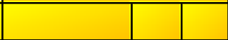

THE SI:HFO2 FEFET: FROM TCAD MODEL TO INTEGRATED 28 NM DEVICE

Besides these three input parameters that served as FOFs, the gate voltage (3 V, 5 V or 7 V), the thickness of the ferroelectric (10 nm, 20 nm or 30 nm) as well as the coercive field (0.5 MV/cm, 1 MV/cm or 2 MV/cm) were chosen as additional variable simulation parameters. Due to the fact that the variation of these input parameters was not considered critical, they were excluded from the FOFs.

Based on the given parameter set and the defined weights of the FOPs and FOFs, a design of simulations was set up and carried out in order to derive an understanding on the optimization potential of the FeFET. The parameter combinations resulting in the highest FOM value are summarized in Tab. 3-2.

Tab. 3-2: Results from FeFET design of simulations. The variable input parameters are highlighted in yellow. FOFs and FOPs are color coded in orange whereas the sum of weights together with the final FOM is shown in red. Grey scale for FOFs and FOPs indicates the weight (dark grey = 0; grey = 1; white = 2).

|  |  |  |  |  |  |  |  |  |  |  |  |  |  |
| --- | --- | --- | --- | --- | --- | --- | --- | --- | --- | --- | --- | --- | --- |
|  |  |  |  |  | FOF | | | FOP | | |  |  |  |
|  | *V G* [V] | *t FE* [nm] | *P r* [C/cm2] | *E C* [MV/cm] | *P s* [C/cm2] |  *FE* |  *IF* | MW [V] | *E ox,max*[MV/cm] | *P 0/P s* | S**FOP** | S **FOF** | **FOM** |
| a | 3 | 30 | 13.5 | 1 | 15 | 30 | 4 | 1.12 | 5.74 | 0.11 | 3 | 6 | 9 |
| b | 3 | 30 | 13.5 | 0.5 | 15 | 30 | 4 | 1.33 | 8.60 | 0.11 | 3 | 6 | 9 |
| c | 5 | 30 | 13.5 | 2 | 15 | 30 | 4 | 1.60 | 9.16 | 0.12 | 3 | 6 | 9 |
| d | 5 | 30 | 13.5 | 1 | 15 | 30 | 8 | 3.10 | 8.97 | 0.21 | 4 | 5 | 9 |
| e | 7 | 30 | 13.5 | 1 | 15 | 30 | 32 | 5.00 | 6.13 | 0.54 | 5 | 4 | 9 |
| f | 7 | 20 | 13.5 | 1 | 15 | 30 | 32 | 3.53 | 7.89 | 0.50 | 5 | 4 | 9 |

Out of the 729 simulations that were performed (six input parameters with three different values each), six simulations resulted in a maximum FOM of nine. Hence, it is revealed that for the given weighing of the FOPs and FOFs no input parameter permutation could achieve the maximum possible FOM of 12. For simulation a) - d), the high FOM can be attributed to a high figure of feasibility since all FOFs are close to the values already observed in experiment. On the other hand, the material parameters known from experiment lead to large depolarization, i.e. a zero weight for the P0 to PS ratio. This can be ascribed to the sub-loop operation for the given parameter set and will most likely result in degraded retention characteristics.

Moreover, the parameter sets e) and f) are able to improve the sum of FOPs, however at the price of reduced feasibility. That is, the main parameter responsible for the improvement, i.e. the high IF of 32, does not seem viable from a real world perspective. Furthermore, from an NVM viewpoint, all six simulations are not able to lift the P0 to PS ratio significantly above 0.5. Hence, the classical retention problem should remain also for HfO2-based FeFET devices. The only way to increase P0 / PS (under the assumption that the substrate doping is fixed) is given by a lower PS value. However, this might have detrimental effects from a statistical viewpoint which is why the weight for PS = 3 was chosen as 0 (see Tab. 3-1).

Concluding it shall be stated that for a different target application, like e.g. a volatile memory application, the weights of the FOPs and FOFs has to be changed. If the FeFET should for example be used as a DRAM replacement [50], a P0 to PS ratio of close to one is only of secondary importance. On the other hand, the Eox,max FOP will gain in importance due to the requirement that the FeFET has to endure an infinite amount of write cycles.

In summary, there is always a trade-off between device performance and technical feasibility to consider. Judging FeFET simulations in terms of weighted FOPs and FOFs represents a practical approach to derive the application specific material and device design requirements.

53

THE SI:HFO2 FEFET: FROM TCAD MODEL TO INTEGRATED 28 NM DEVICE

3.3FeFET Integration into a 28 nm Technology Node

During the course of this thesis it was possible to demonstrate for the first time that, by use of ferroelectric Si:HfO2, FeFET devices can be scaled down to a 28 nm technology node (see chapter 4). This achievement was made possible by the proven CMOS compatibility of HfO2 as a gate dielectric. Other FeFET approaches that are based on classical ferroelectrics like SBT or PZT are either not integratable as dense arrays [70] or show device sizes in the m-range [221]. 28 nm Si:HfO2 ferroelectric field effect transistors on the other hand offer integration densities that might finally enable a competitive FeFET NVM solution in the future.

Moreover, besides the CMOS compatibility of HfO2, the fact that the changes to a standard CMOS process flow are kept at a minimum further improves the viability of the HfO2 FeFET. In order to illustrate the ease of integration for the underlying FeFET concept, this section will first briefly summarize the process flow for a 28 nm HKMG technology. Afterwards, the adjustments to the flow in order to create ferroelectric field effect transistors are discussed. These considerations will lead to the discussion of the embedded memory capability of HfO2-based FeFET devices.

3.3.1Simplified FEOL Flow of a 28 nm CMOS Technology

The introduction of the HKMG technology was probably one of the most radical technological changes experienced by the semiconductor industry during the last years. The introduction was mainly necessitated by the exponential increase of the gate leakage current with scaling. That is, by shrinking the transistor geometries when transitioning from one node to the other, also the thickness of the gate dielectric had continuously been scaled. Consequently, as the gate oxide thickness approached the tunnelling regime, the power consumption due to the gate leakage current would have been unacceptable for future technology nodes. Therefore, Intel pioneered the introduction of HKMG at the 45 nm node [103] and was thereby able to solve some of the most important scaling issues at that time: By replacing SiO2 as the gate dielectric with HfO2 it was possible to maintain or even increase the gate control while reducing the gate leakage current due to the thicker dielectric. This was enabled by the higher dielectric constant of HfO2 (r 20) as compared to SiO2 which suffers from an r of only 3.9. Moreover, the traditional gate electrode was supplemented by a TiN metal that solved i.a. the issue of poly depletion. Accordingly, the HKMG technology has become the de facto standard especially for cutting edge low-power and high performance applications.

In order to understand one of the most important advantages of the HfO2-FeFET concept, i.e. its ease of integration, a basic knowledge of a standard HKMG process flow is required. Fig. 3-12 illustrates in a very simplified manner the most important steps in the front end of line (FEOL) of a HKMG flow (for simplicity reasons, the considerations are limited to NMOS devices). Based on a rough understanding thereof, the process changes that are required for FeFET design are highlighted afterwards.

54

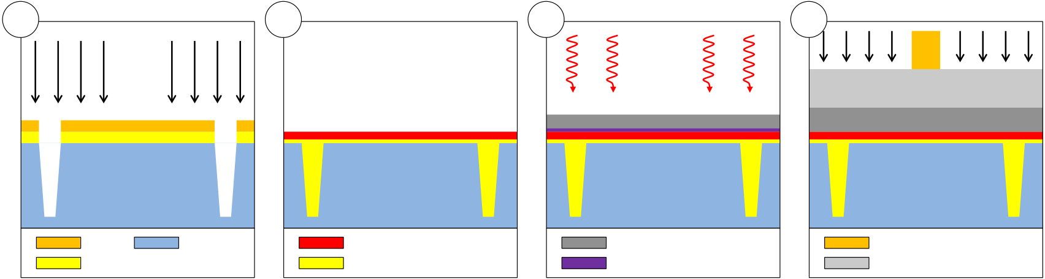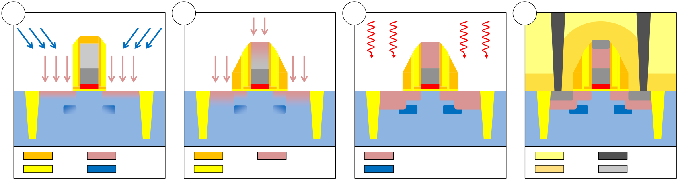

THE SI:HFO2 FEFET: FROM TCAD MODEL TO INTEGRATED 28 NM DEVICE

|  |  |  |  |
| --- | --- | --- | --- |
| a | b | c | d |

MG RIE Anneal

TiN

|  |  |  |  |  |  |  |  |  |  |  |  |  |  |
| --- | --- | --- | --- | --- | --- | --- | --- | --- | --- | --- | --- | --- | --- |
| e | STI | SiN | p-bulk | f | STI | HfO2 | P-S/D | g | TiN | | h | SiN | W |
| SiO2 | P-ext | SiON / SiO2 | La | | Poly-Si |
| Activation | W |
| SiN | SiN | ILD |
| Active Phosphorous | |
| SiO2 | B-halo | SiO2 | Active Boron | | SiN | NiSi |

Fig. 3-12: Simplified 28nm NMOS HKMG FEOL process flow. (a) Trench etch by RIE for active area isolation. (b) SiON interface layer growth followed by HfO2 deposition. (c) Work function metal and dummy metal gate deposition followed by metal gate anneal. (d) Metal gate, poly-Si and SiN hard mask deposition and structuring. (e) Extension and halo implantation after SiN liner and SiO2 spacer deposition. (f) Source / drain implantation after another spacer deposition. (g) Dopant activation anneal. (h) Silicide formation, SiN stress liner deposition, ILD isolation and W contact formation.

In order to manufacture any type of MOSFET in general, the individual active areas have to be isolated from each other first. Therefore a pad oxide is grown onto which a SiN hard mask is deposited. After structuring of the hard mask, trenches are created by reactive ion etching (RIE) (Fig. 3-12 (a)). The trenches are then filled with SiO2 and successively planarized via chemical mechanical polishing (CMP). On the flat surface, a defined interfacial oxide is then grown which is in general a nitrided SiO2 film. In a next step, the high-k dielectric (HfO2) is deposited by ALD (Fig. 3-12 (b)). Afterwards, the work function metal (lanthanum for n-channel FETs) is deposited and covered by a TiN dummy metal. The stack is then annealed in order to diffuse the work function metal into the high-k film (Fig. 3-12 (c)) [210]. Subsequently, the dummy metal is removed and another TiN stack is deposited by physical vapor deposition (PVD). On top of the gate stack, a SiN hard mask is deposited and then structured in a two-step lithographic process which defines the final dimensions (Lg x W) of the transistor (Fig. 3-12 (d)). After the gate stack etch, a SiN liner and a first SiO2 spacer are deposited for encapsulation of the stack. In the following, n+ source and drain extension regions are formed by phosphorous implantation. Moreover, an additional boron halo implantation is used to avoid punch-through of the transistor (Fig. 3-12 (e)). Subsequently, another spacer is deposited that defines the self-aligned source and drain regions (Fig. 3-12 (f)). In the following step, the implant regions are activated by a rapid thermal annealing (RTA) step that is carried out at around 1000 ºC (Fig. 3-12 (g)). Consecutively, NiSi regions are formed in the source / drain as well as on top of the poly-silicon gate region in order to reduce the respective contact resistances. For improvement of electron mobility, a tensile stress liner is deposited thereafter. The tensile stress causes a slight change in spacing between the individual silicon atoms. The slight change in atomic spacing causes the E-k (whereas E is the energy and k the wave vector) band diagram to change especially with respect to its first derivative. This directly affects the so called effective mass of the electrons which, besides other factors, influences the mobility of the

55

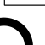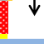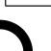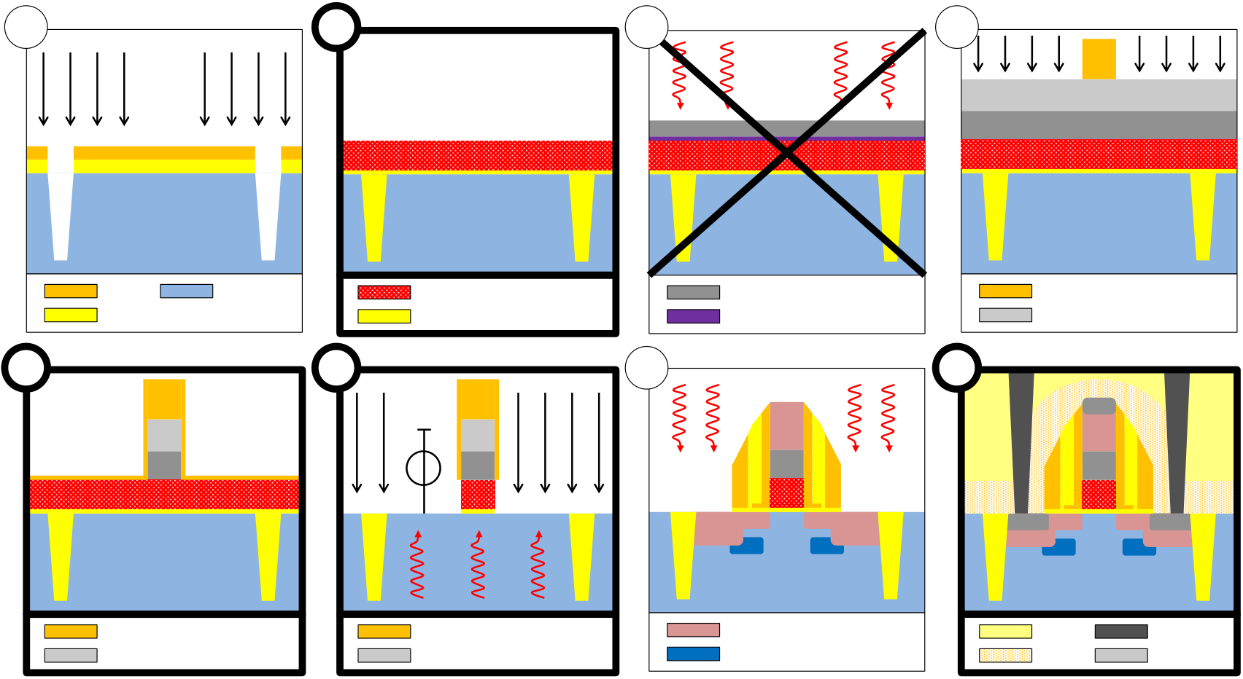

THE SI:HFO2 FEFET: FROM TCAD MODEL TO INTEGRATED 28 NM DEVICE

charge carriers. In the final step of the FEOL process flow, an SiO2 inter-layer-dielectric (ILD) is deposited, structured and then filled with W plugs which provide electrical connection to the active area (Fig. 3-12 (h)).

3.3.2Process Changes Required for Manufacturing of HfO2-based FeFETs

In order to derive ferroelectric field effect transistors from a standard HKMG logic device flow, certain processes were adjusted or added respectively. The changes that were made aimed at transferring the observed ferroelectric properties of the simple MFM stack as good as possible to the integrated flow.

|  |  |  |  |
| --- | --- | --- | --- |
| a | b | c | d1 |

MG   
Anneal

|  |  |  |
| --- | --- | --- |
| Si:HfO2 | TiN | SiN |
| SiON / SiO2 | La | Poly-Si |

|  |  |  |  |  |  |  |  |  |  |
| --- | --- | --- | --- | --- | --- | --- | --- | --- | --- |
| d2 | SiN | d3 | Bias | g | Activation | W | h | ILD | W |
| SiN | Active Phosphorous | |

|  |  |  |  |  |
| --- | --- | --- | --- | --- |
| Poly-Si | Poly-Si | Active Boron | SiN | NiSi |

Fig. 3-13: Process flow for 28 nm HKMG ferroelectric field effect transistors. Changed / new steps with respect to the standard flow are highlighted with thick solid frames. In (b) a 10 nm Si:HfO2 film is deposited. Step (c) is skipped and (d) is split into three sub-steps. (d1), (d2) The metal gate etch is adjusted to stop on the Si:HfO2 film and a SiN liner is deposited for encapsulation. (d3) After liner opening, a hot chuck RIE with DC bias is performed to etch the partially crystalline HfO2. Steps (e)-(g) are identical to the standard flow. (h) Instead of a tensile stress liner, a neutral liner is used.

The first adjustment was made after interfacial layer formation. The lot was transferred to an external partner institute where the 10 nm Si:HfO2 film was ALD processed (Fig. 3-13 (b)). It has to be mentioned that due to the transfer, the actual queue time requirements between SiON formation and HfO2 deposition could not be maintained. Hence, the quality of the HfO2 / SiON interface layer was not according to the standard manufacturing specifications, i.e. not according to the so-called process of record (POR).

After the deposition of the ferroelectric film, the dummy metal gate deposition including the work function metal deposition as well as the subsequent annealing step was skipped (Fig. 3-13 (c)). This was done due to several reasons: First of all, the lanthanum diffusion into the HfO2 was expected to change the process window for achieving ferroelectric properties in the film. In order to maintain the ALD pulse ratios obtained for MFM capacitors, no further additives were therefore allowed to diffuse into the high-k. Moreover, the metal gate anneal inducing the work function metal diffusion would have crystallized the HfO2, which is actually essential for the occurrence of ferroelectric properties. However,

56

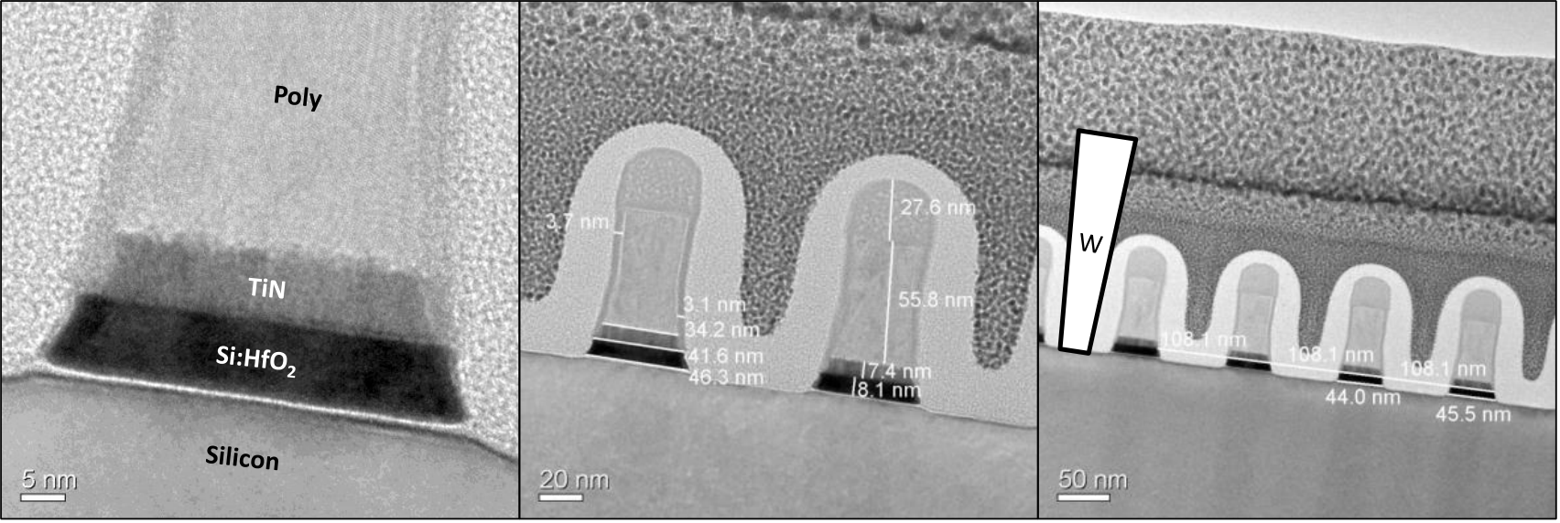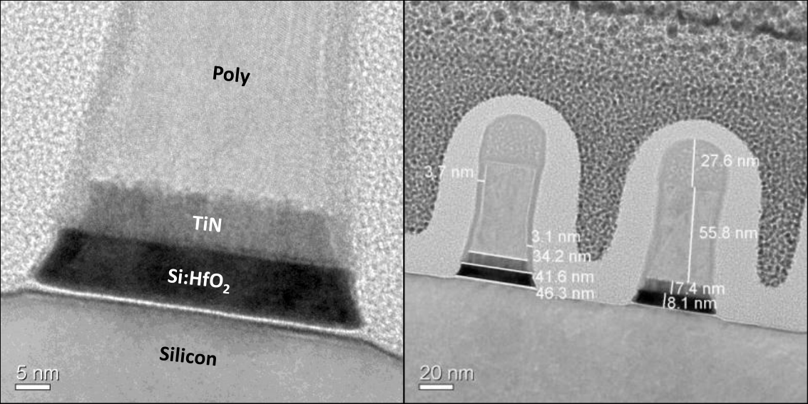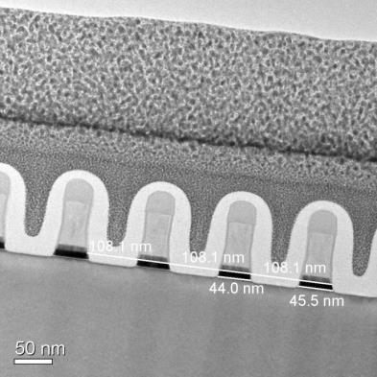

THE SI:HFO2 FEFET: FROM TCAD MODEL TO INTEGRATED 28 NM DEVICE

due to the fact that the dummy TiN is removed afterwards, the ferroelectric properties might have been affected. The importance of a confining top electrode for ferrelectricity in HfO2 and effects of top electrode removal after annealing have e.g. been pointed out in [14, 112]. The standard TiN top electrode formation was therefore carried out right after the Si:HfO2 deposition. The thickness of the TiN electrode was increased to 7 nm in order to maintain comparability to MFM capacitors but was not expected to lead to any significant changes of the ferroelectric properties.

After poly-Si / hard mask deposition and structuring, the gate stack etch needed to be adjusted due to the thicker Si:HfO2. First of all, due to the more than fivefold increase in HfO2 thickness as compared to the POR, the crystallization temperature is significantly reduced. Hence, during poly-Si deposition (above 600 ºC), the Si:HfO2 film will at least partially crystallize (see Fig. 2-4) which in turn complicates the etch as compared to an amorphous film. Furthermore, the RIE of a 10 nm HfO2 film is much more complicated than for standard logic HfO2 thicknesses of  2 nm due to the fact that the etch byproducts have to be removed more efficiently. Accordingly, at the foundry, the final gate stack etch was adjusted to etch only the TiN with a slight undercut, i.e. only with a very small over etch into the HfO2. Then, the SiN liner, which is actually used before the formation of a first spacer, was deposited for stack encapsulation (Fig. 3-13 (d2)). Subsequently, the lot was transferred to the external partner institute for hot-chuck etching of the remaining stack. The SiN liner was first opened and the HfO2 was etched afterwards. Therefore, the RIE was performed at elevated bias and temperature to ensure a steep side wall angle (SWA) of the high-k (Fig. 3-13 (d3)). The quality of the resulting gate stack profiles can be seen in Fig. 3-14.

Fig. 3-14: TEM micrographs of 10 nm Si:HfO2 gate stacks after RIE. The thicker HfO2 leads to footing after the RIE process which increases the physical gate length defined by hafnia to approximately 45 nm (target: 30 nm). The respective gate pitch is 108 nm. A hypothetical placement of a tungsten plug is illustrated on the right hand side.

In Fig. 3-14 it is shown that the footing, which had occurred for 10 nm ferroelectric films after RIE, led to a physical channel length of approximately 45 nm. Furthermore, the poly-to-poly spacing is always reduced by the use of the second SiN liner (4.5 nm in thickness) after the gate stack etch. Since this can cause problems for tungsten contact landing, during final processing of the lot additional pilot wafers were run for advanced process control (APC) targeting at a gate length of 33 nm after SiN hard mask opening.

After the gate stack was fully patterned, the lot was again transferred to the foundry where an additional SiN liner was deposited for a second encapsulation of the stack. The succeeding steps were again identical to the POR flow only with the exception that

57

THE SI:HFO2 FEFET: FROM TCAD MODEL TO INTEGRATED 28 NM DEVICE

extension and halo implants of I/O devices were used for the standard logic devices. Due to the fact that an additional SiN liner was used, the physical gate length was approximately 8 nm longer than for standard logic devices. Hence, the I/O implants, which provide shallower extension regions, ensured a proper electrical connection of the devices.

The last adjustment for deriving FeFETs from the POR flow was made at the point of stress liner deposition. Instead of using tensile and compressive stress liners for NFETs and PFETs, a neutral liner was deposited for all device types (Fig. 3-13 (h)). Again, this was carried out in order to maintain comparability to pure MFM material characteristics observed before: Due to the fact that the ferroelectric phase is highly dependent on mechanical confinement of the film, the tensile or compressive stress liners might in turn also affect the ferroelectric properties. On the other hand, stress liners might represent a viable tool for controlling the ferroelectric properties of HfO2 as well, besides dopant species and thermal treatments.

3.3.3Embedded Memory Capability of FeFET Devices

As outlined in the preceding subsections, deriving Si:HfO2-based ferroelectric field effect transistors from a logic HKMG flow requires only a limited amount of process changes. Accordingly, utilizing the FeFET as a memory transistor besides standard logic transistors, i.e. as an embedded memory device, appears to be coherent. However, the lots that were processed during this thesis were purely of FeFET-type, i.e. no standard logic transistors were processed besides the memory transistors. In order to embed FeFET devices besides logic transistors, in the future, an integration scheme for FeFET besides logic needs to be developed. In this subsection both challenges and the potential of an embedded FeFET memory will be discussed.

The first process change to the standard flow happens when the thick Si:HfO2 layer is deposited. In order to realize also logic transistors that do not possess the thick ferroelectric layer, it was proposed to first deposit the thick Si:HfO2 film and then free the logic area from the ferroelectric [152]. Subsequently, the standard logic high-k would be deposited all over the wafer, also on top of the area containing the ferroelectric film. Even though this might be a viable approach to integrate both memory and logic transistors, a requalification will be required for standard logic devices. Due to the fact that the removal of Si:HfO2 from the logic area is not selective enough with respect to SiON, the quality of the HfO2 to SiON interface will detrimentally be affected. In addition, the non-ferroelectric logic HfO2 acts as a dead layer for the memory cell which might increase the depolarization field and therefore reduce retention.

The next critical step for integrating ferroelectric field effect transistors besides logic devices can be seen in the workfunction adjustment for logic HKMG devices. This had so far always been skipped for FeFET devices since e.g. lanthanum diffusion into the HfO2 will shift or even destroy the process window for achieving ferroelectric properties. Consequently, the additional mask that was introduced for freeing the logic area from the Si:HfO2 might be reused for integration of a separate dummy TiN metal gate without workfunction metal diffusion. Anyhow, the FeFETs are also exposed to the RTA step which is required for diffusion of the workfunction metals into the logic high-k. Accordingly, the thick Si:HfO2 will fully crystallize already during this step. Even though this is not a fundamental problem, there are two effects to consider: First of all, the etching of fully crystallized HfO2, that will take place during gate stack patterning, has a much lower etch rate than for amorphous HfO2. This complicates the etch procedure. More importantly, the removal of the TiN dummy metal gate might affect the ferroelectric properties of the

58

THE SI:HFO2 FEFET: FROM TCAD MODEL TO INTEGRATED 28 NM DEVICE

Si:HfO2 layer which are highly dependent on mechanical encapsulation. Therefore, an integration scheme has to be found which will only free the logic areas from the dummy gate but not the ferroelectric area.

Furthermore, the structuring of the different logic and memory gate stacks was proposed to consist of the standard logic gate stack patterning followed by and FeFET specific RIE while the logic area is protected from this step [152]. This appears to be a viable approach if the dummy TiN gate had also been removed from the ferroelectric area before (thereby potentially affecting the ferroelectric properties). Otherwise, the TiN stacks of logic and memory devices will have a different height and the RIE would have to account for it. Moreover, for the FeFET-only approach, two SiN liners were deposited, one after the adjusted TiN etch and the standard liner to finally encapsulate the stack. This cannot be performed when logic transistors have to be integrated as well. Depositing the SiN liner twice would increase the physical channel length and thereby severely affect the electrical device properties. Consequently, the RIE of the thick Si:HfO2 needs to be adjusted in such a way that no SiN liner is required. Especially with respect to TiN undercut / bleaching, this represents a formidable task [128].

Finally, the stress liner deposition cannot be skipped when integrating both logic devices and ferroelectric field effect transistors. Hence, the previously introduced block mask might be reused to deposit the neutral liner for the memory area whereas logic NFETs and PFETs maintain their standard tensile and compressive stress liners.

Up to this point, one additional block mask is required for integration of the FeFET besides logic devices. This assumes that both positive and negative photo resists can be used and that no FeFET specific implants are envisioned. Moreover, if the write voltages can be reduced to the specifications of I/O devices in a 28 nm process flow ( 3.3 V), no additional high-voltage devices have to be provided. Measures for decreasing the write voltage can either be the reduction of the ferroelectric film thickness or an increase in program / erase times due to the transient characteristics of the ferroelectric (see section 2.2). Both measures however come at the expense of a reduced memory window and write speed respectively.

If the above mentioned integration issues can be solved, HfO2-based ferroelectric field effect transistors hold great promise to be a viable alternative as 28 nm embedded NVM (eNVM). Compared to alternative embedded memory solutions, which are currently manufactured at the 55 nm and developed at the 40 nm node [85], the FeFET approach possesses the significant advantage that it is compatible to a HKMG process flow. Standard Flash-based 1T, 1.5T or 2T approaches will first have to establish integration concepts which can make use of HKMG logic transistors while still utilizing the charge storage based memory cells. Furthermore, for Flash based eNVM approaches, the per bit area consumption relative to the logic area becomes more and more inefficient with ongoing scaling. That is, due to the high voltages that are inherently required for writing charge storage based cells, the peripheral high-voltage transistors cannot be scaled. Hence, for e.g. system on chip (SoC) applications requiring the logic performance of a HKMG technology but only a limited amount of non-volatile memory, the NVM area will capture a large fraction of the chip. In turn, due to its reduced operational voltages, the FeFET technology would provide severe economic benefits for such applications.

59

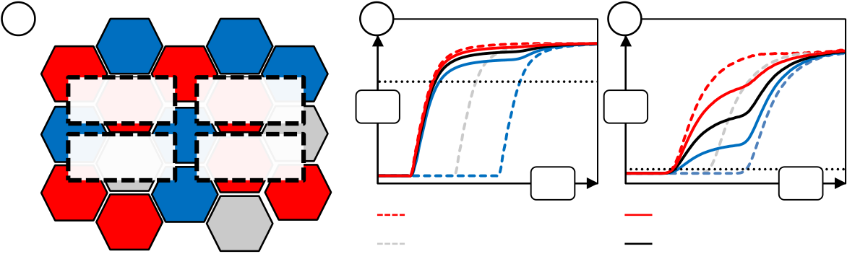

ELECTRICAL CHARACTERISTICS OF SI:HFO2-BASED FEFETS

4Electrical Characteristics of Si:HfO2-Based Ferroelectric Field Effect Transistors

During the course of this thesis, for the first time, ferroelectric field effect transistors based on a 28 nm technology node could be realized according to the integration approach described in the previous chapter. Basic electrical tests were first performed in order to proof proper functionality of the ferroelectric memory. These included i.a. capacitance-voltage (C - V) measurements and drain-current / gate-voltage (Id - Vg) characterization as well as NVM-specific routines such as endurance, retention and retention after cycling measurements. Additional fast transient characteristics of the FeFET cell were determined in order to get a more detailed understanding of trapping effects superimposed on the ferroelectric switching effect. Moreover, based on the results obtained in chapter 2, the FeFET characteristics are correlated to the basic material properties of the Si:HfO2 thin films.

4.1Foreword on Statistical Effects in FeFET Multi-Structures

The majority of the electrical characterization was performed on different n-channel transistors whereas a certain number of transistors were internally connected in parallel. In practice and depending on the device width, this so called multi-structures were composed of 50 - 1300 transistors. Single transistor macros could not be used since they in general possess an ESD (electrostatic discharge) protection diode. This prevents the FeFET from being erased with a negative gate voltage.

This subsection gives credit to statistical effects which have to be taken into consideration when the results presented in the next subsections are analyzed and interpreted. That is, by connecting several transistors in parallel, devices that are performing extraordinarily well can for example dominate the electrical Id-Vg characteristics (Fig. 4-1).

|  |  |  |  |  |  |  |  |  |  |
| --- | --- | --- | --- | --- | --- | --- | --- | --- | --- |
| a | **FE** | **T** | **FE** | **T** | **T** | b | *VG* | c | *VG* |
| **T** | **DUT 1 FE** | **T** | **DUT 3 FE** | **N** | *ID* | *ID* |
| **FE** | **DUT 2 N** | **T** | **DUT 4 FE** | **FE** |
| **FE** | **N** | 100 % FE | 75 % FE / 25 % T |
| 100 % Neutral (N) | 50 % FE / 50 % T |
| 100 % Trapping (T) | 25 % FE / 75 % T |

Fig. 4-1: Statistical effects in FeFET multi-structures. (a) Illustration of the area fraction below each DUT which can be predominantly ferroelectric (FE), neutral (N) or prone to trapping (T). (b) Drain current versus gate voltage characteristic of a theoretical FeFET multi-structure for different degrees of proper functionality (log-scale). Constant current VT criterion is shown as dotted line. (c) Linear plot of the drain current characteristic.

As it was stated in chapter 1, ferroelectric HfO2 is a polycrystalline thin film right at the crystallographic phase boundary between monoclinic and tetragonal / cubic. It was furthermore shown [218] that the films can possess different amounts of orthorhombic phase fraction which is supposed to be responsible for the ferroelectric nature of the material.

60

ELECTRICAL CHARACTERISTICS OF SI:HFO2-BASED FEFETS

Hence, Fig. 4-1 (a) illustrates this fact by four DUTs that are located on an HfO2 film (which is of course structured by an RIE in reality). The film possesses various areas of different crystallographic phase. The effect on an Id-Vg characteristic plotted in log-scale is shown in Fig. 4-1 (b). The characteristics are always sums of 100 DUTs connected in parallel whereas the threshold voltage of each individual device is either shifted by 1V (trapping (T) and ferroelectric (FE) switching respectively) or kept for a neutral (N) device. This corresponds to the expected VT shift occurring for a positive gate pulse, i.e. ferroelectric switching to the low-VT state or parasitic electron trapping from the channel leading to a high-VT state. Since a neutral device is unlikely to exist after a program pulse (large interfacial field stress during programming, see section 3.2.3), special attention is brought to the superposition of various amounts of FE and T transistors. In the logarithmic scale, even for the case that only a minority of transistors (25 %) shows ferroelectric behavior, the Id-Vg characteristic is dominated by these. This is a simple artifact from plotting the sum of Id-Vg characteristics logarithmically which can however cause confusion when e.g. extracting the threshold voltage using a constant current criterion [61]. On a linear scale (Fig. 4-1 (c)) the difference between the different fractions of ferroelectric and trapping effect becomes more evident. There is a clear kink in the characteristic when the devices that are prone to trapping add to the already fully conducting ferroelectric devices. Hence, for a better quantification of statistical effects on multi-structures, different VT criterions like the extrapolated threshold voltage / maximum gm criterion [61] should be used. As an example, for a superposition of ferroelectric and trapping devices there will be multiple local maxima occurring in the gm plot. These can be compared in their magnitudes in order to draw conclusions on the respective device fractions.

For a more qualitative analysis of basic memory characteristics like program / erase endurance and switching kinetics, a simple constant current criterion suffices. In this chapter, many of the device parameters are extracted based on a constant current VT criterion because it resembles the basic device performance. In chapter 6 however, focus will again shift towards statistical effects.

4.2Basic Electrical Characteristics

Standard electrical transistor characterization can be applied to visualize the main memory effects occurring for FeFET devices. The binary state storage essential for realizing a memory device is represented by the flatband voltage shift which in turn shifts the Id-Vg characteristics of the device. This can be analyzed either by capacitance-voltage (C-V) or by drain-current / gate-voltage (Id-Vg) measurements. Similar to PUND measurements for MFM capacitors, the transient characteristics of the program and erase operations leading to the flatband / threshold voltage shift were measured by a program / erase matrix. Memory specific measurements were performed in a similar fashion as it was presented in section 0, only that the state determining parameter is represented by the threshold voltage of the FeFET.

4.2.1Capacitance- and Current-Voltage Characteristics

In order to quantify e.g. the amount of fixed or trapped charges inside gate oxides, capacitance voltage (C-V) measurements are often used to determine the shift in flatband voltage and thereby to calculate the quantity of interest, e.g. the density of trapped charges [153]. For the FeFET, C-V measurements can be used to quantify the flatband voltage shift caused by different polarization states [51].

61

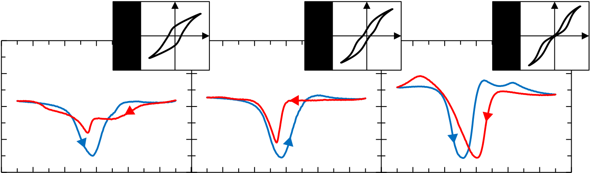

ELECTRICAL CHARACTERISTICS OF SI:HFO2-BASED FEFETS

For C-V characterization, a DC-bias is ramped at the transistor bulk, source and drain terminals (high-side) whereas a small signal AC sine modulation is superimposed on top. The gate is connected to the low-side where AC current flow and again the AC voltage response to the excitation are measured. Hence, the DUT impedance including the capacitance can be calculated [170, 204]. By choosing the sweep range to be wide enough, all areas of transistor operation can be covered (accumulation, depletion and (strong) inversion). Especially for the ferroelectric field effect transistor, a hysteretic sweep throughout all these areas is of particular interest: Under the precondition that the DC-ramp provides sufficient gate bias to switch the polarization, the flatband voltage shift will directly be visualized in the C-V characteristic on the back trace of the measurement.

The measurements were performed on wafers which possessed the three different doping concentrations that were shown for MFM capacitors in section 2.5. Hence, effects from antiferroelectric-like to ferroelectric were expected to occur also for metal-ferroelectric-insulator-semiconductor (MFIS) structures. Strictly speaking, the integrated test structures that were used for C-V characterization were not of the MOS-capacitor type but were transistor structures whereas source-, drain- and bulk regions were connected together. Measurements were carried out on an Agilent B1500A Semiconductor Device Parameter Analyzer equipped with a B1520A Multi Frequency Capacitance Measurement Unit. C-V measurements were carried out using an AC frequency of 100 kHz, a small signal amplitude of 35 mV and a hysteretic sweeping range starting from -5 V up to 5 V in steps of 0.05 V (and back). The DUTs (Lg = W = 2 m; 500 devices in parallel) were chosen large enough such that parasitic overlap capacitances could be neglected.

|  |  |  |  |  |  |  |  |  |  |  |
| --- | --- | --- | --- | --- | --- | --- | --- | --- | --- | --- |
| Capacitance [pF] | 40 | **3.5 mol%** | *P* | *E* | **4.5 mol%** | *P* | *E* | **5.7 mol%** | *P* | *E* |
| 30 |
| 20 |
| 10 |

0

|  |  |  |  |  |  |  |  |  |  |  |  |  |  |  |  |  |  |  |
| --- | --- | --- | --- | --- | --- | --- | --- | --- | --- | --- | --- | --- | --- | --- | --- | --- | --- | --- |
| -6 | -4 | -2 | 0 | 2 | 4 | -6 | -4 | -2 | 0 | 2 | 4 | -6 | -4 | -2 | 0 | 2 | 4 | 6 |
| *VGB* [V] | | *VGB* [V] | | *VGB* [V] | |

Fig. 4-2: C-V characteristics of MFIS capacitors. Three different Si:HfO2 systems (3.5 mol%, 4.5 mol% and 5.7 mol% silicon content) were tested and compared to MFM reference capacitors (corresponding polarization hysteresis are shown as inset). The capacitance versus gate to bulk voltage characteristics were acquired by sweeping VGB from -5 V to 5 V and back to -5 V whereas source, drain and bulk regions were connected together.

First of all, equivalent oxide thicknesses (EOT) were derived from the accumulation capacitance at -5 V. The EOT is calculated by assuming a dielectric constant of 3.9, i.e. the r of SiO2, for the whole gate stack and then calculating the thickness using the measured accumulation capacitance and the known area of the MFIS. Accordingly, the EOT expresses the thickness of an SiO2 film that would lead to the same capacitance as the one measured for the HfO2 / SiON stack.

A clear trend to smaller values was observed for higher silicon doping concentrations: Incorporation of 3.5 mol% of silicon led to an EOT of 3.2 nm, 4.5 mol% to 3 nm and 5.7 mol% to 2.7 nm approximately. Due to the gate stack composition (10 nm Si:HfO2 and 1.2 nm SiON interface layer), the EOT values represent the series connection of the (anti-)

62

ELECTRICAL CHARACTERISTICS OF SI:HFO2-BASED FEFETS

ferroelectric layer and the nitrided SiO2 interface layer. Moreover, inline measurements indicated, that variations of interfacial layer thicknesses did not occur and that the film thickness of the ferroelectric decreased from 10 nm to approximately 9.6 nm for lower silicon content. Even though a reduced thickness would also cause the EOT to decrease, the opposite was calculated from the C-V measurements as stated before. This confirms the observations made for the MFM capacitors, i.e. an increase of the dielectric constant of Si:HfO2 with increasing silicon content.

Moreover, for compositions containing 3.5 mol% and 4.5 mol% silicon, the back sweep from +5 V to -5 V indicates proper ferroelectric operation due to a negative shift of VT. However, with respect to the flatband voltage, i.e. approximately the point at which the saturated accumulation capacitance is again reached, such a shift is not visible anymore. For the 4.5 mol% composition the back-trace of the C-V characteristic almost completely merges with the first trace. Moreover, the 3.5 mol% composition only merges completely at around -3.5 V. Both peculiarities might be correlated to a more or less pronounced ferroelectric relaxation that eliminates the shift in VFB.

Furthermore, for the composition which showed rather pronounced antiferroelectric MFM characteristics (5.7 mol%), the VT of the back-trace is shifted to more positive values. Moreover, the point of deep depletion, i.e. at minimum capacitance, is shifted in the same fashion and its value is approximately identical to the first trace. The uniform positive shift indicates that electron trapping into the HfO2 layer dominates therefore shifting the VT to higher values. The fact that VFB on the back-trace is also almost identical to VFB of the first trace might be attributed to detrapping of electrons in the interval of 0 V to approximately -2 V. In addition, for the 5.7 mol% composition, pronounced capacitance maxima occur both on the first trace in strong inversion and also on the back trace in accumulation. These might stem from the C-V peaks of the antiferroelectric which occur when the gate

voltage is sufficient to overcome VC1/2 (see Fig. 2-1).

Since there were 500 devices connected in parallel for these measurements, statistical effects (see section 4.1) have to be discussed as well. Especially for the 3.5 mol% composition, the back sweep from the positive to the negative side can be thought of as a superposition of devices prone to trapping and devices showing proper ferroelectric switching. Hence, the devices which are prone to trapping would cause the first kink at around 3 V to occur whereas the fraction of devices not prone to trapping would keep the characteristic flat in the interval of [+2 V; 0 V]. This would also explain why the deep depletion capacitance (the minimum in the C-V characteristics) has such a high value on the back trace of the measurement: If there are devices more prone to trapping superimposed, these would already be in accumulation whereas ferroelectric devices are still in depletion. Nevertheless, the lower back-sweep capacitance in the interval of [-2 V; -4 V] cannot reasonably be explained by this approach and intrinsic device phenomena have to be taken into consideration.

Furthermore, hysteretic Id-Vg characteristics of large FeFET devices (Lg = 0.5 m; W = 2 m; 50 devices in parallel) were acquired in order to investigate the transferability from the C-V measurements. The tests were performed on a Keithley 4200-SCS Parameter Analyzer which was equipped with a 4225-PMU Ultra-Fast I-V Module. Best results were obtained using a ramped pulse I-V measurement sequence [223]. The gate terminal of the FeFET multi-structure was pulsed from -5V to 5V (and back) in incremental steps of 50 mV with 200 s pulses (full width at half maximum, FWHM), rise and fall times of 100 s and a delay of 100 s with respect to the drain pulse. The drain terminal was pulsed synchronously at constant 100 mV amplitude.

63

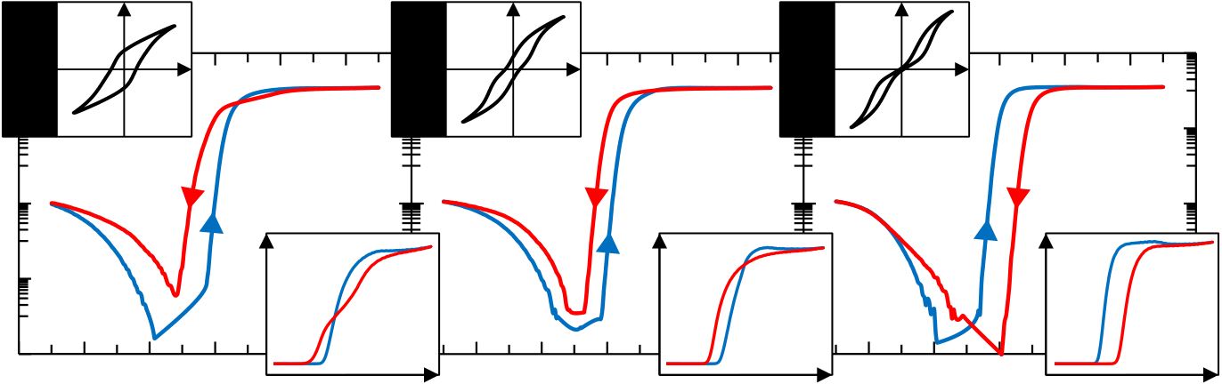

ELECTRICAL CHARACTERISTICS OF SI:HFO2-BASED FEFETS

|  |  |  |  |  |  |  |  |  |  |  |  |  |  |  |  |  |  |  |  |  |  |
| --- | --- | --- | --- | --- | --- | --- | --- | --- | --- | --- | --- | --- | --- | --- | --- | --- | --- | --- | --- | --- | --- |
| Drain Current [A] | 1E-02 | **3.5 mol%** | -4 | *P* | *E* | | *ID* | 4 | **4.5 mol%** | *P* | *E* | | *ID* | 4 | **5.7 mol%** | *P* | *E* | | *ID* | 4 | *VGS* |
| 1E-04 |
| 1E-06 |
| 1E-08 |
| 1E-10 | -6 | -2 | 0 | 2 | *VGS* | -4 | -2 | 0 | 2 | *VGS* | -4 | -2 | 0 | 2 |
| -6 | -6 | 6 |
| *VGS* [V] | | *VGS* [V] | | *VGS* [V] | |

Fig. 4-3: Ramped pulse Id-Vg characteristics for FeFET devices. The Si:HfO2 systems which possessed a remanent polarization already in the MFM structure (3.5 mol% and 4.5 mol%) showed a ferroelectric shift of the threshold voltage (counterclockwise hysteresis). The transistors incorporating the antiferroelectric composition (5.7 mol%) revealed a clockwise hysteresis. Id-Vg characteristics on a linear scale are shown as inset.

Similar to what has been observed for the MFIS C-V characterization, FeFET devices with 3.5 mol% and 4.5 mol% silicon concentration showed a VT shift to smaller values when the gate voltage was swept back from positive to negative voltages (Fig. 4-3 left). As for C-V-characterization, this is a clear indicator for ferroelectric behavior since charge trapping from the channel region would provoke a VT shift into the opposite direction. For the Si:HfO2 systems possessing remanence (3.5 mol% and 4.5 mol%), the inspection of the Id-Vg characteristics on a linear scale reveals a crossing of the backward and forward trace of the sweep. This had been observed in the past [13] and was correlated to trapped charges at the interface from SiON to bulk. Identical to what has been mentioned for C-V characterization, the interfacial field stress is furthermore enhanced with increasing remanent polarization (see subsection 3.2.4). This might be the root cause of the stronger drain current degradation for the 3.5 mol% composition as compared to the 4.5 mol% composition.

By referring back to section 4.1, it is however reasonable to assume that the crossing of the Id-Vg characteristics might also be caused by statistical variation between the DUTs connected in parallel. That is, some of the 50 FeFETs do not properly switch in a ferroelectric manner but are more prone to trapping. The most promising way in order to separate effects from statistical variation and intrinsic device performance is seen in the analysis of single memory cells (see chapter 6).

The Si:HfO2 system with the highest silicon content of 5.7 mol% showed, analogous to the C-V results, pure trapping behaviour. The Id-Vg characteristics were clockwise and crossing of the Id-Vg characteristic on the linear scale was not observed.

In total, both C-V as well as Id-Vg characterization revealed that the pure material properties of the three different Si:HfO2 systems could well transfer to the MFIS structures. However, some phenomena could not be described unambiguously and therefore additional characterization approaches were applied.

4.2.2Memory Window and Program / Erase Matrices

The threshold voltage shift of an n-type FeFET is oppositely oriented as compared to charge trapping based devices and is therefore parasitically influenced when charge trapping occurs. Especially for HKMG stacks, charge trapping can show very fast kinetics which counteracts the ferroelectric VT shift even in the microsecond regime [90]. In order to

64

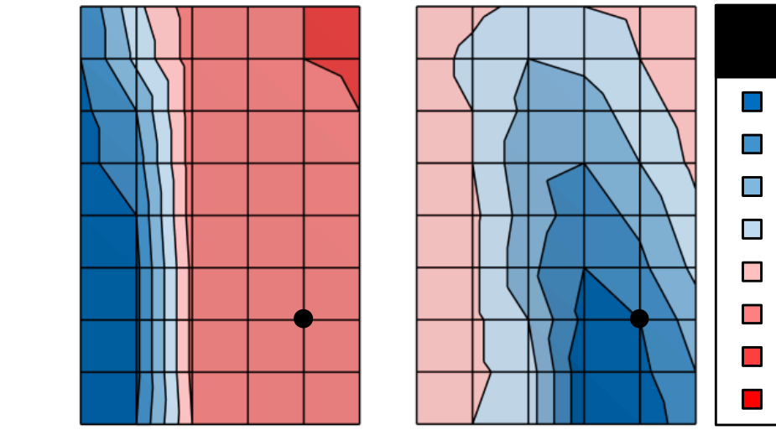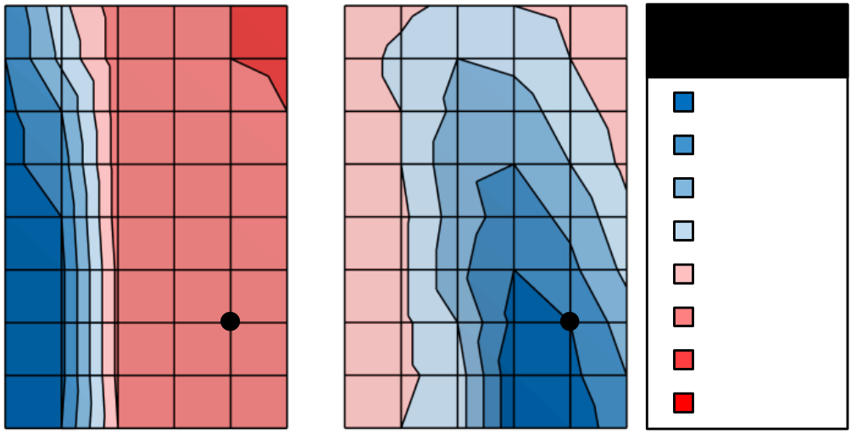

ELECTRICAL CHARACTERISTICS OF SI:HFO2-BASED FEFETS

properly evaluate the memory performance of FeFETs, the most appropriate operating conditions that are able to minimize trapping effects have to be found first. Therefore, so called program / erase matrices have to be acquired before more memory specific tests are carried out. In order to create these matrices, a sequence of write pulses and measurements is performed: First a reference pulse of fixed amplitude and pulse width is applied to the transistor gate while source, drain and bulk terminals are grounded. Depending on the polarity of the pulse, positive or negative, the FeFET is either written into the programmed (low-VT) or erased (high-VT) state. Then, an Id-Vg characteristic is measured in order to determine the reference threshold voltage. Afterwards, a pulse of opposite polarity, i.e. negative or positive, is applied whereas the amplitude and pulse width are parameters that are varied for each measurement sequence. The last part of each measurement sequence is again represented by an Id-Vg sweep that reads the threshold voltage. Hence, a program matrix is created if the parameterized pulse is of positive polarity and an erase matrix is generated when the parameterized pulse is negative. As an example, a matrix for 5 different pulse widths and 5 different amplitudes results in 25 measurement sequences. The outcomes of these measurements are two-dimensional VT maps which illustrate the optimum operating conditions within the respective amplitude and pulse width regions.

|  |  |  |  |  |  |  |  |
| --- | --- | --- | --- | --- | --- | --- | --- |
| Pulse Width [s] | 10-2 | |  | | --- | | Program Matrix | | | |  | | --- | | Erase Matrix | | ***VT*** |
| 10-2 | | ***VT*** |
| 10-3 | Pulse Width [s] | 10-3 | 0.8-1 | 0.8-1 |
| 10-4 | 10-4 | 0.6-0.8 | 0.6-0.8 |
| 0.4-0.6 | 0.4-0.6 |
| 0.2-0.4 | 0.2-0.4 |
| 10-5 | 10-5 | 0-0.2 | 0-0.2 |
| -0.2-0 | -0.2-0 |
| 10-6 | -0.4--0.2 | | | -0.4--0.2 |
| 10-6 | | -0.6--0.4 | -0.6--0.4 |
| 1 2 3 4 5 6 | | -1 -2 -3 -4 -5 -6 |
| Amplitude [V] Amplitude [V] Amplitude [V] | | |

Fig. 4-4: Program / Erase matrices for a short channel FeFET (Lg = 30 nm). The dots indicate the respective position of the reference pulses that were used.

For a short channel FeFET device (Lg = 30 nm; W = 80 nm; 1300 devices in parallel) of 3.5 mol% silicon concentration, the program and erase matrix is shown in Fig. 4-4. The reference pulses were chosen to be 5V / 10 s for the erase and program matrix respectively. Moreover, in order to exclude any effects related to conditioning (see section 0), 100 field cycles at 5V / 10 s were applied before the measurements were carried out. The extraction of the threshold voltage was performed using the constant current criterion ID,VT = 0.1 A  Wtotal / Lg according to JEDEC standard JESD28-A [61].

The program matrix shows a very uniform characteristic almost independent of the programming pulse width. For amplitudes below 2V, the FeFET stays at the reference erased VT state of approximately 0.8V whereas above this amplitude, the device properly programs to a low-VT state of around -0.2V. With respect to the reference state this gives a memory window of 1 V which is similar to previous reports [113]. Only for very long pulse widths of more than 1 ms, the low-VT state is reached for slightly lower program pulses.

65

ELECTRICAL CHARACTERISTICS OF SI:HFO2-BASED FEFETS

At this point, the effects of both trapping and statistical variation and their influence on VT shall be discussed once more. It is important to recall that by applying the constant current VT criterion to multi-structures, the programming of only a minority of devices can already shift the overall threshold voltage to lower values (section 4.1). Transistors programming into the low-VT state for longer pulse widths or higher amplitudes will not be visualized in the map. Furthermore, devices which do not show proper switching but rather trapping behavior will also be disregarded by this evaluation. Hence, this might be an explanation for the very uniform 2D contour of the program matrix.

Even though for the erase matrix, amplitudes smaller than 2V do not lead to significant threshold voltage shift, the overall behavior is quite different: From all regions in the matrix, the transition towards higher VT values is much more gradual than for the program matrix. This is also how it would be expected from simulation (see section 3.2). Moreover, for very large and long pulses, the VT rather shifts to smaller values which could be explained by hole trapping. Furthermore, the erase matrix indicates that it might be advantageous to use erase pulses that are even below the microsecond regime in order to achieve the largest possible memory window.

The FeFET behavior observed in the erase matrix measurements can again reasonably be understood in terms of statistical variation: For the erased case, the majority and not the minority of devices determines the threshold voltage. The more gradual characteristics therefore reflect the worst case tail of the erase distribution. That is, the devices which can only be erased by negative voltages that are large in amplitude are dominating the characteristic. The program matrix on the other hand represents the best case tail of the program distribution, i.e. it is dominated by the devices programming at low positive voltages.

Derived from these analyses, more elaborate matrix measurements were established and applied to various FeFET geometries. Program / erase matrices with constant pulse width can be used to vary both the program as well as the erase amplitude. As an example, a constant pulse width program matrix starts out by applying a -6 V / 1 s reference pulse and afterwards measures the corresponding reference VT. Then, program pulses are ramped incrementally with VT measurements located in between. Hence, by subtracting the VT after each program pulse from the initial reference VT, the evolution of the memory window can be monitored. After one sequence of incrementally increasing program pulses is finished, the next erase pulse is applied, but with reduced amplitude of e.g. -5.5 V / 1 s. Then the sequence of program pulses and VT measurements is repeated. The result of this analysis is a memory window map as a function of both program and erase amplitude using a fixed program / erase pulse width. The constant pulse width erase matrix is created accordingly by inverting the polarity of the program / erase pulses.

The measurement approach was applied to different FeFET geometries in order to analyze scaling effects with respect to program / erase operation. Long channel (Lg = 500 nm and Lg = 100 nm; both W = 2 m; 50 DUTs in parallel) and short channel devices (Lg = 30 nm; W = 80 nm; 1300 DUTs in parallel) were tested. The measurements were carried out for FeFETs with 4.5 mol% silicon concentration and 1 s program / erase pulses were used for almost all matrices. The pulse width dependence was only analyzed for short channel FeFETs by using both 1 s and 10 s pulses, i.e. two sets of constant pulse width program / erase matrices were created (Fig. 4-5). Due to the difference in silicon concentration and testing condition it shall be mentioned in advance that comparisons to Fig. 4-4 can only be made by explicitly taking these differences into consideration.

66

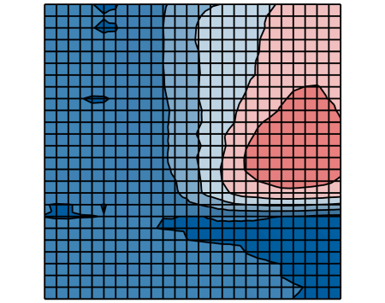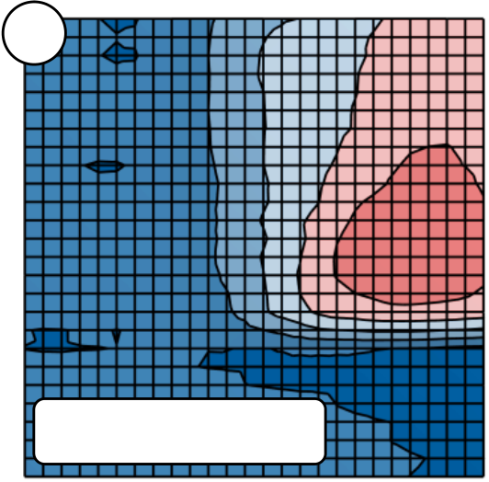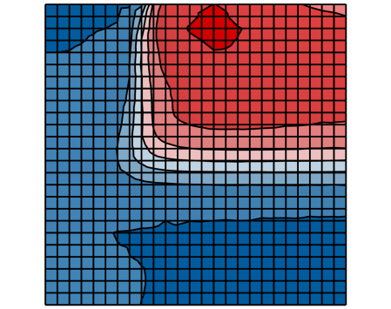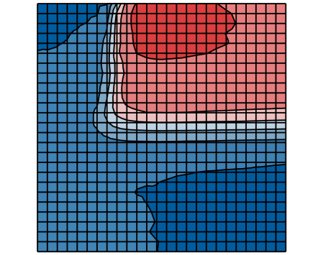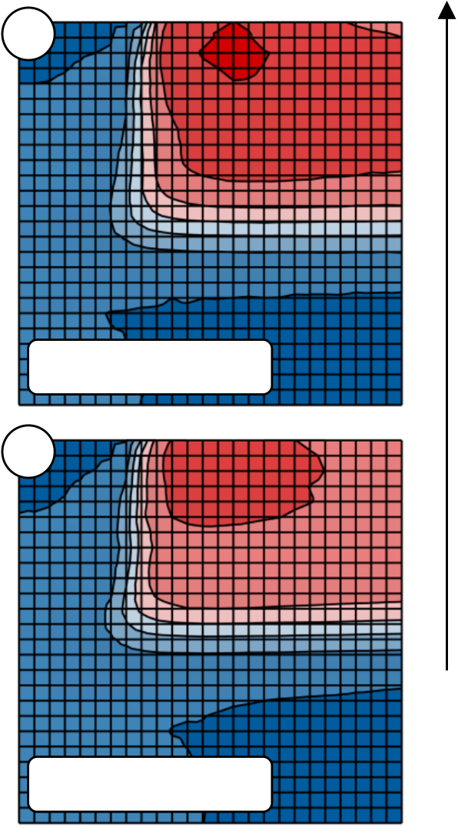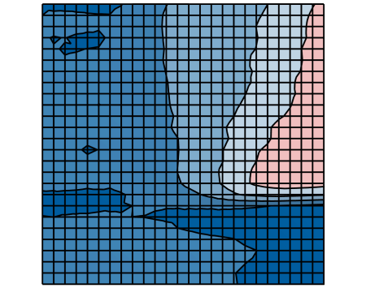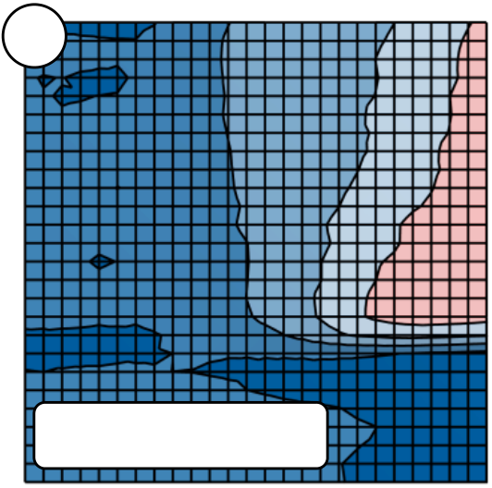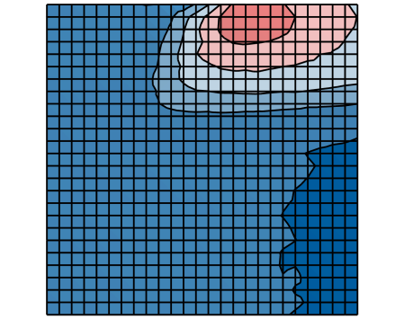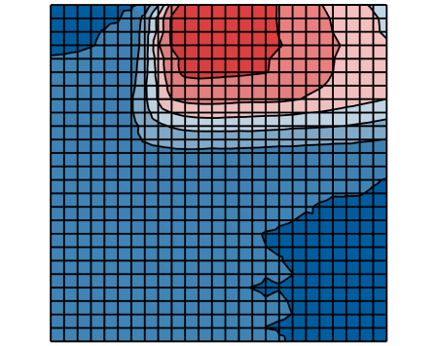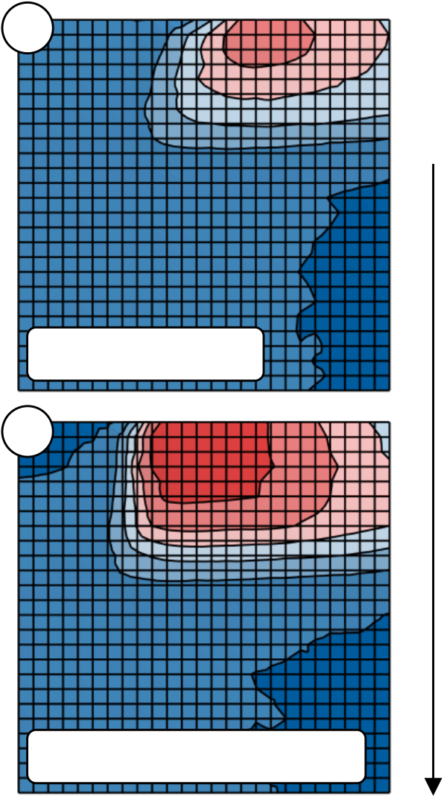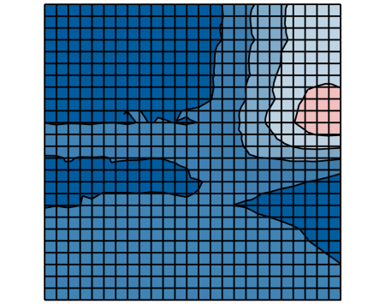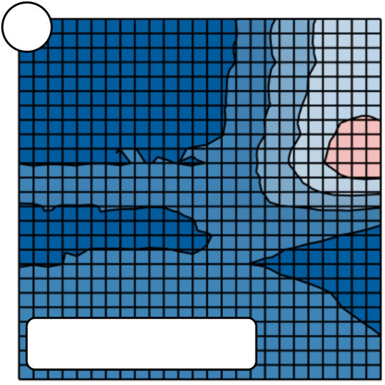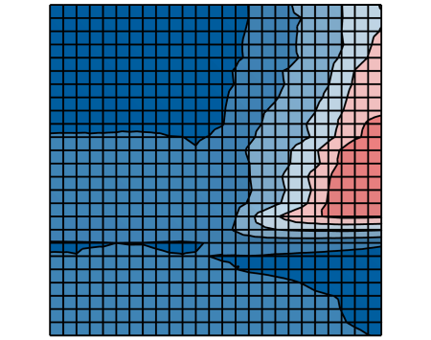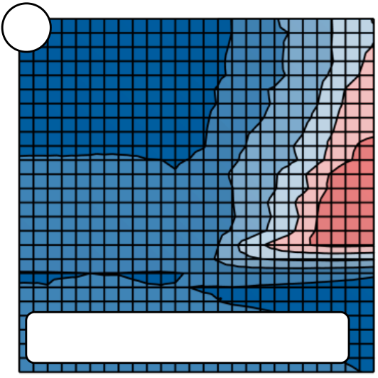

ELECTRICAL CHARACTERISTICS OF SI:HFO2-BASED FEFETS

|  |  |  |  |  |  |  |  |  |  |  |  |
| --- | --- | --- | --- | --- | --- | --- | --- | --- | --- | --- | --- |
| Erase Amplitude [V] Erase Amplitude [V] Erase Amplitude [V] Erase Amplitude [V] Erase Amplitude [V] | -6 | a | Program Amplitude [V] | 6  **MW** | b | *Lg* = 500 nm | | | | -6 | **MW** |
| -5 | *Lg* = 500 nm | 1.2-1.4 5 | | 1.2-1.4 |
| 1.0-1.2 | | 1.0-1.2 |
| -4 |
| 0.8-1.0 4 | | 0.8-1.0 |
| 0.6-0.8 0.4-0.6 3 | | 0.6-0.8 |
| -3 |
| 0.4-0.6 |
| 0.2-0.4 0.0-0.2 2 | | 0.2-0.4 |
| -2 |
| 0.0-0.2 |
| -1 | -0.2-0.0 1 | | -0.2-0.0 |
| -6 | 1 2 3 4 5 6 c  Program Amplitude [V] | Program Amplitude [V] Program Amplitude [V] Program Amplitude [V] | 6 -1 d  **MW** | | -2 | -3 | -4 | -5 | **MW** |
| Erase Amplitude [V] | | | |
| -5 | *Lg* = 100 nm | 1.2-1.4 5 | | *Lg* = 100 nm | | | | -6 | 1.2-1.4 |
| 1.0-1.2 | | 1.0-1.2 |
| -4 |
| 0.8-1.0 4 | | 0.8-1.0 |
| 0.6-0.8 0.4-0.6 3 | | 0.6-0.8 |
| -3 |
| 0.4-0.6 |
| 0.2-0.4 0.0-0.2 2 | | 0.2-0.4 |
| -2 |
| 0.0-0.2 |
| -1 | -0.2-0.0 1 | | -0.2-0.0 |
| 1 2 3 4 5 6 e  Program Amplitude [V] | -2 | -3 | -4 | -5 |
| -6 | 6 -1 f  **MW** | |
| **MW** |
| Erase Amplitude [V] | | | |
| -5 |
| 1.2-1.4 5 | | 1.2-1.4 |
| 1.0-1.2 | | 1.0-1.2 |
| -4 |
| 0.8-1.0 4 | | 0.8-1.0 |
| 0.6-0.8 0.4-0.6 3 | | 0.6-0.8 |
| -3 |
| 0.4-0.6 |
| 0.2-0.4 0.0-0.2 2 | | 0.2-0.4 |
| -2 |
| 0.0-0.2 |
| -1 | *Lg* = 30 nm | Program Amplitude [V] | *Lg* = 30 nm | | | | -6 |
| -0.2-0.0 1 | | -0.2-0.0 |
| 1 2 3 4 5 6 g | -2 | -3 | -4 | -5 |
| -6 | 6 -1 h  **MW** | | **MW** |
| Program Amplitude [V] | Erase Amplitude [V] | | | |
| -5 | *Lg* = 30 nm; PW = 10 s | 1.2-1.4 5 | | -6 | 1.2-1.4 |
| 1.0-1.2 | | 1.0-1.2 |
| -4 |
| 0.8-1.0 4 | | 0.8-1.0 |
| 0.6-0.8 0.4-0.6 3 | | 0.6-0.8 |
| -3 | *Lg* = 30 nm; PW = 10 s | | | |
| 0.4-0.6 |
| 0.2-0.4 0.0-0.2 2 | | 0.2-0.4 |
| -2 |
| 0.0-0.2 |
| -1 | -0.2-0.0 1 | | -0.2-0.0 |
| 1 2 3 4 5 6 | -2 | -3 | -4 | -5 |
| -1 | |
| Program Amplitude [V] | Erase Amplitude [V] | | | |

Fig. 4-5: Constant pulse width program and erase matrices. Scaling effects were investigated for long channel (a), (b) medium channel (c), (d) and short channel (e)-(h) FeFETs. Measurements (a)-(f) were performed using 1 s pulse widths whereas (g)-(f) show the results for 10 s pulses.

67

ELECTRICAL CHARACTERISTICS OF SI:HFO2-BASED FEFETS

For the program matrix of 500 nm long channel devices (Fig. 4-5 (a)), there is an almost instantaneous increase in memory window when the programming voltage is higher than 2.5 - 3 V. In addition, for erase voltages less than 3.5 V in absolute magnitude, no memory window can be observed which means that the programmed state cannot be switched back to a high VT erased state. In total it can be stated that for the program matrix, the memory window is rather constant in the program / erase area enclosed by the intervals of [-4 V; -6 V] and [+3 V; +6 V]. The largest memory window is observed for 3.8 V program and -5.6 V erase voltage.

In order for the erase matrix to look similar to the program matrix, all 50 FeFET devices would have to possess identical program / erase characteristics and cumulative trapping effects must not affect the measurement. It was already pointed out in the previous sections that this is a very unlikely situation and it is again reflected in the constant pulse width erase matrix for the 500 nm devices (Fig. 4-5 (b)): As an example, for a program voltage of 4.4 V, the memory window grows from 0 V at -3 V erase pulse amplitude to 0.8 V at -5.2 V erase pulse amplitude. This wide range of 2.2 V for increasing the memory window by 800 mV cannot be seen for the respective program matrix. There, for the same memory window growth of 800 mV at 4.4 V program amplitude only a 0.6 V erase pulse range needs to be covered. This clearly illustrates the asymmetry between constant pulse width program and erase matrix.

The shape of both program and erase matrix is more or less retained also for the 100 nm and 30 nm channel length devices (Fig. 4-5 (c)-(f)). However, the overall memory window decreases and the voltages required for erasing a device increase in amplitude. Not much can be concluded with respect to the program voltage, only that, from a statistical point of view, even for the smallest FeFET geometries there are still devices programming at around 4 V. These will dominate both program and erase characteristic making non-switched devices invisible inside the program / erase matrices.

Since varying the pulse width would add a fourth dimension to the program / erase matrices, results for short channel devices using 10 s pulses are shown as separate plots in Fig. 4-5 (g) and (h). There it can be seen that the overall memory window size can be increased by approximately 0.2 V and that the program and erase voltages shift to smaller amplitudes. This is in accordance to what is expected from the switching dynamics of the ferroelectric material itself (see section 2.2).

4.2.3Endurance and Fatigue

One of the most important characteristics for non-volatile as well as for volatile memory technologies is represented by its program / erase endurance. For the FeFET in particular this represents the ability to alternatingly shift the Id-Vg characteristic to the low-VT and back to the high-VT state without degrading the device performance. There are several effects that can negatively influence memory characteristics and lead to a non-functional device in the long run: Charge injection by trapping, which can also lead to interface degradation and consequently to gate stack break down, and ferroelectric fatigue are the most relevant for ferroelectric field effect transistors.

The endurance characteristics of long channel as well as short channel devices were analyzed by stressing FeFET devices with bipolar  5 V / 10 s pulses [118]. Based on the results from program / erase matrix measurements (see subsection 4.2.2), these program and erase conditions were identified to be appropriate both in terms of memory window size as well as from an RC time delay point of view (it has to be ensured that pulses reach the DUT properly, independent of the contact resistance of the measurement setup). Moreover,

68

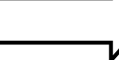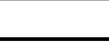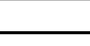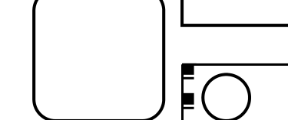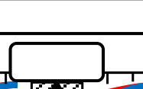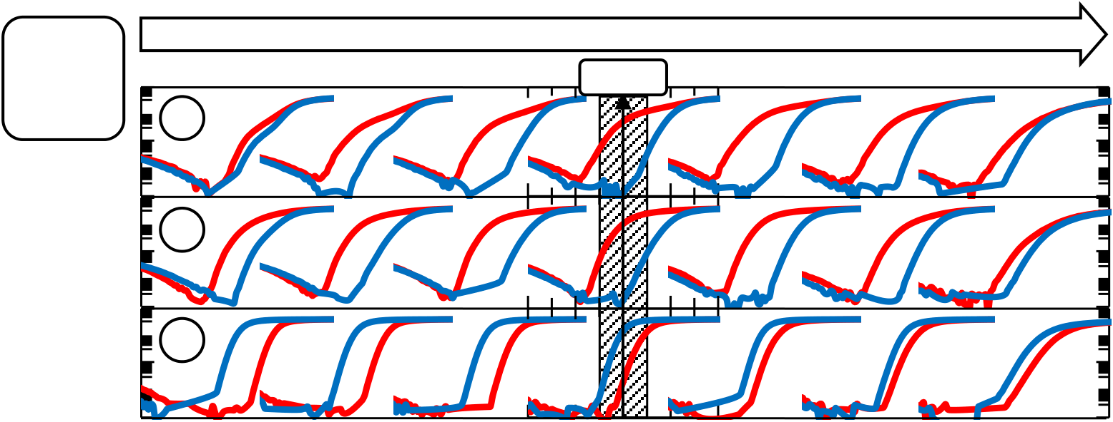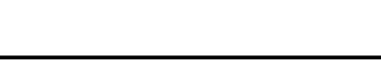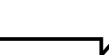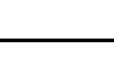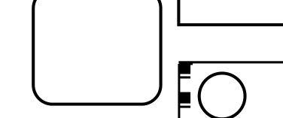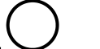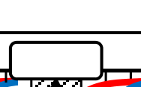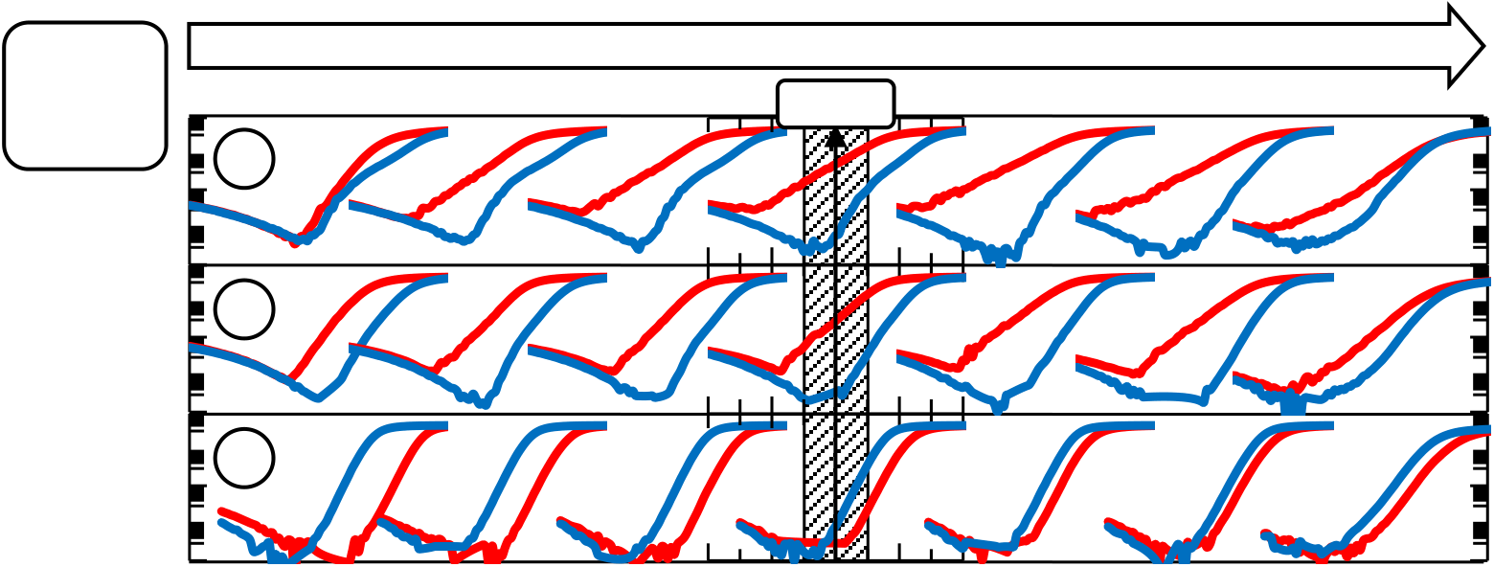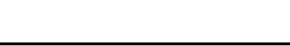

ELECTRICAL CHARACTERISTICS OF SI:HFO2-BASED FEFETS

the conditions were not expected to lead to immediate device degradation due to e.g. charge injection. The programmed and erased Id-Vg characteristics were acquired once each stress decade whereas a pulsed Id-Vg characterization identical to the one described in subsection 4.2.1 was used (Fig. 4-6).

Endurance Cycles

|  |  |  |  |  |  |  |  |  |
| --- | --- | --- | --- | --- | --- | --- | --- | --- |
| *Lg*=260 nm | **a** | 0 | 100 | 101 | 102 | 103 | 104 | 105 |
| *W*=360 nm 300 FeFETs 10-2 log *Id* [A] log *Id* [A] log *Id* [A]   10-6  10-2 10-10  10-6  10-10 10-2  10-6  10-10 | *VRead* | | |
| **b** | 10-2 10-2  log *Id* [A] log *Id* [A]   10-6 10-6  10-10 10-10 | | |
| **c** |
| -2 -1 0 1 2-2 -1 0 1 2 | | |
| Gate Voltage [V] Gate Voltage [V] | | |

Endurance Cycles

|  |  |  |  |  |  |  |  |  |
| --- | --- | --- | --- | --- | --- | --- | --- | --- |
| ***Lg*=30 nm** | **a** | 0 | 100 | 101 | 102 | 103 | 104 | 105 |
| *W*=300 nm 300 FeFETs 10-2 log *Id* [A] log *Id* [A] log *Id* [A]   10-6 10-10 10-2 10-6 10-10 10-2 10-6 10-10 | *VRead* | | |
| **b** | 10-2 10-2  log *Id* [A] log *Id* [A]   10-6 10-6  10-10 10-10 | | |
| **c** |
| -3 -2 -1 0 1-2 -1 0 1 2 | | |
| Gate Voltage [V] Gate Voltage [V] | | |

Fig. 4-6: Endurance characteristics of Si:HfO2 FeFET devices. Long channel (top) and short channel devices (bottom) as well as all available Si:HfO2 compositions from (a) 3.5 mol% to (b) 4.5 mol% and (c) 5.7 mol% were tested. The red Id-Vg characteristic represents the programmed state whereas the blue one represents the erased state.

Interestingly, the Si:HfO2 system with 3.5 mol% silicon concentration shows a quite different behaviour as it was expected from quasi-static Id-Vg measurements in section 4.2.1: Whereas in section 4.2.1 there was a proper VT-shift visible for the hysteretic sweep, this is not the case for neither the long nor the short channel FeFET devices of the mentioned

silicon concentration. Looking at the Id-Vg characteristics and considering statistical variations between the devices, it appears as if some devices do not shift properly to a high-VT state after the erase operation (kink in the Id-Vg characteristic). Only after approximately 100 endurance cycles, proper VT separation between the programmed (red) and erased (blue) state is visible. For the quasi-static measurement, a proper memory window was visible already for virgin devices. Even though the devices in section 4.2.1 were

69

ELECTRICAL CHARACTERISTICS OF SI:HFO2-BASED FEFETS

much wider (W = 2 m), the total width (the product of the number of DUTs and the single device width) was approximately the same (100 m and 108 m respectively). Hence, neglecting additional geometric effects (e.g. the channel length / the device area) it appears that silicon concentrations which produce ferroelectric DC characteristics but appear to be slightly off-target (in this case 3.5 mol%) need either to be exposed to AC or DC stress in order to show proper VT separation of the written states.

Moreover it can be seen that the programmed Id-Vg characteristics for both long channel as well as short channel devices of 3.5 mol% and 4.5 % silicon concentration differ quite a bit. Especially for gate voltages larger than VT, the Id-Vg slope of 3.5 mol% devices is rather flat compared to 4.5 mol% devices. Considering again statistical variations between the 300 FeFETs which are connected in parallel, devices which are in a weak program state can cause the flattening of the Id-Vg characteristics. If all devices would switch in a uniform manner, the Id-Vg characteristics would shift in parallel (see results from simulation in section 3.2 and schematics in section 4.1). The long channel devices possessing a 4.5 mol% silicon concentration show Id-Vg shifts which are close to being parallel. This is also the case for the 5.7 mol% concentration, however and similar to results from section 4.2.1, the VT-shift is solely driven by charge trapping.

For short channel devices, the subthreshold slope, i.e. the inverse slope of the Id-Vg graph for voltages less than VT, is in general significantly smaller due to short channel effects [178]. Hence, this is also the case for the FeFET transistors with 30 nm channel length. However, for the ferroelectric concentrations of 3.5 mol% and 4.5 mol% it is evident that the slopes of programmed and erased Id-Vg characteristics differ significantly. This characteristic is most pronounced for DUTs with 3.5 mol% silicon content. Speaking in terms of statistical variation, the flattened Id-Vg characteristics might be due to weak programming of single transistors. Furthermore this behaviour is in accordance with the trends seen for program / erase matrix characterization: There, both memory window degradation and an increase in erase pulse amplitude were observed for the smallest device geometries (see section 4.2.2). Nevertheless, subthreshold slope degradation due to charge trapping cannot be ruled out. If intrinsic device degradation would cause the low-VT subthreshold slope degradation, then the 3.5 mol% composition can be declared as more prone to this degradation than the 4.5 mol% composition. This would again confirm the assumption that interface degradation can be related to the degree of polarization occurring for a specific material composition.

Furthermore, during the course of program / erase cycling, the VT shift for the 5.7 mol% Si:HfO2 system changes from approximately 1 V due to trapping to almost 0 V. Besides the in general inverted VT shift as compared to the ferroelectric concentrations, also the evolution of the VT shift with cycling is inverted. One possible explanation might lie in the cycling induced growth of remanent polarization for this specific silicon concentration (see subsection 2.5). Though, the actual quantity responsible for the occurrence of a discernable memory window, i.e. the coercive field, cannot be considered large enough for that composition. Besides this ambiguity, it is furthermore interesting to see that the closing of the trap window with cycling shifts the programmed and erased Id-Vg characteristics rather ideally parallel. This suggests that all devices connected in parallel are affected by this field cycling phenomenon in a similar manner.

Nevertheless, all Si:HfO2 systems and their respective Id-Vg characteristics degrade after 105 endurance cycles. The degradation from 104 to 105 cycles is accompanied by a change in subthreshold slope to a higher value which indicates the existence of inhomogeneous trapping effects or an increased interface trap density [9, 178].

70

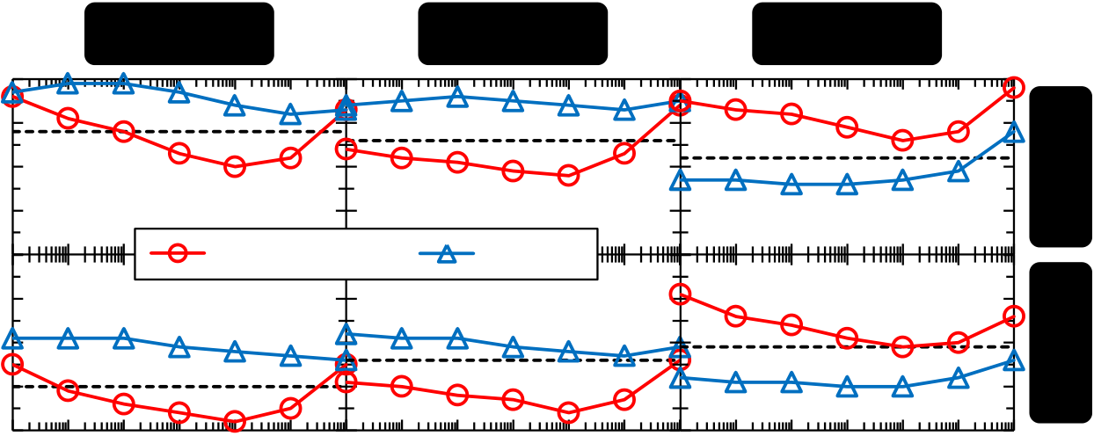

ELECTRICAL CHARACTERISTICS OF SI:HFO2-BASED FEFETS

In addition to Fig. 4-6, it is worth summarizing the endurance characteristics also in terms of the standard VT extraction (constant current criterion) in order to better visualize which of the binary states degrades first (Fig. 4-7).

|  |  |  |
| --- | --- | --- |
| **3.5 mol%** | **4.5 mol%** | **5.7 mol%** |

1   
0.5   
0

|  |  |  |  |
| --- | --- | --- | --- |
| *VT* [V] | -0.5 | Programmed | Programmed |
|  1 | Erased Erased |
| 0.5 | Erased |

0  
-0.5

|  |  |
| --- | --- |
| -1 | 0 100101102103104105 |

Cycles [1]

Fig. 4-7: Summary of endurance characteristics in terms of VT degradation. The virgin VT of each multi-structure is shown as dashed line. Two differnet channel lengths (30 nm and 260 nm) were tested. The threshold voltage was extracted based on the JEDEC constant current criterion.

For the composition with the lowest silicon concentration, i.e. 3.5 mol%, it was already mentioned that no or only a small memory window is visible during the first endurance cycles. In fact the VT shift for both program and erase is first towards values that are higher than the virgin state. With cycling, the low- and high-VT states become symmetric around the virgin VT. The complete loss of memory window between 104 and 105 cycles is mainly caused by the degradation of the low-VT state which is also a well-known phenomenon occurring for Flash-based devices [17]. For Flash-based devices, trapped charges in the tunnel oxide will prevent the memory cell from being properly erased into the low-VT state. Transferring this to FeFET endurance characteristics, trapped electrons at the interface or inside the Si:HfO2 layer would obviously cause the same degradation of the low-VT state. The difference as compared to Flash devices is that the erased state VT is hardly shifting to higher values. Since charge trapping is considered to be a rather uniform effect across all devices, a statistical origin of this artifact is not expected. Hence, for additional studies on the FeFET degradation behavior, this finding has to be considered (see section 4.3).

Starting from the first program / erase operation, the respective threshold voltages of the 4.5 mol% composition are more symmetric with respect to the virgin VT. The memory window degradation is also mainly due to a loss of programmability, however, also the erased VT gradually shifts to lower values during the course of cycling (this can also be observed for the 3.5 mol% concentration). Hence, up to 103 endurance cycles, the whole memory window shifts towards the lower VT side which could be interpreted as ferroelectric imprint occurring due to charge injection / trapping.

The 5.7 mol% composition shows the already mentioned trap window straight from the beginning of the endurance measurement. The trend of the threshold voltage after application of a positive gate pulse (for this composition the high-VT state) also tends to lower values with cycling, similar to the compositions with lower silicon content. However, the degradation of the erased state (for this composition the low-VT state) is almost in parallel to the degradation of the programmed state. This was different for the other compositions as mentioned in the last paragraphs. Moreover, due to the fact that the erased VT for the 5.7 mol% concentration is at such low values which would be expected for a

71

ELECTRICAL CHARACTERISTICS OF SI:HFO2-BASED FEFETS

programmed device, the following might be hypothesized: Assuming that the erase voltages are not sufficient to switch the polarization, they would in turn detrap a significant amount of electrons that might have been injected by a preceding program operation. This would lead to a low-VT state after a negative pulse had been applied. The amount of hole trapping is thereby assumed to be constant for all material compositions. This hypothesis will again be picked up in subsection 4.3.1.

4.3Fast Transient Characteristics

In the previous section it was already highlighted that the ferroelectric phenomena are superimposed by trapping. Accordingly, degradation phenomena which are already present for standard non-ferroelectric HKMG devices will occur for FeFETs as well. Hence, additional characterization methodologies were applied in order to improve the understanding for mechanisms degrading the device performance during cycling. For fast transient characterization of non-volatile memories, the pulse-measurement-unit is specifically well suited [75]. The system provides the ability to release arbitrary voltage waveforms while simultaneously performing current measurements down to the nanosecond regime (acquisition rates of up to 200 megasamples / second). With the system, and similar to section 2.2, it was possible to perform positive-up negative-down (PUND) characterizations also for MFIS geometries. This led to a deeper insight into effects occurring during the program and erase operations and their respective time evolution. Moreover, due to high acquisition rates that are provided by the PMU, it was possible to measure the detrapping characteristics of the FeFET over a time range of more than ten decades. Based on these results, actual access time measurements were performed and give an indication with respect to the possible operational speed of FeFET devices.

4.3.1PUND Characterization of MFIS Capacitors

Positive-up negative-down measurements were already introduced in section 2.2 and were also applied to MFIS devices which had their source and drain regions short circuited. Three different multi-structures were tested (Lg = 40 nm, 100 nm and 2 m; for all devices W = 2 m) whereas the number of devices connected in parallel varied such that the total device area was constant at 2,000 m2 (25,000, 10,000 or 500 devices in parallel). All three Si:HfO2 compositions were tested in order to extend the understanding about the transferability of pure MFM material characteristics to the integrated lot.

Pulses of 5 V and 10 s slope and pulse width were used in order to maintain comparability to endurance measurements (see subsection 4.2.3). Furthermore, the delay time between the four PUND pulses was varied from 10 s to 1 s in order to investigate time dependent effects from e.g. ferroelectric relaxation or charge trapping. In between each PUND sequence, bipolar 5 V stress cycles possessing the same slope and pulse width as the PUND pulses were applied.

72

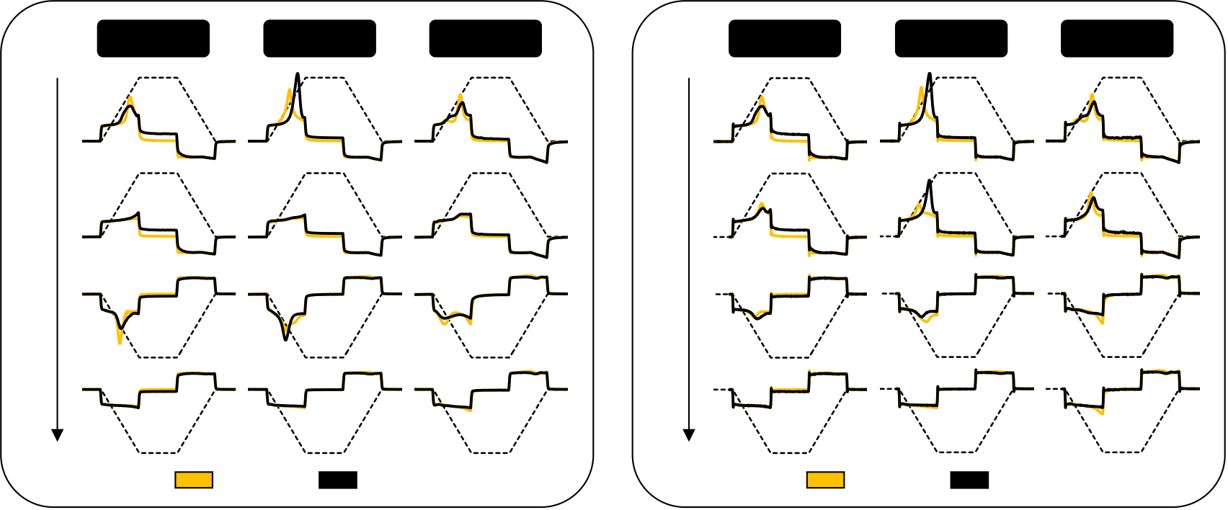

ELECTRICAL CHARACTERISTICS OF SI:HFO2-BASED FEFETS

|  |  |  |  |  |  |  |  |
| --- | --- | --- | --- | --- | --- | --- | --- |
| PUND pulse seq. w/ **10 us delay** | **3.5 mol%** | **4.5 mol%** | **5.7 mol%** | PUND pulse seq. w/ **1 s delay** | **3.5 mol%** | **4.5 mol%** | **5.7 mol%** |
| Initial | 105 cycles | Initial | 105 cycles |

Fig. 4-8: PUND measurements for MFIS capacitors (Lg = 40 nm; W = 2 m; 25,000 DUTs in parallel). The current responses (solid lines) to trapezoidal voltage pulsed (dashed line) are illustrated. All available Si:HfO2 compositions were tested up to 105 endurance cycles. Delay times between the voltage pulses were varied between 10 s (left) and 1 s (right).

The results of PUND characterization for short channel (Lg = 40 nm) devices are shown in Fig. 4-8. For the 5.7 mol% composition, the short delays of 10 s (left) led to a P and U current response that was not expected for the antiferroelectric composition: For an ideal antiferroelectric and independent of the pulse polarity, the ferroelectric displacement current on the rising edge should be exactly the inverse of the one occurring on the falling edge. However, on the falling edge of the P pulse no such current peak is visible. Only the slightly increasing negative current amplitude when the P pulse returns to 0V suggests ferroelectric relaxation as it is known from MFM capacitors (see subsection 0). However, in order for the relaxation assumption to be valid, the U pulse would have to show the inverted transient characteristic on the rising edge as compared to the falling edge of the P pulse. That is, the current magnitude would have to be larger at the beginning of the slope (the relaxed polarization switches again) than at the end of the slope.

Given that in subsection 4.2.1 and 4.2.3 it was shown that this Si:HfO2 composition led to a significant trapping window for transistor devices, a charge injection related origin of the current peak should not be ruled out. There are various scenarios that can be hypothesized (charge injection into a trap band with succeeding gate voltage shielding, interface trapping etc.) and in depth charge trapping analyses should resolve these ambiguities in the future.

For the N pulse and for a virgin device, two humps in the current response are visible whereas the second is just rising at -5 V. This suggests that for more negative amplitudes an additional current peak would occur. A sole increase of leakage current is unlikely since the D pulse should then show similar characteristics. This will become even clearer when considering results of the measurements utilizing one second delay time.

With reference to section 4.2, the 4.5 mol% composition is considered to be predominantly ferroelectric. This is in general also reflected in the PUND measurements using a short delay time: That is, the P pulse shows a large current peak, the U pulse a predominantly dielectric response, the N pulse again a current peak response and finally the D pulse a perfectly dielectric displacement current. Some phenomena however require certain attention: First of all, the magnitudes of the respective P and N pulse current response are significantly different in size. Assuming that detrapping is negligible in the microsecond regime, the difference between P and N pulse shows that a charge injection

73

ELECTRICAL CHARACTERISTICS OF SI:HFO2-BASED FEFETS

effect has to be superimposed on the ferroelectric switching. Independent of any gate stack asymmetry or ferroelectric imprint, the ferroelectric switching current has to be symmetric because it was shown that the Si:HfO2 hysteresis is of Preisach-type (see chapter 3). Hence, this also indicates that in the microsecond regime, the amount of electrons trapped during the P pulse cannot be fully detrapped by the N pulse. Moreover, with cyling it appears that the peak of the P pulse current response on the one hand grows and also shifts to higher gate voltages. The effects observed during cycling will be discussed in more detail in the next paragraphs.

The 3.5 mol% composition shows switching behaviour similar to the 4.5 mol% composition. This is reasonable since the material system also showed a ferroelectric memory window during the Id-Vg analysis (see subsection 4.2.1 and 4.2.3). Nevertheless, the absolute value of the P pulse current response is significantly smaller, especially after cycling. On the other hand, the one for the N pulse is even larger as compared to the 4.5 mol% composition. After 105 endurance cycles, the point at which memory window degradation was observed in subsection 4.2.3, also the leakage current for positive gate voltages increases. However, this leaves the question why there is also memory window degradation occurring for the 4.5 mol% concentration whereas the increase in leakage current is not as severe as for the 3.5 mol% concentration. This will also become clearer when the cycling induced degradation is discussed in detail during the next paragraphs.

During the analysis it became clear that the PUND characterization of the MFIS structures is not at all as straightforward as it was the case for MFM capacitors. Summarizing the observations made for the MFIS structures, the compositions that lead to a ferroelectric memory window (3.5 mol% and 4.5 mol%) and the one that does not (5.7 mol%) can be distinguished as follows: The magnitude of the P pulse response appears to influence the quality of the Id-Vg characteristics. The 4.5 mol% composition shows the largest current response and possesses a ferroelectric Id-Vg memory window straight from the beginning (see section 4.2.3). Since the 3.5 mol% composition and the 5.7 mol% compositions both possess a P pulse response approximately equal in size, the absolute value of the current response is not a sufficient criterion to determine proper functionality of FeFET devices. The property that clearly distinguishes the high and low silicon content compositions is the shape of the N pulse response: Whereas for the 3.5 mol% composition there is a distinct current peak occurring, for the 5.7 mol% sample this is not the case.

In order to broaden the understanding of transient effects affecting the MFIS and therefore the FeFET characterization, the delay time between each PUND pulse was increased to one second. This led to the discovery of several phenomena: For all compositions, the U pulse response then looked very similar to the P pulse response, i.e. a current peak was visible. This can again either be explained by ferroelectric relaxation during the one second delay period or by detrapping of electrons that were captured during the P pulse. However, it is clear that the magnitude of the U pulse current response is much smaller as compared to the P pulse response. This is most prominent for the virgin device state and the 3.5 mol% and 4.5 mol% composition. For these two compositions the N pulse response also shows significantly reduced current peak amplitudes. Assuming that for short delay times the ferroelectric N pulse response is superimposed by a detrapping portion, this might be an explanation why for longer delay times the absolute magnitude of the current response decreases. For the 5.7 mol% composition, the previously observed (10 s delay) first hump in the N pulse current response disappears for one second delay time. This suggests that also this portion of the current response might be correlated to detrapping of electrons.

74

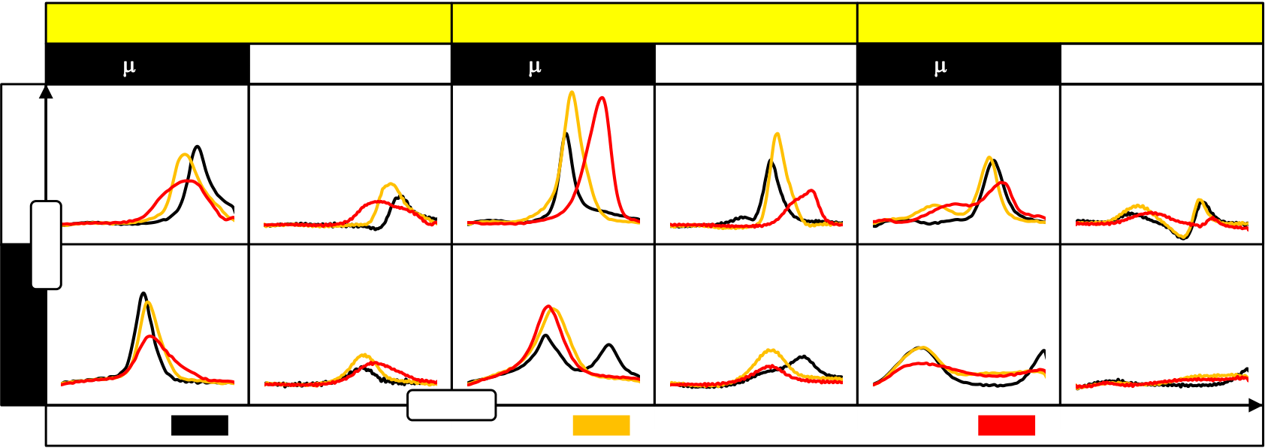

ELECTRICAL CHARACTERISTICS OF SI:HFO2-BASED FEFETS

In order to visualize the cycling and delay time induced effects, the current response of the P and U pulse as well as of the N and D pulse were subtracted from each other. For an MFM capacitor this is sometimes referred to as the switched polarization PSW. However, for the MFIS structure this might not be an appropriate denomination since, as it was discussed, trapping effects are likely to be superimposed on the ferroelectric response. The resulting current differences for the rising slopes of the P and U pulse and for the falling slopes of the N and D pulse are shown in Fig. 4-9 (the plotted time range is always 10 s).

|  |  |  |  |  |  |  |  |
| --- | --- | --- | --- | --- | --- | --- | --- |
| **P-U** | **3.5 mol % silicon** | | *t* [a.u.] | **4.5 mol % silicon** | | **5.7 mol % silicon** | |
| **10** **s delay** | **1 s delay** | **10** **s delay** | **1 s delay** | **10** **s delay** | **1 s delay** |
| *I* [a.u.] | Virgin | | 103 cycles | | 105 cycles | |
| **-(N-D)** |

Fig. 4-9: Subtracted PUND transient current responses. The time intervals for the rising slopes of P and U pulse as well as for the falling slopes of the N and D pulse are shown. Results for all material compositions, delay times as well as for selected endurance cycles are plotted.

For cycling of the 5.7 mol% concentration and 10 s delay time, the P-U response shows two characteristic current peaks, a smaller one at lower voltages and a larger one at higher voltages. By looking at the results for one second delay time, the first peak appears to be independent of the delay time whereas the second peak shifts to lower voltages for the longer delay. This is the reason why the difference between P and U becomes negative at a certain point. As indicated in the last paragraph, the N-D difference shows two current peaks whereas the second one does not reach its maximum at -5 V. However, a delay time of one second more or less eliminates both current responses. Hence, no remanence, neither ferroelectric nor trapping related, can be expected after a certain period of time.

The 4.5 mol% composition shows a much more pronounced P-U response which also remains clearly visible after one second delay time. What is revealed by increasing the delay time and subtracting P and U response is that the total magnitude of the P-U response shrinks with cycling. This cannot be seen in the results for 10 s delay time. There, only an increase in current response accompanied with a shift to larger switching voltages can be recognized. The shift in switching voltage is also visible for one second delay time, however the decreasing P-U amplitude with cycling suggests that true ferroelectric fatigue might occur. Furthermore, the N-D response is significantly different from the 5.7 mol% concentration: For 10 s delay, there are two distinct current peaks which merge into one peak with cycling. For one second delay, the amplitude is again reduced but non-zero. It is interesting to note that especially for the virgin device the second current peak is the stable one over the delay period of one second. Accordingly, if the current peak occurring for lower voltages would be due to ferroelectric switching, from an energetic viewpoint it is unreasonable why it should relax.

For the 3.5 mol% concentration, there are again distinct current peaks for both P-U and N-D response. The P-U difference is significantly smaller than for the 4.5 mol% composition

75

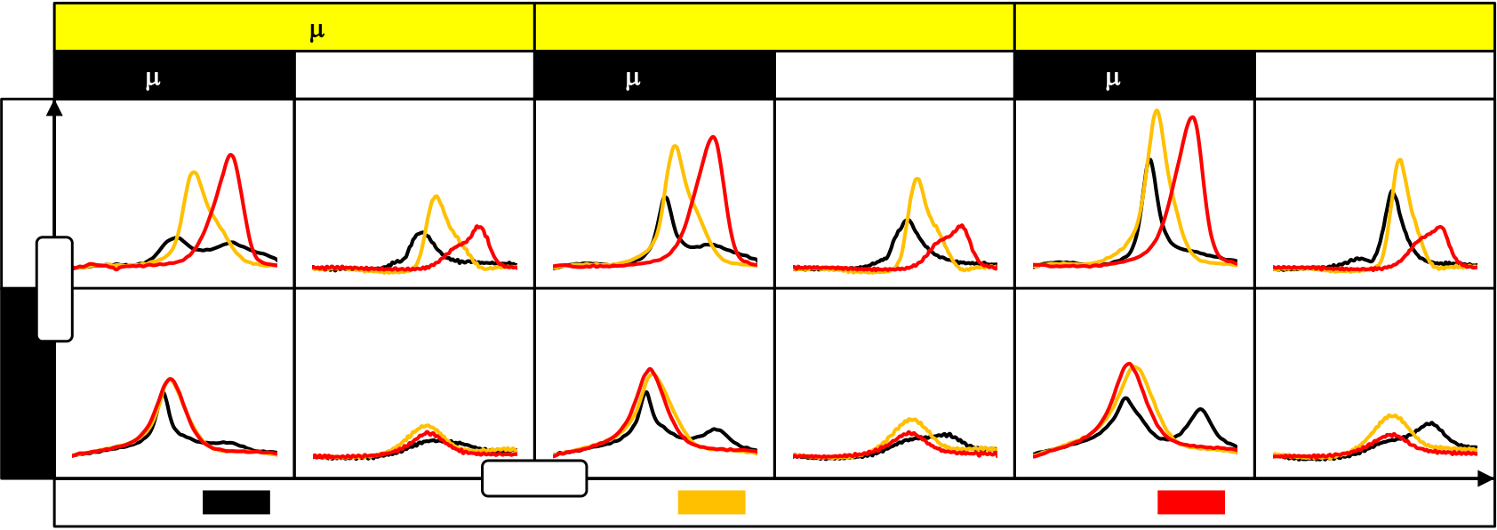

ELECTRICAL CHARACTERISTICS OF SI:HFO2-BASED FEFETS

but similar in size to the N-D response which is even larger as compared to the 3.5 mol% composition.

In addition, the dependence of the PUND current response with respect to device geometry respectively area was analyzed by measuring also MFIS capacitors with 100 nm and 2 m channel length. By reducing the amount of devices connected in parallel, the total device area remained constant at 20,000 m2 (Fig. 4-10).

|  |  |  |  |  |  |  |  |  |
| --- | --- | --- | --- | --- | --- | --- | --- | --- |
| **P-U** | **10** **s delay** | ***Lg* = 2** **m** | **1 s delay** | *t* [a.u.] | ***Lg* = 100 nm** | | ***Lg* = 40 nm** | |
| **10** **s delay** | **1 s delay** | **10** **s delay** | **1 s delay** |
| *I* [a.u.] | Virgin | 103 cycles | | 105 cycles | |
| **-(N-D)** |

Fig. 4-10: Subtracted PUND transient current response for different channel lengths Lg. Results of the 4.5 mol% composition are shown. The test specification was identical to Fig. 4-9.

In Fig. 4-10 it is shown that the shorter the channel length of the 4.5 mol% concentration was, the more pronounced were the switching peaks for the P-U response. Other than truly intrinsic device behavior, a decrease in the current response can also be caused by a smaller effective gate area when for example overlap capacitances start to dominate. However, this would actually be the case for short channel devices, i.e. the trend is inverted to what would be expected. Hence, this suggests that the switching operation is rather supported by device scaling than hindered. Furthermore, the virgin P-U response differs quite significantly for the various channel lengths: For a long channel device, two switching peaks of almost identical amplitude are visible at the beginning. Reducing the channel length leads to a significant growth of the low voltage peak whereas the current peak occurring at higher voltages never vanishes but is rather superimposed by the low voltage peak. For one second delay time, the higher voltage current response is not at all visible, only at the point where severe degradation sets in (after 105 endurance cycles), the peak appears at a similar position, however with much higher amplitude.

For the N-D response, a similar double hump phenomenon can be observed, however more for the short channel than for the long channel devices. Moreover, the merging of peaks also occurs for the negative pulses but no severe shift in switching voltage is visible from 103 to 105 cycles.

As visualized by the severe delay time dependence of the PUND characteristics, effects from interface degradation and charge trapping cannot be excluded from the FeFET analysis. Even though charge trapping and its related degradation mechanisms were not in the focus of this thesis, it became clear that these are non-negligible effects for a thorough understanding of the FeFET device. Basic charge pumping measurements are recommended in order to provide a measure for the severeness of FeFET degradation due to parasitic charge injection. Besides these, single pulse Id-Vg characteristics represent another technique to give a relative estimate about the amount of charge injected during program operations.

76

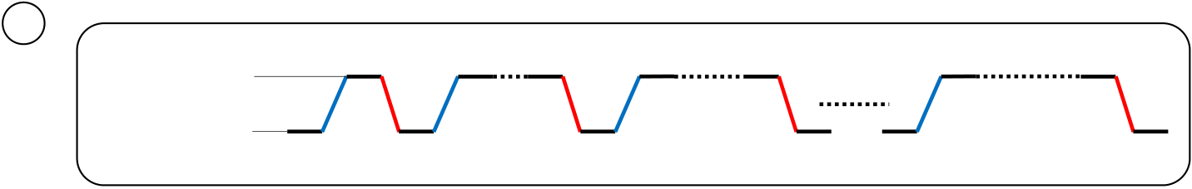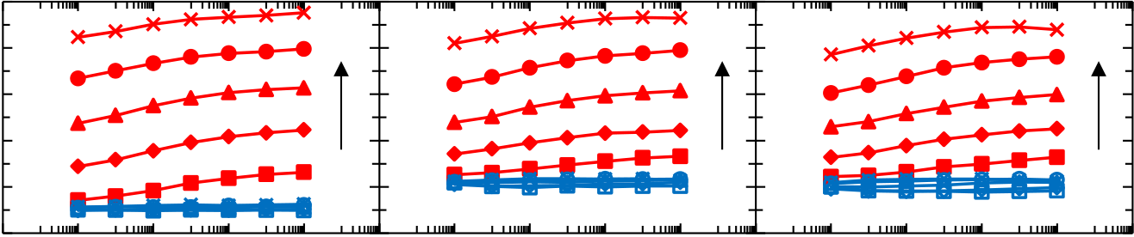

ELECTRICAL CHARACTERISTICS OF SI:HFO2-BASED FEFETS

4.3.2"Single Pulse" Id-Vg Characteristics and Fast Retention

Due to the significant PUND delay dependence observed in the previous section, it is important to understand how these phenomena ultimately affect the most relevant memory parameter, i.e. the threshold voltage. If trapping or ferroelectric relaxation do indeed occur in the microsecond regime, a strong variation in VT can be expected.

The characterization methodology considered most suitable for such an analysis is represented by a "single pulse" Id-Vg characterization [223]. The single pulse technique should not be confused with the ramped pulse technique: Whereas the ramped pulse characterization (e.g. applied in subsection 4.2.1) uses multiple pulses of incrementally increasing amplitude, the single pulse technique uses only one pulse. There, the voltage base of a single pulse corresponds to the start voltage of a standard voltage sweep and the sum of voltage base and amplitude corresponds to the end of the sweep. Utilizing a pulse-measurement-unit as introduced previously, it is possible to sample both voltage and current every 5 nanoseconds during the time the single pulse is applied. Limitations for the quality of the measurement are mainly due to the RC delay of the measurement setup and due to the magnitude of the current the DUT can drive (the faster the measurement the larger the current has to be). However, it could be verified that for a standard probe station setup (PMU connected to a switch matrix; probe station utilizing a standard probe card) and FeFET multi-structures, proper single pulse measurements could be carried out down to the 10 s regime. Hence, it was possible to use the same pulse conditions that had been applied for endurance as well as PUND characterization. Short channel devices (Lg = 30 nm; W = 300 nm; 300 DUTs in parallel) were tested for all available Si:HfO2 compositions. A specific waveform was generated utilizing the Segment Arb™ feature [74] of the pulse measurement unit (Fig. 4-11 (a)).

|  |  |  |  |  |  |  |
| --- | --- | --- | --- | --- | --- | --- |
| a | +1V … +5V | 10 µs | | 100 µs | 1 ms | 10 s |
|  | -5V | | | 10 µs |
| 10 µs | | 10 µs |
|  | |  | | --- | | **5.7 mol%** | | | |  | |  | | --- | | **4.5 mol%** | | **3.5 mol%** |

4

|  |  |  |  |  |  |  |  |  |  |  |  |  |  |  |  |
| --- | --- | --- | --- | --- | --- | --- | --- | --- | --- | --- | --- | --- | --- | --- | --- |
| *VT* [V] | 3 | 10-5 | 10-3 | 10-1 | 5V | 10-5 | 10-3 | 10-1 | 101 | 5V | 10-5 | 10-3 | 10-1 | 101 | 5V |
| 2 | 1V | 1V | 1V |
| 1 |
| 0 |
| -1 | 101 |

Program Pulse Width [s]

Fig. 4-11: Single pulse Id-Vg characterization of FeFET devices. (a) The applied pulse train included seven pulses which increased exponentially in pulse width. The pulse train was parameterized in terms of its pulse height. Measurements were taken during rising (blue) and falling (red) edge. (b) VT shift for all Si:HfO2 compositions as a function of pulse width and amplitude.

The applied pulse train varied in its voltage level between a constant -5 V base / erase voltage and a parameterized amplitude / program voltage. The erase duration was kept constant at 10 s. In total, there were seven program pulses applied during the course of the pulse train whereas the program duration was increased exponentially from 10 s to 10 seconds (Fig. 4-11 (a)). During the time the pulse train was changing its polarity, i.e. on

77

ELECTRICAL CHARACTERISTICS OF SI:HFO2-BASED FEFETS

the rising and falling edges, the drain current was sampled for VD = 0.1 V. Consequently, from these measurements the erased state reference VT (rising edge) and the parameterized programmed VT (falling edge) could be extracted.

As shown in Fig. 4-11 (b), for each material composition, pulse width and amplitude, the programmed VT acquired on the falling edge (red) is higher than the reference erase VT. Hence, the Id-Vg characteristic runs clockwise as it is the case for a device prone to trapping. Especially for the required FeFET programming voltages of around 4 - 5 V, drain current sampling on the falling edge reveals a trap window of 3 - 4 V (!) with respect to the reference state. This confirms that the current response to the P pulse of the PUND measurement (see subsection 4.3.1) is indeed superimposed by severe trapping contributions.

Comparing between the different material compositions in more detail, it is at first consistent to previous results that the reference erase VT lies at approximately 0 V for the ferroelectric compositions of 3.5 mol% and 4.5 mol%. As compared to Fig. 4-7, it is also consistent that the antiferroelectric composition shows a much lower erased VT, whereas the reason for this circumstance is not yet fully understood (see subsection 4.2.3). Moreover, for low programming amplitudes (1 - 2 V), the increase in trap window size, i.e. the VT measured on the falling edge minus the VT of the preceding rising edge, is much larger for the antiferroelectric composition than for the ferroelectric compositions. For even higher programming amplitudes, the shift in threshold voltage per amplitude and pulse width increment is quite similar to the ferroelectric compositions. However, this is not expected if the antiferroelectric material property translates completely to the FeFET device: For an antiferroelectric FET, an increased interfacial field stress will only occur when the material switches the polarization from antiparallel to parallel. This would correspondingly also increase the tunneling probability into the antiferroelectric film. However, especially for

fields in the range of Ec,+ FE E  Ec1,+ AFE (see subsection 2.1), trapping should be significantly more pronounced for the ferroelectric compositions. Since this could not be observed in the measurements, the hypothesis of subsection 4.3.1 shall be revisited: Assuming that an imprinted program state leads to the low virgin VT, the trap window will develop in a similar manner as it is the case for the 4.5 mol% and 3.5 mol% compositions.

These observations obviously raise questions about the possibility to operate the array at RAM-speed. Even though program and erase speed was demonstrated to lie in the nanosecond for both material and FeFET device [111], the single pulse Id-Vg measurements indicate that instantaneous read-out after program is not possible.

In order to convey a better understanding on how severely the superimposed trapping contribution affects the read-out operation, the transient evolution of the threshold voltage characteristics after program was investigated. Therefore, a specific pulse train was applied which was preceded by 102 or 104 bipolar stress cycles in order to analyze the degradation dependence of the transient VT characteristics in addition (Fig. 4-12 (a)). After the bipolar stress cycles were applied, the program state was set by a +5 V / 10 s pulse. Both erased (rising edge) and program (falling edge) reference states were measured during the time the program pulse was applied utilizing the single pulse Id-Vg method. The shortest and most reasonable delay after program and before a succeeding single pulse Id-Vg acquisition was 10 s since the measurement itself necessitates a duration of 10 s. After this first delay period, the sweep range of the single pulse Id-Vg measurement was reduced to [-1V; 1V]. This was done in order not to disturb / detrap the written state while still enabling the capture of VT at each stage of the measurement. A single pulse Id-Vg measurement was

78

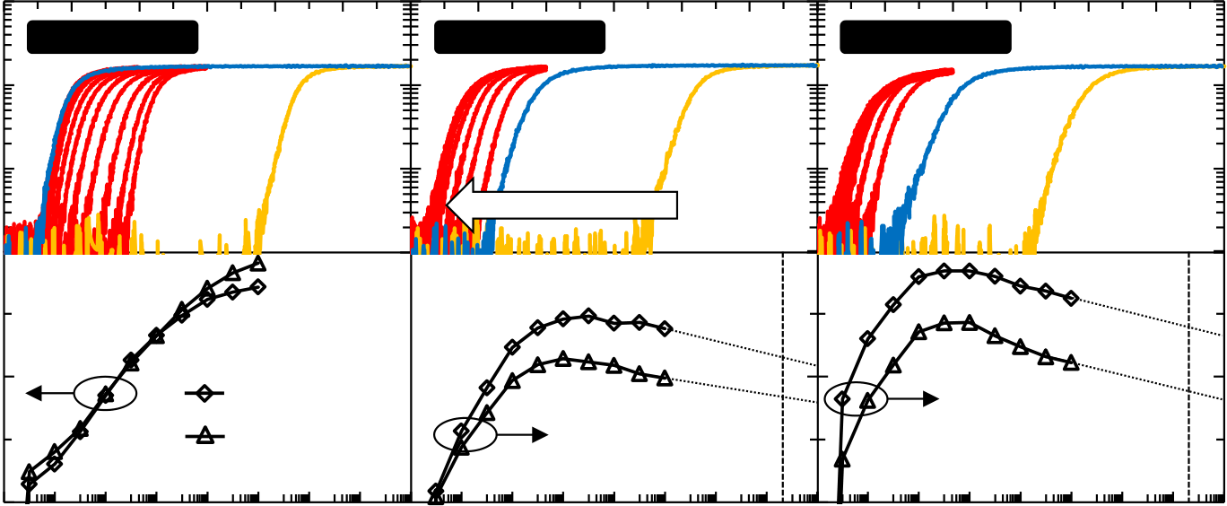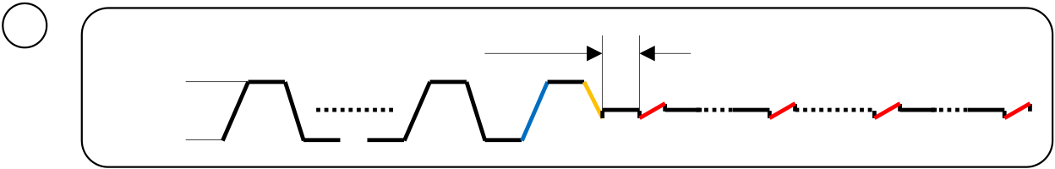

ELECTRICAL CHARACTERISTICS OF SI:HFO2-BASED FEFETS

afterwards applied after each decade of delay which enabled the analysis of the transient VT evolution from 10 s to 104 s delay time (Fig. 4-12 (a)). Using a common NVM nomenclature, the test can actually be described as a (fast) retention after cycling test. Hence, it extends standard retention tests by a transient analysis down to the microsecond regime and additionally parameterizes it in terms of previously applied stress cycles.

|  |  |  |  |  |  |
| --- | --- | --- | --- | --- | --- |
| a | +5V | 102x / | 10 µs | 100 µs | 104 s |
| 104x |

-5V

Gate Voltage [V]

|  |  |  |  |  |  |  |  |  |  |  |
| --- | --- | --- | --- | --- | --- | --- | --- | --- | --- | --- |
|  | 10-2 | **5.7 mol%** | -1 | 0 | 1 | 2 | 3 | 4 | 5 | **3.5 mol%** |
| *ID* [A] | 10-3 | **4.5 mol%** | |
| 10-4 |

retention time

|  |  |  |  |  |  |  |  |  |  |  |  |  |
| --- | --- | --- | --- | --- | --- | --- | --- | --- | --- | --- | --- | --- |
| Trap Window [V] | 10-5 | 102x 5V | -6 -4 -2 | 0 | 2 | 4 | 6 | 10 y | 10 | 10 y | 1.25 | FE Window [V] |
| -0.2 | 1 |
| -0.6 | 0.75 |
| -1 | 104x 5V | 0.5 |
| -1.4 | 8 | 0.25 |

Log Retention Time [s]

Fig. 4-12: Transient VT evolution / retention after cycling. (a) Applied pulse train with color coded measurement segments as they reappear in (b) Id-Vg characteristics of all measurement segments for a 102x cycled device (top). The extracted VT after 102x and 104x cycling shows a ferroelectric window for 4.5 mol% and 3.5 mol% whereas the trap window of the 5.7 mol% concentration decays logarithmically (bottom).

As it was observed in Fig. 4-11 and reappearing in Fig. 4-12 (b), the VT extracted from the falling edge of the program pulse is severely shifted due to electron trapping. However, for the ferroelectric compositions, already after the shortest delay time of 10 s a finite ferroelectric memory window appears (the memory window is calculated as the extracted VT after the respective delay period minus the erase reference VT). The memory window grows for delay times up to approximately one second and then starts to decay logarithmically. This also explains the proper visibility of the memory window for tests which are alternatingly employing write pulses and (quasi-) DC Id-Vg characterization (e.g. program / erase matrices). There, the delay time between applying a write pulse and switching to source-measurement-units (SMU) for (quasi-) DC drain current measurement is at least one second.

By extrapolating the transient VT-characteristics to ten years it can be verified that ferroelectric memory characteristics can be maintained. This validates proper retention after cycling which represents an essential benchmark for the realization of a non-volatile memory.

For the antiferroelectric concentration, the behaviour is, once again, quite different: Besides the fact that the erase reference VT is at a much lower value, the time required to detrap all electrons appears to be much longer. However, caution should be exercised when making this comparison with respect to the ferroelectric concentrations: It cannot be ruled

79

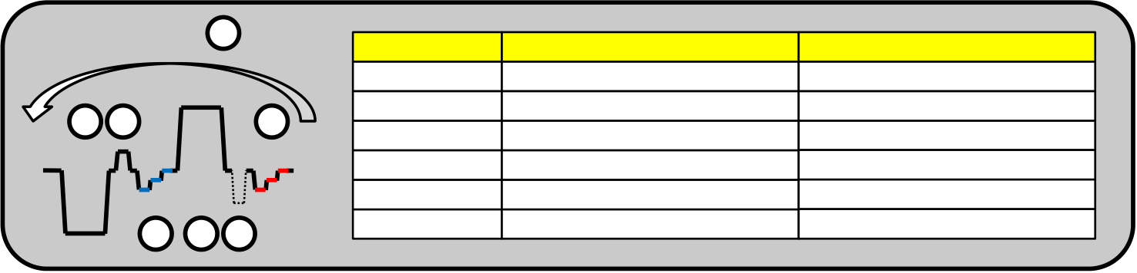

ELECTRICAL CHARACTERISTICS OF SI:HFO2-BASED FEFETS

out that also for the ferroelectric compositions, electrons might be detrapped even in between one second and 104 seconds retention time. This might simply not be visible due to the superposition of the ferroelectric memory window.

4.3.3Transistor Access Time

In the previous sections, single pulse Id-Vg measurements revealed that instantaneous read after program is not feasible for FeFET devices. Nevertheless, fast retention characteristics demonstrated that a ferroelectric memory window is again present after 10 s delay time. However, a one second delay time was required to reach the maximum ferroelectric memory window.

In order to improve read speed and margin after program, a read operational scheme can be applied which is based on the utilization of detrap pulses. In general, after a write operation, a pulse of reduced and inverted polarity is applied in order to detrap charge carriers that might have been injected previously. Due to the fact that an erased state could immediately be read out after the application of a negative gate pulse (see e.g. Fig. 4-11 or Fig. 4-12), the analysis focused on an acceleration of the low-VT state read out. Another pulse train was defined for the determination of the required negative detrap pulse that has to be applied after a program operation (Fig. 4-13).

|  |  |  |  |  |  |  |  |
| --- | --- | --- | --- | --- | --- | --- | --- |
| Loop for e | | | e | f | Segment | Function | Parameterization |
| a | b | | a | Erase reference | -5 V / 10 us |
| b | Hole detrap pulse | 1.5 V / 1 us |
| c | Read OFF current | (-1V; -0.5V; 0V) / 1 us |
| c | | d | d | Program reference | +5 V / 10 us |
| e | Electron detrap pulse | 0V…3V/ 100ns…100us |
| f | Read ON current | (-1V; -0.5V; 0V) / 1 us |

Fig. 4-13: Pulse train definition for analysis of transistor access time. The electron detrap pulse was parameterized in terms of pulse width and amplitude whereas the hole detrap pulse was kept constant. Tri-level read out segments are color coded for erased (blue) and programmed state (red).

The pulse train which was applied first sets an initial erased VT state by applying a pulse of -5 V / 10 s. 100 nanoseconds afterwards, a small hole detrap pulse of 1.5 V / 1 s is applied in order to ensure that no trapped holes artificially raise the drain current in the succeeding read operation. The off-state drain current of the FeFET is sensed at three voltages levels (-1 V, -0.5 V and 0 V) which all have a duration of 1 s. This ensures maximum read speed while at the same time influencing the written state as little as possible. For a real circuit, the transition times and read durations can of course be chosen in the nanosecond regime. For a standard probe station setup prone to significant RC parasitics, a read duration should not fall below 1 s. After the erased state is read, a program operation of +5 V / 10 s follows. Similar to the erase detrap pulse, but obviously opposite in polarity, an electron detrap pulse is applied 100 ns after program. The pulse was parameterized in terms of its pulse width and amplitude ranging from 0 V to -3 V and from 100 ns to 100 s. Again 100 nanoseconds afterwards, the same read operation as for the erased state was repeated. Hence, the on-current of the device was read out and divided by the previously extracted off-current which enabled the derivation of ION/IOFF contour plots (Fig. 4-14).

80

ELECTRICAL CHARACTERISTICS OF SI:HFO2-BASED FEFETS

|  |  |  |  |  |  |  |
| --- | --- | --- | --- | --- | --- | --- |
| **3.5 mol %** | **VRead = -1 V** | **VRead = -0.5 V** | | **VRead = 0 V** | 10-4 | |
|  | | | |
| 510-5 10-5  510-6 10-6  510-7 | Pulse Width [s] |
| 10-7 | |
| **4.5 mol %** |  | | | | |  |  |  |  |  |  |  |  |  |  |  |  |  |  |  |  |  |  |  |  |  |  |  |  |  |  |  | | --- | --- | --- | --- | --- | --- | --- | --- | --- | --- | --- | --- | --- | --- | --- | --- | --- | --- | --- | --- | --- | --- | --- | --- | --- | --- | --- | | |  |  | | --- | --- | | ***ION* / *IOFF*** | | | |  | | --- | |  | | 103 - 104 | | |  | | --- | |  | | 102- 103 | | |  | | --- | |  | | 101 - 102 | | |  | | --- | |  | | 100 - 101 | | |  | | --- | |  | | 10-1 - 100 | | |  | | --- | |  | | 10-2 - 10-1 | | |  | | --- | |  | | 10-3 - 10-2 | | |  | | --- | |  | | 10-4 - 10-3 | | | |
| **5.7 mol %** |  | | | |
| 0 | -1 | -2 | -3 |

Detrap Pulse [V]

Fig. 4-14: Transistor access time in terms of ION/IOFF contour plots. For all material compositions, read out was performed at three different gate voltage levels. The on-current to off-current ratio is parameterized in terms of the amplitude and width of the detrap pulse. The absolute magnitudes of the ION/IOFF ratios are limited by the off-current resolution of the measurement setup.

In general and for all measurements performed, the absolute value of the ION/IOFF ratio was limited by the current resolution of the PMU. For pulse durations of 1 s as they were used during read operation, no current below 10 A can be sensed. Hence, ION/IOFF ratios given in Fig. 4-14 are actually much larger due to the fact that off currents generally lie in the range of 1 nA (see Fig. 4-3). Furthermore, results for detrapping pulse widths below 500 nanoseconds have to be treated with caution since the RC time constant of the measurement setup is in the same range.

For the 3.5 mol% composition, a read level of -0.5 V led to the highest ION/IOFF ratio. The interrelation between detrap amplitude and pulse width was approximately exponential which is a reasonable finding for the expected detrapping process. Moreover it is interesting to see that even for a -3 V/100 s detrap pulse, the ION/IOFF ratio remains in the range of 102 - 103. Due to the fact that erase voltages are generally in the range of -5 V to -6 V, the -3 V/100 s detrap pulse actually disturbs the programmed state by half of the actual erase voltage. This could in principle lead to a (partial) loss of the programmed state which would in turn reduce the ION/IOFF ratio. A more detailed study on the effects of disturb signals will be given in subsection 5.3.2.

For the 4.5 mol% composition, the ideal read out voltage shifts to 0 V whereas for these FeFETs, a clear disturb of the programmed state is visible: Detrap amplitudes which are too large in terms of their absolute magnitude start to erase the FeFET which in turn leads to a reduction in ION/IOFF ratio.

81

ELECTRICAL CHARACTERISTICS OF SI:HFO2-BASED FEFETS

Concluding on the transistor access times after program, within a real memory circuit with small RC parasitics, read access could be provided in the nanosecond regime for detrap voltages between -2 V and -3 V. This however comes at the expense of jeopardizing the stability of the written state due to the fact that the detrap voltages are approaching the disturb tolerance limit of the FeFET. Depending on the requirements set by the memory application, reduced access times in the microsecond regime might be used in order to decrease the probability of unwanted state disturb.

Finally, the results for the antiferroelectric composition show that due to the more positive and significantly steeper Id-Vg characteristics, only the read at 0 V is able to probe both erased and programmed state. The slow transient detrapping characteristics observed for fast retention measurements (Fig. 4-12) are again confirmed in the access time measurement: Only very negative amplitudes together with long pulse widths are able to detrap the FeFET device such that the ION/IOFF ratio approaches unity.

In summary, the electrical characterization of FeFETs revealed that the superposition of charge trapping phenomena and the ferroelectric switching complicates device analysis quite significantly. This chapter shall be concluded by some important remarks that can serve as general guidelines for analysis and interpretation of FeFET device characteristics:

• The 1:1 transfer of MFM material properties to the FeFET cannot be taken for granted. Since Si:HfO2 is grown on a SiON interface layer, interdiffusion of silicon cannot be ruled out. This will ultimately shift the most appropriate molar concentration providing the best ferroelectric hysteresis. This is confirmed by the fact that the FeFETs with 4.5 mol% silicon incorporated have the most proper ferroelectric memory characteristics.

An imprinted ferroelectric state needs to be considered based on the virgin VT•  
and based on the absolute VT states after program and erase. In order to at least detect imprint for the Si:HfO2 system, write voltages have to be raised to levels which are close to gate stack breakdown. An alternative to this can be seen in biasing the DUTs at DC voltages while at the same time heating up the wafer. This might reveal / remove an imprint for the ferroelectric material.

• Depending on the silicon concentration incorporated into the host lattice, the dielectric permittivity for the ferroelectric will change quite significantly. This will change the overall voltage divider for the MFIS stack which in turn leads to e.g. different interfacial and high-k field stress for the same gate voltages applied.

• The coercive voltage and the remanent polarization of Si:HfO2 depend significantly on dopant species / concentration, film thickness and thermal treatment of the film. These ferroelectric parameters in turn have severe influence on interfacial field stress and the depolarization field which drive degradation as well as ferroelectric relaxation.

82

FEFET CELL ARRAY STUDY

5FeFET Cell Array Study

Besides single memory cells, in order to develop volatile or non-volatile memories with reasonable bit density, array architectures have to be defined such that the periphery overhead (i.a. decoders) is kept at a minimum. Hence, memory cells need to share their terminals by means of common signal lines which are i.a. called word-, bit- or sourceline. For both volatile as well as non-volatile memories, several solutions have been found in the past which balance the need for high bit density and reliable memory operation. The first section of this chapter is devoted to the discussion of classical non-volatile memory architectures and their applicability to FeFET memory cells in terms of their operational principle. Furthermore, alternative memory architectures, partially derived from volatile memory architectures, are presented and discussed as well. The theoretical concepts of memory array operation are furthermore verified and validated by (mixed-mode) TCAD simulations and experimental findings for FeFET multi structures.

5.1Cell Array Concepts based on Classical Non-Volatile

Memory Architectures

Due to the analogy of the memory state representation in FeFET and Flash devices, i.e. the shift in threshold voltage depending on the written state, the applicability of Flash architectures is discussed first. The most dominant architectures are called NAND and NOR according to their Boolean relation between input (wordline) and output (bitline). Moreover, derived from the NOR architecture, the AND array represents another alternative to connect memory cells to common signal lines [208]. In the following, the architectures and their corresponding FeFET operational schemes are discussed.

|  |
| --- |
|  |

|  |  |  |  |  |  |  |  |  |
| --- | --- | --- | --- | --- | --- | --- | --- | --- |
| |  | | --- | |  | | | | |  | | --- | |  | | | |  |
|  | |  | |  |  |
|  | | |  | | |
|  |  | | | | |

Fig. 5-1: AND, NOR and NAND FeFET memory array unit cells. The major difference between the first two concepts is represented in the way sourcelines are shared between neighboring cells. The NAND architecture is quite different from AND and NOR since cells are series connected.

In all architectures, cells in one row share their gate contacts with each other by a common connection to the wordline WL. Furthermore, for AND / NOR, drain contacts are shared between cells in one column by means of connection to the bitline BL. For the NAND architecture this is in principle true as well, whereas access to the bitline is provided by series connection of transistors (the so called string).

83

FEFET CELL ARRAY STUDY

AND and NOR architectures have classically been used for Flash memories which require random read capability [167], i.e. fast read access to individual bits has to be provided. Due to the fact that severeal application specific implementations of NOR and AND architectures have been developed during the last decades, these architectures are distinct in various ways. For instance, one of the differences between AND and NOR can be represented by the way the connection to the bitline is achieved: For the NOR architecture, two cells are always contacted directly to the first metal layer whereas for the AND architecture a diffused bitline is used. This enables a slightly smaller cell size for the AND architecture as compared to the NOR architecture (8F2 as compared to 10F2, whereas F represents the smallest feature size of a technology node [29]). This in turn results in a slower operation of the AND architecture due to the higher resistance of the diffused bitline. In case the source areas are not common to all cells in a memory block, there is also a difference in the way the sourceline SL is shared: For the AND architecture, cells in one column share their source contacts whereas for the NOR architecture this is the case for cells in one row. This has no immediate relevance for Flash-based cells (Flash memory blocks in general have a common sourceline) but provides an additional degree of freedom with respect to disturb inhibition of FeFET cells as will be shown later on. Moreover, the NAND architecture is quite different from both AND and NOR due to the fact that the memory cells are serially connected in a string. Access to the strings of memory cells is provided by the so called select gates (Select-Gate-Drain SGD and Select-Gate-Source SGS). The source is common to all cells in one memory block. The major advantage of this architecture lies in the sharing of source and drain regions between transistors which minimizes the cell size to 4F2. The advantage of high bit density comes at the price of a reduced drain current due to the series connection of several transistors. This is one of the reasons why the NAND architecture is more useful for data than for code storage.

The fourth terminal of the FeFET, i.e. the bulk contact, is omitted in the cell array analysis due to the fact that the well / bulk is considered to be common to all FeFETs. A non-common bulk contact has been discussed in the past [199] and seems only possible with specific integration schemes [192]. Even though this was not considered in this study, it represents a promising approach especially with respect to disturb inhibition.

Since the program and erase physics behind Flash devices are fundamentally different from FeFET devices, operational schemes of the array architectures will vary as well. First, the AND array is analyzed by comparing exemplified operational schemes for AND Flash devices [20] to proposed operational schemes for FeFET arrays (Tab. 5-1).

Tab. 5-1: Operational schemes for AND architecture. F represents a floating node.

|  |  |  |  |  |  |  |  |  |  |  |  |  |  |  |  |  |  |  |  |  |  |  |  |  |  |  |  |  |  |  |  |  |  |  |  |  |  |  |  |  |  |  |  |  |  |  |  |  |  |  |  |  |  |  |  |  |  |  |  |  |  |  |  |  |  |  |  |  |  |  |  |  |  |  |  |  |  |  |  |  |  |  |  |  |  |  |  |  |  |  |  |  |  |  |  |  |  |  |  |  |  |  |  |  |  |  |  |
| --- | --- | --- | --- | --- | --- | --- | --- | --- | --- | --- | --- | --- | --- | --- | --- | --- | --- | --- | --- | --- | --- | --- | --- | --- | --- | --- | --- | --- | --- | --- | --- | --- | --- | --- | --- | --- | --- | --- | --- | --- | --- | --- | --- | --- | --- | --- | --- | --- | --- | --- | --- | --- | --- | --- | --- | --- | --- | --- | --- | --- | --- | --- | --- | --- | --- | --- | --- | --- | --- | --- | --- | --- | --- | --- | --- | --- | --- | --- | --- | --- | --- | --- | --- | --- | --- | --- | --- | --- | --- | --- | --- | --- | --- | --- | --- | --- | --- | --- | --- | --- | --- | --- | --- | --- | --- | --- | --- |
| |  |  |  |  |  |  |  |  |  | | --- | --- | --- | --- | --- | --- | --- | --- | --- | |  | AND Architecture | | | | | | | | |  | Operational Scheme | WL (m) | WL (m+1) | BL (n) | BL (n+1) | SL (n) | SL (n+1) | Bulk | | Program Flash (m, n+1) | FN Program | -9V | 0V | 0V | 3V | F | F | 0V | | Erase Flash (m, n+1) | FN WLW Erase | 13V | 0V | 0V | 0V | 0V | 0V | 0V | | Read Flash (m, n+1) | Standard | *V R* | 0V | 0 (1V) | 1V | 0V | 0V | 0V | | Program FeFET (m, n+1) | "*V DD*/2" | 5V | 2.5V | 2.5V | 0V | 2.5V | 0V | 0V | | "*V DD*/3" | 5V | 1.7V | 3.3V | 0V | 3.3V | 0V | 0V | | Erase FeFET (m, n+1) | "*V DD*/2" | -5V | -2.5V | -2.5V | 0V | -2.5V | 0V | 0V | | "*V DD*/3" | -5V | -1.7V | -3.3V | 0V | -3.3V | 0V | 0V | | WLW Erase | 0V | F/5V | F | F | F | F | 5V | | PSDES | 0V | 3.3V | 1.7V | 5V | 1.7V | 5V | 0V | | Read FeFET (m, n+1) | Standard | 0V | -1V | 0 (1V) | 1V | 0V | 0V | 0V | | WL (m) | SL (n) | BL ( |
| WL (m+1) | S |

84

FEFET CELL ARRAY STUDY

It shall again be highlighted that in Flash devices the program operation is in general referred to as the operation that causes electrons to tunnel / to be injected into the floating gate thereby shifting the VT to higher values. On the contrary, the erase operation removes the electrons from the floating gate which causes the VT to shift to lower values. However for the AND Flash architecture, this nomenclature is inverted. Due to the fact that Fowler-Nordheim (FN) tunneling is used in order to reduce power consumption as compared to NOR Flash, bit- or byte-wise write operations can only be provided by extracting electrons via the drain area. Hence, the program operation is achieved by applying -9 V to the selected wordline and +3 V to the selected bitline. This operational scheme works as long as the -9 V gate to drain / bulk disturb for cells in row m and the -3 V gate to drain disturb in row n+1 does not parasitically change the memory state of neighboring cells. The erase operation, which tunnels electrons into the floating gate, is performed by applying 13 V to the selected wordline while keeping bit- and sourcelines on ground (wordline-wise erase = WLW-erase). Depending on the parallelization of the read, several bitlines are driven to 1 V while applying a read bias to the selected wordline.

For the exemplified FeFET operational schemes, an n-channel FeFET is considered whereas the following is assumed in addition: Based on a 10 nm ferroelectric Si:HfO2 thin film, the FeFET program / erase voltages will be in the range of  5 V (see e.g. chapter 3 and 4). Moreover, the memory window shall by symmetric around 0 V gate voltage with a MW size of approximately 1 V. Hence, the programmed VT is at -0.5 V whereas the erased VT lies at 0.5 V.

As mentioned already in chapter 1, due to the non-ideal ferroelectric hysteresis, state loss due to disturb signals is more severe for FeFETs as it is the case for Flash devices. Hence, the write operations applied to one FeFET cell must not affect the polarization state of neighboring cells. A well-known approach in order to inhibit neighboring cells from being parasitically written is given by the so called "VDD/2" and "VDD/3" scheme [41, 199]. For the program operation, i.e. writing the selected cell to the low-VT state, neighboring bit- and sourcelines are raised to 2.5 V (VDD/2) or 3.3 V (VDD/3) in order to decrease the electric field across cells which are not supposed to be programmed. Hence, both schemes can reduce the program disturb to one half or one third of the program voltage (5 V). The reduced disturb provided by the VDD/3 scheme is however counteracted by an additional voltage level that has to be generated by peripheral circuits and also timing of the inhibit signals becomes more complicated as will be shown in section 5.3.1. It shall moreover be mentioned that for the VDD/3 scheme a proper program inhibition for cells sharing the selected wordline can only be achieved if the theoretical disturb voltage of VDD/3 is still larger than VT. Otherwise, there will be no inversion channel created providing the required link to the source and drain regions to which the inhibit signals are applied. In the exemplified case, the VDD/3 disturb voltage amounts to 1.7 V which is still significantly larger than the erased VT of 0.5 V. Hence, the 3.3 V inhibit signal will properly transfer underneath the gate stack.

For the erase operation, which is in general represented by writing a high VT state using a negative gate gate voltage, the schemes can be applied in a similar manner, however only with severe drawbacks: Under the assumption that the bulk is common to all cells in one memory block, it has to be kept on ground in order to provide a proper erase operation of the selected cell. Due to the forward bias of the bulk to source / drain diodes in neighboring array columns (negative inhibit voltages on n++ regions), this would however cause severe current flow to occur from bulk to source / drain. An unacceptable condition if data needs to be written continuously. Hence, at first sight it seems that the smallest entity to be erased is again wordline-wise. That is, 5 V are applied to the bulk whereas the selected

85

FEFET CELL ARRAY STUDY

wordline is put on ground and unselected wordlines are either kept floating or are raised to 5 V depending on capacitance of the wordlines.

Though, during the course of this thesis an alternative so called "positive-source-drain-erase-scheme" (PSDES) was proposed. The scheme applies positive write voltages to both source- and bitlines of the column in which the cell to be erased is situated. By that, block-, WLW- and bit-erase can be achieved (Fig. 5-2).

|  |  |  |  |  |  |  |  |  |  |  |  |
| --- | --- | --- | --- | --- | --- | --- | --- | --- | --- | --- | --- |
|  | **PSDES Bit-Erase** | | |  | **PSDES WLW-Erase** | | |  | **PSDES Block-Erase** | | |
| WL = 0 V | **BL = 1.7 V or F** | | **BL = 5 V** | WL = 0 V | **BL = 5V** | | **BL = 5V** | WL = 0 V | **BL = 5V** | | **BL = 5V** |
|  | | |  | | |  | | |
| **WL = 3.3 V** | **WL = 5V** | WL = 0 V |
| **or F** | **or F** |
| **SL = 1.7 V or F** | **SL = 5 V** | | **SL = 5V** | **SL = 5V** | | **SL = 5V** | **SL = 5V** | |
| Bulk = 0 | | | Bulk = 0 | | | Bulk = 0 | | |

Fig. 5-2: Positive-Source-Drain-Erase-Scheme. The granularity of the erase ranges from single bit-erase over WLW-erase up to block erase. Cells exposed to positive source / drain voltages are erased in case the wordline is set to 0 V.

It is important to emphasize that there is a clear difference between the PSDES and similar operational schemes for Flash devices which also use positive source or drain voltages to achieve a low-VT state [17]: First and foremost, the negative voltage difference between gate and source / drain induces the high-VT state for FeFETs and not the low-VT state as it is the case for Flash devices. This is, however, an obvious result due to the inverted VT control of the FeFET with respect to the electric field across the gate stack. The most important difference is represented by the fact that the PSDES only works for short channel devices since it depends both on the homogeneity of the electric field distribution inside the gate stack as well as on an operation close to or in punch through. Strictly speaking, the PSDES works best for gate stacks which possess a certain aspect ratio such that the electric field inside the gate stack is sufficiently uniform (see also section 5.3.1). As shown in Fig. 5-2, the PSDES can then be applied in various ways depending on the requirements of the application. If a whole memory block shall be erased, all source- and bitlines are raised to 5 V whereas the wordlines are kept at ground (obviously a standard positive bulk erase would fulfill the same purpose). A WLW-erase can also be achieved using the PSDES by applying 5 V to all source- and bitlines while only the wordline to be erased is set to ground. Depending on the wordline capacitance, non-selected wordlines are either kept floating or raised to 5 V as well. If an application requires a true random erase operation, the PSDES provides a single bit erase capability as well. Neighboring columns are raised to 3.3 V and unselected wordlines are raised to 1.7 V, similar to the program inhibit approach. Again, depending on word-, source- and bitline capacitances, unselected signal lines can be floating, too.

With respect to the read operation and depending on the amount of parallelization that can be provided by the periphery, multiple bitlines are raised to 1 V in order to enable proper read current for sensing. Due to the fact that the low-VT state was defined to lie at -0.5 V, an erased cell to be read can mistakenly be interpreted as programmed since

86

FEFET CELL ARRAY STUDY

programmed cells in the same coulum draw current even at zero gate bias. Therefore, an inhibit signal, e.g. -1 V, has to be applied to unselected wordlines in order to put potentially programmed cells into a non-conducting state. With respect to power consumption during read, it is therefore essential to shift the FeFET low-VT state to above 0 V (e.g. by adjusting the threshold voltage or source / drain implant conditions). On the other hand, it has been shown in the past that i.a. program disturb and data retention of FeFETs are highly susceptible to the positioning of the threshold voltage [52].

In general, the power consumption of operating schemes utilizing inhibit signals always needs to be taken into account. Hence, for product applications a tradeoff between high bit density and low power consumption is required. However, compared to e.g. NOR Flash, which will be covered next, at least the power consumption due to program inhibition is still anticipated to be much lower than the power consumption caused by CHE currents.

Tab. 5-2: Operational schemes for NOR architecture.

|  |  |  |  |  |  |  |  |  |  |  |  |  |  |  |  |  |  |  |  |  |  |  |  |  |  |  |  |  |  |  |  |  |  |  |  |  |  |  |  |  |  |  |  |  |  |  |  |  |  |  |  |  |  |  |  |  |  |  |  |  |  |  |  |  |  |  |  |  |  |  |  |  |  |  |  |  |  |  |  |  |  |  |  |  |  |  |  |  |  |  |  |  |  |  |  |  |  |  |  |  |  |  |  |  |  |  |
| --- | --- | --- | --- | --- | --- | --- | --- | --- | --- | --- | --- | --- | --- | --- | --- | --- | --- | --- | --- | --- | --- | --- | --- | --- | --- | --- | --- | --- | --- | --- | --- | --- | --- | --- | --- | --- | --- | --- | --- | --- | --- | --- | --- | --- | --- | --- | --- | --- | --- | --- | --- | --- | --- | --- | --- | --- | --- | --- | --- | --- | --- | --- | --- | --- | --- | --- | --- | --- | --- | --- | --- | --- | --- | --- | --- | --- | --- | --- | --- | --- | --- | --- | --- | --- | --- | --- | --- | --- | --- | --- | --- | --- | --- | --- | --- | --- | --- | --- | --- | --- | --- | --- | --- | --- | --- | --- |
| |  |  |  |  |  |  |  |  |  | | --- | --- | --- | --- | --- | --- | --- | --- | --- | |  | NOR Architecture | | | | | | | | |  | Operational Scheme | WL (m) | WL (m+1) | BL (n) | BL (n+1) | SL (m) | SL (m+1) | Bulk | | Program Flash (m, n+1) | CHE Injection | 12V | 0V | 0V | 5V | 0V | 0V | 0V | | Erase Flash (m, n+1) | FN Erase | -8V | 0V | F | F | 5V | F | 0V | | Read Flash (m, n+1) | Standard | *V R* | 0V | 0 (1V) | 1V | 0V | 0V | 0V | | Program Cell (m, n+1) | "*V DD*/3" | 5V | 1.7V | 3.3V | 0V | 0V | 0V | 0V | | "*V DD*/3" low power | 5V | 0V/-1V | 3.3V | 0V | 3.3V | F/0V | 0V | | WLW Program | 5V | 0V | 0V | 0V | 0V | 0V | 0V | | Erase Cell (m, n+1) | "*V DD*/3" | -5V | -1.7V | -3.3V | 0V | -3.3V | 0V | 0V | | PSDES | 0V | 0V/2.5V | F | 5V | 5V | F/5V | 0V | | Block Erase | 0V | 0V | F | F | F | F | 5V | | Read Cell (m, n+1) | Standard | 0V | 0V/-1V | 0 (1V) | 1V | 0V | F/0V | 0V | | WL (m) | BL ( |
| WL (m+1) |

As compared to AND, the NOR architecture has been introduced much earlier for Flash and has ever since remained the workhorse for applications requiring faster single byte program and random read operations [10]. Due to the long history of NOR Flash, many development stages have been passed accompanied by several changes for operating the array. However, the general programming scheme is still based on channel hot electron (CHE) injection. As an example, the gate and drain bias is raised to 12 V and 5 V respectively which causes a severe acceleration and avalanche multiplication of electrons in the channel. Due to the energy gain these electrons experience, charge injected into the floating gate happens at the drain side [20]. Writing the low-VT state for NOR Flash (erase operation) is similar to the program operation of AND Flash: By applying a negative gate and a positive source voltage, electrons are removed from the floating gate via FN tunneling. The read is identical to the AND architecture, only that the speed is higher due to the direct bitline contact of each cell (that however increases the cell size by 2F2).

Assuming again the existence of sourcelines common only to a fraction of cells in an array (one sourceline per row), the difficulty in utilizing the NOR architecture for FeFETs is caused by the fact that wordlines are running in parallel to sourcelines (see Fig. 5-1). If a VDD/3 scheme is applied to program FeFET NOR arrays, unselected bitlines are raised to 3.3 V whereas the selected bitline and the selected as well as unselected sourcelines are kept at ground. The unselected wordlines are raised to 1.7 V in order to decrease the electric field across cells which reside in unslected columns. It is obvious that this scheme will lead to unacceptable power consumption during program due to current flow occurring in all cells except the ones sharing the coulumn with the selected cell. Moreover, the proper

87

FEFET CELL ARRAY STUDY

functionality of program inhibition for cells which share the same wordline is questionable. The effectiveness of the inhibit signal depends on the voltage drop across the channel region which in turn depends on the load connected to the source (the sourceline).

In order to reduce power consumption due the described parasitic current flow, 3.3 V can be applied to the selected sourceline in addition. This VDD/3 low-power scheme will improve the program inhibition for cells sharing the selected wordline due to the fact that both source and drain regions are then raised to 3.3 V. In addition the unselected rows can either be grounded or have to be inhibited by -1 V depending on the availability of separate or common sourcelines. In total, this scheme limits the parasitic current flow during program to the selected cell. However, similar to the questionable program inhibition for the standard VDD/3 scheme, the effectiveness of the program operation remains to be proven. In order to program cell (m, n+1), the 3.3 V applied to SL (m) have to drop properly across the channel region which depends on the load connected to the selected bitline. If the load is high, only a small portion of the 3.3 V sourceline bias will drop across the channel region which in turn inhibits the proper programming of the selected cell.

In order to eliminate parasitic current flow altogether, WLW-programming can be applied as indicated in Tab. 5-2. Apparently, a bit-wise erase scheme needs to be provided in turn. As mentioned for the AND architecture, the VDD/3 scheme using a negative gate erase will not work due to the parasitic current flow through unselected source / drain junctions. However, the proposed PSDES can be applied to the NOR architecture as well. By raising SL(m) and BL(n+1) to 5 V while keeping WL(m) at ground, cell (m,n+1) can be erased. Cutting off unselected bitlines via pass transistors eliminates current flow through potentially programmed cells sharing the selected bitline. Moreover, the source side disturb of the cells sharing the selected wordline is not supposed to be sufficient to change the polarization state. If the sourceline is common to all cells in the array, then an additional 2.5 V has to be applied to non-selected wordlines in order to inhibit erasure of non-selected cells in the selected column.

Last but not least, a standard bulk erase scheme can of course also be performed under the condition that one of the proposed single-bit programming schemes can be applied. Furthermore, for the read operation and in case of a negative programmed VT, a read inhibition of unselected wordlines has to be applied if sourcelines are common to all cells. If separate sourcelines are available, no read inhibition has to be provided for the NOR architecture due to the orthogonality of bit- and sourcelines.

The last of the classical non-volatile memory architectures that shall be discussed for a FeFET application is represented by the NAND array. The use of FeFETs for NAND architectures has been proposed and demonstrated in the past [221] and was suggested as a Solid-State-Disk (SSD) replacement [105]. The operational schemes are quite different from those suggested for AND and NOR due to the fact that source and drain contacts can only be accessed via the series connection of multiple transistors. Tab. 5-3 lists the proposed operational schemes for FeFET NAND arrays.

Tab. 5-3: Operational schemes for NAND architecture.

|  |  |  |  |  |  |  |  |  |  |  |  |  |  |  |  |  |  |  |  |  |  |  |  |  |  |  |  |  |  |  |  |  |  |  |  |  |  |  |  |  |  |  |  |  |  |  |  |  |  |  |  |  |  |  |  |  |  |  |  |  |  |  |  |  |  |  |  |  |  |  |  |  |  |  |  |  |  |
| --- | --- | --- | --- | --- | --- | --- | --- | --- | --- | --- | --- | --- | --- | --- | --- | --- | --- | --- | --- | --- | --- | --- | --- | --- | --- | --- | --- | --- | --- | --- | --- | --- | --- | --- | --- | --- | --- | --- | --- | --- | --- | --- | --- | --- | --- | --- | --- | --- | --- | --- | --- | --- | --- | --- | --- | --- | --- | --- | --- | --- | --- | --- | --- | --- | --- | --- | --- | --- | --- | --- | --- | --- | --- | --- | --- | --- | --- |
| |  |  |  |  |  |  |  |  |  |  |  | | --- | --- | --- | --- | --- | --- | --- | --- | --- | --- | --- | |  | NAND Architecture | | | | | | | | | | |  | Operational Scheme | SGD | WL (m-1) | WL (m) | WL (m+1) | SGS | BL (n) | BL (n+1) | SL | Bulk | | Program Cell (m, n+1) | TPI | 2.5V | 2.5V | 4V | 0V | 0V | 2V | 0V | 0V | 0V | | GSBPI | 1.1V | 3.1V | 5V | 0V | 0V | 1.1V | 0.6V | 0V | 0V | | LSBPI | 1.1V | 0V - 1.1V | 5V | 0V | 0V | 1.1V | 0V | 0V | 0V | | Erase Cell (m, n+1) | Block Erase | 0V | 0V | 0V | 0V | 0V | F | F | F | 5V | | Read Cell (m, n+1) | Standard | 0.5V | 0.5V | 0V | 0.5V | 0.5V | 1V | 1V | 0V | 0V | | SGD | BL ( |

WL (m-1)

88 WL (m)

WL (m+1)

FEFET CELL ARRAY STUDY

The first programming scheme is derived from the Traditional Program Inhibit (TPI) pattern of the NAND architecture [187]. In order to program cell (m,n+1), the corresponding wordline is raised to 5V and access to the bitline is provided by applying a pass voltage of 2.5 V to all cells which lie closer to the bitline than the cell to be programmed. For the string in which the cell to be programmed is situated, the bitline is kept at ground. The worst case pass voltage disturb for erased cells in the selected string passing through the ground potential then amounts to less than 2 V (2.5 V minus VT,ers and the voltage drop across the interface layer). Furthermore, assuming that a FeFET can also be programmed with 4 V (e.g. by utilizing a longer pulse width, see section 2.2), it enables the programming of the low-VT state for the selected FeFET cell. Bitlines of unselected strings are raised to 2 V in order to force the inhibit voltage underneath the selected wordline. By this, program disturb can actively be minimized to less than 2 V for cells sharing wordline m. There is however a clear disadvantage of this, and in general of all schemes requiring voltages on bit- and sourceline that are larger than the logic VDD (in general 1.1 V): On the one hand, periphery transistors have to be used that can withstand these elevated voltages (I/O- or even HV-transistors). On the other hand, more charge pump stages have to be provided to generate the required elevated voltages. This will increase the periphery overhead and therefore decrease the average bit density respectively increase the overall cost of the memory.

In order to eliminate elevated voltage signals on the bitlines, the so called Global-Self-Boost-Program-Inhibit (GSBPI) scheme [172] can be applied. For programming of cell (m,n+1), 5 V and 3.1 V are applied to selected and unselected wordlines respectively. In this scheme, the pass voltage can be defined in a more flexible fashion provided that erased cells on the selected string are not disturbed and that unselected strings are properly cut-off. That is, setting SGD to logic 1.1 V provides the opportunity that strings can either be connected or disconnected by applying 0  VBL (1.1 V - VT,ers = 0.6 V) or VBL 0.6 V to the respective bitlines. Different from the TPI which actively forces an inhibit voltage, the GSBPI capacitively raises the channel potential of unselected strings, the so called "self-boost". Due to the fact that all cells in an unselected string are electrically floating, the channel potential can be raised to approximately 80% of the pass voltage depending on the coupling ratio, i.e. the voltage divider between gate stack and channel to bulk capacitance [172]. For the specific case of a FeFET NAND, this however means that 5 V - 0.8  3.1 V 2.5 V must not disturb the state of program inhibited cells. Moreover, the erased cells in the selected string must not change their state due to the pass voltage disturb they experience. This is why the bitline voltage on the selected string is raised to 0.6 V which is sufficiently low to connect the string via SGD but also sufficiently high to reduce the pass voltage disturb to 2.5 V.

The GSBPI scheme will most likely only be possible if the ferroelectric possesses a high Pr/PS ratio and a small remanent polarization such that it can withstand both pass voltage and program disturb while at the same time properly programming the selected cell.

For further reduction of disturb in NAND architectures, the Local-Self-Boost-Program-Inhibit (LSBPI) scheme [64] seems particularly interesting for the FeFET NAND [220] and represents the last of the programming patterns which is discussed. As compared to the GSBPI, the LSBPI does not boost the channel region of the whole unselected string (globally) but introduces an additional voltage level, the so called "cut voltage", for cells on wordlines directly adjacent to the selected wordline. This voltage level is chosen such that the adjacent cell in an unselected string disconnects the program inhibited cell from the rest

89

FEFET CELL ARRAY STUDY

of the string. This provides an increased boost and therefore less disturb for cells sharing the programmed wordline. Furthermore, the cut voltage is chosen such that it ensures that the adjacent cell in a selected string is still able to pass the bitline voltage to the cell to be programmed. Consequently, by means of introducing Vcut it is possible to reduce parasitic program disturb as well as the pass voltage amplitude since the self-boost is now localized to the cells of the selected wordline.

The erase for a FeFET NAND architecture is identical to NAND Flash and is performed by raising the p-well potential to a voltage which is sufficient to write the high-VT state. For sake of completeness it shall be mentioned that bulk erase schemes always require the existence of an isolated p-well process which is however regularly available at large semiconductor foundries. The read operation is also performed identical to NAND Flash operational schemes, i.e. the wordline of the cell to be read is grounded whereas all other wordlines are biased at a pass voltage larger than VT,ers. Depending on the state of the FeFET to be read, current is either drawn to the sourceline or not.

5.2Multi-Transistor Arrays and Operational Schemes

Besides classical non-volatile 1T memory architectures, so called multi-transistor arrays represent another alternative for realizing memory architectures. Therefore and similar to e.g. DRAM memories, access transistors can be used to decouple memory cells which are not supposed to be written. For Flash-based embedded technologies, e.g. the two-transistor (2T) cell improved scalability [189] and also reduced source-side disturb as compared to alternative architectures like the FLOTOX cell and the split gate cell respectively [89].

Due to the fundamentally different underlying physics of the FeFET as compared to charge storage-based devices, multi-transistor arrays must aim at uniformly reducing the electric field across passive memory cells. Accordingly, access transistors can either be used to disconnect terminals exposed to program and erase signals per se or terminals can be disconnected from any defined potential in order to create an electrically floating node. In Fig. 5-3 different approaches utilizing access transistors are shown.

|  |  |  |  |  |  |  |  |
| --- | --- | --- | --- | --- | --- | --- | --- |
| |  | | --- | |  | | |  | | --- | |  | | | | |  | | --- | |  | |
|  |  |  |
|  |  | | |  |
|  |  |

Fig. 5-3: Multi-transistor arrays. The 2T NOR cell decouples the source of the memory cell whereas the 2T NAND cell adds parallel transistors for each cell and array string. By utilizing a 3T NOR cell, the drain of the memory cell is decoupled as well.

As the careful reader might already have recognized in the previous section, access transistors have to be defined to be of logic, and not of memory type (SGD and SGS, see Fig. 5-1). However, at the point in time when the test chip was fabricated, no dual gate oxide process was available (see section 3.3). Hence, it has to be mentioned that all arrays

90

FEFET CELL ARRAY STUDY

were completely consisting of FeFET transistors. Accordingly, depending on the type of FeFET transistor which is used (i.e. programmed VT smaller or larger than 0 V) care has to be taken that the access transistor is again erased after operation in order to avoid an unwanted normally-on state.

The 2T NOR architecture is derived from the standard NOR architecture whereas an access transistor is added in between the source of the memory FeFET and the sourceline of the respective row of FeFETs. Furthermore, access transistors in one column share the gate contact by connection to the Write Enable Line WEL. As the name suggests, WEL is activated if a cell in the respective column needs to be programmed whereas it is kept on ground for unselected columns. In addition, the 3T NOR array inserts another access transistor between drain and bitline such that two terminals of the memory cell can be decoupled from its surrounding. The amount of write enable lines remains the same since the two access transistors are shorted at the gate. Adding an extra transistor to the NAND array is performed in a quite different manner. Each memory cell is supported by a so called pass transistor whereas the name originates from the purpose the transistor fulfills: By parallel connection via source and drain, the pass voltage disturb of the NAND architecture can be eliminated.

The operational schemes of the multi-transistor arrays are derived from the traditional memory architectures and can resolve some of the disturb issues. This comes however at the prize of a decreased bit density. The desired operating scheme for the 2T NOR architecture is summarized in Tab. 5-4.

Tab. 5-4: Operational scheme for 2T NOR architecture.

|  |  |  |  |  |  |  |  |  |  |  |  |  |  |  |  |  |  |  |  |  |  |  |  |  |  |  |  |  |  |  |  |  |  |  |  |  |  |  |  |  |  |  |  |  |  |  |  |  |  |  |  |  |  |  |  |  |  |
| --- | --- | --- | --- | --- | --- | --- | --- | --- | --- | --- | --- | --- | --- | --- | --- | --- | --- | --- | --- | --- | --- | --- | --- | --- | --- | --- | --- | --- | --- | --- | --- | --- | --- | --- | --- | --- | --- | --- | --- | --- | --- | --- | --- | --- | --- | --- | --- | --- | --- | --- | --- | --- | --- | --- | --- | --- | --- |
| |  |  |  |  |  |  |  |  |  |  |  | | --- | --- | --- | --- | --- | --- | --- | --- | --- | --- | --- | |  | 2T NOR Architecture | | | | | | | | | | |  | Operational Scheme | WL (m) | WL (m+1) | WEL (n) | WEL (n+1) | BL (n) | BL (n+1) | SL (m) | SL (m+1) | Bulk | | Program Cell (m, n+1) | "*V DD*/3" | 5V | F | 0V | 0.5V | 3.3V | 0V | 0V | 0V | 0V | | Erase Cell (m, n+1) | PSDES | 0V | 0V | 0V | 5.5V | 0V | 5V | 5V | 0V | 0V | | Read Cell (m, n+1) | Standard | 0V | 0V | 0V | 0.5V | 0V | 1V | 0V | F | 0V | | WL (m) | WEL ( |

The 2T NOR architecture resolves the problem of parasitic current flow and arguable program (inhibition) functionality which was mentioned for the traditional NOR

|  |  |
| --- | --- |
| architecture in the previous section. However, program inhibit signals still have to be applied to unselected bitlines which leads to additional power consumption due to charging | WL (m+1) |

to 3.3 V. It is furthermore assumed that a 3.3 V disturb (program inhibit for cell (m,n)) or even a 5 V disturb (erase disturb for cell (m+1,n+1)) between drain and gate does not alter the VT-state. In order to reduce power consumption during program operation, a local bitline select transistor can be used to bring the bitline into an electrically floating condition. However, due to the in general large amount of cells connected to one bitline, the bitline capacitance will be too large to provide program inhibition by self-boost.

The erase is again performed by the proposed PSDES. It has to be mentioned that by using the PSDES, access transistors have to withstand gate voltages of at least 5.5 V and source voltages of 5 V such that the sourceline voltage can properly reach the device. Hence, no standard logic transistors can be used which in turn decreases the bit density of the memory. The read operation for the 2T NOR architecture is similar to previous schemes.

The problem of increased power consumption due to utilization of inhibit signals can further be counteracted by adding another select transistor between drain and bitline. This results in the 3T architecture.

91

FEFET CELL ARRAY STUDY

Tab. 5-5: Operational scheme for 3T NOR architecture

|  |  |  |  |  |  |  |  |  |  |  |
| --- | --- | --- | --- | --- | --- | --- | --- | --- | --- | --- |
|  | 3T NOR Architecture | | | | | | | | | |
|  | Operational Scheme | WL (m) | WL (m+1) | WEL (n) | WEL (n+1) | BL (n) | BL (n+1) | SL (m) | SL (m+1) | Bulk |
| Program Cell (m, n+1) | "*V DD*/3" | 5V | 0V | 0V | 0.5V | 0V | 0V | 0V | 0V | 0V |
| Erase Cell (m, n+1) | PSDES | 0V | 0V | 0V | 5.5V | 0V | 5V | 5V | 0V | 0V |
| Read Cell (m, n+1) | Standard | 0V | 0V | 0V | 0.5V | 0V | 1V | 0V | F | 0V |

Hence, program inhibit signals can be avoided altogether since cells sharing the selected wordline are locally self-boosted similar to the LSBPI in the NAND architecture. For single bit erase by PSDES it is again assumed that a 5 V drain side disturb does not alter the programmed state of cells sharing the selected column. Both for 3T and 2T NOR architectures, an alternative erase scheme is of course represented by block wise bulk erase or WLW negative gate erase. Even though bit alterability is then lost, the most energy efficient operating scheme arises for the 3T NOR architecture: In an ideal case, only the selected wordline has to be raised to 5 V for a few nanoseconds while the WEL consumes only power from charging to 0.5 V.

Moreover, adding extra transistors to the NAND architecture aims at avoiding the pass voltage disturb which is occurring for both program as well as read operations. By connecting logic transistors in parallel to the FeFET memory cells, disturbance can be reduced significantly.

Tab. 5-6: Operational scheme for 2T NAND architecture

|  |  |  |  |  |  |  |  |  |  |  |  |  |  |
| --- | --- | --- | --- | --- | --- | --- | --- | --- | --- | --- | --- | --- | --- |
|  | 2T NAND Architecture | | | | | | | | | | | | |
|  | Operational Scheme | SGD | WL (m-1) | WL (m) | WL (m+1) | RL (m-1) | RL (m) | RL (m+1) | SGS | BL (n) | BL (n+1) | SL | Bulk |
| Program Cell (m, n+1) | LSBPI | 1.1V | 0 | 5V | 0 | 0V-1.1V | 0 | 0 | 0 | 1.1V | 0 | 0 | 0 |
| Erase Cell (m, n+1) | Block Erase | 0 | 0 | 0 | 0 | 0 | 0 | 0 | 0 | F | F | F | 5V |
| Read Cell (m, n+1) | Standard | 0.5V | 0 | 0 | 0 | 0.5V | 0 | 0.5V | 0.5V | 0V (1V) | 1V | 0 | 0 |

In the 2T NAND architecture, transfer of the ground potential to cell (m,n+1) can now be provided by raising pass transistors connected to the readline RL to the logic 1.1 V level. This has to be done for all pass transistors having an index smaller than (m-1). At RL (m-1) the cut voltage is applied according to the LSBPI scheme. Hence, the pass disturb, which is most severe for cells in the selected string, is eliminated. Similarly, this is also the case for the read operation where pass voltages are only applied to read lines (except for index m) and all wordlines are kept at ground. However, program disturb for cells sharing the selected wordline remains the same.

5.3Validation and Verification of Proposed Array Concepts

In order to verify the assumptions which were made for defining the array operating conditions, both TCAD simulation as well as electrical characterization can be applied. Finite Element Analysis (FEA), as it is used for TCAD simulation, is i.a. able to accurately calculate the electric field distribution also for more complex transistor geometries as they are used on a 28 nm technology node. By applying the operational schemes which were suggested in the previous sections to a so called mixed-mode simulation model, it is possible to check on the parasitic state loss in a more detailed fashion as it is possible for electrical characterization. However, the simulation model itself has to be validated by results

92

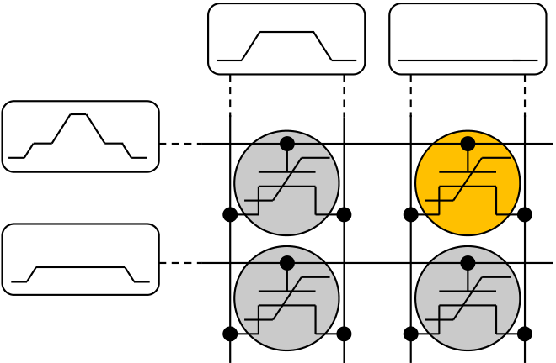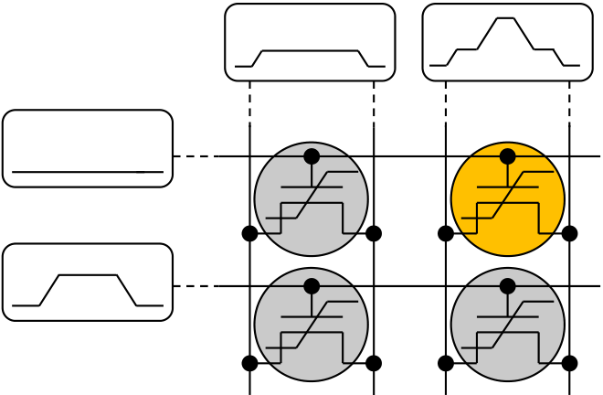

FEFET CELL ARRAY STUDY

obtained from electrical characterization. Both, results from TCAD simulation as well as electrical characterization, are presented in the following subsections.

5.3.1TCAD Simulation of Elementary Array Architectures

As introduced in section 3.2, TCAD simulations can be used to model the memory behavior of ferroelectric field effect transistors. Beyond that, these simulations can be extended to connect multiple 2D or even 3D transistor geometries including the addition of HSPICE compact models. Thus, mixed-mode TCAD simulations are situated in between pure TCAD simulations and compact model simulations like HSPICE. By using this approach it is possible to create memory array unit cells as described in section 5.1 which then serve as the basis for verifying the operational schemes by simulation. In the following, the simulations are limited to the most promising array concepts, i.e. AND and NAND.

At the beginning, the AND array was analyzed with respect to its program / erase characteristics and its related disturbs. Depending on which write operation shall be performed on a FeFET, different worst case disturb scenarios can be identified in terms of the memory array unit cell (Fig. 5-4).

|  |  |  |  |  |  |
| --- | --- | --- | --- | --- | --- |
| WL (m) | **Write low-*VT* state „1“** | | WL (m) | **Write high-*VT* state „0“** | |
| SL / BL (n) | SL / BL (n+1) | SL / BL (n) | SL / BL (n+1) |
| 0 | 0 | 1 | 1 |
| WL (m+1) | 1 | 0 | WL (m+1) | 0 | 1 |

Fig. 5-4: AND array worst case disturb scenarios for a VDD/3 scheme. Cell (1,2) is selected to be programmed (left) or erased (right). Worst case binary states are shown in circles for each cell. Waveforms that are applied to each signal line are delineated.

Worst case scenarios are defined such that the electric field across the gate stack of cells not to be written always counteracts the current binary state. During the program operation of cell (1,2) for example, the inhibit signals that are applied cause a negative voltage drop across cell (2,1) (to be precise, this is the disturb for gate to source / drain). Hence, if the cell has previously been written in a low-VT state ("1") the negative voltage drop will tend to erase the cell. This therefore represents the worst case.

Besides the actual voltage level of the inhibit signals, timing is crucial for the VDD/3 scheme of the AND array. Due to the RC-delay in large memory arrays, it cannot be assumed that pulses reach devices simultaneously. Hence, voltage levels have to be raised consecutively ensuring that all terminals have reached the desired voltage level before increasing / decreasing further. Otherwise, certain cells might experience disturb signals larger than VDD/3 which would in turn lead to the alteration of their binary states. This is the reason why for programming or erasing a FeFET cell in an AND array, tri-level pulses have to be applied.

In order to analyze the degree of disturb depending on the magnitude of the inhibit signal, TCAD simulations were performed for memory array unit cells. Therefore, the worst case initial states were set first and afterwards, the three different disturb scenarios (cell

93

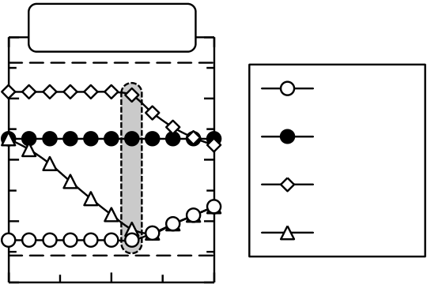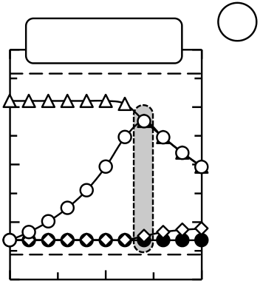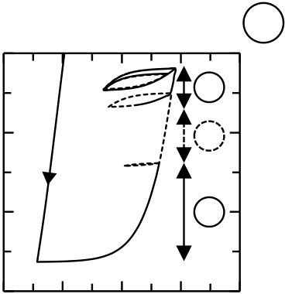

FEFET CELL ARRAY STUDY

(1,1), cell (2,1) and cell (2,2)) were applied to the transistor. The magnitude of the inhibit signal was defined in terms of the inhibit factor inh:

|  |  |  |  |
| --- | --- | --- | --- |
| ( ) | (5-1) | ( ) | (5-2) |
|  |  |
|  |
| ( ) | (5-3) | ( ) | (5-4) |

The selected wordline m was programmed with a 5 V pulse whereas unselected word-, source-, and bitlines where inhibited with a certain voltage parameterized in terms of inh. Depending on the inhibit signal, the loss of threshold voltage was extracted and correlated to the polarization loss of the ferroelectric (Fig. 5-5).

|  |  |  |  |  |  |  |  |  |  |  |  |  |  |  |  |  |  |  |  |  |  |  |  |  |  |
| --- | --- | --- | --- | --- | --- | --- | --- | --- | --- | --- | --- | --- | --- | --- | --- | --- | --- | --- | --- | --- | --- | --- | --- | --- | --- |
| a | *VT* [V] | 1.2 | 0 | P-Disturb | Eref | 1 | b | *P* [µC/cm2] | 0 | -2 | -1 | 0 | 1 | 3 | 2 | c | *VT* [V] | 1.2 | 0 | E-Disturb | Eref | 1 | Cell (1,1) | 1 | |
| 0.8 | 0.8 | 0 | |
| -2 |
| 0.4 | 0.5 | Pref | 2 | 0.4 | 0.5 | Pref | Cell (1,2) | *VT* [V] | 0 |
| -4 | 1 | Cell (2,1) |
| 0 | 0 |
| Cell (2,2) |
| -0 | |
| -6 |
| -0.4 | -0.4 |
| *inh* [1 | |
| *inh* [1] | *EFE* [MV/cm] | | | *inh* [1] |

Fig. 5-5: Simulated program and erase disturb in an AND-architecture (10 nm Si:HfO2). (a) When programming cell (1,2), the least program disturb occurs for an inhibit factor of 0.7 (highlighted in grey). The reference VT after program and erase is shown as dashed line. (b) Polarization loss due to program disturb in cell (1,1) for inh = 0.7. Numerals indicate polarization loss due to (1) depolarization of the erased state, (2) read disturb and (3) program disturb. (c) Erase disturb in a PSDES for erasing cell (1,2).

The material parameters for simulation were again taken from the experimental P-E characteristics of a 10 nm Si:HfO2 film (see Fig. 3-1). After setting the worst case states for program disturb, the reference threshold voltages were extracted first using a wordline sweep from -1.5 V to 1.5 V while biasing the bitlines at 100 mV. Even though the 5 V write amplitude is not sufficient to bring the FeFET into polarization saturation, it suffices to induce a memory window of approximately 1.25 V. Afterwards, the program operation for cell (1,2) was carried out whereas program an inhibit pulses were applied to the signal lines according to Fig. 5-4. Subsequently, another read operation identical to the one used for reference VT extraction was carried out. In Fig. 5-5 (a), the results from these program disturb analysis are shown. First of all it can be observed that when no inhibit pulses are applied, the threshold voltages after program disturb do not reach the respective reference VT. This is caused by the read disturb that occurs when sweeping the wordlines from -1.5 V to 1.5 V. Moreover, the cells sharing the selected wordline, in this case cell (1,1), completely loses its initial erased state because it is programmed in the same manner due to inh = 0. Only for an inhibit factor of 0.7 it is possible to more or less maintain the high-VT state of cell (1,1). For inhibit factors higher than 0.7, the program disturb on both cell (1,1) and cell (2,2) approaches VP/2 which gradually deteriorates the erased state. Even though for inh = 1 and cell (2,1) the disturb voltage across the gate to source / drain region is also VP/2, it does not affect the VT state that severely. This originates from the fact that, different from cell (1,1) and (2,2), the scenario of cell (2,1) represents a disturb of the low-VT state. It is triggered by large positive source / drain potentials which are not as effective

94

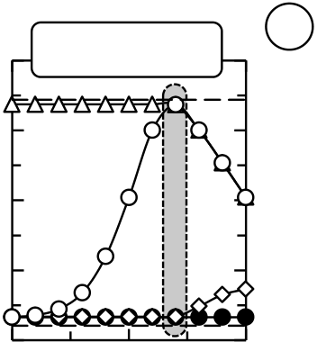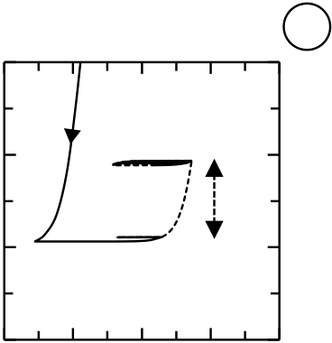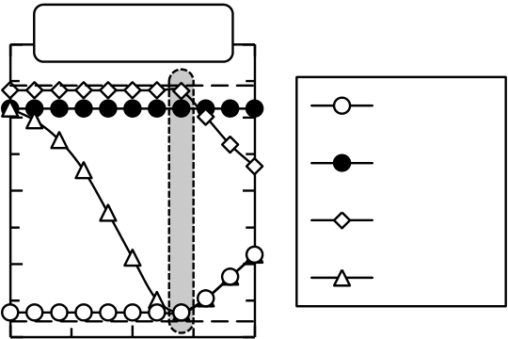

FEFET CELL ARRAY STUDY

in changing the gate stack polarization as e.g. negative gate voltages. This will be explained in the succeeding paragraphs where the erase disturb via PSDES will be analyzed in more detail.

The various origins of polarization loss are again illustrated by the P-EFE characteristics of cell (1,1) in Fig. 5-5 (b). The most severe polarization loss is actually caused by the internal depolarization field which is inherent to the material composition and the FeFET device. Moreover, the read disturb also reduces the polarization by approximately 1.5 C/cm2. The final program disturb reduces the polarization to around 0.5 C/cm2 which is still sufficient to maintain the memory window, i.e. in the case of program disturb the surface charge density is still sufficient to stay in accumulation.

For a bit-wise erase of the AND array, the PSDES was proposed in section 5.1. Therefore, an erase operation as illustrated in Fig. 5-4 was simulated and the disturbs of cells adjacent to cell (1,2) were extracted (Fig. 5-5 (c)). By using 5 V for the PSDES, the high-VT state of cell (1,2) was approximately 300 mV lower than for cell (2,1). This originates from the fact that the initial erased state of cell (2,1) was set by a negative gate erase which is more effective than the PSDES. However, for an inhibit factor of 0.6, a reasonable sense margin of 600 mV can still be maintained (MW between cell (1,2) and (2,2)). The shift of the inhibit factor of about 0.1 between program and erase disturb is also caused by the different effectiveness of positive gate program and positive source / drain erase operation.

In order to illustrate the influence of ferroelectric material parameters on the disturb characteristics, the simulation was also carried out for FeFETs with a 30 nm Si:HfO2 ferroelectric. The ferroelectric properties were again adjusted to those observed in experiments (see section 2.4) and write and read amplitudes were raised to 7 V and 2.5 V respectively.

|  |  |  |  |  |  |  |  |  |  |  |  |  |  |  |  |  |  |  |  |  |
| --- | --- | --- | --- | --- | --- | --- | --- | --- | --- | --- | --- | --- | --- | --- | --- | --- | --- | --- | --- | --- |
| a | *VT* [V] | 3 | 0 | P-Disturb | 1 | b | *P* [µC/cm2] | 0 | -2 | -1 | 0 | 1 | 2 | c | *VT* [V] | 3 | 0 | E-Disturb | 1 | *VT* [V] |
| 2 | 0.5 | -1 | 2 | 0.5 |
| 1 | 1 |
| -2 |
| 0 | 0 |
| -3 |
| -1 | -1 |
| *inh* [1] | *EFE* [MV/cm] | | | *inh* [1] |

Fig. 5-6: Simulated program and erase disturb in an AND-architecture (30 nm Si:HfO2). Program disturb (a) and erase disturb (c) show almost no loss in MW margin when operated with an inhibit factor of inh = 0.7. (b) Polarization loss is only due to read disturb which approximately halves the polarization.

The material parameters of a 30 nm Si:HfO2 film, which had already been identified to be advantageous for the FeFET itself (see chapter 3), are also beneficial with respect to the array operation. For an inhibit factor of 0.7, both program (Fig. 5-6 (a)) and erase disturb (Fig. 5-6 (c)) can be minimized. Solely the sweep based read operation causes a parasitic polarization loss (Fig. 5-6 (b)). Hence, by using a read operation based not on extracting VT but rather on the ION to IOFF ratio, disturb can be eliminated altogether. Moreover, for the thicker film, the PSDES is more effective since it is able to shift the threshold voltage almost identical to a negative gate erase. The efficiency of the PSDES as a function of the

95

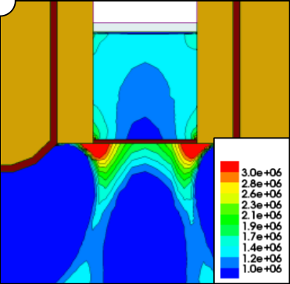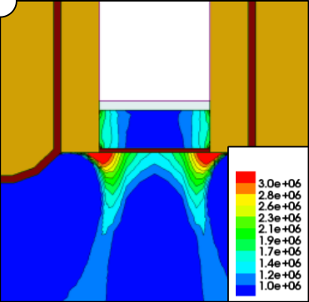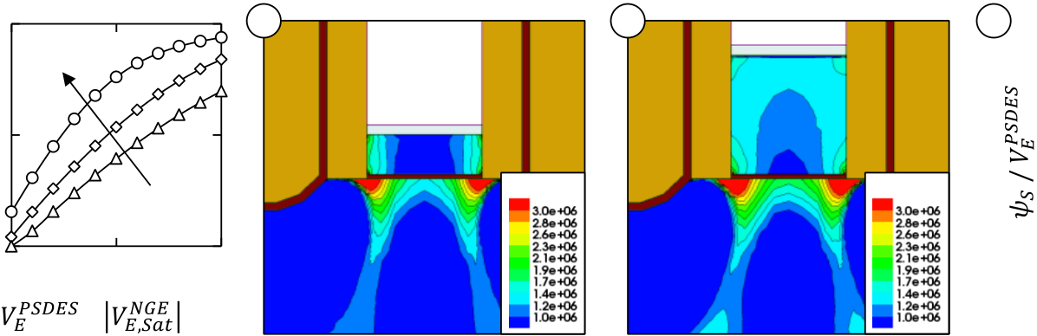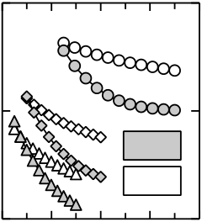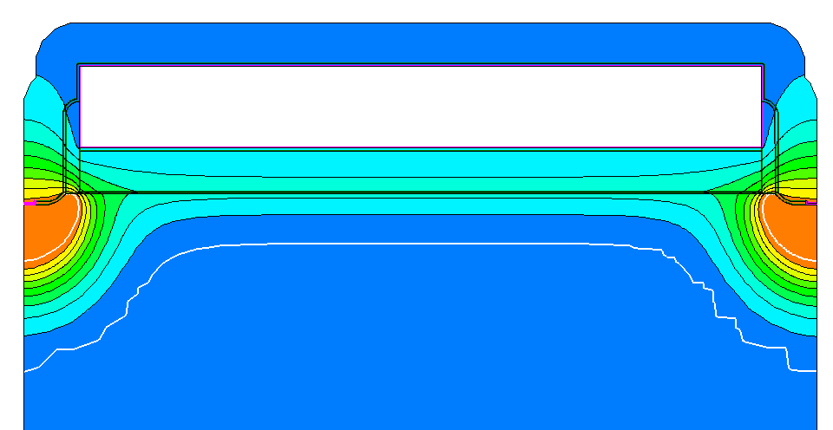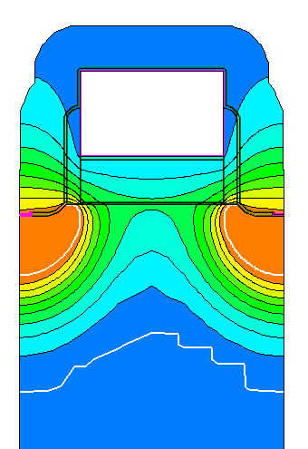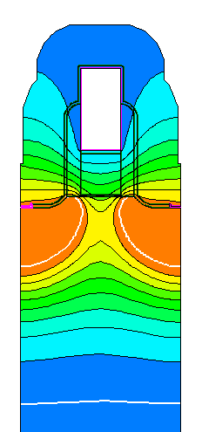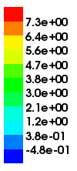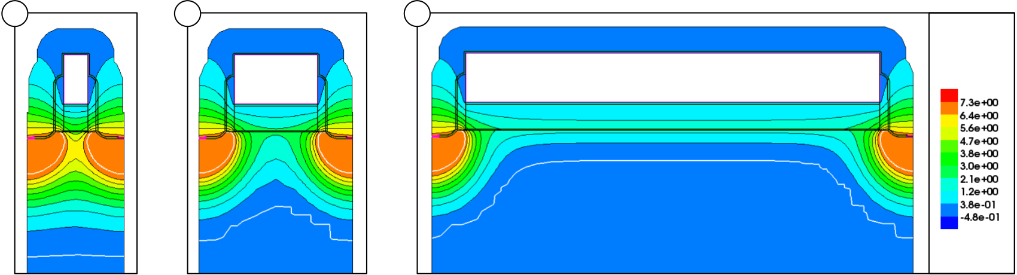

FEFET CELL ARRAY STUDY

film thickness and compared to a negative gate erase was subsequently analyzed in more

detail (Fig. 5-7).

|  |  |  |  |  |  |  |  |  |  |  |  |  |  |  |  |  |
| --- | --- | --- | --- | --- | --- | --- | --- | --- | --- | --- | --- | --- | --- | --- | --- | --- |
|  | 1 | 30 nm HK | | | b | *E* [V/cm] | c | *E* [V/cm] | d | [1] | 0.9 | 2 | 4 | 6 | w/ *P* | 10 |
| [1] |
|  | 0.5 | 10 nm HK | | | 0.7 |
| / |
|  |
| w/o *P* |
| 0 | 0.5 | 0.75 | 1 | 0.5 | 8 |
| / | | [1] |  | | [1] |

Fig. 5-7: Erase efficiency of a positive source / drain erase scheme. Ferroelectric material parameters characteristic for 30 nm films were applied to all film thicknesses. (a) Minimum polarization versus source / drain voltage characteristics for a PSDES scheme. Both polarization and voltage are normalized to the spontaneous polarization and to the negative gate voltage required to reach polarization saturation respectively. (b), (c) electric field distribution of 10 nm and 30 nm ferroelectric films for a PSDES to NGE voltage ratio of 0.75. (d) Normalized surface potential as a function of the source / drain erase voltage for both ferroelectric and non-ferroelectric gate stacks.

In a first step, the negative gate erase (NGE) voltage required to reach polarization

saturation was determined. For 10 nm, 15 nm and 30 nm film thickness, negative gate

voltages of -5 V, -6 V and -9 V were sufficient to bring FeFETs with a PS of 2.005 C/cm2

into saturation. By ramping the source / drain potential from 50 % to 100 % of the NGE

voltage (absolute value) required for polarization saturation, the efficiency of the PSDES

was determined (Fig. 5-7 (a)). It was found that for thicker films, the erase efficiency of the

PSDES increased significantly which was attributed to the more uniform electric field

distribution within the gate stack. The possibility of a higher punch-through contribution

for thicker films due to the elevated source / drain voltages could be eliminated. For

identical PSDES voltages, thicker films transfer the source / drain voltage more efficiently

towards the insulator semiconductor interface (Fig. 5-7 (d)).

Even though the degree of punch-through is not the determining factor for PSDES

efficiency, it is however an essential prerequisite for the functionality of the erase scheme in

general. This is illustrated by the channel length dependence of the PSDES (Fig. 5-8).

|  |  |  |
| --- | --- | --- |
| a | b | c |

  [V]

Fig. 5-8: Electrostatic potential distribution for different transistor lengths. Equipotential lines in the gate stack are denser for (a) 30 nm FeFETs than for transistors with (b) 100 nm or (c) 500 nm channel length. The electrostatic potential distribution was extracted for 6.75 V source / drain potential whereas gate and bulk were grounded. For 500 nm channel length, the channel depletion zone is caused by the positive polarization state that serves as the initial device state.

As shown in Fig. 5-8, for shorter channel devices, the electrostatic potential underneath

the gate stack is significantly enhanced due to the increased punch-through effect. For

96

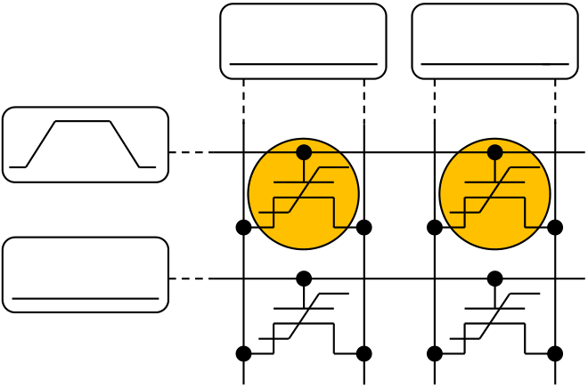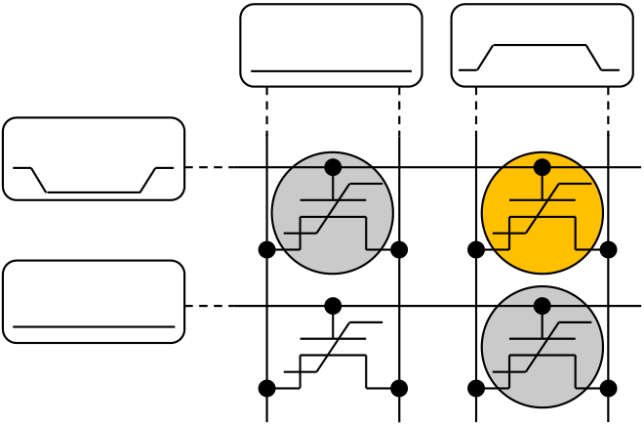

FEFET CELL ARRAY STUDY

longer channels, the punch-through is negligible and the PSDES is not able to erase the FeFET anymore. It shall be mentioned that for the simulations that were performed, no avalanche multiplication as utilized for floating gate operational schemes had been considered [68]. In case thicker ferroelectric films are used, the source / drain potentials have to be increased in order to still reach the coercive field of the ferroelectric. This will in turn lead to a more severe reverse bias of the source / drain to bulk p-n junctions such that simulations should account for avalanche multiplication as well.

Derived from the findings of the PSDES in a VDD/3 scenario, the most energy efficient operational scheme, i.e. the PSDES in VDD/2 configuration was analyzed. The major advantage of the VDD/2 approach is that no inhibit voltages are required for non-selected signal lines. This reduces the power consumption for program and erase to a minimum since only the selected signal lines have to be charged to VDD/2. Moreover, as compared to a VDD/3 scheme, synchronization of the voltage signals is not as stringent. However, negative wordline voltages are required which again complicates the implementation of the circuit periphery.

|  |  |  |  |  |  |
| --- | --- | --- | --- | --- | --- |
| WL (m) | **Write low-*VT* state „1“** | | WL (m) | **Write high-*VT* state „0“** | |
| SL / BL (n) | SL / BL (n+1) | SL / BL (n) | SL / BL (n+1) |
| 0 | 0 | 1 | 1 |
| WL (m+1) | WL (m+1) | 1 | |

Fig. 5-9: Low-power AND array worst case disturb scenarios for VDD/2 PSDES. In order to eliminate inhibit signals, the write operation is performed WLW. All cells sharing the selected wordline are programmed. The erase operation to the high-VT state is bit selective whereas cells sharing the same word-, bit- or sourceline are exposed to a VDD/2 disturb.

Compared to the VDD/3 scheme, a VDD/2 scheme which utilizes the PSDES approach is not as bit selective as the VDD/3 approach due to the fact that no inhibit voltages are used. The program operation is applied WLW whereas the erase operation is bit selective. However, one major disadvantage of the scheme is that the magnitude of the disturb increases to VDD/2 for cells sharing the selected signal lines. In order to determine the severeness of disturb in a VDD/2 PSDES, the erase operation was simulated for both 10 nm and 30 nm Si:HfO2 thin films (Fig. 5-10).

97

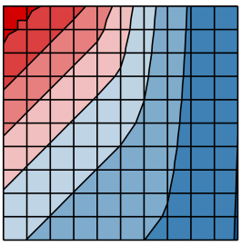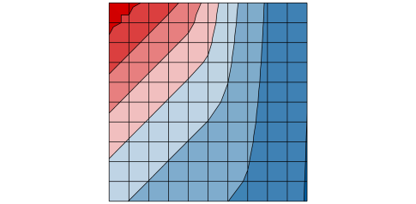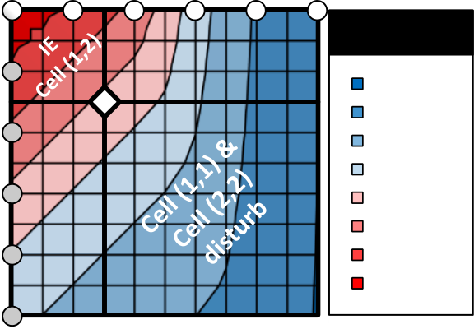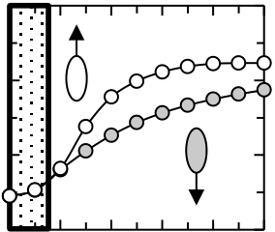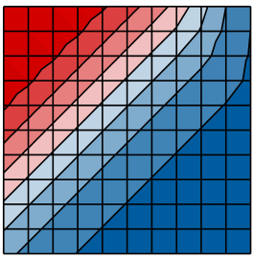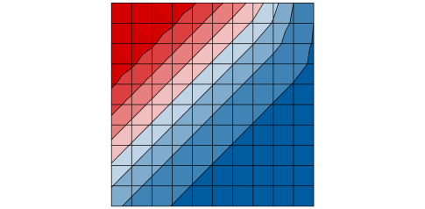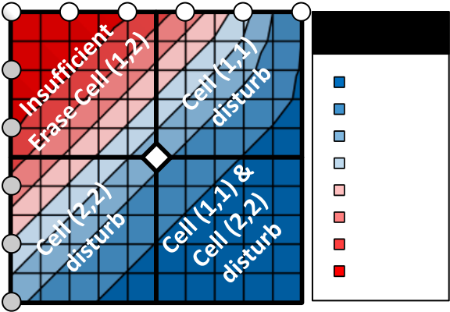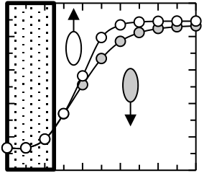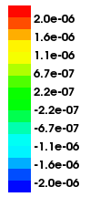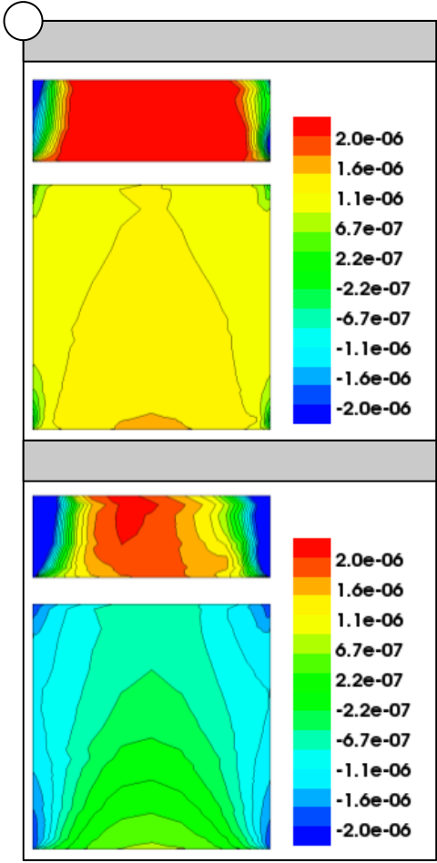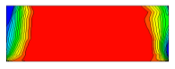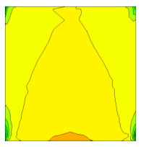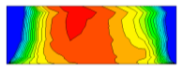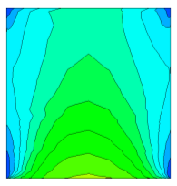

FEFET CELL ARRAY STUDY



|  |  |  |  |  |  |  |  |  |  |  |  |  |  |  |  |  |  |  |  |
| --- | --- | --- | --- | --- | --- | --- | --- | --- | --- | --- | --- | --- | --- | --- | --- | --- | --- | --- | --- |
| a | 0 | *VWL (m)* [V] | | ***VT* [V]** |  | *VWL (m)* at *VSL / BL (n)* = 0 [V] | | | | | | | | | | | e | **Cell (1,1)** | *P* [C/cm2] |
| 0 -1 -2 -3 -4 -5 | |
| 0 | | -2 | | -4 | | -6 | | -8 | | -10 |
| **Cell (1,1)** | |
| 2 | | | | | | | | | | |
| *VSL / BL (n+1)* [V] | 1 | **disturb** | | 1.00-1.25 | *VT* [V] | 1  0 | **disturb free** | | | | | | | | | | **Cell (1,2)** | *P* [C/cm2] |
| 2 | 0.75-1.00 |
| **Cell (2,2)** | **disturb** | 0.50-0.75 |
| 0.25-0.50 |
| 3 |
| 0.00-0.25 |
| -0.25-0.00 | -1 | | | | | | | | | | |
| 4 |
| -0.50--0.25 |
|  | 0 | | 2 | 4 | | 6 | | 8 | | 10 | |
| -0.75--0.50 |
|  | 5 | *VSL / BL (n+1)* at *VWL(m+1)* = 0 [V] | | | | | | | | | | |
| *VWL (m)* [V] | |
| *VWL (m)* at *VSL / BL (n)* = 0 [V] | | | | | | | | | | |
| 0 -1 -2 -3 -4 -5 | |
| *VSL / BL (n+1)* [V] | 0 | ***VT* [V]** | *VT* [V] | 0 | | -2 | | -4 | | -6 | | -8 | | -10 |
| 3 | | | | | | | | | | |
| 1 |
| 2.00-2.50 | 2  1  0 | | **disturb free** | | | | | | | | |
| 1.50-2.00 |
| 2 |
| 1.00-1.50 |
| 3 | 0.50-1.00 |
| 0.00-0.50 | -1 | | | | | | | | | | |
| 4 | -0.50-0.00 | -2 | | | | | | | | | | |
| -1.00--0.50 |
| 0 | | 2 | 4 | | 6 | | 8 | | 10 | |
| -1.50--1.00 |
| 5 | *VSL / BL (n+1)* at *VWL(m+1)* = 0 [V] | | | | | | | | | | |

Fig. 5-10: AND array erase characteristics operated in VDD/2 PSDES. (a) 10 nm and (b) 30 nm Si:HfO2 erase characteristics for cell (1,2) as a function of wordline and source- / bitline bias. The transistor had previously been programmed in a fully saturated program state by applying 10 V to the gate of the transistor. Parasitic disturb characteristics of cell (1,1) (zero SL / BL voltage) and cell (2,2) (zero WL voltage) for the (c) 10 nm and (d) 30 nm Si:HfO2 case. (e) Si:HfO2 polarization profiles for the 10 nm and 30 nm film at maximum erase bias. Results from erase disturb on cell (1,1) and intentional erase on cell (1,2) are shown.

For a 10 nm film, the erase of cell (1,2) was analyzed first with respect to different wordline and source- / bitline voltages. The previously described higher erase efficiency of a NGE is again reflected in the contour lines of the cell (1,2) erase characteristics (Fig. 5-10 (a)). For example, applying -3 V to WL(m) while keeping SL/BL(n+1) at ground causes a shift to higher VT values than when +3 V are applied to SL/BL(n+1) while keeping WL(m) at ground. This is a simple result from the different electric field distribution of NGE and PSDES. These two cases also describe the disturb scenarios which occur for cell (1,1) and cell (2,2) respectively, i.e. cell (1,1) experiences a negative gate voltage disturb while cell (2,2) experiences a positive source / drain voltage disturb. The disturb scenarios effectively represent the first row and the first column of Fig. 5-10 (a) and are additionally extended to 10 V amplitudes in Fig. 5-10 (c). In total, a disturb free operation for cell (1,1) and cell (2,2) was considered until approximately 25 % memory window loss. This resulted in an operational point of -1.5 V (WL) / +1.5 V (SL/BL). However, the erase of cell (1,2) was rather incomplete for these operating conditions which makes the VDD/2 PSDES not a viable option for devices possessing ferroelectric films of 10 nm thickness.

On the other hand, for the 30 nm Si:HfO2 case, the VDD/2 scheme was more appropriate. For the same 25 % memory window loss specification for disturbed cells, the erase operation of cell (1,2) increases the relative memory window by more than 25 % (the relative memory window is the absolute MW normalized to the maximum achievable MW). This can be seen in Fig. 5-10 (b) by the shift of the operational point (diamond) into the bluish high-VT area. Hence, due to a remaining memory window of  2 V between erased cell (1,2) and disturbed cells (1,1) and (2,2), the VDD/2 PSDES appears to be a viable option for FeFETs possessing a 30 nm Si:HfO2 film.

98

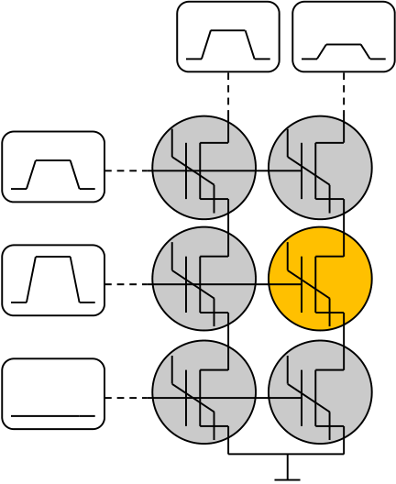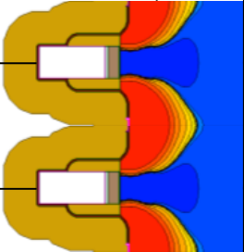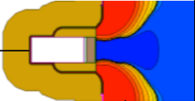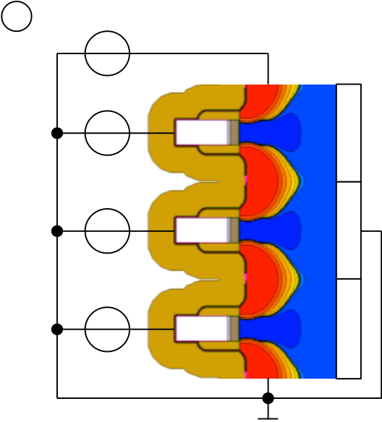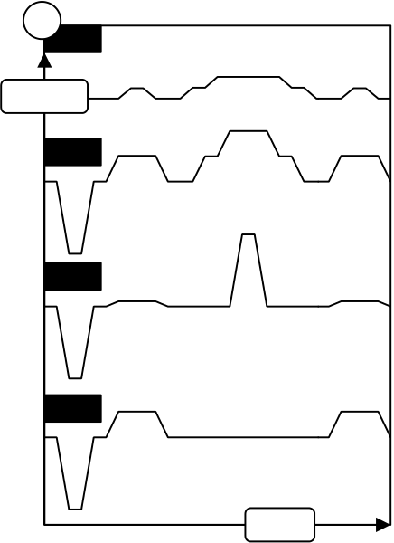

FEFET CELL ARRAY STUDY

The potential functionality of the VDD/2 PSDES is again based on both the higher erase efficiency of the PSDES for thicker ferroelectric films and the more suitable ferroelectric parameters that were extracted from experiment. Another illustration of this is given by the polarization profile within the HfO2 at erase bias (Fig. 5-10 (e)). For the 10 nm film it can be seen that a large volume fraction of the ferroelectric stays in a positive polarization state which prohibits a proper shift to the high-VT erased state. For the 30 nm film, besides an overall reduced polarization due to different ferroelectric parameters, the polarization in the stack is more uniform. Moreover, a clear differentiation between a predominantly positive polarization state for cell (1,1) and a predominantly negative polarization state for cell (1,2) can be observed.

Besides the AND architecture, the NAND array can also be considered a viable candidate for FeFET memory arrays. Three different operational schemes were proposed in section 5.1 which are derived from traditional NAND Flash memories. In the following paragraphs, the functionality of the Traditional Program Inhibit (TPI) and Global/Local-Self-Boost-Program-Inhibit (G/LSBPI) scheme are verified based on TCAD simulations. As mentioned before, by mixed-mode simulations it was possible to couple several TCAD geometries with lumped circuit elements. Hence, a fundamental NAND unit cell was created via series connection of three FeFET devices (Fig. 5-11).

|  |  |  |  |  |  |  |  |  |  |  |
| --- | --- | --- | --- | --- | --- | --- | --- | --- | --- | --- |
|  |  *VP* disturb   *Vpass* disturb | BL (1) | BL (2) | | b | WL1 | BL | Cell 1 | c | **BL** |
| Voltage | |
| WL (1) | 0 0 0 0 | |  | WL2 | **WL1** | |
| WL (2) | WL3 | Cell 2 | **WL2** | |
| WL (3) | 0 0 | | | Cell 3 | **WL3** | |

Time

Fig. 5-11: NAND worst case program and pass disturb and modeling thereof. (a) Worst case scenario for a program operation in NAND architecture. (b) Simple mixed-mode simulation model of three series connected FeFETs with lumped voltage sources. (c) Simulated pulse sequences in case of VWL1 = 0.7 VWL2 and VBL = 0.3 Vwrite wheras VWL2 = 7 V.

As an example, in case of a TPI scheme, an actual inhibit voltage is applied to the bitlines of non-selected strings which then has to transfer to the cells sharing the programmed wordline. On the other hand, for the G/LSBPI schemes, the unselected strings are disconnected from the bitline such that program inhibit takes place via global or local self-boost. In order to model the efficiency of these different operational schemes, a mixed-mode TCAD model was created by simple series connection of three FeFET transistors (Fig. 5-11 (b)). The gates were connected to lumped voltage sources and the drain of the first cell was connected to another lumped voltage source which provided the bitline signal. Depending on the magnitude of the voltage pulses applied to the gates and drain of the string, the mentioned operational schemes could be modeled. The actual pulse trains that were used for simulation first set all of the string cells into an erased state via NGE, followed by a read of the string current, the actual program operation and finally another read operation (Fig. 5-11 (c)). Similar to the simulations of the AND architecture, tri-level

99

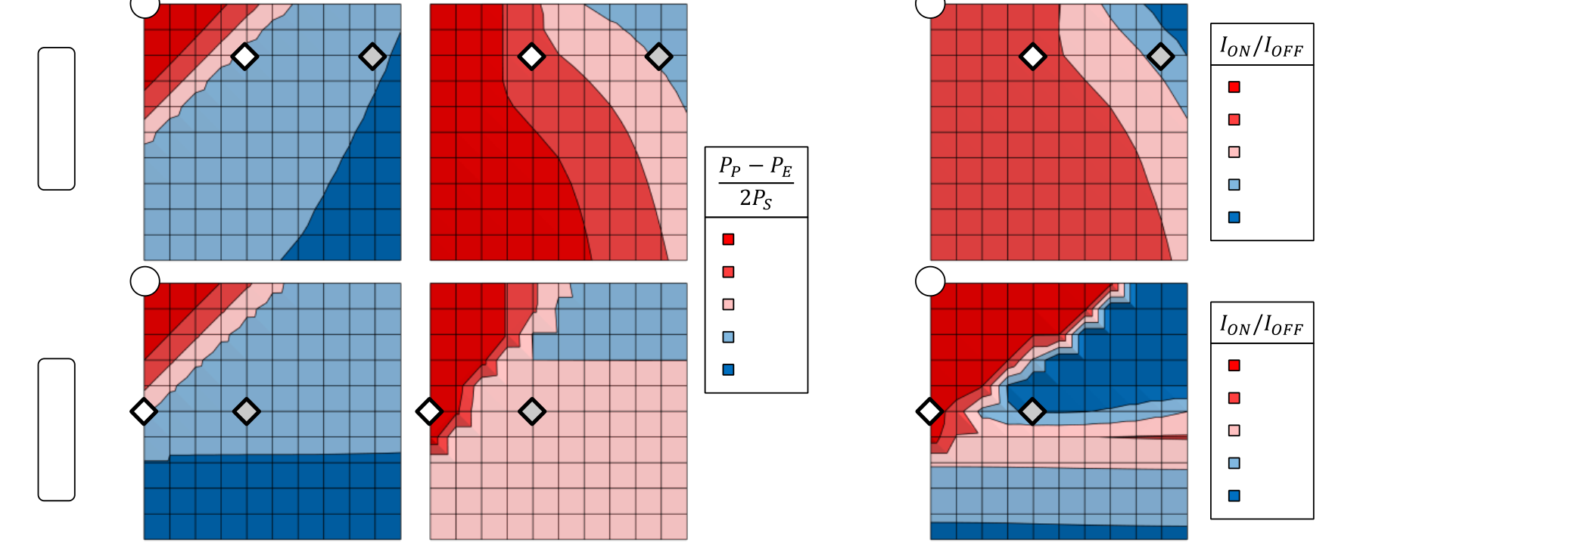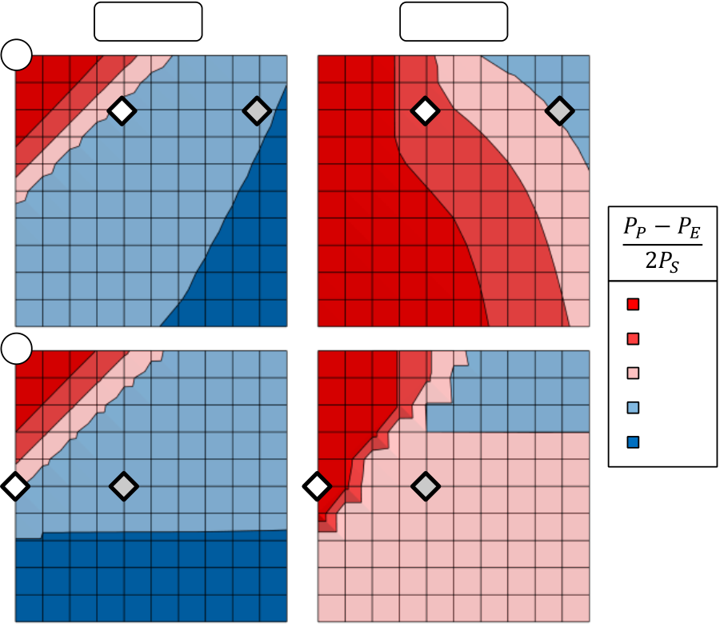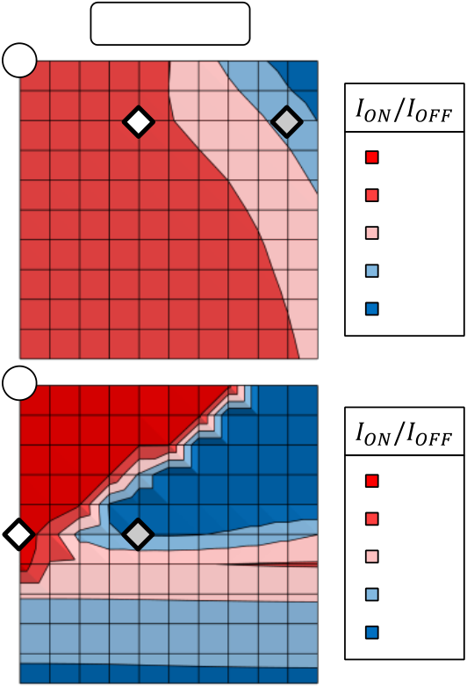

FEFET CELL ARRAY STUDY

pulses with appropriate delay times were chosen in order to reduce the magnitudes of the parasitic disturb signals.

By parameterizing the simulations in terms of Vpass and VBL, the effectiveness of the proposed operational schemes could be analyzed. Based on these results, the most reasonable operating condition for a FeFET NAND architecture was extracted (Fig. 5-12).

|  |  |  |  |  |  |  |  |  |  |  |  |  |  |  |  |  |  |  |  |  |
| --- | --- | --- | --- | --- | --- | --- | --- | --- | --- | --- | --- | --- | --- | --- | --- | --- | --- | --- | --- | --- |
| 1 | a |  | Cell 1 | | 0.8-1.0 | | | | Cell 2 | | | | | |  | 3T String | |  |  |  |
| 1 | | | | | b |
| 0.8 0.8-1.0  *Lg* = 30 nm  0.6-0.8 0.6  0.4-0.6   0.4 0.2-0.4 |  |  |  |  | 0.8  1E+4-1E+5 | | | | | |  | 0.4 | 0.6 |  |  | 104-105 |
| 0.6-0.8 | | | | 1E+3-1E+4 0.6 | | | | | |
| 103-104 |
| 0.4-0.6 | | | | 1E+2-1E+3  0.4  1E+1-1E+2 | | | | | | 102-103 |
| 0.2-0.4 | | | | 101-102 |
| 0.0-0.2 0.2  *Vpass* / *VP/E* [1]   0  1  0.8  0.8-1.0 | c |  |  |  | 0.0-0.2 | | | | 0.8-1.0 | | | | 1E+0-1E+1 0.2  *Vpass* / *VP/E* [1]   0  1  0.8  1E+8-1E+10 | d |  |  |  |  |
| 100-101 |
| 0.8-1.0 | | | | 0.6-0.8 | | | |
| 0.4-0.6 | | | |
| 0.2-0.4 | | | |
|  |  |  |  |  | 0.0-0.2 | | | |  |  |  | 108-1010 |
| *Lg* = 500 nm  0.6-0.8 0.6  0.4-0.6  0.4  0.2-0.4  0.0-0.2 0.2 | 0.6-0.8 | | | | 1E+6-1E+8 0.6 | 106-108 |
| 0.4-0.6 | | | | 1E+4-1E+6 | | | | | | 104-106 |
| 0.2-0.4 | | | | 0.4  1E+2-1E+4 | | | | | |
| 102-104 |
| 0.0-0.2 | | | | 1E+0-1E+2 0.2 | | | | | | 100-102 |
| 0 | 0 | 0.2 | 0.4 | 0.6 | 0.8 | 1 | 0 | 0.2 | 0 | | | | | | 0.2 | 0.8 | 1 |  |
| 0.4 | 0.6 | 0.8 | 1 | | 0 |
| *VBL* / *VP/E* [1] | | | | |  |  |  |  |  | | --- | --- | --- | --- | --- | | |  |  |  |  | | --- | --- | --- | --- | |  | Selected string |  | Non-selected string | | | | | | | | *VBL* / *VP/E* [1] | |

Fig. 5-12: Results from 3T-NAND-string simulation. (a) and (c) show the fraction of switched polarization (polarization after program PP minus polarization after erase PE) normalized by 2PS (devices with (a) 30 nm and (b) 500 nm channel length respectively). (b), (d) Corresponding on- to off-current ratio of the string extracted from the read operation after program and erase respectively.

The FeFETs that were used for NAND string simulation were again parameterized according to a 30 nm Si:HfO2 ferroelectric thin film. Accordingly, the program and erase voltages were chosen to be 7 V which ensured a saturated operation of the device. The three transistors of the string were first initialized into an erased state by applying a negative gate voltage. Even though Cell 2 of the string had both source and drain regions floating, the erased state was almost identical to Cell 1 and 3 which justified the negative gate erase. Afterwards, the string current was read by applying 2.5 V to Cell 1 and 3 whereas Cell 2 was kept at 0.5 V. The higher amplitude for Cell 1 and 3 ensured that also fully erased cells were driven above their threshold voltage. The cell under specific consideration, i.e. Cell 2, was set to the lower read voltage of 0.5 V to either drive a significant current if programmed into a low-VT state or to inhibit the current flow if it had previously been erased. Consequently, after erasing all three cells at the beginning, the reference off-current of the string was recorded by the read operation. For the sake of completeness it shall again be highlighted that the read operation itself creates a certain amount of disturb. However, compared to the succeeding program disturb, the read disturb was found to be negligible.

After the read operation of the erased state, the actual program operation was carried out utilizing tri-level pulses aiming to minimize state disturb. First, the bitline signal was ramped to half of its final value. When this level was reached, WL 1 was also ramped to half of its final value. Afterwards, the bitline voltage was further increased to its final value followed by the ramp of WL 1, also to its final value. At the point at which both bitline

100

FEFET CELL ARRAY STUDY

and WL 1 had reached their desired amplitudes, the actual program pulse of 7 V was applied to WL 2. This transient sequence was used in order to apply the bitline inhibit voltage always before WL 1 was ramped to the next level in order to minimize Vpass disturb.

The final values of both WL 1 and bitline voltage were parameterized and were always multiples of 10 % Vwrite (0.7 V). For both short and long channel devices, Fig. 5-12 shows the results of these simulations for Cell 1 and Cell 2 in terms of the change in polarization due to the program operation. Furthermore it summarizes the effect of the change in polarization with respect to the resulting ION to IOFF ratio of the string current.

First of all, the state disturb due to the 2.5 V read signal could be extracted for Cell 1 under zero Vpass and VBL bias. It can be seen that up to 40 % of the maximum switched polarization of 2PS are already altered by the read operation (Fig. 5-12 (a) and (c)). Even though this read disturb is quite significant, it does not prohibit the operation in NAND architecture as will be shown in the next paragraphs. For short channel devices and large bitline / relatively low pass voltages, the difference between polarization after erase PE and after program PP becomes less than 20 % of 2PS. This can be attributed to a restoring of the erased state after read due to a partial positive bitline erase (similar to the PSDES for an AND architecture). For long channel devices, this trend cannot be observed due to the ineffectiveness of the erase for a positive bitline voltage. Furthermore, for zero bitline bias, the erased state of Cell 1 is gradually disturbed starting from Vpass = 50 % Vwrite, i.e. at around 3.5 V. By increasing the bitline voltage, obviously also the onset of Vpass disturb is shifted to higher voltages. Hence, the Vpass disturb scenarios of both long and short channel devices can be considered quite identical.

For Cell 2, a zero Vpass and VBL bias corresponds to the cell being cut off from Cell 1 and 3. For short channel devices, the program operation provokes an additional state loss of approximately 70 % which adds to the  20 % state loss due to read disturb. This results in an almost complete program operation even though the cell should be cut off. Hence, due to the non-ideal off-state behavior of short channel devices, the cut-off does not properly work for the given device geometry. Accordingly, program inhibition by local self-boost does not seem viable. On the other hand, long channel devices lose only additional 25 % of 2PS which indicates that a self-boost operation might work in this case.

The overall operating conditions for both short channel and long channel devices were finally extracted from the on- to off-current characteristics of the string (Fig. 5-12 (b) and (d)). Under the premise of proper program, program inhibition and avoidance of Vpass disturb, the operating conditions for strings of short channel cells are as follows: High pass voltages of 80 % and bitline voltages of 40 % (selected string) and 90 % (non-selected string) of Vwrite have to be chosen in order to enable a NAND architecture and operation. This results in a current ratio of selected and non-selected string of approximately 50 which is not ideal but still reasonable to sense. However, for the given Vwrite of 7 V, the required bitline voltages by far exceed the standard supply or I/O voltages. This will in turn result in a larger effective cell size due to the increased area consumption of HV periphery transistors and memory cells.

On the contrary, for long channel devices, the ION/IOFF ratio validates that no high Vpass voltages are required to enable the NAND architecture and operation. A pass voltage of 3.5 V enables both the programming of the selected cell whereas programming can also be inhibited by applying 2.8 V to the bitline of non-selected strings. The resulting string current ratio is around seven orders of magnitude which provides a much higher sensing margin as compared to short channel devices. Moreover, the maximum bitline voltage is in the range of standard I/O specifications which means that bitline periphery does not require space consuming HV devices.

101

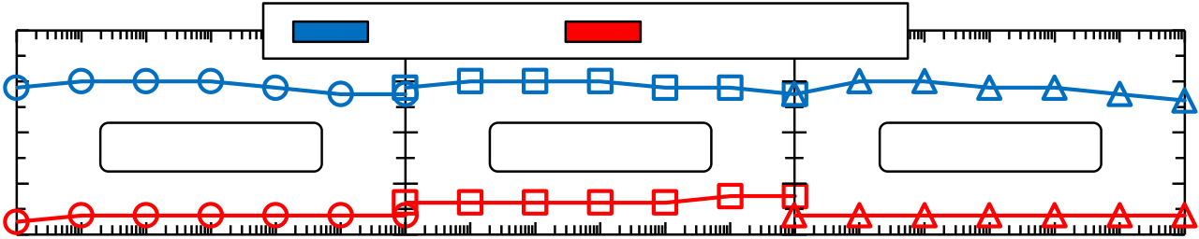

FEFET CELL ARRAY STUDY

5.3.2State Disturb and Write Inhibition of Single FeFET Cells

Besides validating the proposed operational schemes by TCAD simulations, electrical characterization of multi-transistor macros was used in order to emulate the disturb scenarios ocurring in FeFET memory arrays. That is, the multi-structure is first written into a programmed or erased state by applying the corresponding electrical field. Afterwards, a field of opposite polarity and reduced amplitude is applied in order to emulate disturb conditions that would occur in a memory array. As described in the previous sections, there are various ways of operating the same memory array which accordingly translates into various disturb scenarios.

The mentioned tri-level waveforms were used to study the disturb characteristics of multi-transistor structures (Lg = 30 nm; W = 1 m; 100 devices in parallel) in a VDD/3 PSDES AND scheme. In total, there were six disturb tests performed, i.e. the worst case scenarios for cell (1,1), cell (2,1) and cell (2,2) which occur for writing a "1" or a "0" to cell (1,2) (compare Fig. 5-4). The multi-structure was first either programmed with a 4 V/10 s pulse on the gate or erased by a 5 V/1 s pulse on source and drain regions in order to write the initial state for the respective disturb test. Then, waveforms according to Fig. 5-4 were applied numerous times in order to disturb the FeFET cell accordingly. Once per cycling decade, Id-Vg characteristics were acquired to check on the potential VT degradation. As an example, for the worst case scenario of cell (1,1), the multi-structure was erased (brought into the "0"state) by applying 5 V/1 s pulse to its source and drain regions. Afterwards, the tri-level gate pulse as well as the two level drain / source pulse was applied. The base level of both pulses was 0 V, the intermediate level of the tri-level pulse was VDD/3, i.e. 4 V/3 ≈ 1.3 V, the amplitude of the source/drain pulse was 24 V/3 ≈ 2.7V and the third level of the tri-level pulse was obviously 4 V. The pulse widths and delay times were chosen in the 10 s range such that the source/drain pulse started to rise only when the first level of the tri-level pulse had already reached 1.3 V. Furthermore, the second slope of the tri-level pulse started to rise only after the source/drain pulse had already reached 2.7 V. This ensured that at no point in time VGS or VGD were larger than 1.3 V. Moreover, due to the fact that the erased VT was not higher than VDD/3, the inhibit voltage was expected to transfer properly underneath the gate stack.

|  |  |  |  |  |  |  |
| --- | --- | --- | --- | --- | --- | --- |
| *VT* [V] | 1.2 | Cell (1,1) | Erased | Cell (2,1) | Programmed | Cell (2,2) |
| 0.8 |
| 0.4 |
| 0 |

 -0.4

0 100101102103104105

Disturb Cycles [1]

Fig. 5-13: Results from worst case disturb measurements for an AND architecture in PSDES operation. Depending on the imagined state written to cell (1,2), neighboring cells were initially either programmed or erased. The preceding disturb signals did not significantly affect the initial state.

For the three cells adjacent to cell (1,2), all disturb scenarios did not yield any significant change of the initially written binary state (Fig. 5-13). Hence, also from the experiments performed on the multi-structures it can be concluded that the VDD/3 PSDES might enable the RAM-type operation of FeFET AND arrays.

102

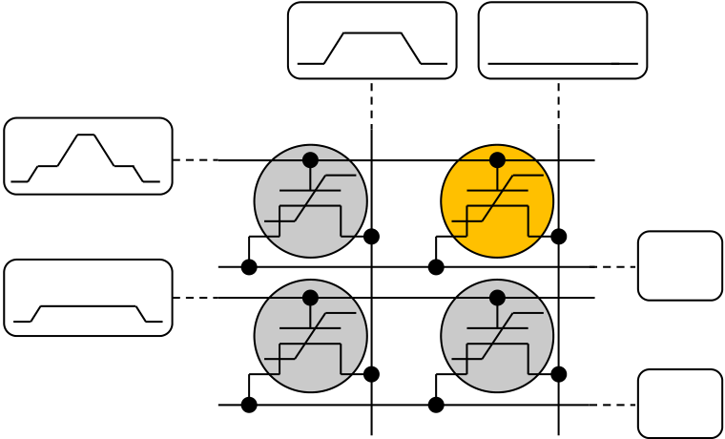

FEFET CELL ARRAY STUDY

Furthermore, the VDD/3 program inhibit scheme was investigated for a NOR-type architecture. In order to make the source terminal floating for this type of operational scheme, the source was disconnected manually before each disturb sequence. The waveforms applied as well as the evolution of the VT-states with disturb cycling is shown in Fig. 5-14.

|  |  |  |  |  |  |  |  |  |
| --- | --- | --- | --- | --- | --- | --- | --- | --- |
| a | BL (n) | BL (n+1) |  | b |  |  |  | Erased Cell (1,1) |
|  | |
|  | 0 | 0 | F |  | *VT* [V] | 0.8 | Programmed Cell (2,1) | |
| WL (m) | SL (m) |  | Erased Cell (2,2) |
|  | |
| 0.4 |
| 0 |
| WL (m+1) | 1 | 0 | F | SL (m+1) | -0.4 |
|  -0.8 |
| 0 100 101 102 103 104 105 | |
| Disturb Cycles [1] | |

Fig. 5-14: NOR-type worst case program disturb scenario. (a) Shows the memory array unit cell with the pulses applied to the signal lines. (b) Illustrates that the VT-states of the cells remain unchanged.

Even though the manual disconnection of the source terminal reduces the parasitic capacitance as compared to keeping the needle connected, it is still not comparable to the situation in an integrated array. Hence, it was not clear if programming could be inhibited properly with such a measurement setup. However, as shown in Fig. 5-14 (b), the worst case disturb scenarios did not alter the respective cell states. Nevertheless, it remains questionable if such an operational scheme would also work in a real NOR-array since it could not be tested how the actually to be programmed cell (1,2) is affected by a floating source node.

103

FEFET MEMORY ARRAYS

6FeFET Memory Arrays

Based on the cell array study, a multi-project-wafer (MPW) test chip was defined containing those memory arrays which were presented in the previous sections. Due to the fact that no decoder periphery was utilized, only small memory arrays could be created whose size was limited by the number of contact pads of the test chip. For example, a 121 bit NOR array consisted of eleven wordlines, eleven bitlines and one common sourceline which had directly been routed to the I/O pads of the test chip. Together with an additional bulk and ESD protection contact, the 25 I/O pads that can be contacted in parallel by a probe card were already exhausted.

The FeFET test chip layout was then successfully transferred onto a multi-project wafer tape-out and subsequently manufactured on a 28 nm process flow. In order to achieve the desired ferroelectric properties, MFM reference capacitors were again manufactured and characterized first. Afterwards, the target Si:HfO2 compositions were used for manufacturing of the FeFET memory arrays. In the end, small memory arrays up to 121 bit could be analyzed with respect to their initial VT and program / erase distributions.

6.1Ferroelectric Reference Capacitors

Identical to the process route of previously processed test chips, the memory functionalization of standard HKMG transistors was achieved by a change in the HfO2 doping and thickness. Similar to section 2.5, MFM reference capacitors had been manufactured in order to both validate the ALD process stability and determine the specific molar concentrations required for achieving ferroelectric hysteresis.

The MFM (TiN/Si:HfO2/TiN) capacitors were manufactured utilizing the shadow mask approach described in chapter 2. ALD pulse ratios were chosen such that silicon molar concentrations of 3.7 mol%, 4.3 mol%, 4.7 mol% and 5.2 mol% were achieved. Different from the standard MFM processing approach, the post metallization anneal was adjusted more specifically to a standard HKMG process flow. That is, in the past only the peak temperature of the source / drain junction spike anneal was utilized to emulate transistor fabrication characteristics. For the MFM reference capacitors of the integrated lot, especially the thermal budget for poly silicon gate deposition was additionally taken into account. Hence, the total post metallization anneal amounted to 20 min  620 ºC + 1 s 1050 ºC = 207 hºC.

Fig. 6-1 shows the ferroelectric hysteresis of the MFM reference capacitors. Polarization values and current amplitudes are normalized to their respective maximum values due to the fact that the area of the capacitors could not unambiguously be determined (the shadow mask was slightly shifted during processing). Measurements were again performed on an AixACCT TF Analyzer 3000.

104

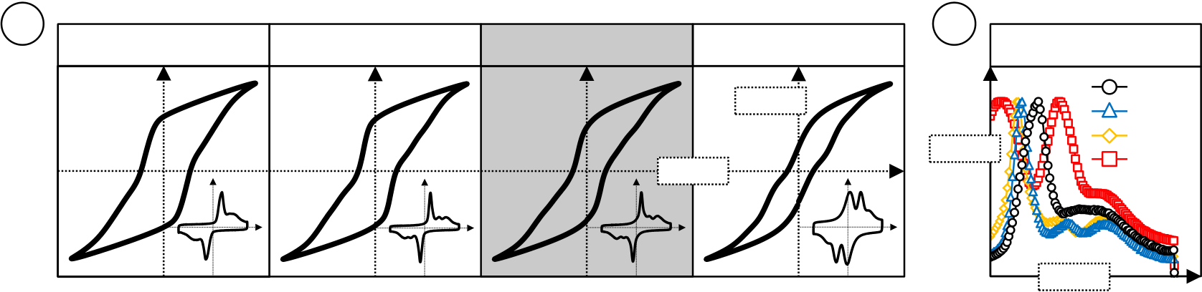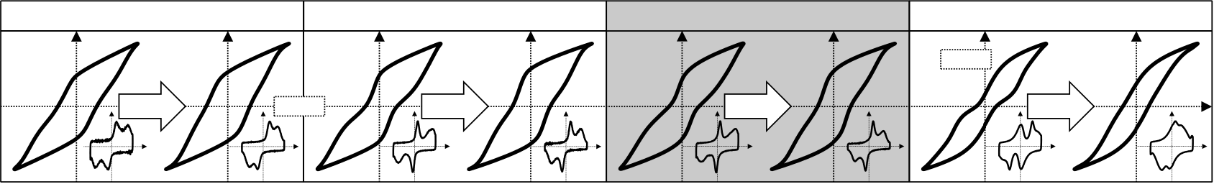

FEFET MEMORY ARRAYS

|  |  |  |  |  |  |  |  |
| --- | --- | --- | --- | --- | --- | --- | --- |
| a | 3.7 mol% | 4.3 mol% | 4.7 mol% | *E* [a.u.] | 5.2 mol% | b | Current vs. Field |
| *P* [a.u.] | *I* [a.u.] | 3.7 % |
| 4.3 % |
| 4.7 % |
| 5.2 % |

*E* [a.u.]

Fig. 6-1: P-E and I-E relationship of MFM reference capacitors. (a) P-E hysteresis and corresponding I-E response (shown as inset). The 4.7 mol% composition was later excluded for processing of the device lot. Samples were measured up to 3.5 MV/cm. Polarizations and currents are normalized to the maximum polarization Pmax and the maximum current Imax respectively. (b) Magnified current response for the positive rising edge of the applied triangular voltage signal.

The standard hysteresis measurements were carried out at a frequency of 1 kHz using an electric field amplitude of 3.5 MV/cm. The amplitude was chosen in such a way that dielectric breakdown did not occur but at the same time that the sweeping range was large enough to bring the hysteresis into saturation.

The range of silicon molar concentrations starting from 3.7 mol% and ending at 5.2 mol% resulted in the expected transition from a ferroelectric to an antiferroelectric or rather pinched hysteresis. Similar to results presented in chapter 2, all samples showed a strong constriction of the hysteresis, i.e. multiple switching peaks could be observed. The 5.2 mol% composition still showed some remanent polarization similar to the 4.5 mol% composition that was used for the test chip of chapter 4. Since for the multi-transistor structures that specific concentration led to the best FeFET properties, it was also included for the MPW processing.

Furthermore, the characterization of polarization fatigue was also performed in order to distinguish between material degradation and potential charge trapping induced degradation which was expected to occur in FeFET memory arrays, too.

|  |  |  |  |
| --- | --- | --- | --- |
| 3.7 mol% | 4.3 mol% | 4.7 mol% | 5.2 mol% |

*P* [a.u.]

|  |  |  |  |  |
| --- | --- | --- | --- | --- |
| 106 | *E* [a.u.] | 106 | 106 | 106 |

Fig. 6-2: Fatigue characteristics of MFM reference capacitors. For each composition, virgin hysteresis and hysteresis after 106 endurance cycles are shown. Both measurement and cycling were performed at 2.25 MV/cm sweeping amplitude. Corresponding I-E characteristics are given as inset.

Measurements were performed using a 100 kHz fatigue frequency and an electric field amplitude of 2.25 MV/cm. Almost all samples suffered from hard dielectric breakdown after 106 cycles. Only the 5.2 mol% composition was able to endure up to 5107 endurance cycles which is in accordance to previous results (see Fig. 2-14).

Hence, for the Si:HfO2 material system using chloride based precursors and a comparatively large PMA thermal budget, the endurance characteristics can be considered quite poor as compared to recently published results [219]. It is not yet fully understood which processing conditions are influencing Si:HfO2 fatigue characteristics the most, however, as mentioned in subsection 2.3.1, the thermal budget indeed plays an important role.

105

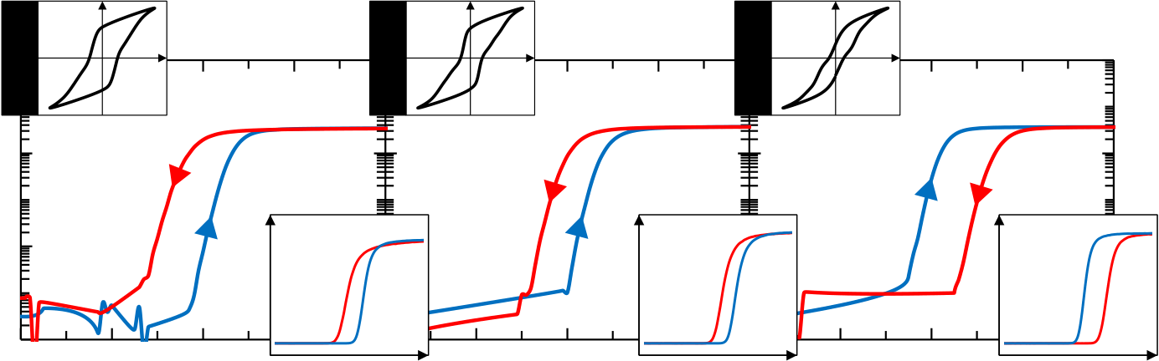

FEFET MEMORY ARRAYS

6.2Program / Erase Characteristics of FeFET Cell Arrays

FeFET memory arrays were first tested according to the procedure given in subsection 4.2.1, i.e. all cells in an array were tested as a parallel connection. This ensured an as close as possible comparison to the FeFET multi-structures that were analyzed before. Quasi-DC Id-Vg measurements were performed in order to verify which of the three chosen silicon dopant concentrations (3.7 mol%, 4.3 mol% or 5.2 mol%) induced a proper ferroelectric memory window. Therefore, the 11 wordlines of a 121 bit NOR array (34 nm x 80 nm cell dimension) were connected in parallel and hysteretically swept from -5V to 5V. The 11 bitlines of the array were connected in parallel as well and a constant bias voltage of 100 mV was applied (Fig. 6-3).

|  |  |  |  |  |  |  |  |  |  |  |  |  |  |  |  |  |  |  |
| --- | --- | --- | --- | --- | --- | --- | --- | --- | --- | --- | --- | --- | --- | --- | --- | --- | --- | --- |
| Drain Current [A] | 1E-03 | **3.7 mol%** | *P* | -1 | *E* | 0 | *ID* | **4.3 mol%** | *P* | *E* | 0 | *ID* | **5.2 mol%** | *P* | *E* | 0 | *ID* | *VGS* |
| 1E-05 |
| 1E-07 |
| 1E-09 | -2 | 1 | *VGS* | -1 | 1 | *VGS* | -1 | 1 |
| -2 | -2 | 2 |

*VGS* [V]

Fig. 6-3: Quasi-DC Id-Vg characteristics of parallel connected 121 bit FeFET NOR array. Hysteretic gate voltage sweeping range was from -5 V to +5 V and back. Corresponding MFM P-E hysteresis as well as Id-Vg characteristics on a linear scale are shown as inset.

On the parallel connected array it was possible to verify that the 3.7 mol% as well as the 4.3 mol% composition showed a proper ferroelectric / counterclockwise Id-Vg hysteresis. When plotted on a linear scale and compared to the ferroelectric concentrations of the previous test chip (Fig. 4-3), the shift of the current characteristics was even more ideal / more parallel. Hence, the ferroelectric characteristics of the MFM capacitors again transferred well to the integrated device lot. Furthermore, the 5.2 mol% composition could only produce a trap window, i.e. a clockwise Id-Vg hysteresis.

Consequently, the next step was to reproduce the results from the quasi-DC measurement on the parallel connected array also on each individual FeFET cell. Therefore, an array of the 4.3 mol% composition was first programmed / erased at  5 V / 1 us or at  7 V / 1 us. This was again achieved by connecting all wordlines together while keeping the other terminals on ground. However, the read procedure after program / erase was then carried out cell-wise. That is, the wordline of the selected cell was swept from -1 V to 2 V while the corresponding bitline was biased at 100 mV. Unselected wordlines were set to a -1.5 V read inhibit voltage, i.e. cells that potentially reside in a low-VT state are brought into a non-conducting accumulation or depletion state. This ensures that the bitline current that is sensed is dominated by the selected cell and not by the unselected cells sharing the same bitline. Surprisingly, the resulting VT distributions did not reflect proper memory characteristics as they were first anticipated from the quasi-DC measurements (Fig. 6-4).

106

FEFET MEMORY ARRAYS

|  |  |  |  |  |  |  |  |  |  |  |  |  |  |  |  |  |  |  |
| --- | --- | --- | --- | --- | --- | --- | --- | --- | --- | --- | --- | --- | --- | --- | --- | --- | --- | --- |
| WL1 | BL1 | BL2 | BL3 | BL4 | BL5 | BL6 | BL7 | BL8 | BL9 | BL10 | BL11 | b | ***VT* [V]** | -1 - -0.75 | c | -0.75 - -0.5 | -0.5 - -0.25 | -0.25 - 0 |
| 0 - 0.25 | 0.25 – 0.5 | 0.5 - 0.75 | 0.75 - 1 |
| a | d |
| WL2 |

WL3   
WL4   
WL5   
WL6   
WL7   
WL8   
WL9   
WL10

|  |  |  |  |  |  |  |  |  |  |  |  |  |  |  |  |  |  |  |  |  |  |  |  |  |  |  |  |  |  |  |  |  |  |  |  |  |  |  |  |  |  |  |  |  |  |  |  |  |  |  |  |  |  |  |  |  |  |  |  |  |  |  |  |  |  |  |  |  |  |  |  |  |  |  |  |  |  |  |  |  |  |  |  |  |  |  |  |  |  |  |  |  |  |  |  |  |  |  |  |  |  |  |  |  |  |  |  |  |  |  |  |  |  |  |  |  |  |  |  |  |  |  |  |  |  |  |  |  |  |  |  |  |  |  |  |  |  |  |  |  |  |  |  |  |  |  |  |  |  |  |  |  |  |  |  |  |  |  |  |  |  |  |  |  |  |  |  |  |  |  |  |  |  |  |  |  |  |  |  |  |  |  |  |  |  |  |  |  |  |  |  |  |  |  |  |  |  |  |  |  |  |
| --- | --- | --- | --- | --- | --- | --- | --- | --- | --- | --- | --- | --- | --- | --- | --- | --- | --- | --- | --- | --- | --- | --- | --- | --- | --- | --- | --- | --- | --- | --- | --- | --- | --- | --- | --- | --- | --- | --- | --- | --- | --- | --- | --- | --- | --- | --- | --- | --- | --- | --- | --- | --- | --- | --- | --- | --- | --- | --- | --- | --- | --- | --- | --- | --- | --- | --- | --- | --- | --- | --- | --- | --- | --- | --- | --- | --- | --- | --- | --- | --- | --- | --- | --- | --- | --- | --- | --- | --- | --- | --- | --- | --- | --- | --- | --- | --- | --- | --- | --- | --- | --- | --- | --- | --- | --- | --- | --- | --- | --- | --- | --- | --- | --- | --- | --- | --- | --- | --- | --- | --- | --- | --- | --- | --- | --- | --- | --- | --- | --- | --- | --- | --- | --- | --- | --- | --- | --- | --- | --- | --- | --- | --- | --- | --- | --- | --- | --- | --- | --- | --- | --- | --- | --- | --- | --- | --- | --- | --- | --- | --- | --- | --- | --- | --- | --- | --- | --- | --- | --- | --- | --- | --- | --- | --- | --- | --- | --- | --- | --- | --- | --- | --- | --- | --- | --- | --- | --- | --- | --- | --- | --- | --- | --- | --- | --- | --- | --- | --- | --- | --- | --- |
| WL11 | |  |  |  |  |  |  |  |  |  |  |  |  |  |  |  |  |  |  |  |  |  |  |  |  |  |  |  |  |  |  | | --- | --- | --- | --- | --- | --- | --- | --- | --- | --- | --- | --- | --- | --- | --- | --- | --- | --- | --- | --- | --- | --- | --- | --- | --- | --- | --- | --- | --- | --- | | 5V / | |  |  |  |  |  |  |  |  |  |  |  |  |  |  |  |  |  |  |  | | | | | | | | |  | |  |  |  |  |  |  |  |  |  |  |  |  |  |  |  |  |  |  | | 1 | u | s | s |  |  |  |  |  |  |  |  |  |  |  |  |  |  | | 1 | u | s | s |  |  |  |  |  |  |  |  |  |  |  |  |  |  | |  |  |  |  |  |  |  |  |  |  |  |  |  |  |  |  |  |  |  |  |  |  |  |  |  |  |  |  | |  |  |  |  |  |  |  |  |  |  |  |  |  |  |  |  |  |  |  |  |  |  |  |  |  | |  |  |  |  |  |  |  |  |  |  |  |  |  |  |  |  |  |  |  |  | |  |  |  |  |  |  |  |  |  |  |  |  |  |  |  |  |  |  |  |  |  |  |  |  |  |  |  |  |  |  | | | |  |  |  |  |  |  |  |  |  |  |  |
|  |  |  |  |  |  |  |  |  |  |  |
|  |  |  |  |  |  |  |  |  |  |  |  |  |  |
|  |  |  |  |  |  |  |  |  |  |  |  |  |  |

FEFET MEMORY ARRAYS

which was difficult to establish for some cells. Afterwards, a cell-wise erase at -7 V / 1 us was performed followed by an ISPP scheme ranging between 1 V and 6 V in steps of 1 V (Fig. 6-5).

|  |  |  |  |  |  |  |  |  |  |  |  |  |  |  |  |  |  |  |
| --- | --- | --- | --- | --- | --- | --- | --- | --- | --- | --- | --- | --- | --- | --- | --- | --- | --- | --- |
| WL1 | BL1 | BL2 | BL3 | BL4 | BL5 | BL6 | BL7 | BL8 | BL9 | BL10 | b | ***VT* [V]** | -1.5 - -1.25 | c | -1.25 - -1 | -1 - -0.75 | -0.75 - -0.5 | # Devices [1] |
| -0.5 - -0.25 | -0.25 - 0 | 0 - 0.25 | 0.25 - 0.5 |
| a | d | 60 |
| WL2 | 30 |
| WL3 |
| WL4 | 0 |
| WL5 |
| WL6 | 1 5 |
| WL7 | Amp [V] |

WL8

|  |  |  |  |  |  |  |  |  |  |  |  |  |  |  |  |  |  |  |  |  |  |  |  |  |  |  |  |  |  |  |  |  |  |  |  |  |  |  |  |  |  |  |  |  |  |  |  |  |  |  |  |  |  |  |  |  |  |  |  |  |  |  |  |  |  |  |  |  |  |  |  |  |  |  |  |  |  |  |  |  |  |  |  |  |  |  |  |  |  |  |  |  |  |  |  |  |  |  |  |  |  |  |  |  |  |  |  |  |  |  |  |  |  |  |  |  |  |  |  |  |  |  |  |  |  |  |  |  |  |  |  |  |  |  |  |  |  |  |  |  |  |  |  |  |  |  |  |  |  |  |  |  |  |  |  |  |  |  |  |  |  |  |  |  |  |  |  |  |  |  |  |  |  |  |  |  |  |  |  |  |  |  |  |  |  |  |  |  |  |  |  |  |  |  |  |  |  |  |  |  |  |  |  |  |  |  |  |  |  |  |  |  |  |  |  |  |  |  |  |  |  |  |  |  |  |  |  |  |  |  |  |  |  |  |  |  |  |  |  |  |  |  |  |  |  |  |  |  |  |  |
| --- | --- | --- | --- | --- | --- | --- | --- | --- | --- | --- | --- | --- | --- | --- | --- | --- | --- | --- | --- | --- | --- | --- | --- | --- | --- | --- | --- | --- | --- | --- | --- | --- | --- | --- | --- | --- | --- | --- | --- | --- | --- | --- | --- | --- | --- | --- | --- | --- | --- | --- | --- | --- | --- | --- | --- | --- | --- | --- | --- | --- | --- | --- | --- | --- | --- | --- | --- | --- | --- | --- | --- | --- | --- | --- | --- | --- | --- | --- | --- | --- | --- | --- | --- | --- | --- | --- | --- | --- | --- | --- | --- | --- | --- | --- | --- | --- | --- | --- | --- | --- | --- | --- | --- | --- | --- | --- | --- | --- | --- | --- | --- | --- | --- | --- | --- | --- | --- | --- | --- | --- | --- | --- | --- | --- | --- | --- | --- | --- | --- | --- | --- | --- | --- | --- | --- | --- | --- | --- | --- | --- | --- | --- | --- | --- | --- | --- | --- | --- | --- | --- | --- | --- | --- | --- | --- | --- | --- | --- | --- | --- | --- | --- | --- | --- | --- | --- | --- | --- | --- | --- | --- | --- | --- | --- | --- | --- | --- | --- | --- | --- | --- | --- | --- | --- | --- | --- | --- | --- | --- | --- | --- | --- | --- | --- | --- | --- | --- | --- | --- | --- | --- | --- | --- | --- | --- | --- | --- | --- | --- | --- | --- | --- | --- | --- | --- | --- | --- | --- | --- | --- | --- | --- | --- | --- | --- | --- | --- | --- | --- | --- | --- | --- | --- | --- | --- | --- | --- | --- | --- | --- | --- | --- | --- | --- | --- | --- | --- | --- | --- | --- |
| WL9 | |  |  |  |  |  |  |  |  |  |  |  |  |  |  |  |  |  |  |  |  |  |  |  |  |  |  |  |  |  |  |  |  |  |  |  |  |  |  |  |  |  |  |  |  |  |  |  |  |  |  |  |  |  |  |  |  |  |  |  | | --- | --- | --- | --- | --- | --- | --- | --- | --- | --- | --- | --- | --- | --- | --- | --- | --- | --- | --- | --- | --- | --- | --- | --- | --- | --- | --- | --- | --- | --- | --- | --- | --- | --- | --- | --- | --- | --- | --- | --- | --- | --- | --- | --- | --- | --- | --- | --- | --- | --- | --- | --- | --- | --- | --- | --- | --- | --- | --- | | In | itia | l |  |  |  |  |  |  |  |  |  |  |  |  |  |  |  |  |  |  |  |  |  |  |  |  |  |  |  |  |  |  |  |  |  |  |  |  |  |  |  |  |  |  |  |  |  |  |  |  |  |  |  |  |  |  |  |  | |  |  |  |  |  |  |  |  |  |  |  |  |  |  |  |  |  |  |  |  |  |  |  |  |  |  |  |  |  |  |  |  |  |  |  |  |  |  |  |  |  |  |  |  |  |  |  |  |  |  |  |  |  |  |  |  |  |  |  | |  |  |  |  |  |  |  |  |  |  |  |  |  |  |  |  |  |  |  |  |  |  |  |  |  |  |  |  |  |  |  |  |  |  |  |  |  |  |  |  |  |  |  |  |  |  |  |  |  |  |  |  |  |  |  |  |  |  |  | |  |  |  |  |  |  |  |  |  |  |  |  |  |  |  |  |  |  |  |  |  |  |  |  |  |  |  |  |  |  |  |  |  |  |  |  |  |  |  |  |  |  |  |  |  |  |  |  |  |  |  |  |  |  |  |  |  |  |  | | | | | | |  |  |  |  |  |  |  |  |
|  |  |  |  |  |  |  |  |
|  |  |  |  |  |  |  |  |  |  |  |  |  |  |

CONCLUSION AND OUTLOOK

7Conclusion and Outlook

The memory specific characteristics of ferroelectric Si:HfO2 and its related FeFET application were analyzed in detail. Based on simple capacitor structures it was possible to show that the novel ferroelectric possesses proper non-volatile memory characteristics. Thermal stability of the switching effect, retention and endurance characteristics all could fulfill or even surpass the requirements of state-of-the-art NVM materials. Moreover, investigations regarding the switching kinetics of the ferroelectric led to the assignment of a nucleation-limited-switching mechanism in 10 nm Si:HfO2 thin films. These results validate that polarization switching in Si:HfO2 might indeed happen at the speed of sound. Furthermore, it was demonstrated that the ferroelectric material properties of Si:HfO2 can be tailored significantly. The molar concentration of silicon incorporated into the HfO2 host lattice, post metallization annealing conditions as well as thickness scaling allow for the adjustment and optimization of the ferroelectric according to application specific requirements.

Due to the proven CMOS compatibility of HfO2, the world's first 28 nm ferroelectric field effect transistors could be realized as the central application of this thesis. Various characterization methodologies were applied in order to determine how good the previously determined NVM material characteristics can be translated to the FeFET. The switching speed was again validated to be solely limited by the measurement setup, i.e. write operations in the microsecond-regime could be achieved without restrictions. For the first time it was also possible to demonstrate that retention characteristics could be extrapolated to ten years even after a significant amount of polarization reversals had been performed. The total amount of endurance cycles was however significantly reduced as compared to the characteristics obtained for ferroelectric capacitors. Based on fast transient electrical characterization, electron trapping in the gate stack of the FeFET was proposed as the most likely cause. This hypothesis was supported by TCAD simulations which revealed an interfacial field stress of more than 20 MV/cm, i.e. close to hard dielectric breakdown.

Besides accelerated endurance degradation, the parasitic charge trapping that superimposes the ferroelectric memory characteristics was also found to deteriorate the read access speed after program. A countermeasure to mitigate these negative effects was presented in terms of a detrapping pulse scheme. This enables the read access time to remain in the microsecond regime while maintaining proper memory operation without disturb.

Moreover, a viable option for improving the endurance characteristics in the future is represented by material engineering of the ferroelectric itself. For slightly thicker Si:HfO2 films, a significantly reduced remanent polarization was observed in experiments. TCAD simulations revealed that the FeFET properties might severely improve if the ferroelectric properties can be adjusted as suggested by these experimental results.

Derived from these simulations, a general procedure for device optimization was proposed which allows for taking the feasibility of engineering certain material parameters into account. By separating the figure of merit of a FeFET design in terms of figures of performance and feasibility, a realistic device optimization is envisioned. Furthermore, the procedure can be utilized for optimization of different target applications (e.g. volatile vs.

non-volatile memories) by adjusting the various weights of the figures of performance.

In order to lift the Si:HfO2 FeFET concept from single device to array level, a cell array study was carried out which served as the basis for a novel test chip. The applicability of

109

CONCLUSION AND OUTLOOK

classical transistor architectures like AND, NOR and NAND was investigated in terms of theoretical, simulated and experimental analyses. A VDD/3 operation was identified as a viable scheme for a FeFET array in AND configuration whereas a novel so called Positive-Source-Drain-Erase-Scheme (PSDES) was proposed. The scheme possesses bit selectivity for both program and erase operation and therefore enables a true random access operation of the array.

Based on the cell array study, a test chip was designed and manufactured that allowed the array operation of 28 nm FeFET cells for the first time. Final measurements indicated that the threshold voltage distribution of individual FeFET cells is rather wide and a uniform operation of the arrays could not be demonstrated at the beginning. However, by utilizing an Incremental-Step-Pulse-Programming scheme it was possible to separate the programmed and erased VT-distribution of a 90 bit NAND array by approximately 300 mV.

In summary, the results presented in this thesis confirm that the recently discovered ferroelectric properties of HfO2 are indeed in favor of ferroelectric memory applications. The extraordinary NVM characteristics of the material itself can be translated to aggressively scaled FeFET devices which can be used to build high density memory arrays. Future work will have to focus on the statistical evaluation of large size memory arrays in order to validate final product applicability of Si:HfO2 FeFET memories. Moreover, Si:HfO2 also holds great promise to be applicable to alternative memory concepts like e.g. traditional 1T-1C FRAM memories.

Due to the NVM properties and the proven CMOS compatibility of Si:HfO2, the presented research findings shall motivate increased efforts aiming at the commercialization of memory applications based on ferroelectric hafnium oxide.

110

REFERENCES

References

[1] M. Alexe and A. Gruverman. Nanoscale Characterisation of Ferroelectric Materials: Scanning Probe Microscopy Approach. NanoScience and Technology. Springer, 2004. ISBN 9783540206620. URL [http://books.google.de/-](http://books.google.de/books?id=4v86FC8AEGYC) [books?id=4v86FC8AEGYC.](http://books.google.de/books?id=4v86FC8AEGYC)

[[2]](http://books.google.de/books?id=4v86FC8AEGYC)  [H. Aochi. Bics flash as a fut](http://books.google.de/books?id=4v86FC8AEGYC)ure 3d non-volatile memory technology for ultra high density storage devices. In Memory Workshop, 2009. IMW *’*09. IEEE International, pages 1–2, May 2009. doi: [10.1109/IMW.2009.5090581.](http://dx.doi.org/10.1109/IMW.2009.5090581)

G. Atwood. Current and emerging memory technology landscape. In Flash Memor[y Summit, 2011.](http://dx.doi.org/10.1109/IMW.2009.5090581) [3]   
[4] O. Auciello, K. D. Gifford, D. J. Lichtenwalner, R. Dat, H. N. Al-Shareef, K. R. Bellur, and A. I. Kincon. A review of composition-structure-property relationships for pzt-based heterostructure capacitors. Integrated Ferroelectrics, 6 (1-4): 173–187, 1995. doi: [10.1080/10584589508019363.](http://dx.doi.org/10.1080/10584589508019363) URL [http://www.tandfonline.com/doi/-](http://www.tandfonline.com/doi/abs/10.1080/10584589508019363) [abs/10.1080/10584589508019363.](http://www.tandfonline.com/doi/abs/10.1080/10584589508019363)

[[5]](http://www.tandfonline.com/doi/abs/10.1080/10584589508019363)  [M. Avrami. Kinetics of phase cha](http://www.tandfonline.com/doi/abs/10.1080/10584589508019363)nge. ii transformation-time relations for random distribution of nuclei. The Journal of Chemical Physics, 8 (2): 212–224, 1940. doi: [http://dx.doi.org/10.1063/1.1750631.](http://dx.doi.org/http:/dx.doi.org/10.1063/1.1750631) URL [http://-](http://scitation.aip.org/content/aip/journal/jcp/8/2/10.1063/1.1750631) [scitation.aip.org/content/aip/journal/jcp/8/2/10.1063/](http://scitation.aip.org/content/aip/journal/jcp/8/2/10.1063/1.1750631)[1.1750631.](http://dx.doi.org/http:/dx.doi.org/10.1063/1.1750631)

[[6]](http://scitation.aip.org/content/aip/journal/jcp/8/2/10.1063/1.1750631)  [J. M. Benedetto. Imprint induced failure modes in ferroelectric no](http://scitation.aip.org/content/aip/journal/jcp/8/2/10.1063/1.1750631)n-volatile memories. Integrated Ferroelectrics, 15 (1-4): 29–38, 1997. doi: [10.1080/10584589708015694.](http://dx.doi.org/10.1080/10584589708015694) URL [http://www.tandfonline.com/doi/abs/10.1080/-](http://www.tandfonline.com/doi/abs/10.1080/10584589708015694) [10584589708015694.](http://www.tandfonline.com/doi/abs/10.1080/10584589708015694)

[[7]](http://www.tandfonline.com/doi/abs/10.1080/10584589708015694)  [J. M. Benedetto, M.](http://www.tandfonline.com/doi/abs/10.1080/10584589708015694) L. Roush, I. K. Lloyd, R. Ramesh, and B. Rychlik. The temperature dependence of ferroelectric imprint. Integrated Ferroelectrics, 10 (1-4): 279–288, 1995. doi: [10.1080/10584589508012284.](http://dx.doi.org/10.1080/10584589508012284) URL [http://www.tandfonline.com/doi/abs/10.1080/10584589508012284.](http://www.tandfonline.com/doi/abs/10.1080/10584589508012284)

[8] [G. Bertotti and I. Mayergoyz. The Science of Hysteresis: Mathema](http://www.tandfonline.com/doi/abs/10.1080/10584589508012284)tical modeling and applications. Number Bd.

1 in Elsevier series in electromagnetism. Elsevier, 2006. ISBN 9780123694317. URL [http://books.google.de/-books?id=UdFOC7glImsC.](http://books.google.de/books?id=UdFOC7glImsC)

[[9]](http://books.google.de/books?id=UdFOC7glImsC)  [M. Beug, T. Melde, M. Isle](http://books.google.de/books?id=UdFOC7glImsC)r, L. Bach, M. Ackermann, S. Riedel, K. Knobloch, and C. Ludwig. Anomalous erase behavior in charge trapping memory cells. In Non-Volatile Semiconductor Memory Workshop, 2008 and 2008 International Conference on Memory Technology and Design. NVSMW/ICMTD 2008. Joint, pages 121–123, May 2008. doi: [10.1109/NVSMW.2008.42.](http://dx.doi.org/10.1109/NVSMW.2008.42)

[10] R. Bez, E. Cam[erlenghi, A. Modelli, and](http://dx.doi.org/10.1109/NVSMW.2008.42) A. Visconti. Introduction to flash memory. Proceedings of the IEEE, 91 (4): 489–502, April 2003. ISSN 0018-9219. doi: [10.1109/JPROC.2003.811702.](http://dx.doi.org/10.1109/JPROC.2003.811702)

[11] T. Boescke. Crystalline Hafnia and Zirconia b[ased Dielectric for Memory Ap](http://dx.doi.org/10.1109/JPROC.2003.811702)plications. PhD thesis, University Hamburg-Harburg, 2010.

[12] T. Boescke, J. Heitmann, and U. Schroder. Integrated circuit with dielectric layer, May 4 2010. URL [http://-](http://www.google.com/patents/US7709359) [www.google.com/patents/US7709359.](http://www.google.com/patents/US7709359) US Patent 7,709,359.

[[13]](http://www.google.com/patents/US7709359)  [T. Boescke, J. Muller, D. Brauhaus, U](http://www.google.com/patents/US7709359). Schroder, and U. Bottger. Ferroelectricity in hafnium oxide: Cmos compatible ferroelectric field effect transistors. In Electron Devices Meeting (IEDM), 2011 IEEE International, pages 24.5.1–24.5.4, Dec 2011. doi: [10.1109/IEDM.2011.6131606.](http://dx.doi.org/10.1109/IEDM.2011.6131606)

[14] T. S. Boescke, J. Müller, D. Bräuhaus, U. Schröder, and U. Böttger. Ferroelectricity in hafnium oxide thin films. Applied Physics Letters, 99 (10): 102903, 2011. doi: [http://dx.doi.org/10.1063/1.3634052.](http://dx.doi.org/http:/dx.doi.org/10.1063/1.3634052) URL [http://-](http://scitation.aip.org/content/aip/journal/apl/99/10/10.1063/1.3634052) [scitation.aip.org/content/aip/journal/apl/99/10/10.1063/](http://scitation.aip.org/content/aip/journal/apl/99/10/10.1063/1.3634052)[1.3634052.](http://dx.doi.org/http:/dx.doi.org/10.1063/1.3634052)

[15] T. S. Boescke, S. Teichert, D. Br[ä](http://scitation.aip.org/content/aip/journal/apl/99/10/10.1063/1.3634052)uhaus, J. M[ü](http://scitation.aip.org/content/aip/journal/apl/99/10/10.1063/1.3634052)ller, U. Schr[ö](http://scitation.aip.org/content/aip/journal/apl/99/10/10.1063/1.3634052)der, U. Böttger, and T. Mikolajick. Phase transitions in ferroelectric silicon doped hafnium oxide. Applied Physics Letters, 99 (11): 112904, 2011. doi: [http://dx.doi.org/10.1063/1.3636434.](http://dx.doi.org/http:/dx.doi.org/10.1063/1.3636434) URL [http://scitation.aip.org/content/aip/journal/apl/99/11/10.1063/-](http://scitation.aip.org/content/aip/journal/apl/99/11/10.1063/1.3636434) [1.3636434.](http://dx.doi.org/http:/dx.doi.org/10.1063/1.3636434)

[16] D. Bondurant. Ferroelectronic ram memory family for critical data storage. Ferroelectrics, 112 (1): 273–282, 1990. doi: [10.1080/00150199008008233.](http://dx.doi.org/10.1080/00150199008008233) URL [http://www.tandfonline.com/doi/abs/10.1080/00150199008008233.](http://www.tandfonline.com/doi/abs/10.1080/00150199008008233) [17] J. Brewer [and M. Gill. Nonvolatile Me](http://dx.doi.org/10.1080/00150199008008233)mory [Technologies with Emphasis on Flash: A Comprehensive Guide to](http://www.tandfonline.com/doi/abs/10.1080/00150199008008233)  Understanding and Using Flash Memory Devices. IEEE Press Series on Microelectronic Systems. Wiley, 2008. ISBN 9780470181348. URL http://books.google.de/books?id=_LnHhkHRH9EC.

D. A. Buck. Ferroelectrics for digital information storage and switching. Technical report, MIT Digital [18]   
Computer Laboratory, 1952.

[19] G. W. Burr, M. J. Breitwisch, M. Franceschini, D. Garetto, K. Gopalakrishnan, B. Jackson, B. Kurdi, C. Lam, L. A. Lastras, A. Padilla, B. Rajendran, S. Raoux, and R. S. Shenoy. Phase change memory technology. Journal of Vacuum Science & Technology B, 28 (2): 223–262, 2010. doi: [http://dx.doi.org/10.1116/1.3301579.](http://dx.doi.org/http:/dx.doi.org/10.1116/1.3301579) URL [http://scitation.aip.org/content/avs/journal/jvstb/28/2/10.111](http://scitation.aip.org/content/avs/journal/jvstb/28/2/10.1116/1.3301579)[6/1.3301579.](http://dx.doi.org/http:/dx.doi.org/10.1116/1.3301579)

[G. Campardo, R. Micheloni, and D. Novosel. VLSI-Design of Non-Volatile](http://scitation.aip.org/content/avs/journal/jvstb/28/2/10.1116/1.3301579) Memories. Springer, 2005. ISBN [20]   
9783540265009. URL [http://books.google.de/books?id=g5jI-nyMbBMC.](http://books.google.de/books?id=g5jI-nyMbBMC)

[21] J. Celinska, V. Joshi, [S. Narayan, L. McMillan, and C. Paz de Araujo. E](http://books.google.de/books?id=g5jI-nyMbBMC)ffects of scaling the film thickness on the ferroelectric properties of srbi2ta2o9 ultra thin films. Applied Physics Letters, 82 (22): 3937–3939, 2003. doi:

111

REFERENCES

[http://dx.doi.org/10.1063/1.1579559.](http://dx.doi.org/http:/dx.doi.org/10.1063/1.1579559) URL [http://scitation.aip.org/content/aip/journal/apl/82/22/10.1063/-](http://scitation.aip.org/content/aip/journal/apl/82/22/10.1063/1.1579559)[1.1579559.](http://dx.doi.org/http:/dx.doi.org/10.1063/1.1579559)

[22] P. Chandra and P. B. Littlewood. A landau primer for ferroelectrics. In Physics of Ferroelectrics, pages 69–116.

Springer, 2007. doi: [10.1007/978-3-540-34591-6_3.](http://dx.doi.org/10.1007/978-3-540-34591-6_3) URL [http://arxiv.org/pdf/cond-mat/-0609347.pdf?origin](http://arxiv.org/pdf/cond-mat/0609347.pdf?origin=publication_detail)[=publication_detail.](http://dx.doi.org/10.1007/978-3-540-34591-6_3)

[[23]](http://arxiv.org/pdf/cond-mat/0609347.pdf?origin=publication_detail)  [A. Chanthbouala, V. Garcia, R. O. Ch](http://arxiv.org/pdf/cond-mat/0609347.pdf?origin=publication_detail)erifi, K. Bouzehouane, S. Fusil, X. Moya, S. Xavier, H. Yamada, C. Deranlot, N. D. Mathur, et al. A ferroelectric memristor. Nature materials, 11 (10): 860–864, 2012.

D.-Y. Choi, K. T. Lee, C.-K. Baek, C. W. Sohn, H. C. Sagong, E.-Y. Jung, J.-S. Lee, and Y.-H. Jeong. [24]   
Interfacial-layer-driven dielectric degradation and breakdown of hfsion/sion gate dielectric nmosfets. Electron Device Letters, IEEE, 32 (10): 1319–1321, Oct 2011. ISSN 0741-3106. doi: [10.1109/LED.2011.2161861.](http://dx.doi.org/10.1109/LED.2011.2161861)

[25] Y. Choi, I. Song, M.-H. Park, H. Chung, S. Chang, B. Cho, J. Kim, Y. O[h, D. Kwon, J. Sunwoo, J. S](http://dx.doi.org/10.1109/LED.2011.2161861)hin, Y. Rho, C. Lee, M.-G. Kang, J. Lee, Y. Kwon, S. Kim, J. Kim, Y.-J. Lee, Q. Wang, S. Cha, S. Ahn, H. Horii, J. Lee, K. Kim, H. Joo, K. Lee, Y.-T. Lee, J. Yoo, and G. Jeong. A 20nm 1.8v 8gb pram with 40mb/s program bandwidth. In Solid-State Circuits Conference Digest of Technical Papers (ISSCC), 2012 IEEE International, pages 46–48, Feb 2012. doi: [10.1109/ISSCC.2012.6176872.](http://dx.doi.org/10.1109/ISSCC.2012.6176872)

[26] F. Chu, E. Kim, D. Kim, a[nd S. Emley. Enhanced endura](http://dx.doi.org/10.1109/ISSCC.2012.6176872)nce performance of 0.13 um nonvolatile f-ram products, 2013. URL [http://www.cypress.com/?docID=44702.](http://www.cypress.com/?docID=44702)

[27] S. Clima, D. J. Wou[ters, C. Adelmann, T. Schenk, U. Schroed](http://www.cypress.com/?docID=44702)er, M. Jurczak, and G. Pourtois. Identification of the ferroelectric switching process and dopant-dependent switching properties in orthorhombic hfo2: A first principles insight. Applied Physics Letters, 104 (9): 092906, 2014. doi: [http://dx.doi.org/10.1063/1.4867975.](http://dx.doi.org/http:/dx.doi.org/10.1063/1.4867975) URL [http://scitation.aip.org/content/aip/journal/apl/104/9/10.1063/1.4867975.](http://scitation.aip.org/content/aip/journal/apl/104/9/10.1063/1.4867975)

[28] R. Cohen. Nanocapacitors: undead layers breathe new life. Nature materials, 8 (5): 366–368, 2009. [29] J. Cooke. Flash memory 101: An introduction to nand flash, March 2006. URL [http://www.eetimes.com/-](http://www.eetimes.com/document.asp?doc_id=1272118) [document.asp?doc_id=1272118.](http://www.eetimes.com/document.asp?doc_id=1272118)

[30] L. Cross and R. Newnham. History of ferroelectrics. J Am Ceram, 11: 289–305, 1987.

[31] L. E. Cross. Relaxor ferroelectrics. Ferroelectrics, 76 (1): 241–267, 1987. doi: [10.1080/00150198708016945.](http://dx.doi.org/10.1080/00150198708016945) URL [http://www.tandfonline.com/doi/abs/10.1080/00150198708016945.](http://www.tandfonline.com/doi/abs/10.1080/00150198708016945)

[32] D. Damjanovic. Hysteresis in piezoelectric and ferroelectric materials. The science of hysteresis, 3: 337–465, 2005.

[33] J. E. Daniels, A. Pramanick, and J. L. Jones. Time-resolved characterization of ferroelectrics using high-energy x-ray diffraction. Ultrasonics, Ferroelectrics and Frequency Control, IEEE Transactions on, 56 (8): 1539–1545, August 2009. ISSN 0885-3010. doi: [10.1109/TUFFC.2009.1218.](http://dx.doi.org/10.1109/TUFFC.2009.1218)

M. Dawber, N. Stucki, C. Lichtens[teiger, S. Gariglio, P. Ghose](http://dx.doi.org/10.1109/TUFFC.2009.1218)z, and J.-M. Triscone. Tailoring the properties of [34]   
artificially layered ferroelectric superlattices. Advanced Materials, 19 (23): 4153–4159, 2007. ISSN 1521-4095. doi: [10.1002/adma.200700965.](http://dx.doi.org/10.1002/adma.200700965) URL [http://dx.doi.org/10.1002/adma.200700965.](http://dx.doi.org/10.1002/adma.200700965)

[35] A. Devonshire. Theory of ferroelectrics. Advances in Physics, 3 (10): 85–130, 1954. doi:   
 [10.1080/00018735400101173](http://dx.doi.org/10.1080/00018735400101173). URL [http://www.tandfonline.com/doi/abs/10.1080/00018735400101173.](http://www.tandfonline.com/doi/abs/10.1080/00018735400101173)

[36] [K. Dragosits. Modeling and](http://dx.doi.org/10.1080/00018735400101173) simul[ation of ferroelectric devices. PhD thesis, Technical University of Vi](http://www.tandfonline.com/doi/abs/10.1080/00018735400101173)enna, 2000. URL [http://www.iue.tuwien.ac.at/phd/dragosits/diss.html.](http://www.iue.tuwien.ac.at/phd/dragosits/diss.html)

[37] M. E[. Drougard, R. Landauer, and D. R. Young. Dielectric](http://www.iue.tuwien.ac.at/phd/dragosits/diss.html) behavior of barium titanate in the paraelectric state.

Phys. Rev., 98: 1010–1014, May 1955. doi: [10.1103/PhysRev.98.1010](http://dx.doi.org/10.1103/PhysRev.98.1010). URL [http://link.aps.org/doi/10.1103/-PhysRev.98.1010.](http://link.aps.org/doi/10.1103/PhysRev.98.1010)

[[38]](http://link.aps.org/doi/10.1103/PhysRev.98.1010)  [C. Dubourdieu, J](http://link.aps.org/doi/10.1103/PhysRev.98.1010). Bruley, T. M. Arruda, A. Posadas, J. Jordan-Sweet, M. M. Frank, E. Cartier, D. J. Frank, S. V. Kalinin, A. A. Demkov, et al. Switching of ferroelectric polarization in epitaxial batio3 films on silicon without a conducting bottom electrode. Nature nanotechnology, 8 (10): 748–754, 2013.

[39] S. Ducharme, V. M. Fridkin, A. V. Bune, S. P. Palto, L. M. Blinov, N. N. Petukhova, and S. G. Yudin.

Intrinsic ferroelectric coercive field. Phys. Rev. Lett., 84: 175–178, Jan 2000. doi: [10.1103/PhysRevLett.84.175.](http://dx.doi.org/10.1103/PhysRevLett.84.175) URL [http://link.aps.org/doi/10.1103/PhysRevLett.84.175.](http://link.aps.org/doi/10.1103/PhysRevLett.84.175)

[40] J. T. [Evans. Characterizing ferroelectric materials, 2010. U](http://link.aps.org/doi/10.1103/PhysRevLett.84.175)RL [http://www.ferrodevices.com/1/297/files/-](http://www.ferrodevices.com/1/297/files/Ferroelectric_Properties_and_Instrumentation.pdf) [Ferroelectric_Properties_and_Instrumentation.pdf.](http://www.ferrodevices.com/1/297/files/Ferroelectric_Properties_and_Instrumentation.pdf)

[[41]](http://www.ferrodevices.com/1/297/files/Ferroelectric_Properties_and_Instrumentation.pdf)  [M. Fitsilis. Scaling of the ferroelectric field effect](http://www.ferrodevices.com/1/297/files/Ferroelectric_Properties_and_Instrumentation.pdf) transistor and programming concepts for non-volatile memory applications. PhD thesis, Techn. Hochsch., Diss., Aachen, Aachen, 2005. URL [http://sylvester.bth.rwth-](http://sylvester.bth.rwth-aachen.de/dissertationen/2005/044/index.htm) [aachen.de/dissertationen/2005/044/index.htm.](http://sylvester.bth.rwth-aachen.de/dissertationen/2005/044/index.htm)

[[42]](http://sylvester.bth.rwth-aachen.de/dissertationen/2005/044/index.htm)  [V. Fridkin and S. Ducharme. Ferroelectricity](http://sylvester.bth.rwth-aachen.de/dissertationen/2005/044/index.htm) at the Nanoscale: Basics and Applications. NanoScience and Technology. Springer, 2013. ISBN 9783642410079. URL [http://books.google.de/books?id=dUq4AQAAQBAJ.](http://books.google.de/books?id=dUq4AQAAQBAJ)

[43] D. Frohman-Bentchkowsky. Memory behavior in a float[ing-gate avalanche-injection mos (famos) structure.](http://books.google.de/books?id=dUq4AQAAQBAJ)

Applied Physics Letters, 18 (8): 332–334, 1971. doi: [http://dx.doi.org/10.1063/1.1653685.](http://dx.doi.org/http:/dx.doi.org/10.1063/1.1653685) URL [http://-scitation.aip.org/content/aip/journal/apl/18/8/10.1](http://scitation.aip.org/content/aip/journal/apl/18/8/10.1063/1.1653685)[063/1.1653685.](http://dx.doi.org/http:/dx.doi.org/10.1063/1.1653685)

[[44]](http://scitation.aip.org/content/aip/journal/apl/18/8/10.1063/1.1653685)  [Fujitsu. Fram® ferroelectric ram technology. URL](http://scitation.aip.org/content/aip/journal/apl/18/8/10.1063/1.1653685) [http://www.fuji](http://scitation.aip.org/content/aip/journal/apl/18/8/10.1063/1.1653685)[tsu.com/emea/services/microelectronics/-](http://www.fujitsu.com/emea/services/microelectronics/fram/technology.html) [fram/technology.html.](http://www.fujitsu.com/emea/services/microelectronics/fram/technology.html)

112

REFERENCES

|  |  |
| --- | --- |
| [45] | V. Garcia, S. Fusil, K. Bouzehouane, S. Enouz-Vedrenne, N. D. Mathur, A. Barthelemy, and M. Bibes. Giant |

tunnel electroresistance for non-destructive readout of ferroelectric states. Nature, 460 (7251): 81–84, 2009.

[46] C. G. B. Garrett and W. H. Brattain. Physical theory of semiconductor surfaces. Phys. Rev., 99: 376–387, Jul 1955. doi: [10.1103/PhysRev.99.376.](http://dx.doi.org/10.1103/PhysRev.99.376) URL [http://link.aps.org/doi/10.1103/PhysRev.99.376.](http://link.aps.org/doi/10.1103/PhysRev.99.376)

[47] M. Gokha[le and P. Graham. Recon](http://dx.doi.org/10.1103/PhysRev.99.376)figura[ble Computing: Accelerating Computation with F](http://link.aps.org/doi/10.1103/PhysRev.99.376)ield-Programmable Gate Arrays. Springer, 2006. ISBN 9780387261065. URL [http://books.google.de/books?id=EekiPw1SpmkC.](http://books.google.de/books?id=EekiPw1SpmkC)

[48] J. A. Gonzalo. Critical behavior of ferroelectric triglycine sulfate. Phys. Rev., 144: 662–665, Apr 1966. doi: [10.1103/PhysRev.144.662.](http://dx.doi.org/10.1103/PhysRev.144.662) URL [http://link.aps.org/doi/10.1103/PhysRev.144.662.](http://link.aps.org/doi/10.1103/PhysRev.144.662)

[49] [G. H. Haertling. Ferroelec](http://dx.doi.org/10.1103/PhysRev.144.662)tric ce[ramics: History and technology. Journal of the Am](http://link.aps.org/doi/10.1103/PhysRev.144.662)erican Ceramic Society, 82 (4): 797–818, 1999. ISSN 1551-2916. doi: [10.1111/j.1151-2916.1999.tb01840.x.](http://dx.doi.org/10.1111/j.1151-2916.1999.tb01840.x) URL [http://dx.doi.org/10.1111/-](http://dx.doi.org/10.1111/j.1151-2916.1999.tb01840.x) [j.1151-2916.1999.tb01840.x.](http://dx.doi.org/10.1111/j.1151-2916.1999.tb01840.x)

[J. Han and T. Ma. Ferroele](http://dx.doi.org/10.1111/j.1151-2916.1999.tb01840.x)ctric dynamic random access memory, May 23 2000. URL [http://www.google.com/-](http://www.google.com/patents/US6067244)[[50]](http://dx.doi.org/10.1111/j.1151-2916.1999.tb01840.x)   
[patents/US6067244.](http://www.google.com/patents/US6067244) US Patent 6,067,244.

[51] T. Haneder. Beitr*[ä](http://www.google.com/patents/US6067244)*ge zum ferroelektrischen Transistor und zu dessen Integration in nicht-fl*ü*chtige Speicher.

PhD thesis, Universität Regensburg, 2005. URL [http://epub.uni-regensburg.de/10321/1/-Dissertation%20Thomas%20Haneder.pdf.](http://epub.uni-regensburg.de/10321/1/Dissertation%20Thomas%20Haneder.pdf)

[[52]](http://epub.uni-regensburg.de/10321/1/Dissertation%20Thomas%20Haneder.pdf)  [T. Hatanaka, M. Takahashi, S. Sakai, an](http://epub.uni-regensburg.de/10321/1/Dissertation%20Thomas%20Haneder.pdf)d K. Takeuchi. A zero vth memory cell ferroelectric-nand flash memory with 32% read disturb, 24% program disturb, 10% data retention improvement for enterprise ssd. In Solid State Device Research Conference, 2009. ESSDERC *’*09. Proceedings of the European, pages 225–228, Sept 2009. doi: [10.1109/ESSDERC.2009.5331440.](http://dx.doi.org/10.1109/ESSDERC.2009.5331440)

[53] [M. Helm, J.-K. Park, A. Ghalam,](http://dx.doi.org/10.1109/ESSDERC.2009.5331440) J. Guo, C. wan Ha, C. Hu, H. Kim, K. Kavalipurapu, E. Lee,   
 A. Mohammadzadeh, D. Nguyen, V. Patel, T. Pekny, B. Saiki, D. Song, J. Tsai, V. Viajedor, L. Vu, T. Wong, J. H. Yun, R. Ghodsi, A. D’Alessandro, D. Di Cicco, and V. Moschiano. 19.1 a 128gb mlc nand-flash device using 16nm planar cell. In Solid-State Circuits Conference Digest of Technical Papers (ISSCC), 2014 IEEE International, pages 326–327, Feb 2014. doi: [10.1109/ISSCC.2014.6757454.](http://dx.doi.org/10.1109/ISSCC.2014.6757454)

E. J. Huibregtse and D. R. Young. Triple hy[steresis loops and the free-ene](http://dx.doi.org/10.1109/ISSCC.2014.6757454)rgy function in the vicinity of the 5°c [54]   
transition in bati<span class="aps-inline-formula"><math><mrow><msub><mrow><mi   
mathvariant="normal">o</mi></mrow><mrow><mn>3</mn></mrow></msub></mrow></math></span>. Phys. Rev., 103: 1705–1711, Sep 1956. doi: [10.1103/PhysRev.103.1705.](http://dx.doi.org/10.1103/PhysRev.103.1705) URL [http://link.aps.org/doi/10.1103/-](http://link.aps.org/doi/10.1103/PhysRev.103.1705)  
[PhysRev.103.1705.](http://link.aps.org/doi/10.1103/PhysRev.103.1705)

[[55]](http://link.aps.org/doi/10.1103/PhysRev.103.1705)  [M. Hyuk Park, H.](http://link.aps.org/doi/10.1103/PhysRev.103.1705) Joon Kim, Y. Jin Kim, T. Moon, and C. Seong Hwang. The effects of crystallographic orientation and strain of thin hf0.5zr0.5o2 film on its ferroelectricity. Applied Physics Letters, 104 (7): 072901, 2014. doi: [http://dx.doi.org/10.1063/1.4866008.](http://dx.doi.org/http:/dx.doi.org/10.1063/1.4866008) URL [http://scitation.aip.org/content/aip/journal/apl/104/7/-](http://scitation.aip.org/content/aip/journal/apl/104/7/10.1063/1.4866008) [10.1063/1](http://scitation.aip.org/content/aip/journal/apl/104/7/10.1063/1.4866008)[.4866008.](http://dx.doi.org/http:/dx.doi.org/10.1063/1.4866008)

[[56]](http://scitation.aip.org/content/aip/journal/apl/104/7/10.1063/1.4866008)  [A.-M. Ionescu, K.](http://scitation.aip.org/content/aip/journal/apl/104/7/10.1063/1.4866008) Boucart, K. Moselund, V. Pott, and D. Tsamados. Small slope micro/nano-electronic switches. In Semiconductor Conference, 2007. CAS 2007. International, volume 2, pages 397–402, Oct 2007. doi: [10.1109/SMICND.2007.4519743.](http://dx.doi.org/10.1109/SMICND.2007.4519743)

[57] [ITRS. International technology](http://dx.doi.org/10.1109/SMICND.2007.4519743) roadmap for semiconductors: Process integration, devices and structures. Online, 2013. URL [http://www.itrs.net/Links/2013ITRS/2013Chapters/2013PIDS.pdf.](http://www.itrs.net/Links/2013ITRS/2013Chapters/2013PIDS.pdf)

[58] B. Jaffe, R[. S. Roth, and S. Marzullo. Piezoelectric properties of lead zirconate-](http://www.itrs.net/Links/2013ITRS/2013Chapters/2013PIDS.pdf)lead titanate solid-solution ceramics. Journal of Applied Physics, 25 (6): 809–810, 1954. doi: [http://dx.doi.org/10.1063/1.1721741.](http://dx.doi.org/http:/dx.doi.org/10.1063/1.1721741) URL [http://scitation.aip.org/content/aip/journal/jap/25/6/10.1063/1](http://scitation.aip.org/content/aip/journal/jap/25/6/10.1063/1.1721741)[.1721741.](http://dx.doi.org/http:/dx.doi.org/10.1063/1.1721741)

[59] [J. Jang, H.-S. Kim, W. Cho, H. Cho, J. Kim, S. I. Shim, Y. Jang, J.-H. Je](http://scitation.aip.org/content/aip/journal/jap/25/6/10.1063/1.1721741)ong, B.-K. Son, D. W. Kim, Kihyun, J.-J. Shim, J. S. Lim, K.-H. Kim, S. Y. Yi, J.-Y. Lim, D. Chung, H.-C. Moon, S. Hwang, J.-W. Lee, Y.-H. Son, U.-i. Chung, and W.-S. Lee. Vertical cell array using tcat(terabit cell array transistor) technology for ultra high density nand flash memory. In VLSI Technology, 2009 Symposium on, pages 192–193, June 2009.

[60] J. Javanifard, T. Tanadi, H. Giduturi, K. Loe, R. Melcher, S. Khabiri, N. Hendrickson, A. Proescholdt, D. Ward, and M. Taylor. A 45nm self-aligned-contact process 1gb nor flash with 5mb/s program speed. In Solid-State Circuits Conference, 2008. ISSCC 2008. Digest of Technical Papers. IEEE International, pages 424– 624, Feb 2008. doi: [10.1109/ISSCC.2008.4523238.](http://dx.doi.org/10.1109/ISSCC.2008.4523238)

JEDEC. Procedure [for measuring n-channel mosf](http://dx.doi.org/10.1109/ISSCC.2008.4523238)et hot-carrier-induced degradation under dc stress, 2001. URL [61]   
[http://www.jedec.org/sites/default/files/docs/jesd28a.pdf.](http://www.jedec.org/sites/default/files/docs/jesd28a.pdf)

[62] [A. Q. Jiang, H. J. Lee, C. S. Hwang, and J. F. Scott. Sub-](http://www.jedec.org/sites/default/files/docs/jesd28a.pdf)picosecond processes of ferroelectric domain switching from field and temperature experiments. Advanced Functional Materials, 22 (1): 192–199, 2012. ISSN 1616-3028. doi: [10.1002/adfm.201101521.](http://dx.doi.org/10.1002/adfm.201101521) URL [http://dx.doi.org/10.1002/adfm.201101521.](http://dx.doi.org/10.1002/adfm.201101521)

[63] B. J[iang, P. Zurcher, R. Jone](http://dx.doi.org/10.1002/adfm.201101521)s, S. [Gillespie, and J. Lee. Computationally efficie](http://dx.doi.org/10.1002/adfm.201101521)nt ferroelectric capacitor model for circuit simulation. In VLSI Technology, 1997. Digest of Technical Papers., 1997 Symposium on, pages 141– 142, June 1997. doi: [10.1109/VLSIT.1997.623738.](http://dx.doi.org/10.1109/VLSIT.1997.623738)

[64] T.-S. Jung, Y.-J. Ch[oi, K.-D. Suh, B.-H. Suh, J.-](http://dx.doi.org/10.1109/VLSIT.1997.623738)K. Kim, Y.-H. Lim, Y.-N. Koh, J.-W. Park, K.-J. Lee, J.-H.

Park, K.-T. Park, J.-R. Kim, J.-H. Yi, and H.-K. Lim. A 117-mm2 3.3-v only 128-mb multilevel nand flash

113

REFERENCES

memory for mass storage applications. Solid-State Circuits, IEEE Journal of, 31 (11): 1575–1583, Nov 1996. ISSN 0018-9200. doi: [10.1109/JSSC.1996.542301.](http://dx.doi.org/10.1109/JSSC.1996.542301)

[65] J. Junquera and P. G[hosez. Critical thickness for](http://dx.doi.org/10.1109/JSSC.1996.542301) ferroelectricity in perovskite ultrathin films. Nature, 422 (6931): 506–509, 2003.

[66] W. Kaenzig. Ferroelectrics and antiferroeletrics. Solid State Physics, 4: 1–197, 1957.

[67] D. Kahng and S. M. Sze. A floating gate and its application to memory devices. Bell System Technical Journal, 46 (6): 1288–1295, 1967. ISSN 1538-7305. doi: [10.1002/j.1538-7305.1967.tb01738.x.](http://dx.doi.org/10.1002/j.1538-7305.1967.tb01738.x) URL [http://dx.doi.org/-](http://dx.doi.org/10.1002/j.1538-7305.1967.tb01738.x) [10.1002/j.1538-7305.1967.tb01738.x.](http://dx.doi.org/10.1002/j.1538-7305.1967.tb01738.x)

[[68]](http://dx.doi.org/10.1002/j.1538-7305.1967.tb01738.x)  [D. Kahng, J. Brews, and W. J. Sun](http://dx.doi.org/10.1002/j.1538-7305.1967.tb01738.x)dburg. Avalanche punch-through erase (apte) mode in dual-dielectric charge- storage (ddc) cells. Electron Devices, IEEE Transactions on, 24 (5): 531–535, May 1977. ISSN 0018-9383. doi: [10.1109/T-ED.1977.18773.](http://dx.doi.org/10.1109/T-ED.1977.18773)

[69] [S. Kalinin and A. Gruverm](http://dx.doi.org/10.1109/T-ED.1977.18773)an. Scanning Probe Microscopy: Electrical and Electromechanical Phenomena at the Nanoscale. Number Bd. 1 in Scanning Probe Microscopy: Electrical and Electromechanical Phenomena at the Nanoscale. Springer, 2007. ISBN 9780387286686. URL [http://books.google.de/books?id=Ua8fxzc2kTwC.](http://books.google.de/books?id=Ua8fxzc2kTwC)

[70] Y. Kaneko, Y. Nishitani, M. Ueda, E. Tokumitsu, and [E. Fujii. A 60 nm channel length ferroelectric-gat](http://books.google.de/books?id=Ua8fxzc2kTwC)e field- effect transistor capable of fast switching and multilevel programming. Applied Physics Letters, 99 (18): 182902, 2011. doi: [http://dx.doi.org/10.1063/1.3657413.](http://dx.doi.org/http:/dx.doi.org/10.1063/1.3657413) URL [http://scitation.aip.org/content/aip/journal/apl/99/18/-](http://scitation.aip.org/content/aip/journal/apl/99/18/10.1063/1.3657413) [10.1063/1](http://scitation.aip.org/content/aip/journal/apl/99/18/10.1063/1.3657413)[.3657413.](http://dx.doi.org/http:/dx.doi.org/10.1063/1.3657413)

[[71]](http://scitation.aip.org/content/aip/journal/apl/99/18/10.1063/1.3657413)  [Y. Kaneko, Y. Nis](http://scitation.aip.org/content/aip/journal/apl/99/18/10.1063/1.3657413)hitani, M. Ueda, and A. Tsujimura. Neural network based on a three-terminal ferroelectric memristor to enable on-chip pattern recognition. In VLSI Technology (VLSIT), 2013 Symposium on, pages T238–T239, June 2013.

A. Kawahara, R. Azuma, Y. Ikeda, K. Kawai, Y. Katoh, Y. Hayakawa, K. Tsuji, S. Yoneda, A. Himeno, [72]   
K. Shimakawa, T. Takagi, T. Mikawa, and K. Aono. An 8 mb multi-layered cross-point reram macro with 443 mb/s write throughput. Solid-State Circuits, IEEE Journal of, 48 (1): 178–185, Jan 2013. ISSN 0018-9200. doi: [10.1109/JSSC.2012.2215121.](http://dx.doi.org/10.1109/JSSC.2012.2215121)

[73] [H. F. Kay and J. W. Dunn.](http://dx.doi.org/10.1109/JSSC.2012.2215121) Thickness dependence of the nucleation field of triglycine sulphate. Philosophical Magazine, 7 (84): 2027–2034, 1962. doi: [10.1080/14786436208214471.](http://dx.doi.org/10.1080/14786436208214471) URL [http://www.tandfonline.com/doi/-](http://www.tandfonline.com/doi/abs/10.1080/14786436208214471) [abs/10.1080/14786436208214471.](http://www.tandfonline.com/doi/abs/10.1080/14786436208214471)

[[74]](http://www.tandfonline.com/doi/abs/10.1080/14786436208214471)  [Keithley. Model 4200-SCS Semic](http://www.tandfonline.com/doi/abs/10.1080/14786436208214471)onductor Characterization System Reference Manual. Keithley Instruments, 4200-901-01 rev. n edition, 2011.

[75] Keithley. Pulse i-v characterization of non-volatile memory technologies, 2013. URL [http://www.keithley.com/-](http://www.keithley.com/data?asset=56338) [data?asset=56338.](http://www.keithley.com/data?asset=56338)

[76] R. D. King-Smith and D. Vanderbilt. Theory of polarization of crystalline solids. Phys. Rev. B, 47: 1651–1654, Jan 1993. doi: [10.1103/PhysRevB.47.1651.](http://dx.doi.org/10.1103/PhysRevB.47.1651) URL [http://link.aps.org/doi/10.1103/PhysRevB.47.1651.](http://link.aps.org/doi/10.1103/PhysRevB.47.1651)

[77] E. H. Kisi, C. [J. Howard, and R. J. Hill. C](http://dx.doi.org/10.1103/PhysRevB.47.1651)rysta[l structure of orthorhombic zirconia in partially stab](http://link.aps.org/doi/10.1103/PhysRevB.47.1651)ilized zirconia. Journal of the American Ceramic Society, 72 (9): 1757–1760, 1989. ISSN 1551-2916. doi: [10.1111/j.1151-2916.1989.tb06322.x.](http://dx.doi.org/10.1111/j.1151-2916.1989.tb06322.x) URL [http://dx.doi.org/10.1111/j.1151-2916.1989.tb06322.x.](http://dx.doi.org/10.1111/j.1151-2916.1989.tb06322.x)

[E. Kitagawa, S. Fujita, K. Nomura,](http://dx.doi.org/10.1111/j.1151-2916.1989.tb06322.x) H. N[oguchi, K. Abe, K. Ikegami, T. Daibou, Y. Kato, C. K](http://dx.doi.org/10.1111/j.1151-2916.1989.tb06322.x)amata, [78]   
S. Kashiwada, N. Shimomura, J. Ito, and H. Yoda. Impact of ultra low power and fast write operation of advanced perpendicular mtj on power reduction for high-performance mobile cpu. In Electron Devices Meeting (IEDM), 2012 IEEE International, pages 29.4.1–29.4.4, Dec 2012. doi: [10.1109/IEDM.2012.6479129.](http://dx.doi.org/10.1109/IEDM.2012.6479129)

[79] C. Kittel. Theory of antiferroelectric crystals. Phys. Rev., 82: 729–732, Jun 1951. doi: [10.1103/PhysRev.82.729.](http://dx.doi.org/10.1103/PhysRev.82.729) URL [http://link.aps.org/doi/10.1103/PhysRev.82.729.](http://link.aps.org/doi/10.1103/PhysRev.82.729)

[80] M. Kohli and P. Muralt. Poling of ferroelectric thin films. Ferroelectrics, 225 (1): 155–162, 1999. doi: [10.1080/00150199908009123.](http://dx.doi.org/10.1080/00150199908009123) URL [http://www.tandfonline.com/doi/abs/10.1080/00150199908009123.](http://www.tandfonline.com/doi/abs/10.1080/00150199908009123)

[81] [M. Kohli, P. Muralt, and N.](http://dx.doi.org/10.1080/00150199908009123) Sette[r. Removal of 90° domain pinning in (100)?pb(zr0.15ti0.85)o3 thin](http://www.tandfonline.com/doi/abs/10.1080/00150199908009123) films by pulsed operation. Applied Physics Letters, 72 (24): 3217–3219, 1998. doi: [http://dx.doi.org/10.1063/1.121554.](http://dx.doi.org/http:/dx.doi.org/10.1063/1.121554) URL [http://scitation.aip.org/content/aip/journal/apl/72/24/10.1063/1.1](http://scitation.aip.org/content/aip/journal/apl/72/24/10.1063/1.121554)[21554.](http://dx.doi.org/http:/dx.doi.org/10.1063/1.121554)

A. N[. Kolmogorov. On the statistical theory of the crystallization of metals. Bu](http://scitation.aip.org/content/aip/journal/apl/72/24/10.1063/1.121554)ll. Acad. Sci. USSR, Math. Ser, [82]   
1: 355–359, 1937.

[83] J.-M. Koo, B.-S. Seo, S. Kim, S. Shin, J.-H. Lee, H. Baik, J.-H. Lee, J. H. Lee, B.-J. Bae, J.-E. Lim, D.-C. Yoo, S.-O. Park, H.-S. Kim, H. Han, S. Baik, J.-Y. Choi, Y. J. Park, and Y. Park. Fabrication of 3d trench pzt capacitors for 256mbit fram device application. In Electron Devices Meeting, 2005. IEDM Technical Digest. IEEE International, pages 4 pp.–343, Dec 2005. doi: [10.1109/IEDM.2005.1609345.](http://dx.doi.org/10.1109/IEDM.2005.1609345)

K. Kotani, I. Kawayama, M. Tonouchi, Y. Hotta, a[nd H. Tabata. Dielectric and f](http://dx.doi.org/10.1109/IEDM.2005.1609345)erroelectric properties of c-axis [84]   
oriented strontium bismuth tantalate thin films applied transverse electric fields. Journal of Applied Physics, 99 (12): 124106, 2006. doi: [http://dx.doi.org/10.1063/1.2205351.](http://dx.doi.org/http:/dx.doi.org/10.1063/1.2205351) URL [http://scitation.aip.org/content/aip/-journal/jap/99/12/10.1](http://scitation.aip.org/content/aip/journal/jap/99/12/10.1063/1.2205351)[063/1.2205351.](http://dx.doi.org/http:/dx.doi.org/10.1063/1.2205351)

[[85]](http://scitation.aip.org/content/aip/journal/jap/99/12/10.1063/1.2205351)  [A. Kotov. Three generations of embed](http://scitation.aip.org/content/aip/journal/jap/99/12/10.1063/1.2205351)ded superflash split gate cell: scaling progress and challenges. In Leti Innovation Days *–* Memory Workshop 2013, 2013.

[86] L. Landau. Zur theorie der phasenumwandlungen ii. Phys. Z. Sowjetunion, 11: 26–35, 1937.

114

REFERENCES

|  |  |
| --- | --- |
| [87] | C.-K. Lee, E. Cho, H.-S. Lee, C. S. Hwang, and S. Han. First-principles study on doping and phase stability of |

hfo2. Phys. Rev. B, 78: 012102, Jul 2008. doi: [10.1103/PhysRevB.78.012102.](http://dx.doi.org/10.1103/PhysRevB.78.012102) URL [http://link.aps.org/doi/-10.1103/PhysRevB.78.012102.](http://link.aps.org/doi/10.1103/PhysRevB.78.012102)

[[88]](http://link.aps.org/doi/10.1103/PhysRevB.78.012102)  [H. J. Lee, G. W. Hwang, K. L](http://link.aps.org/doi/10.1103/PhysRevB.78.012102)ee, G. H. Kim, and C. Seong Hwang. Atomic layer deposition of pbtio3 and its component oxide films. In Applications of Ferroelectrics, 2007. ISAF 2007. Sixteenth IEEE International Symposium on, pages 152–155, May 2007. doi: [10.1109/ISAF.2007.4393198.](http://dx.doi.org/10.1109/ISAF.2007.4393198)

[89] Y.-K. Lee, J. H. Moon, Y. H. Kim, M.-J. Chun[, S.-Y. Ha, S. Choi, H. Yoo,](http://dx.doi.org/10.1109/ISAF.2007.4393198) H. Jeon, J. Yu, J.-U. Han, E. Jung, and C. Chung. 2t-fn envm with 90 nm logic process for smart card. In Non-Volatile Semiconductor Memory Workshop, 2008 and 2008 International Conference on Memory Technology and Design. NVSMW/ICMTD 2008. Joint, pages 26–27, May 2008. doi: [10.1109/NVSMW.2008.13.](http://dx.doi.org/10.1109/NVSMW.2008.13)

[90] C. Leroux, J. Mitard, G. Ghibaudo[, X. Garros, G. Reimbold,](http://dx.doi.org/10.1109/NVSMW.2008.13) B. Guillaumor, and F. Martin. Characterization and modeling of hysteresis phenomena in high k dielectrics. In Electron Devices Meeting, 2004. IEDM Technical Digest. IEEE International, pages 737–740, Dec 2004. doi: [10.1109/IEDM.2004.1419276.](http://dx.doi.org/10.1109/IEDM.2004.1419276)

H. Lichte, P. Formanek, A. Lenk, M. Linck, C. Matzeck, [M. Lehmann, and P. Simon. E](http://dx.doi.org/10.1109/IEDM.2004.1419276)lectron holography: [91]   
Applications to materials questions. Annu. Rev. Mater. Res., 37: 539–588, 2007.

[92] J. E. Lowther, J. K. Dewhurst, J. M. Leger, and J. Haines. Relative stability of of zro2 and hfo2 structural phases. Phys. Rev. B, 60: 14485–14488, Dec 1999. doi: [10.1103/PhysRevB.60.14485.](http://dx.doi.org/10.1103/PhysRevB.60.14485) URL [http://link.aps.org/-](http://link.aps.org/doi/10.1103/PhysRevB.60.14485) [doi/10.1103/PhysRevB.60.14485.](http://link.aps.org/doi/10.1103/PhysRevB.60.14485)

[[93]](http://link.aps.org/doi/10.1103/PhysRevB.60.14485)  [H.-T. Lue, C.-J. Wu, and T.-Y.](http://link.aps.org/doi/10.1103/PhysRevB.60.14485) Tseng. Device modeling of ferroelectric memory field-effect transistor (femfet).

Electron Devices, IEEE Transactions on, 49 (10): 1790–1798, Oct 2002. ISSN 0018-9383. doi: [10.1109/TED.2002.803626.](http://dx.doi.org/10.1109/TED.2002.803626)

[94] A. Lueker. A short history of ferroelectricity. Technical report, Technical report, Instituto superior Técnico, Departamento de Fisica, Portugal, 2011. URL [http://arne-lueker.de/Objects/work/ferroelectrics_introduction/-](http://arne-lueker.de/Objects/work/ferroelectrics_introduction/A%20Short%20History%20of%20Ferroelectricity.pdf) [A%20Short%20History%20of%20Ferroelectricity.pdf.](http://arne-lueker.de/Objects/work/ferroelectrics_introduction/A%20Short%20History%20of%20Ferroelectricity.pdf)

[[95]](http://arne-lueker.de/Objects/work/ferroelectrics_introduction/A%20Short%20History%20of%20Ferroelectricity.pdf)  [T.-P. Ma and J.-P. Han. Why is nonvolatile ferroelec](http://arne-lueker.de/Objects/work/ferroelectrics_introduction/A%20Short%20History%20of%20Ferroelectricity.pdf)tric memory field-effect transistor still elusive? Electron Device Letters, IEEE, 23 (7): 386–388, July 2002. ISSN 0741-3106. doi: [10.1109/LED.2002.1015207.](http://dx.doi.org/10.1109/LED.2002.1015207)

P. Maksymovych, S. Jesse, P. Yu, R. Ramesh, A. P. Baddorf, and S. V[. Kalinin. Polarization contr](http://dx.doi.org/10.1109/LED.2002.1015207)ol of electron [96]   
tunneling into ferroelectric surfaces. Science, 324 (5933): 1421–1425, 2009. doi: [10.1126/science.1171200.](http://dx.doi.org/10.1126/science.1171200) URL [http://www.sciencemag.org/content/324/5933/1421.abstract.](http://www.sciencemag.org/content/324/5933/1421.abstract)

[97] [S. Masui, T. Ninomiya, M. Oura, W. Yokozeki, K. Mukaida,](http://www.sciencemag.org/content/324/5933/1421.abstract) and S. Kawashima. A ferroelectric memory-based secure dynamically programmable gate array. Solid-State Circuits, IEEE Journal of, 38 (5): 715–725, May 2003. ISSN 0018-9200. doi: [10.1109/JSSC.2003.810034.](http://dx.doi.org/10.1109/JSSC.2003.810034)

W. J. Merz. Switchin[g time in ferroelectric batio](http://dx.doi.org/10.1109/JSSC.2003.810034)3 and its dependence on crystal thickness. Journal of Applied [98]   
Physics, 27 (8): 938–943, 1956. doi: [http://dx.doi.org/10.1063/1.1722518.](http://dx.doi.org/http:/dx.doi.org/10.1063/1.1722518) URL [http://scitation.aip.org/-content/aip/journal/jap/27/8/10.1](http://scitation.aip.org/content/aip/journal/jap/27/8/10.1063/1.1722518)[063/1.1722518.](http://dx.doi.org/http:/dx.doi.org/10.1063/1.1722518)

[[99]](http://scitation.aip.org/content/aip/journal/jap/27/8/10.1063/1.1722518)  [R. Micheloni, A. Marelli, and K. Eshghi. Inside S](http://scitation.aip.org/content/aip/journal/jap/27/8/10.1063/1.1722518)olid State Drives (SSDs). Springer Series in Advanced Microelectronics. Springer Netherlands, 2012. ISBN 9789400751453. URL [http://books.google.de/-](http://books.google.de/books?id=S8xRtkF7hUkC) [books?id=S8xRtkF7hUkC.](http://books.google.de/books?id=S8xRtkF7hUkC)

[Micron. P8p parallel phase](http://books.google.de/books?id=S8xRtkF7hUkC) change memory (pcm). Online, 2005. URL www.micron.com/~/media/Documents/-[[100]](http://books.google.de/books?id=S8xRtkF7hUkC)   
Products/Data%20Sheet/PCM/p8p_parallel_pcm_ds.pdf.

[101] S. Migita, Y. Morita, W. Mizubayashi, and H. Ota. Preparation of epitaxial hfo2 film (eot=0.5 nm) on si substrate using atomic-layer deposition of amorphous film and rapid thermal crystallization (rtc) in an abrupt temperature gradient. In Electron Devices Meeting (IEDM), 2010 IEEE International, pages 11.5.1–11.5.4, Dec 2010. doi: [10.1109/IEDM.2010.5703342.](http://dx.doi.org/10.1109/IEDM.2010.5703342)

S. L. Mill[er and P. J. McWhorter. Phys](http://dx.doi.org/10.1109/IEDM.2010.5703342)ics of the ferroelectric nonvolatile memory field effect transistor. Journal [102]   
of Applied Physics, 72 (12): 5999–6010, 1992. doi: [http://dx.doi.org/10.1063/1.351910.](http://dx.doi.org/http:/dx.doi.org/10.1063/1.351910) URL [http://-](http://scitation.aip.org/content/aip/journal/jap/72/12/10.1063/1.351910)  
[scitation.aip.org/content/aip/journal/jap/72/12/1](http://scitation.aip.org/content/aip/journal/jap/72/12/10.1063/1.351910)[0.1063/1.351910.](http://dx.doi.org/http:/dx.doi.org/10.1063/1.351910)

[[103]](http://scitation.aip.org/content/aip/journal/jap/72/12/10.1063/1.351910)  [K. Mistry, C. Allen, C. Auth, B. Beattie, D. Bergstrom, M. Bost,](http://scitation.aip.org/content/aip/journal/jap/72/12/10.1063/1.351910) M. Brazier, M. Buehler, A. Cappellani, R. Chau, C.-H. Choi, G. Ding, K. Fischer, T. Ghani, R. Grover, W. Han, D. Hanken, M. Hattendorf, J. He, J. Hicks, R. Huessner, D. Ingerly, P. Jain, R. James, L. Jong, S. Joshi, C. Kenyon, K. Kuhn, K. Lee, H. Liu, J. Maiz, B. Mcintyre, P. Moon, J. Neirynck, S. Pae, C. Parker, D. Parsons, C. Prasad, L. Pipes, M. Prince, P. Ranade, T. Reynolds, J. Sandford, L. Shifren, J. Sebastian, J. Seiple, D. Simon, S. Sivakumar, P. Smith, C. Thomas, T. Troeger, P. Vandervoorn, S. Williams, and K. Zawadzki. A 45nm logic technology with high- k+metal gate transistors, strained silicon, 9 cu interconnect layers, 193nm dry patterning, and 100% pb-free packaging. In Electron Devices Meeting, 2007. IEDM 2007. IEEE International, pages 247–250, Dec 2007. doi: [10.1109/IEDM.2007.4418914.](http://dx.doi.org/10.1109/IEDM.2007.4418914)

[104] [T. Miwa, J. Yamada, H. Koi](http://dx.doi.org/10.1109/IEDM.2007.4418914)ke, H. Toyoshima, K. Amanuma, S. Kobayashi, T. Tatsumi, Y. Maejima, H. Hada, and T. Kunio. Nv-sram: a nonvolatile sram with backup ferroelectric capacitors. Solid-State Circuits, IEEE Journal of, 36 (3): 522–527, Mar 2001. ISSN 0018-9200. doi: [10.1109/4.910492.](http://dx.doi.org/10.1109/4.910492)

115

REFERENCES

|  |  |
| --- | --- |
| [105] | K. Miyaji, S. Noda, T. Hatanaka, M. Takahashi, S. Sakai, and K. Takeuchi. A 1.0v power supply, 9.5gbyte/sec |

write speed, single-cell self-boost program scheme for ferroelectric nand flash ssd. In Memory Workshop (IMW), 2010 IEEE International, pages 1–4, May 2010. doi: [10.1109/IMW.2010.5488322.](http://dx.doi.org/10.1109/IMW.2010.5488322)

[106] M. Moreau. Estimating the energy consumption of emerging random access memory technologies. Master’s thesis, Norwegian University of Science and Technology, 2013.

[107] M. Morozov. Softening and Hardening Transitions in Ferroelectric Pb(Zr,Ti)O3 Ceramics. PhD thesis, École polytechnique fédérale de Lausanne, 2005. URL [http://books.google.de/books?id=8aBHQwAACAAJ.](http://books.google.de/books?id=8aBHQwAACAAJ)

[108] J. Mueller, T. Boescke, U. Schroeder, M. Reinicke, L. Oberbeck, D. Zhou, W. Weinreich, P. Kücher, M. Lemberger, and L. Frey. Improved manufacturability of zro2 mim capacitors by process stabilizing hfo2 addition. Microelectronic Engineering, 86 (7–9): 1818 – 1821, 2009. ISSN 0167-9317. doi:   
 [http://dx.doi.org/10.1016/j.mee.2009.03.076.](http://dx.doi.org/http:/dx.doi.org/10.1016/j.mee.2009.03.076) URL [http://www.sciencedirect.com/science/article/pii/-](http://www.sciencedirect.com/science/article/pii/S0167931709002494) [S0167931709002494. {INFOS} 2009.](http://dx.doi.org/http:/dx.doi.org/10.1016/j.mee.2009.03.076)

[[109]](http://www.sciencedirect.com/science/article/pii/S0167931709002494)  [J. Mueller, T. S. Bo](http://www.sciencedirect.com/science/article/pii/S0167931709002494)escke, D. Braeuhaus, U. Schroeder, U. Boettger, J. Sundqvist, P. Kuecher, T. Mikolajick, and L. Frey. Ferroelectric zr0.5hf0.5o2 thin films for nonvolatile memory applications. Applied Physics Letters, 99 (11): 112901, 2011. doi: [http://dx.doi.org/10.1063/1.3636417.](http://dx.doi.org/http:/dx.doi.org/10.1063/1.3636417) URL [http://scitation.aip.org/content/aip/-](http://scitation.aip.org/content/aip/journal/apl/99/11/10.1063/1.3636417) [journal/apl/99/11/10.1063](http://scitation.aip.org/content/aip/journal/apl/99/11/10.1063/1.3636417)[/1.3636417.](http://dx.doi.org/http:/dx.doi.org/10.1063/1.3636417)

[[110]](http://scitation.aip.org/content/aip/journal/apl/99/11/10.1063/1.3636417)  [J. Mueller, U. Schroeder, T. S. Boesck](http://scitation.aip.org/content/aip/journal/apl/99/11/10.1063/1.3636417)e, I. Mueller, U. Boettger, L. Wilde, J. Sundqvist, M. Lemberger, P. Kuecher, T. Mikolajick, and L. Frey. Ferroelectricity in yttrium-doped hafnium oxide. Journal of Applied Physics, 110 (11): 114113, 2011. doi: [http://dx.doi.org/10.1063/1.3667205.](http://dx.doi.org/http:/dx.doi.org/10.1063/1.3667205) URL [http://scitation.aip.org/-](http://scitation.aip.org/content/aip/journal/jap/110/11/10.1063/1.3667205) [content/aip/journal/jap/110/11/10.](http://scitation.aip.org/content/aip/journal/jap/110/11/10.1063/1.3667205)[1063/1.3667205.](http://dx.doi.org/http:/dx.doi.org/10.1063/1.3667205)

[[111]](http://scitation.aip.org/content/aip/journal/jap/110/11/10.1063/1.3667205)  [J. Mueller, T. Boescke, U. Schroder, R. Hoffmann, T](http://scitation.aip.org/content/aip/journal/jap/110/11/10.1063/1.3667205). Mikolajick, and L. Frey. Nanosecond polarization switching and long retention in a novel mfis-fet based on ferroelectric HfO_2. Electron Device Letters, IEEE, 33 (2): 185–187, Feb 2012. ISSN 0741-3106. doi: [10.1109/LED.2011.2177435.](http://dx.doi.org/10.1109/LED.2011.2177435)

[112] J. Mueller, T. S. Boescke, U. Schroeder, S. M[ueller, D. Braeuhaus, U. Bo](http://dx.doi.org/10.1109/LED.2011.2177435)ettger, L. Frey, and T. Mikolajick.

Ferroelectricity in simple binary zro2 and hfo2. Nano Letters, 12 (8): 4318–4323, 2012. doi: [10.1021/nl302049k.](http://dx.doi.org/10.1021/nl302049k) URL [http://pubs.acs.org/doi/abs/10.1021/nl302049k.](http://pubs.acs.org/doi/abs/10.1021/nl302049k)

[113] J. M[ueller, E. Yurchuk, T. Schloesser, J. Paul, R. Hof](http://pubs.acs.org/doi/abs/10.1021/nl302049k)fmann, S. Mueller, D. Martin, S. Slesazeck, P. Polakowski, J. Sundqvist, M. Czernohorsky, K. Seidel, P. Kucher, R. Boschke, M. Trentzsch, K. Gebauer, U. Schroder, and T. Mikolajick. Ferroelectricity in hfo2 enables nonvolatile data storage in 28 nm hkmg. In VLSI Technology (VLSIT), 2012 Symposium on, pages 25–26, June 2012. doi: [10.1109/VLSIT.2012.6242443.](http://dx.doi.org/10.1109/VLSIT.2012.6242443)

[114] J. Mueller, T. Boescke, S. Mueller, E. Yurchuk, P. Polakow[ski, J. Paul, D. Martin, T. Sch](http://dx.doi.org/10.1109/VLSIT.2012.6242443)enk, K. Khullar, A. Kersch, W. Weinreich, S. Riedel, K. Seidel, A. Kumar, T. Arruda, S. Kalinin, T. Schlosser, R. Boschke, R. van Bentum, U. Schroder, and T. Mikolajick. Ferroelectric hafnium oxide: A cmos-compatible and highly scalable approach to future ferroelectric memories. In Electron Devices Meeting (IEDM), 2013 IEEE International, pages 10.8.1–10.8.4, Dec 2013. doi: [10.1109/IEDM.2013.6724605.](http://dx.doi.org/10.1109/IEDM.2013.6724605)

[115] S. Mueller, C. Adelmann, A. Singh, S. Van Elsho[cht, U. Schroeder, and T. Mik](http://dx.doi.org/10.1109/IEDM.2013.6724605)olajick. Ferroelectricity in gd- doped hfo2 thin films. ECS Journal of Solid State Science and Technology, 1 (6): N123–N126, 2012. doi: [10.1149/2.002301jss.](http://dx.doi.org/10.1149/2.002301jss) URL [http://jss.ecsdl.org/content/1/6/N123.abstract.](http://jss.ecsdl.org/content/1/6/N123.abstract)

[S. Mueller, J. Muelle](http://dx.doi.org/10.1149/2.002301jss)r, A. [Singh, S. Riedel, J. Sundqvist, U. Schroeder, an](http://jss.ecsdl.org/content/1/6/N123.abstract)d T. Mikolajick. Incipient [116]   
ferroelectricity in al-doped hfo2 thin films. Advanced Functional Materials, 22 (11): 2412–2417, 2012. ISSN 1616-3028. doi: [10.1002/adfm.201103119.](http://dx.doi.org/10.1002/adfm.201103119) URL [http://dx.doi.org/10.1002/adfm.201103119.](http://dx.doi.org/10.1002/adfm.201103119)

[117] S. Mueller, S. S[ummerfelt, J. Muller, U.](http://dx.doi.org/10.1002/adfm.201103119) Schro[eder, and T. Mikolajick. Ten-nanometer ferr](http://dx.doi.org/10.1002/adfm.201103119)oelectric si:hfo2 films for next-generation fram capacitors. Electron Device Letters, IEEE, 33 (9): 1300–1302, Sept 2012. ISSN 0741- 3106. doi: [10.1109/LED.2012.2204856.](http://dx.doi.org/10.1109/LED.2012.2204856)

S. Muelle[r, J. Mueller, R. Hoffmann, E](http://dx.doi.org/10.1109/LED.2012.2204856). Yurchuk, T. Schlosser, R. Boschke, J. Paul, M. Goldbach, T. Herrmann, [118]   
A. Zaka, U. Schroder, and T. Mikolajick. From mfm capacitors toward ferroelectric transistors: Endurance and disturb characteristics of hfo_2 -based fefet devices. Electron Devices, IEEE Transactions on, 60 (12): 4199–4205, Dec 2013. ISSN 0018-9383. doi: [10.1109/TED.2013.2283465.](http://dx.doi.org/10.1109/TED.2013.2283465)

[119] S. Mueller, J. Mueller, U. Schro[eder, and T. Mikolajick. Rel](http://dx.doi.org/10.1109/TED.2013.2283465)iability characteristics of ferroelectric si:hfo2 thin films for memory applications. Device and Materials Reliability, IEEE Transactions on, 13 (1): 93–97, March 2013. ISSN 1530-4388. doi: [10.1109/TDMR.2012.2216269.](http://dx.doi.org/10.1109/TDMR.2012.2216269)

[120] S. Mueller, E. Yurchuk, S. [Slesazeck, T. Mikolajick, J. M](http://dx.doi.org/10.1109/TDMR.2012.2216269)ueller, T. Herrmann, and A. Zaka. Performance investigation and optimization of si:hfo2 fefets on a 28 nm bulk technology. In Applications of Ferroelectric and Workshop on the Piezoresponse Force Microscopy (ISAF/PFM), 2013 IEEE International Symposium on the, pages 248–251, July 2013. doi: [10.1109/ISAF.2013.6748709.](http://dx.doi.org/10.1109/ISAF.2013.6748709)

[121] H. Naganuma, Y. Inoue, and S[. Okamura. Evaluation of ele](http://dx.doi.org/10.1109/ISAF.2013.6748709)ctrical properties of leaky bifeo 3 films in high electric field region by high-speed positive-up–negative-down measurement. Applied Physics Express, 1 (6): 061601, 2008. URL [http://stacks.iop.org/1882-0786/1/i=6/a=061601.](http://stacks.iop.org/1882-0786/1/i=6/a=061601)

[122] V. Nagarajan, S. A[ggarwal, A. Gruverman, R. Ramesh, and R. Waser](http://stacks.iop.org/1882-0786/1/i=6/a=061601). Nanoscale polarization relaxation in a polycrystalline ferroelectric thin film: Role of local environments. Applied Physics Letters, 86 (26): 262910, 2005.

116

REFERENCES

doi: [http://dx.doi.org/10.1063/1.1977183.](http://dx.doi.org/http:/dx.doi.org/10.1063/1.1977183) URL [http://scitation.aip.org/content/aip/journal/apl/86/26/-10.1](http://scitation.aip.org/content/aip/journal/apl/86/26/10.1063/1.1977183)[063/1.1977183.](http://dx.doi.org/http:/dx.doi.org/10.1063/1.1977183)

[[123]](http://scitation.aip.org/content/aip/journal/apl/86/26/10.1063/1.1977183)  [H. Nazarian. Cross](http://scitation.aip.org/content/aip/journal/apl/86/26/10.1063/1.1977183)bar resistive memory: The future technology for nand flash. Technical report, Crossbar Inc., 2013.

[124] Y. Nishitani, Y. Kaneko, M. Ueda, T. Morie, and E. Fujii. Three-terminal ferroelectric synapse device with concurrent learning function for artificial neural networks. Journal of Applied Physics, 111 (12): 124108, 2012.

doi: [http://dx.doi.org/10.1063/1.4729915.](http://dx.doi.org/http:/dx.doi.org/10.1063/1.4729915) URL [http://scitation.aip.org/content/aip/journal/jap/111/12/-10.1](http://scitation.aip.org/content/aip/journal/jap/111/12/10.1063/1.4729915)[063/1.4729915.](http://dx.doi.org/http:/dx.doi.org/10.1063/1.4729915)

[125] T. Olsen, U. Schr[ö](http://scitation.aip.org/content/aip/journal/jap/111/12/10.1063/1.4729915)der, S. Müller, A. Krause, D. Martin, A. Singh, J. Müller, M. Geidel, and T. Mikolajick. Co- sputtering yttrium into hafnium oxide thin films to produce ferroelectric properties. Applied Physics Letters, 101 (8): 082905, 2012. doi: [http://dx.doi.org/10.1063/1.4747209.](http://dx.doi.org/http:/dx.doi.org/10.1063/1.4747209) URL [http://scitation.aip.org/content/aip/journal/-](http://scitation.aip.org/content/aip/journal/apl/101/8/10.1063/1.4747209) [apl/101/8/10.1063/1.4](http://scitation.aip.org/content/aip/journal/apl/101/8/10.1063/1.4747209)[747209.](http://dx.doi.org/http:/dx.doi.org/10.1063/1.4747209)

[[126]](http://scitation.aip.org/content/aip/journal/apl/101/8/10.1063/1.4747209)  [H. Orihara, S. Hashimoto, an](http://scitation.aip.org/content/aip/journal/apl/101/8/10.1063/1.4747209)d Y. Ishibashi. A theory of d-e hysteresis loop based on the avrami model. Journal of the Physical Society of Japan, 63 (3): 1031–1035, 1994. doi: [10.1143/JPSJ.63.1031.](http://dx.doi.org/10.1143/JPSJ.63.1031) URL [http://-](http://journals.jps.jp/doi/abs/10.1143/JPSJ.63.1031)  
 [journals.jps.jp/doi/abs/10.1143/JPSJ.63.1031.](http://journals.jps.jp/doi/abs/10.1143/JPSJ.63.1031)

[127] I. Page. Reconfigurable processor architectures. Microprocessors and Microsystems, 20 (3): 185 – 196, 1996.

ISSN 0141-9331. doi: [http://dx.doi.org/10.1016/0141-9331(95)01076-9.](http://dx.doi.org/http:/dx.doi.org/10.1016/0141-9331(95)01076-9) URL [http://www.sciencedirect.com/-science/article/pii/01](http://www.sciencedirect.com/science/article/pii/0141933195010769)[41933195010769.](http://dx.doi.org/http:/dx.doi.org/10.1016/0141-9331(95)01076-9)

[[128]](http://www.sciencedirect.com/science/article/pii/0141933195010769)  [J. Paul, V. Beyer, P. Michalowski, M.](http://www.sciencedirect.com/science/article/pii/0141933195010769) Beug, L. Bach, M. Ackermann, S. Wege, A. Tilke, N. Chan,   
 T. Mikolajick, U. Bewersdorff-Sarlette, R. Knöfler, M. Czernohorsky, and C. Ludwig. Tan metal gate damage during high-k (al2o3) high-temperature etch. Microelectronic Engineering, 86 (4–6): 949 – 952, 2009. ISSN 0167- 9317. doi: [http://dx.doi.org/10.1016/j.mee.2008.12.025.](http://dx.doi.org/http:/dx.doi.org/10.1016/j.mee.2008.12.025) URL [http://www.sciencedirect.com/science/article/pii/-](http://www.sciencedirect.com/science/article/pii/S0167931708006370) [S0167931708006370.](http://www.sciencedirect.com/science/article/pii/S0167931708006370) {MNE} ’08 The 34th International Conference on Micro- and Nano-Engineering (MNE).

[[129]](http://www.sciencedirect.com/science/article/pii/S0167931708006370)  [C. A. Paz De Arauj](http://www.sciencedirect.com/science/article/pii/S0167931708006370)o. Sbt ferams. Technical report, Symetrix Corporation, 2014. URL [http://-](http://symetrixcorp.com/wp-content/uploads/2014/01/TechFile002.pdf) [symetrixcorp.com/wp-content/uploads/2014/01/TechFile002.pdf.](http://symetrixcorp.com/wp-content/uploads/2014/01/TechFile002.pdf)

[[130]](http://symetrixcorp.com/wp-content/uploads/2014/01/TechFile002.pdf)  [C. A. Paz De Araujo, J. Cuchiaro, L. McMillan, M. Scott, and J.](http://symetrixcorp.com/wp-content/uploads/2014/01/TechFile002.pdf) Scott. Fatigue-free ferroelectric capacitors with platinum electrodes. Nature, 374 (6523): 627–629, 1995.

[131] F. Preisach. Über die magnetische nachwirkung. Zeitschrift f*ü*r Physik, 94 (5-6): 277–302, 1935. ISSN 0044-3328. doi: [10.1007/BF01349418.](http://dx.doi.org/10.1007/BF01349418) URL [http://dx.doi.org/10.1007/BF01349418.](http://dx.doi.org/10.1007/BF01349418)

[132] K. M. Rabe. Nanoelectronics: New life for the’dead layer’. Nature Nanotechnology, 1 (3): 171–172, 2006. doi: [10.1038/nnano.2006.162.](http://dx.doi.org/10.1038/nnano.2006.162)

[133] [K. M. Rabe, C. H. Ahn,](http://dx.doi.org/10.1038/nnano.2006.162) and J.-M. Triscone. Physics of ferroelectrics: a modern perspective, volume 105. Springer, 2007.

[134] R. Ramesh. Thin films: Theory leads the way to new devices. Nature nanotechnology, 3 (1): 7–8, 2008.

[135] R. Ramesh and N. A. Spaldin. Multiferroics: progress and prospects in thin films. Nature materials, 6 (1): 21–29, 2007.

[136] Ramtron. F-ram technology brief. Technical report, Ramtron, 2007. URL [http://www.digikey.com/-](http://www.digikey.com/Web%20Export/Supplier%20Content/ramtron-1140/pdf/ramtron-tech-ferroelectric.pdf?redirected=1) [Web%20Export/Supplier%20Content/ramtron-1140/pdf/ramtron-tech-ferroelectric.pdf?redirected=1.](http://www.digikey.com/Web%20Export/Supplier%20Content/ramtron-1140/pdf/ramtron-tech-ferroelectric.pdf?redirected=1)

[[137]](http://www.digikey.com/Web%20Export/Supplier%20Content/ramtron-1140/pdf/ramtron-tech-ferroelectric.pdf?redirected=1)  [R. Resta. Macroscopic polarization in crystalline dielectrics: the geometric phase approach. Rev. Mod](http://www.digikey.com/Web%20Export/Supplier%20Content/ramtron-1140/pdf/ramtron-tech-ferroelectric.pdf?redirected=1). Phys., 66: 899–915, Jul 1994. doi: [10.1103/RevModPhys.66.899.](http://dx.doi.org/10.1103/RevModPhys.66.899) URL [http://link.aps.org/doi/10.1103/RevModPhys.66.899.](http://link.aps.org/doi/10.1103/RevModPhys.66.899)

[138] R. Resta. Polarization as a berry phase. Europhysics News, 28 (1): 18–20, 1997. URL [http://link.springer.com/-](http://link.springer.com/article/10.1007/s00770-997-0018-4) [article/10.1007/s00770-997-0018-4.](http://link.springer.com/article/10.1007/s00770-997-0018-4)

[[139]](http://link.springer.com/article/10.1007/s00770-997-0018-4)  [S. E. Reyes-Lillo, K. F. Garrity, a](http://link.springer.com/article/10.1007/s00770-997-0018-4)nd K. M. Rabe. Antiferroelectricity in thin film zro2 from first principles. arXiv preprint arXiv:1403.3878, 2014. URL [http://arxiv.org/abs/1403.3878.](http://arxiv.org/abs/1403.3878)

[140] J. T. Rickes. Advanced circuit design of gig[abit-density ferroelectric random](http://arxiv.org/abs/1403.3878)-access memories. PhD thesis, Universitätsbibliothek, 2002. URL [http://darwin.bth.rwth-aachen.de/opus3/volltexte/2002/461/pdf/-](http://darwin.bth.rwth-aachen.de/opus3/volltexte/2002/461/pdf/Rickes_Juergen.pdf) [Rickes_Juergen.pdf.](http://darwin.bth.rwth-aachen.de/opus3/volltexte/2002/461/pdf/Rickes_Juergen.pdf)

[[141]](http://darwin.bth.rwth-aachen.de/opus3/volltexte/2002/461/pdf/Rickes_Juergen.pdf)  [N. Rizzo, D. Houss](http://darwin.bth.rwth-aachen.de/opus3/volltexte/2002/461/pdf/Rickes_Juergen.pdf)ameddine, J. Janesky, R. Whig, F. Mancoff, M. Schneider, M. DeHerrera, J. Sun, K. Nagel, S. Deshpande, H.-J. Chia, S. Alam, T. Andre, S. Aggarwal, and J. Slaughter. A fully functional 64 mb ddr3 st- mram built on 90 nm cmos technology. Magnetics, IEEE Transactions on, 49 (7): 4441–4446, July 2013. ISSN 0018-9464. doi: [10.1109/TMAG.2013.2243133.](http://dx.doi.org/10.1109/TMAG.2013.2243133)

J. Rodriguez, K[. Remack, J. Gertas, L. Wang](http://dx.doi.org/10.1109/TMAG.2013.2243133), C. Zhou, K. Boku, J. Rodriguez-Latorre, K. R. Udayakumar, [142]   
S. Summerfelt, T. Moise, D. Kim, J. Groat, J. Eliason, M. Depner, and F. Chu. Reliability of ferroelectric random access memory embedded within 130nm cmos. In Reliability Physics Symposium (IRPS), 2010 IEEE International, pages 750–758, May 2010. doi: [10.1109/IRPS.2010.5488738.](http://dx.doi.org/10.1109/IRPS.2010.5488738)

[143] I. Ross. Semiconductive translating device, M[ay 7 1957. URL](http://dx.doi.org/10.1109/IRPS.2010.5488738) [http://www](http://dx.doi.org/10.1109/IRPS.2010.5488738)[.google.com/patents/US2791760.](http://www.google.com/patents/US2791760) US Patent 2,791,760.

A. Rusu. Negative Capacitance Transistor. PhD thesis, ECOLE POLYTECHNIQUE FEDERALE DE [144]   
LAUSANNE, 2012. URL [http://biblion.epfl.ch/EPFL/theses/2012/5276/5276_abs.pdf.](http://biblion.epfl.ch/EPFL/theses/2012/5276/5276_abs.pdf)

[145] S. Sakai and M. Takahas[hi. Recent progress of ferroelectric-gate field-effect transistors](http://biblion.epfl.ch/EPFL/theses/2012/5276/5276_abs.pdf) and applications to nonvolatile logic and fenand flash memory. Materials, 3 (11): 4950–4964, 2010.

117

REFERENCES

|  |  |
| --- | --- |
| [146] | S. Salahuddin. Negative capacitance in a ferroelectric-dielectric heterostructure for ultra low-power computing. |

In SPIE NanoScience+ Engineering, pages 846111–846111. International Society for Optics and Photonics, 2012.

[147] S. Salahuddin and S. Datta. Use of negative capacitance to provide voltage amplification for low power nanoscale devices. Nano Letters, 8 (2): 405–410, 2008. doi: [10.1021/nl071804g.](http://dx.doi.org/10.1021/nl071804g) URL [http://pubs.acs.org/doi/-](http://pubs.acs.org/doi/abs/10.1021/nl071804g) [abs/10.1021/nl071804g.](http://pubs.acs.org/doi/abs/10.1021/nl071804g)

[[148]](http://pubs.acs.org/doi/abs/10.1021/nl071804g)  [G. A. Salvatore. Ferroe](http://pubs.acs.org/doi/abs/10.1021/nl071804g)lectric field effect transistor for memory and switch applications. PhD thesis, ECOLE POLYTECHNIQUE FEDERALE DE LAUSANNE, 2011. URL [http://infoscience.epfl.ch/record/162136/files/-](http://infoscience.epfl.ch/record/162136/files/EPFL_TH4990.pdf) [EPFL_TH4990.pdf.](http://infoscience.epfl.ch/record/162136/files/EPFL_TH4990.pdf)

[[149]](http://infoscience.epfl.ch/record/162136/files/EPFL_TH4990.pdf)  [G. A. Samara. The](http://infoscience.epfl.ch/record/162136/files/EPFL_TH4990.pdf) relaxational properties of compositionally disordered abo 3 perovskites. Journal of Physics: Condensed Matter, 15 (9): R367, 2003. URL [http://stacks.iop.org/0953-8984/15/i=9/a=202.](http://stacks.iop.org/0953-8984/15/i=9/a=202)

[150] E. Sawaguchi, H. Maniwa, and S. Hoshino. Antiferroelectric structure of lead zirconate. Phys. Rev., 83: 1078– 1078, Sep 1951. doi: [10.1103/PhysRev.83.1078.](http://dx.doi.org/10.1103/PhysRev.83.1078) URL [http://link.aps.org/doi/10.1103/PhysRev.83.1078.](http://link.aps.org/doi/10.1103/PhysRev.83.1078)

[151] T. Schenk, S. Muell[er, U. Schroeder, R. Materl](http://dx.doi.org/10.1103/PhysRev.83.1078)ik, A. [Kersch, M. Popovici, C. Adelmann, S. Van Elshoc](http://link.aps.org/doi/10.1103/PhysRev.83.1078)ht, and T. Mikolajick. Strontium doped hafnium oxide thin films: Wide process window for ferroelectric memories. In Solid-State Device Research Conference (ESSDERC), 2013 Proceedings of the European, pages 260–263, Sept 2013. doi: [10.1109/ESSDERC.2013.6818868.](http://dx.doi.org/10.1109/ESSDERC.2013.6818868)

[152] T. Schloe[sser and P. Baars. Semiconductor](http://dx.doi.org/10.1109/ESSDERC.2013.6818868) device comprising ferroelectric elements and fast high-k metal gate transistors, Mar. 11 2013. US Patent App. 13/793,645.

[153] D. Schroder. Semiconductor Material and Device Characterization. Wiley, 2006. ISBN 9780471749080. URL [http://books.google.de/books?id=OX2cHKJWCKgC.](http://books.google.de/books?id=OX2cHKJWCKgC)

[154] E. Schroedinger. Studien über kinetik der dielektrika, den schmelzpunkt, pyro-und piezoelektrizität. Wien. Ber.- 1912.-Abt. A, 2: 1937–1973, 1912.

[155] I. Schultz, H. Goebel, and M. Ullmann. Modelling polarisation of ferroelectric sbt capacitors including temperature dependence. Electronics Letters, 37 (20): 1216–1217, Sep 2001. ISSN 0013-5194. doi: [10.1049/el:20010829.](http://dx.doi.org/10.1049/el:20010829)

[156] J. Scott. Data storage: Multiferroic memories. Nature materials, 6 (4): 256–257, 2007. [157] J. F. Scott. Ferroelectric memories, volume 3. Springer, 2000.

[158] J. F. Scott. Applications of modern ferroelectrics. Science, 315 (5814): 954–959, 2007. doi: [10.1126/science.1129564.](http://dx.doi.org/10.1126/science.1129564) URL [http://www.sciencemag.org/content/315/5814/954.abstract.](http://www.sciencemag.org/content/315/5814/954.abstract)

[159] J. F. Scott and C. A. Paz de Araujo. Ferroelectric memories. Science, 246 (4936): 1400–1405, 1989. doi: [10.1126/science.246.4936.1400.](http://dx.doi.org/10.1126/science.246.4936.1400) URL [http://www.sciencemag.org/content/246/4936/1400.abstract.](http://www.sciencemag.org/content/246/4936/1400.abstract)

[160] [G. Servalli. A 45nm generation](http://dx.doi.org/10.1126/science.246.4936.1400) phas[e change memory technology. In Electron Devices Meeting (I](http://www.sciencemag.org/content/246/4936/1400.abstract)EDM), 2009 IEEE International, pages 1–4, Dec 2009. doi: [10.1109/IEDM.2009.5424409.](http://dx.doi.org/10.1109/IEDM.2009.5424409)

[161] B. S. Sharma, S. F. Vogel, and P. I. Prentky. Retention in thin ferroelectric films. Ferroelectrics, 5 (1): 69–75, 1973. doi: [10.1080/00150197308235781.](http://dx.doi.org/10.1080/00150197308235781) URL [http://www.tandfonline.com/doi/abs/10.1080/00150197308235781.](http://www.tandfonline.com/doi/abs/10.1080/00150197308235781)

[162] A. Sheikh[oleslami and P. Gulak. A sur](http://dx.doi.org/10.1080/00150197308235781)vey of [circuit innovations in ferroelectric random-access memories.](http://www.tandfonline.com/doi/abs/10.1080/00150197308235781)  Proceedings of the IEEE, 88 (5): 667–689, May 2000. ISSN 0018-9219. doi: [10.1109/5.849164.](http://dx.doi.org/10.1109/5.849164)

[163] S.-S. Sheu, P.-C. Chiang, W.-P. Lin, H.-Y. Lee, P.-S. Chen, Y.-S. Chen, T[.-Y. Wu, F. Chen,](http://dx.doi.org/10.1109/5.849164) K.-L. Su, M.-J.

Kao, K.-H. Cheng, and M.-J. Tsai. A 5ns fast write multi-level non-volatile 1 k bits rram memory with advance write scheme. In VLSI Circuits, 2009 Symposium on, pages 82–83, June 2009.

[164] S.-S. Sheu, M.-F. Chang, K.-F. Lin, C.-W. Wu, Y.-S. Chen, P.-F. Chiu, C.-C. Kuo, Y.-S. Yang, P.-C. Chiang, W.-P. Lin, C.-H. Lin, H.-Y. Lee, P.-Y. Gu, S.-M. Wang, F. Chen, K.-L. Su, C.-H. Lien, K.-H. Cheng, H.-T. Wu, T.-K. Ku, M.-J. Kao, and M.-J. Tsai. A 4mb embedded slc resistive-ram macro with 7.2ns read-write random- access time and 160ns mlc-access capability. In Solid-State Circuits Conference Digest of Technical Papers (ISSCC), 2011 IEEE International, pages 200–202, Feb 2011. doi: [10.1109/ISSCC.2011.5746281.](http://dx.doi.org/10.1109/ISSCC.2011.5746281)

[165] G. Shirane, K. Suzuki, and A. Takeda. Phase transitions in solid [solutions of pbzro3 and pbtio3](http://dx.doi.org/10.1109/ISSCC.2011.5746281) (ii) x-ray study.

Journal of the Physical Society of Japan, 7 (1): 12–18, 1952. doi: [10.1143/JPSJ.7.12.](http://dx.doi.org/10.1143/JPSJ.7.12) URL [http://-journals.jps.jp/doi/abs/10.1143/JPSJ.7.12.](http://journals.jps.jp/doi/abs/10.1143/JPSJ.7.12)

[[166]](http://journals.jps.jp/doi/abs/10.1143/JPSJ.7.12)  [J. Slaughter, N. Rizzo, J. Janesky, R. Whi](http://journals.jps.jp/doi/abs/10.1143/JPSJ.7.12)g, F. Mancoff, D. Houssameddine, J. Sun, S. Aggarwal, K. Nagel, S. Deshpande, S. Alam, T. Andre, and P. LoPresti. High density st-mram technology (invited). In Electron Devices Meeting (IEDM), 2012 IEEE International, pages 29.3.1–29.3.4, Dec 2012. doi:   
 [10.1109/IEDM.2012.6479128.](http://dx.doi.org/10.1109/IEDM.2012.6479128)

[167] [Smithsonian. Smithsonian: T](http://dx.doi.org/10.1109/IEDM.2012.6479128)he chip collection, 1997. URL [http://smithsonianchips.si.edu/ice/cd/-](http://smithsonianchips.si.edu/ice/cd/MEMORY97/SEC10.PDF) [MEMORY97/SEC10.PDF.](http://smithsonianchips.si.edu/ice/cd/MEMORY97/SEC10.PDF)

[[168]](http://smithsonianchips.si.edu/ice/cd/MEMORY97/SEC10.PDF)  [G. A. Smolenskii and A. A](http://smithsonianchips.si.edu/ice/cd/MEMORY97/SEC10.PDF)gronovskaya. Unknown. Sov. Phys. Solid St., 1: 149?152, 1959. URL [http://-](http://www.nature.com/nature/journal/v374/n6523/abs/374627a0.html) [www.nature.com/nature/journal/v374/n6523/abs/374627a0.html.](http://www.nature.com/nature/journal/v374/n6523/abs/374627a0.html)

[Spansion. Mirrorbit® quad technology: The first 4-bit-per-cell flas](http://www.nature.com/nature/journal/v374/n6523/abs/374627a0.html)h memory. Technical report, Spansion LLC, [[169]](http://www.nature.com/nature/journal/v374/n6523/abs/374627a0.html)   
2006.

[170] L. Stauffer. Fundamentals of semiconductor c-v measurements, February 2009. URL www.keithley.com/- data?asset=52523.

118

REFERENCES

|  |  |
| --- | --- |
| [171] | I. Stolichnov, A. K. Tagantsev, E. Colla, N. Setter, and J. S. Cross. Physical model of retention and |

temperature-dependent polarization reversal in ferroelectric films. Journal of Applied Physics, 98 (8): 084106, 2005. doi: [http://dx.doi.org/10.1063/1.2112174.](http://dx.doi.org/http:/dx.doi.org/10.1063/1.2112174) URL [http://scitation.aip.org/content/aip/journal/jap/98/8/-10.1063/1](http://scitation.aip.org/content/aip/journal/jap/98/8/10.1063/1.2112174)[.2112174.](http://dx.doi.org/http:/dx.doi.org/10.1063/1.2112174)

[[172]](http://scitation.aip.org/content/aip/journal/jap/98/8/10.1063/1.2112174)  [K.-D. Suh, B.-H. S](http://scitation.aip.org/content/aip/journal/jap/98/8/10.1063/1.2112174)uh, Y.-H. Lim, J.-K. Kim, Y.-J. Choi, Y.-N. Koh, S.-S. Lee, S.-C. Kwon, B.-S. Choi, J.-S.

Yum, J.-H. Choi, J.-R. Kim, and H.-K. Lim. A 3.3 v 32 mb nand flash memory with incremental step pulse programming scheme. Solid-State Circuits, IEEE Journal of, 30 (11): 1149–1156, Nov 1995. ISSN 0018-9200. doi: [10.1109/4.475701.](http://dx.doi.org/10.1109/4.475701)

[173] [S. Summerfelt, T.](http://dx.doi.org/10.1109/4.475701) Moise, K. Udayakumar, K. Boku, K. Remack, J. Rodriguez, J. Gertas, H. McAdams, S. Madan, J. Eliason, J. Groat, D. Kim, P. Staubs, M. Depner, and R. Bailey. High-density 8mb 1t-1c ferroelectric random access memory embedded within a low-power 130nm logic process. In Applications of Ferroelectrics, 2007. ISAF 2007. Sixteenth IEEE International Symposium on, pages 9–10, May 2007. doi: [10.1109/ISAF.2007.4393151.](http://dx.doi.org/10.1109/ISAF.2007.4393151)

[174] [E. Supriyanto. Dynamisches](http://dx.doi.org/10.1109/ISAF.2007.4393151) Verhalten ferroelektrischer Kondensatoren: Modellierung und Charakterisierungg. PhD thesis, Helmut-Schmidt-Universität, Holstenhofweg 85, 22043 Hamburg, 2004.

[175] E. Supriyanto, I. Schultz, M. Ullmann, and H. Goebel. Ferroelectric capacitor compact model including dynamic and temperature behavior. In Applications of Ferroelectrics, 2002. ISAF 2002. Proceedings of the 13th IEEE International Symposium on, pages 61–64, May 2002. doi: [10.1109/ISAF.2002.1195870.](http://dx.doi.org/10.1109/ISAF.2002.1195870)

[176] Symetrix. Feram. Online, April 2014. URL [http://www.sy](http://www.symetrixcorp.com/?page_id=19)[metrixcorp.com/?page_id=19](http://dx.doi.org/10.1109/ISAF.2002.1195870)[.](http://www.symetrixcorp.com/?page_id=19)

Synopsis. Sentaurus Device User Guide. Sy[nopsis, d-2010.03 edition, March 2010. URL](http://www.symetrixcorp.com/?page_id=19) [http://151.100.120.244/-](http://151.100.120.244/personale/palma/elettronicaIPalma/Sentaurus-sdevice_ug.pdf)[177]   
[personale/palma/elettronicaIPalma/Sentaurus-sdevice_ug.pdf.](http://151.100.120.244/personale/palma/elettronicaIPalma/Sentaurus-sdevice_ug.pdf)

[[178]](http://151.100.120.244/personale/palma/elettronicaIPalma/Sentaurus-sdevice_ug.pdf)  [S. Sze and K. Ng. Physics of Semiconductor Devices. Wiley, 2](http://151.100.120.244/personale/palma/elettronicaIPalma/Sentaurus-sdevice_ug.pdf)006. ISBN 9780470068304. URL [http://-](http://books.google.de/books?id=o4unkmHBHb8C) [books.google.de/books?id=o4unkmHBHb8C.](http://books.google.de/books?id=o4unkmHBHb8C)

[[179]](http://books.google.de/books?id=o4unkmHBHb8C)  [A. Tagantsev, V. Sherman, K. Astafiev, J. V](http://books.google.de/books?id=o4unkmHBHb8C)enkatesh, and N. Setter. Ferroelectric materials for microwave tunable applications. Journal of electroceramics, 11 (1-2): 5–66, 2003.

[180] A. Tagantsev, K. Vaideeswaran, S. Vakhrushev, A. Filimonov, R. Burkovsky, A. Shaganov, D. Andronikova, A. Rudskoy, A. Baron, H. Uchiyama, et al. The origin of antiferroelectricity in pbzro3. Nature communications, 4: 1–8, 2013. doi: [10.1038/ncomms3229.](http://dx.doi.org/10.1038/ncomms3229)

[181] A. K. Tagantsev, [I. Stolichnov, E. L. C](http://dx.doi.org/10.1038/ncomms3229)olla, and N. Setter. Polarization fatigue in ferroelectric films: Basic experimental findings, phenomenological scenarios, and microscopic features. Journal of Applied Physics, 90 (3): 1387–1402, 2001. doi: [http://dx.doi.org/10.1063/1.1381542.](http://dx.doi.org/http:/dx.doi.org/10.1063/1.1381542) URL [http://scitation.aip.org/content/aip/journal/-](http://scitation.aip.org/content/aip/journal/jap/90/3/10.1063/1.1381542) [jap/90/3/10.1063/1.1381542.](http://scitation.aip.org/content/aip/journal/jap/90/3/10.1063/1.1381542)

[[182]](http://scitation.aip.org/content/aip/journal/jap/90/3/10.1063/1.1381542)  [A. K. Tagantsev, I. Stolichno](http://scitation.aip.org/content/aip/journal/jap/90/3/10.1063/1.1381542)v, N. Setter, J. S. Cross, and M. Tsukada. Non-kolmogorov-avrami switching kinetics in ferroelectric thin films. Phys. Rev. B, 66: 214109, Dec 2002. doi: [10.1103/PhysRevB.66.214109.](http://dx.doi.org/10.1103/PhysRevB.66.214109) URL [http://link.aps.org/doi/10.1103/PhysRevB.66.214109.](http://link.aps.org/doi/10.1103/PhysRevB.66.214109)

[183] [A. K. Tagantsev, I. Stolichnov, N. Setter, and J. S. C](http://link.aps.org/doi/10.1103/PhysRevB.66.214109)ross. Nature of nonlinear imprint in ferroelectric films and long-term prediction of polarization loss in ferroelectric memories. Journal of Applied Physics, 96 (11): 6616– 6623, 2004. doi: [http://dx.doi.org/10.1063/1.1805190.](http://dx.doi.org/http:/dx.doi.org/10.1063/1.1805190) URL [http://scitation.aip.org/content/aip/journal/jap/-](http://scitation.aip.org/content/aip/journal/jap/96/11/10.1063/1.1805190) [96/11/10.1063/](http://scitation.aip.org/content/aip/journal/jap/96/11/10.1063/1.1805190)[1.1805190.](http://dx.doi.org/http:/dx.doi.org/10.1063/1.1805190)

[[184]](http://scitation.aip.org/content/aip/journal/jap/96/11/10.1063/1.1805190)  [K. Takahashi, K. Aizawa,](http://scitation.aip.org/content/aip/journal/jap/96/11/10.1063/1.1805190) B.-E. Park, and H. Ishiwara. Thirty-day-long data retention in ferroelectric-gate field- effect transistors with hfo2 buffer layers. Japanese Journal of Applied Physics, 44 (8): 6218–6220, 2005. doi: [10.7567/JJAP.44.6218.](http://dx.doi.org/10.7567/JJAP.44.6218) URL [http://jjap.jsap.jp/link?JJAP/44/6218/.](http://jjap.jsap.jp/link?JJAP/44/6218/)

[185] [M. Takahashi, A. Oga](http://dx.doi.org/10.7567/JJAP.44.6218)wa, A. [Hirano, Y. Kamimuta, Y. Watanabe, K.](http://jjap.jsap.jp/link?JJAP/44/6218/) Iwamoto, S. Migita, N. Yasuda, H. Ota, T. Nabatame, and A. Toriumi. Gate-first processed fusi/hfo2/hfsiox/si mosfets with eot=0.5 nm - interfacial layer formation by cycle-by-cycle deposition and annealing. In Electron Devices Meeting, 2007. IEDM 2007.

IEEE International, pages 523–526, Dec 2007. doi: [10.1109/IEDM.2007.4418990.](http://dx.doi.org/10.1109/IEDM.2007.4418990)

[186] X. Tan, C. Ma, J. Frederick, S. Beckman, and K. [G. Webber. The antiferroelect](http://dx.doi.org/10.1109/IEDM.2007.4418990)ric to ferroelectric phase transition in lead-containing and lead-free perovskite ceramics. Journal of the American Ceramic Society, 94 (12): 4091–4107, 2011. ISSN 1551-2916. doi: [10.1111/j.1551-2916.2011.04917.x.](http://dx.doi.org/10.1111/j.1551-2916.2011.04917.x) URL [http://dx.doi.org/10.1111/-](http://dx.doi.org/10.1111/j.1551-2916.2011.04917.x) [j.1551-2916.2011.04917.x.](http://dx.doi.org/10.1111/j.1551-2916.2011.04917.x)

[[187]](http://dx.doi.org/10.1111/j.1551-2916.2011.04917.x)  [T. Tanaka, Y. Tanaka, H](http://dx.doi.org/10.1111/j.1551-2916.2011.04917.x). Nakamura, H. Oodaira, S. Aritome, R. Shirota, and F. Masuoka. A quick intelligent program architecture for 3 v-only nand-eeproms. In VLSI Circuits, 1992. Digest of Technical Papers., 1992 Symposium on, pages 20–21, June 1992. doi: [10.1109/VLSIC.1992.229256.](http://dx.doi.org/10.1109/VLSIC.1992.229256)

[188] S. Tanakamaru, T. Hatanaka, R. Yajima, M[. Takahashi, S. Sakai, and K.](http://dx.doi.org/10.1109/VLSIC.1992.229256) Takeuchi. A 0.5v operation, 32% lower active power, 42% lower leakage current, ferroelectric 6t-sram with vth self-adjusting function for 60% larger st atic noise margin. In Electron Devices Meeting (IEDM), 2009 IEEE International, pages 1–4, Dec 2009. doi: [10.1109/IEDM.2009.5424369.](http://dx.doi.org/10.1109/IEDM.2009.5424369)

[189] G. [Tao, A. Scarpa, K. van Dijk, L](http://dx.doi.org/10.1109/IEDM.2009.5424369). van Marwijk, D. Dormans, J. Garbe, D. Boter, and R. Verhaar. Device architecture and reliability aspects of a novel 1.22 um2 eeprom cell in 0.18 um node for embedded applications.

Microelectronic Engineering, 72 (1–4): 415 – 420, 2004. ISSN 0167-9317. doi:   
[http://dx.doi.org/10.1016/j.mee.2004.01.024](http://dx.doi.org/http:/dx.doi.org/10.1016/j.mee.2004.01.024). URL [http://www.sciencedirect.com/science/article/pii/-](http://www.sciencedirect.com/science/article/pii/S0167931704000292)[S0167931704000292. Proceedings of the 13th](http://dx.doi.org/http:/dx.doi.org/10.1016/j.mee.2004.01.024) Bienn[ial Conference on Insulating Films on Semiconductors.](http://www.sciencedirect.com/science/article/pii/S0167931704000292)

119

REFERENCES

|  |  |
| --- | --- |
| [190] | S. Tehrani, J. Pak, M. Randolph, Y. Sun, S. Haddad, E. Maayan, and Y. Betser. Advancement in charge-trap |

flash memory technology. In Memory Workshop (IMW), 2013 5th IEEE International, pages 9–12, May 2013. doi: [10.1109/IMW.2013.6582082.](http://dx.doi.org/10.1109/IMW.2013.6582082)

[191] TI. Fram – new generation of non-volatile memory, 2009. URL [http://www.ti.com/lit/ml/szzt014a/-](http://www.ti.com/lit/ml/szzt014a/szzt014a.pdf) [szzt014a.pdf.](http://www.ti.com/lit/ml/szzt014a/szzt014a.pdf)

[[192]](http://www.ti.com/lit/ml/szzt014a/szzt014a.pdf)  [A. Tilke, L.](http://www.ti.com/lit/ml/szzt014a/szzt014a.pdf) Pescini, M. Stiftinger, R. Kakoschke, D. Shum, N. Chan, S. Kim, and K. Han. Novel buried bitline integration for compact cell design in high-performance embedded flash memory with deep trench isolation. In Non-Volatile Semiconductor Memory Workshop, 2006. IEEE NVSMW 2006. 21st, pages 21–23, Feb 2006. doi: [10.1109/.2006.1629478.](http://dx.doi.org/10.1109/.2006.1629478)

[193] [R. J. Tilley. Crystals a](http://dx.doi.org/10.1109/.2006.1629478)nd crystal structures. John Wiley & Sons, 2006.

[194] Y. Tkachev, X. Liu, and A. Kotov. Floating-gate corner-enhanced poly-to-poly tunneling in split-gate flash memory cells. Electron Devices, IEEE Transactions on, 59 (1): 5–11, Jan 2012. ISSN 0018-9383. doi: [10.1109/TED.2011.2171346.](http://dx.doi.org/10.1109/TED.2011.2171346)

[195] [K. Tomida, K. Kita, and A.](http://dx.doi.org/10.1109/TED.2011.2171346) Toriumi. Dielectric constant enhancement due to si incorporation into hfo2. Applied Physics Letters, 89 (14): 142902, 2006. doi: [http://dx.doi.org/10.1063/1.2355471](http://dx.doi.org/http:/dx.doi.org/10.1063/1.2355471). URL [http://scitation.aip.org/-](http://scitation.aip.org/content/aip/journal/apl/89/14/10.1063/1.2355471) [content/aip/journal/apl/89/14/10.1063/1.2](http://scitation.aip.org/content/aip/journal/apl/89/14/10.1063/1.2355471)[355471.](http://dx.doi.org/http:/dx.doi.org/10.1063/1.2355471)

[[196]](http://scitation.aip.org/content/aip/journal/apl/89/14/10.1063/1.2355471)  [K. Tsuchida, T. Inaba, K. Fujita, Y. Ueda, T. Shi](http://scitation.aip.org/content/aip/journal/apl/89/14/10.1063/1.2355471)mizu, Y. Asao, T. Kajiyama, M. Iwayama, K. Sugiura, S. Ikegawa, T. Kishi, T. Kai, M. Amano, N. Shimomura, H. Yoda, and Y. Watanabe. A 64mb mram with clamped-reference and adequate-reference schemes. In Solid-State Circuits Conference Digest of Technical Papers (ISSCC), 2010 IEEE International, pages 258–259, Feb 2010. doi: [10.1109/ISSCC.2010.5433948.](http://dx.doi.org/10.1109/ISSCC.2010.5433948)

K. Udayakumar, S. Summerfelt, T. Moise, and M. Jain. Hydrogen barrie[r for ferroelectric capacitors, M](http://dx.doi.org/10.1109/ISSCC.2010.5433948)ay 14 [197]   
2013. URL [http://www.google.com/patents/US8440508.](http://www.google.com/patents/US8440508) US Patent 8,440,508.

[198] M. Ueda, Y[. Kaneko, Y. Nishitani, T. Morie, and E. Fuj](http://www.google.com/patents/US8440508)ii. Biologically-inspired learning device using three- terminal ferroelectric memristor. In Device Research Conference (DRC), 2012 70th Annual, pages 275–276.

IEEE, 2012.

[199] M. Ullmann. Ferroelektrische Feldeffekttransistoren: Modellierung und Anwendung. Fortschritt-Berichte VDI.: Elektronik/Mikro- und Nanotechnik. VDI-Verlag, 2002. ISBN 9783183354092. URL [http://books.google.de/-](http://books.google.de/books?id=7wAcAgAACAAJ) [books?id=7wAcAgAACAAJ.](http://books.google.de/books?id=7wAcAgAACAAJ)

[[200]](http://books.google.de/books?id=7wAcAgAACAAJ)  [M. Ullmann, H. Goebel, H. H](http://books.google.de/books?id=7wAcAgAACAAJ)oenigschmid, T. Haneder, and G. W. Dietz. An accurate compact model for ferroelectric memory field effect transistors. In Simulation of Semiconductor Processes and Devices, 1999.

SISPAD *’*99. 1999 International Conference on, pages 175–178, 1999. doi: [10.1109/SISPAD.1999.799289.](http://dx.doi.org/10.1109/SISPAD.1999.799289)

[201] M. Ullmann, H. Goebel, H. Hoenigschmid, and T. Haneder. A bsim3v3 a[nd dfim based ferroelectric field](http://dx.doi.org/10.1109/SISPAD.1999.799289) effect transistor model. IEICE transactions on electronics, 83 (8): 1324–1330, 2000.

[202] J. Valasek. Piezo-electric and allied phenomena in rochelle salt. Phys. Rev., 17: 475–481, Apr 1921. doi: [10.1103/PhysRev.17.475.](http://dx.doi.org/10.1103/PhysRev.17.475) URL [http://link.aps.org/doi/10.1103/PhysRev.17.475.](http://link.aps.org/doi/10.1103/PhysRev.17.475)

[203] [A. von Hippel, R. G. Bre](http://dx.doi.org/10.1103/PhysRev.17.475)ckenr[idge, F. G. Chesley, and L. Tisza. High dielectric](http://link.aps.org/doi/10.1103/PhysRev.17.475) constant ceramics. Industrial & Engineering Chemistry, 38 (11): 1097–1109, 1946. doi: [10.1021/ie50443a009.](http://dx.doi.org/10.1021/ie50443a009) URL [http://pubs.acs.org/doi/abs/-](http://pubs.acs.org/doi/abs/10.1021/ie50443a009) [10.1021/ie50443a009.](http://pubs.acs.org/doi/abs/10.1021/ie50443a009)

[A. Wadsworth. The](http://pubs.acs.org/doi/abs/10.1021/ie50443a009) parametric measurement handbook, March 2012. URL [http://www.sel.eesc.usp.br/-](http://www.sel.eesc.usp.br/informatica/upload/jma/agilent/The%20Parametric%20Measurement%20Handbook%20-%20March%202012.pdf)[[204]](http://pubs.acs.org/doi/abs/10.1021/ie50443a009)   
[informatica/upload/jma/agilent/The%20Parametric%20Measurement%20Handbook%20-%20March%202012.pdf.](http://www.sel.eesc.usp.br/informatica/upload/jma/agilent/The%20Parametric%20Measurement%20Handbook%20-%20March%202012.pdf)

[[205]](http://www.sel.eesc.usp.br/informatica/upload/jma/agilent/The%20Parametric%20Measurement%20Handbook%20-%20March%202012.pdf)  [J. Wang, Y. Liu, H. Yang, and H. Wang. A compare-and-write ferroelectric nonvolatile flip-flop for energy-](http://www.sel.eesc.usp.br/informatica/upload/jma/agilent/The%20Parametric%20Measurement%20Handbook%20-%20March%202012.pdf) harvesting applications. In Green Circuits and Systems (ICGCS), 2010 International Conference on, pages 646– 650, June 2010. doi: [10.1109/ICGCS.2010.5542984.](http://dx.doi.org/10.1109/ICGCS.2010.5542984)

[206] Y. Wang, Y. Liu, S. [Li, D. Zhang, B. Zhao, M.-F.](http://dx.doi.org/10.1109/ICGCS.2010.5542984) Chiang, Y. Yan, B. Sai, and H. Yang. A 3us wake-up time nonvolatile processor based on ferroelectric flip-flops. In ESSCIRC (ESSCIRC), 2012 Proceedings of the, pages 149–152, Sept 2012. doi: [10.1109/ESSCIRC.2012.6341281.](http://dx.doi.org/10.1109/ESSCIRC.2012.6341281)

[207] W. L. Warren, D. Dimo[s, G. E. Pike, B. A. Tuttle, M. V.](http://dx.doi.org/10.1109/ESSCIRC.2012.6341281) Raymond, R. Ramesh, and J. T. Evans. Voltage shifts and imprint in ferroelectric capacitors. Applied Physics Letters, 67 (6): 866–868, 1995. doi: [http://dx.doi.org/10.1063/1.115531.](http://dx.doi.org/http:/dx.doi.org/10.1063/1.115531) URL [http://scitation.aip.org/content/aip/journal/apl/67/6/10.1063/-](http://scitation.aip.org/content/aip/journal/apl/67/6/10.1063/1.115531) [1.115531.](http://dx.doi.org/http:/dx.doi.org/10.1063/1.115531)

[R. Waser](http://scitation.aip.org/content/aip/journal/apl/67/6/10.1063/1.115531). Nanotechnology: Volume 3 Information Technology I. Wiley-VCH, 2008. ISBN 3527317384. URL [[208]](http://scitation.aip.org/content/aip/journal/apl/67/6/10.1063/1.115531)   
[http://eu.wiley.com/WileyCDA/WileyTitle/productCd-3527317384.html.](http://eu.wiley.com/WileyCDA/WileyTitle/productCd-3527317384.html)

[209] R. Waser, R. Dittmann, G. Staikov, and K. Szot. Redox-based resistive switching memories – nanoionic mechanisms, prospects, and challenges. Advanced Materials, 21 (25-26): 2632–2663, 2009. ISSN 1521-4095. doi: [10.1002/adma.200900375.](http://dx.doi.org/10.1002/adma.200900375) URL [http://dx.doi.org/10.1002/adma.200900375.](http://dx.doi.org/10.1002/adma.200900375)

[210] [K. Watanabe and S. Koy](http://dx.doi.org/10.1002/adma.200900375)ama. [Semiconductor device having dual work func](http://dx.doi.org/10.1002/adma.200900375)tion metal, 2013. URL [https://-](https://www.google.com/patents/US8343865) [www.google.com/patents/US8343865.](https://www.google.com/patents/US8343865) US Patent 8,343,865.

[G. Weon Hwang, H. Ju Lee, K. Lee,](https://www.google.com/patents/US8343865) and C. Seong Hwang. Atomic layer deposition and electrical properties of [[211]](https://www.google.com/patents/US8343865)   
pbtio3 thin films using metallorganic precursors and h2o. Journal of The Electrochemical Society, 154 (3): G69–G76, 2007. doi: [10.1149/1.2431317.](http://dx.doi.org/10.1149/1.2431317) URL [http://jes.ecsdl.org/content/154/3/G69.abstract.](http://jes.ecsdl.org/content/154/3/G69.abstract)

120

REFERENCES

|  |  |
| --- | --- |
| [212] | B. Wul and I. Goldman. Dielectric constants of titanates of metals of the second group. Compt. rend. Acad. sci. |

URSS, 46: 139–42, 1945.

[213] Y. Xie. Emerging Memory Technologies: Design, Architecture, and Applications. Springer, 2014. URL [http://-](http://link.springer.com/book/10.1007/978-1-4419-9551-3) [link.springer.com/book/10.1007/978-1-4419-9551-3.](http://link.springer.com/book/10.1007/978-1-4419-9551-3)

[[214]](http://link.springer.com/book/10.1007/978-1-4419-9551-3)  [K.-H. Xue, J. Celinska, and C. A. Paz de Araujo. L](http://link.springer.com/book/10.1007/978-1-4419-9551-3)ow temperature preparation of ferroelectric bismuth titanate thin films. Applied Physics Letters, 95 (5): 052908, 2009. doi: [http://dx.doi.org/10.1063/1.3204002.](http://dx.doi.org/http:/dx.doi.org/10.1063/1.3204002) URL [http://scitation.aip.org/content/aip/journal/apl/95/5/10.106](http://scitation.aip.org/content/aip/journal/apl/95/5/10.1063/1.3204002)[3/1.3204002.](http://dx.doi.org/http:/dx.doi.org/10.1063/1.3204002)

[215] [J. Yater, S. T. Kang, C. M. Hong, B. Min, D. Kolar, K. Loiko, J. Shen, B](http://scitation.aip.org/content/aip/journal/apl/95/5/10.1063/1.3204002). Winstead, H. Gasquet,   
 S. Mohammed, A. Hardell, W. Malloch, B. Cook, R. Syzdek, A. Jarrar, J. Feddeler, K. Baker, K. M. Chang, S. Herrin, R. Parks, and G. Chindalore. First-ever high-performance, low-power 32-bit microcontrollers with embedded nanocrystal flash and enhanced eeprom memories. In IC Design Technology (ICICDT), 2012 IEEE International Conference on, pages 1–3, May 2012. doi: [10.1109/ICICDT.2012.6232858.](http://dx.doi.org/10.1109/ICICDT.2012.6232858)

[216] T. yi Liu, T. H. Yan, R. Scheuerlein, Y. Chen, J. Lee, [G. Balakrishnan, G. Yee, H. Zha](http://dx.doi.org/10.1109/ICICDT.2012.6232858)ng, A. Yap, J. Ouyang, T. Sasaki, A. Al-Shamma, C. Chen, M. Gupta, G. Hilton, A. Kathuria, V. Lai, M. Matsumoto, A. Nigam, A. Pai, J. Pakhale, C. H. Siau, X. Wu, Y. Yin, N. Nagel, Y. Tanaka, M. Higashitani, T. Minvielle, C. Gorla, T. Tsukamoto, T. Yamaguchi, M. Okajima, T. Okamura, S. Takase, H. Inoue, and L. Fasoli. A 130.7-mm2 2- layer 32-gb reram memory device in 24-nm technology. Solid-State Circuits, IEEE Journal of, 49 (1): 140–153, Jan 2014. ISSN 0018-9200. doi: [10.1109/JSSC.2013.2280296.](http://dx.doi.org/10.1109/JSSC.2013.2280296)

[217] H. Yoda, S. Fujita, N. Shimom[ura, E. Kitagawa, K. Abe, K](http://dx.doi.org/10.1109/JSSC.2013.2280296). Nomura, H. Noguchi, and J. Ito. Progress of stt- mram technology and the effect on normally-off computing systems. In Electron Devices Meeting (IEDM), 2012 IEEE International, pages 11.3.1–11.3.4, Dec 2012. doi: [10.1109/IEDM.2012.6479023.](http://dx.doi.org/10.1109/IEDM.2012.6479023)

[218] E. Yurchuk, J. Müller, S. Knebel, J. Sundqvist, A. P. Graham, T. Melde, U. Schröder, and T. Mikolajick. Impact of layer thickness on the ferroelectric behaviour of silicon doped hafnium oxide thin films. Thin Solid Films, 533 (0): 88 – 92, 2013. ISSN 0040-6090. doi: [http://dx.doi.org/10.1016/j.tsf.2012.11.125.](http://dx.doi.org/http:/dx.doi.org/10.1016/j.tsf.2012.11.125) URL [http://-](http://www.sciencedirect.com/science/article/pii/S0040609012016264) [www.sciencedirect.com/science/article/pii/S004060](http://www.sciencedirect.com/science/article/pii/S0040609012016264)[9012016264. {EMRS} 2012 Symposium L.](http://dx.doi.org/http:/dx.doi.org/10.1016/j.tsf.2012.11.125)

[219] E. Yurchuk, J. Mueller, J. Paul, R. Hoffmann, S. Mueller, D. Martin, S. Slesazeck, U. Schröder, J. Sundqvist, T. Schloesser, R. Boschke, R. van Bentum, M. Trentzsch, and T. Mikolajick. Origin of endurance degradation in the novel hfo2-based 1t ferroelectric non-volatile memories. In Proceedings of the IEEE International Reliability Physics Symposium (IRPS), 2014.

[220] X. Zhang, K. Miyaji, M. Takahashi, K. Takeuchi, and S. Sakai. 0.5v bit-line-voltage self-boost-programming in ferroelectric-nand flash memory. In Memory Workshop (IMW), 2011 3rd IEEE International, pages 1–4, May 2011. doi: [10.1109/IMW.2011.5873233.](http://dx.doi.org/10.1109/IMW.2011.5873233)

[221] X. Zhang, [M. Takahashi, K. Takeuchi,](http://dx.doi.org/10.1109/IMW.2011.5873233) and S. Sakai. 64 kbit ferroelectric-gate-transistor-integrated nand flash memory with 7.5 v program and long data retention. Japanese Journal of Applied Physics, 51: 04DD01, 2012. doi: [10.7567/JJAP.51.04DD01.](http://dx.doi.org/10.7567/JJAP.51.04DD01) URL [http://jjap.jsap.jp/link?JJAP/51/04DD01/.](http://jjap.jsap.jp/link?JJAP/51/04DD01/)

[222] X. [Zhao and D. Vanderbilt. Fi](http://dx.doi.org/10.7567/JJAP.51.04DD01)rst-pri[nciples study of structural, vibrational, and l](http://jjap.jsap.jp/link?JJAP/51/04DD01/)attice dielectric properties of hafnium oxide. Phys. Rev. B, 65: 233106, Jun 2002. doi: [10.1103/PhysRevB.65.233106](http://dx.doi.org/10.1103/PhysRevB.65.233106). URL [http://-](http://link.aps.org/doi/10.1103/PhysRevB.65.233106) [link.aps.org/doi/10.1103/PhysRevB.65.233106.](http://link.aps.org/doi/10.1103/PhysRevB.65.233106)

[[223]](http://link.aps.org/doi/10.1103/PhysRevB.65.233106)  [Y. Zhao, C. D. Young, R. Choi, and B. H. Lee](http://link.aps.org/doi/10.1103/PhysRevB.65.233106). Pulsed characterization of charge-trapping behavior in high-k gate dielectrics, May 2006. URL www.keithley.com/data?asset=50464.

121

CURRICULUM VITAE

Curriculum Vitae   
Stefan Mueller

(*28th of March, 1985)

Eschenweg 9   
95632 Wunsiedel   
Germany   
Phone: +49-176-21135373   
E-Mail: stefan.mueller@namlab.com

Scientific Career

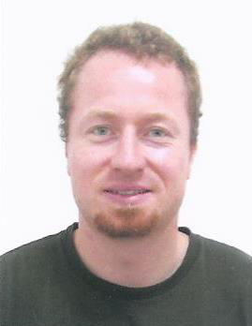

April 2011 - December 2014

August 2009 - March 2011

March 2009 - March 2011

October 2007 - September 2008

October 2005 - September 2007

PhD Student at NaMLab gGmbH / TU Dresden

Graduate studies at the German Institute of Science and Technology, Singapore:   
- Joint-degree program of TU Munich and NTU Singapore   
- Course of studies: Microelectronics (M.Sc.)

- GPA: 1.0 (A+, “passed with high distinction”)

Graduate studies at the University of Technology Munich, Germany:   
- Course of studies: Mechatronics and IT (M.Sc.

/ German Dipl.-Ing.)   
- Majors: Electronics and Computer Science and Microtechnology

- GPA: 1.5 (A- / B+, “passed with distinction”)

Bachelor degree: Undergraduate studies at the University of Technology Munich, Germany:   
- Course of studies: Mechanical Engineering (B.Sc.)   
- Major: Electronics and Computer Science

- GPA: 1.5 (A- / B+, “passed with distinction”)

Pre-degree: Undergraduate studies at the University of Saarbruecken, Germany:   
- Course of studies: Mechatronics (Pre-degree / German Vordiplom)   
- GPA: 1.6 (B+)